Level1-Task1(Top cuisines)-----Dataset used is Datasetcleaned.csv-----
Determine the top three most common cuisines in the dataset.
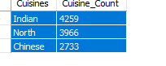
Calculate the percentage of restaurants that serve each of the top cuisines.

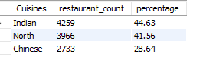
Task2----
Identify the city with the highest number of restaurants in the dataset.
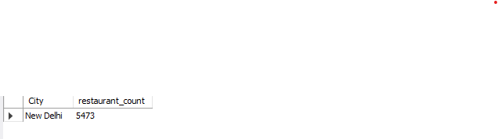

Calculate the average rating for restaurants in each city.

City average_rating  Inner City  Quezon City | 4.900000  4.800000
Makati City | 4.650000
Pasig City | 4.633333
Mandaluyong City | 4.625000
Beechworth | 4.600000
London | 4.535000
Taguig City | 4.525000
Tagaytay City | 4.500000
Lincoln | 4.500000
Secunderabad | 4.500000
Rio De Janeiro | 4.489474
Orlando | 4.478947
Tampa Bay | 4.410000
Palm Cove | 4.400000
Tanunda | 4.400000
Rest Of Hawaii | 4.394737
Bangalore | 4.375000
Dubai | 4.370000
Pasay City | 4.366667
Jakarta | 4.356250
Hyderabad | 4.344444
Chennai | 4.315000
Ankara | 4.305000
Clatskanie | 4.300000
Vernonia | 4.300000
Vineland Station | 4.300000
Abu Dhabi | 4.300000
Mohali | 4.300000
Tangerang | 4.300000
Randburg | 4.300000
Sandton | 4.300000
Stanbul | 4.292857
Auckland | 4.275000
Boise | 4.260000
Kolkata | 4.255000
San Juan City | 4.250000
Wellington City | 4.250000
Goa | 4.245000
Des Moines | 4.235000
Pune | 4.220000
Athens | 4.200000
Pensacola | 4.200000
Panchkula | 4.200000
Bandung | 4.200000
Johannesburg | 4.200000
Lucknow | 4.195238
Guwahati | 4.190476
Pretoria | 4.190000
Savannah | 4.168421
Cedar RapidsIowa City | 4.165000
Ahmedabad | 4.161905
SO Paulo | 4.152941
Coimbatore | 4.135000
Macon | 4.131579
Augusta | 4.130000
Jaipur | 4.130000
Davenport | 4.127778
Dalton | 4.110000
Cape Town | 4.110000
East Ballina | 4.100000
Huskisson | 4.100000
Trentham East | 4.100000
Edinburgh | 4.090000
Mumbai | 4.085000
Kochi | 4.080000
Doha | 4.060000
Chandigarh | 4.050000
Dehradun | 4.050000
Manchester | 4.045000
Gainesville | 4.042105
Columbus | 4.030000
Sharjah | 4.030000
Vadodara | 4.025000
Vizag | 4.005000
Princeton | 4.000000
Bhubaneshwar | 3.980952
Ludhiana | 3.980000
Indore | 3.970000
Agra | 3.965000
Nagpur | 3.965000
Bhopal | 3.950000
Surat | 3.935000
Weirton | 3.900000
Birmingham | 3.873684
Colombo | 3.870000
Bogor | 3.850000
Kanpur | 3.815000
Santa Rosa | 3.800000
Hepburn Springs | 3.800000
Lakes Entrance | 3.800000
Middleton Beach | 3.800000
Sioux City | 3.765000
Mangalore | 3.745000
Puducherry | 3.730000
Valdosta | 3.715000
ChathamKent | 3.700000
Fernley | 3.700000
Forrest | 3.700000
Inverloch | 3.700000
Phillip Island | 3.700000
Mysore | 3.695000
Amritsar | 3.685714
BrasLia | 3.678947
Pocatello | 3.668421
Waterloo | 3.650000
Dicky Beach | 3.600000
Lakeview | 3.600000
Lorn | 3.600000
Monroe | 3.600000
Ojo Caliente | 3.600000
Victor Harbor | 3.600000
Singapore | 3.575000
Albany | 3.552941
Dubuque | 3.535000
Nashik | 3.520000
Varanasi | 3.510000
Armidale | 3.500000
Flaxton | 3.500000
Macedon | 3.500000
Patna | 3.455000
Ranchi | 3.455000
Penola | 3.400000
Allahabad | 3.395000
Aurangabad | 3.375000
Gurgaon | 3.330674
Potrero | 3.300000
Yorkton | 3.300000
New Delhi | 3.297381
Balingup | 3.200000
Winchester Bay | 3.200000
Noida | 3.159626
Faridabad | 3.103311
Cochrane | 3.100000
Ghaziabad | 3.100000
Consort | 3.000000
Mayfield | 2.900000
Paynesville | 2.600000
Mc Millan | 2.400000
Montville | 2.400000
Determine the city with the highest average rating.
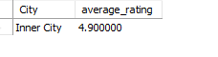
Task 3
Create a histogram or bar chart to visualize the distribution of price ranges
among the restaurants.

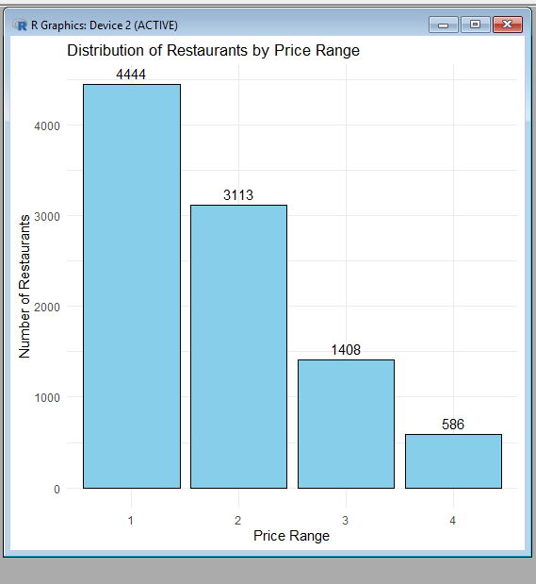
Calculate the percentage of restaurants in each price range category.

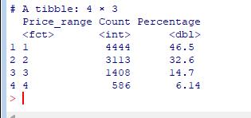

Task4-----
Determine the percentage of restaurants that offer online delivery. Compare the average ratings of restaurants with and without online delivery.
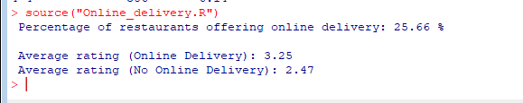

Level2-Task1------
Analyze the distribution of aggregate ratings and determine the most common
rating range. Calculate the average number of votes received by restaurants.

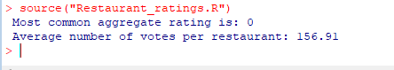
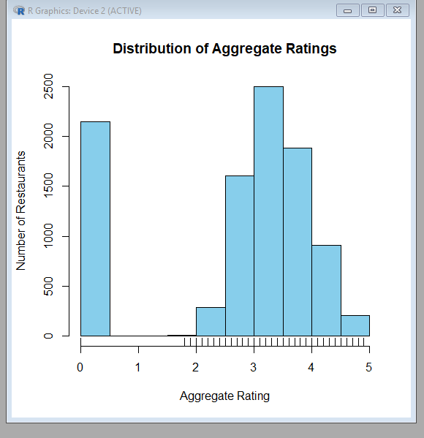
Task2----
Identify the most common combinations of cuisines in the dataset.
Determine if certain cuisine combinations tend to have higher ratings.
