Paul Methot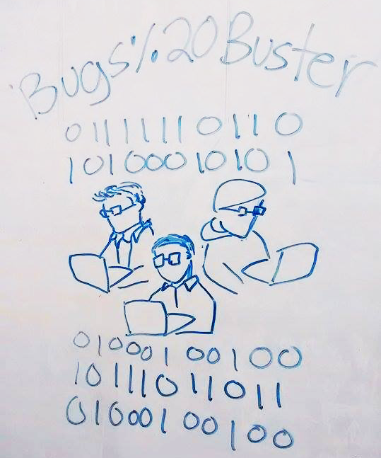

Kelvin Gonzales

Victor Luna

IAT381 Milestone

“We GIT it done!”

Halloumi App by Bug%20Busters

**App Statement:**

To easily calculate diverse house bills, tips and currency for people on the go.

**List of Features:**

* + - Flat navigation experience
    - Calculate bills
      * + Hydro
        + Internet
        + Cable
        + Gas
        + Rent
        + Others
    - Tip calculator
      * + For groups of people
        + Individual
    - Currency exchange
    - Home page

**Target Audience:**

* + - People living with roommates
      * + Students
        + Homestay Family
        + Landlords
        + Couples
    - People who goes to restaurants and give the right amount of tip
    - People that manage money in different countries
      * + International students
        + Travelers
        + Business people
        + Matt
    - Salehen

**Link to Repository:** <https://github.com/vluna/IAT381-Assignment1-Taken3/tree/dev>

**Link to App:** http://vluna.github.io/IAT381-Assignment1-Taken3/app/dist/#/split-bill

**Web Framework:**

* + - Angular.js: We are using this framework because there is a lot you can do with it. Also, there is a a lot of documentation for it.
    - Yeoman: We are using it as a tool to generate code and make our life easier by using angular

**CSS Framework:**

* + - Bootstrap: The css is generated already by it and we just need to incorporate it in our code easily. We do not have to touch the css, we just call the classes into our HTML

**Mobile Layout:**

* + - **Prototype:** https://github.com/vluna/IAT381-Assignment1-Taken3/tree/dev/content/Prototype
    - **Wireframes:** https://github.com/vluna/IAT381-Assignment1-Taken3/blob/master/content/DigitalWireframes.pdf
    - **Flowchart:** https://github.com/vluna/IAT381-Assignment1-Taken3/blob/master/content/ReadMe/IAT381FlowChart.pdf