wk3.R

myeon

2023-04-17

# a plot from week 3  
x <- 1:50  
  
plot(x, sin(x))

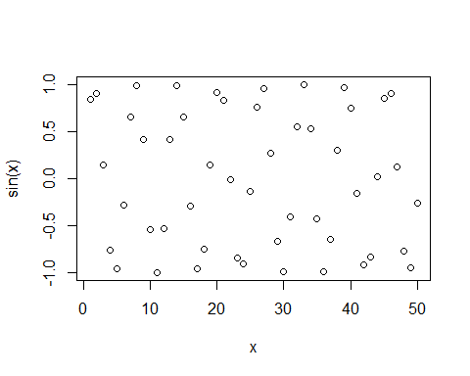

# make this a bit nicer  
plot(x, sin(x), typ="l", col="blue", lwd=3)

