Yuma Tools® Installation Guide

YANG-Based Unified Modular Automation Tools
Table Of Contents
Yuma Tools Installation Guide
1 Preface 2
1.1 Legal Statements 2
1.2 Restricted Rights Legend 2
1.3 Additional Resources 2
1.3.1 WEB Sites 2
1.3.2 Mailing Lists 3
1.4 Conventions Used in this Document 3
2 Introduction 4
2.1 Intended Audience 4
2.2 Yuma Packages 4
3 Installation Requirements 5
3.1 Supported Platforms 5
3.2 External Packages 5
3.2.1 libxml2 5
3.2.2 libssh2 5
3.2.3 libncurses 5
3.2.4 libssl 5
4 Quick Installation 5
4.1 Ubuntu 9.10 6
4.2 Fedora 12 6
4.3 Fedora 10 6
4.4 MacOsX 10.5 6

Preface

Legal Statements
Copyright 2009 - 2010 Netconf Central, Inc., All Rights Reserved.

Restricted Rights Legend
This software is provided with RESTRICTED RIGHTS.
Use, duplication, or disclosure by the U.S. Government is subject to restrictions set forth in subparagraph (c)(1)(ii) of the Rights in Technical Data and Computer Software clause at DFARS 252.227-7013 or subparagraphs(c)(1) and (2) of the Commercial Computer Software - Restricted Rights at 48 CFR 52.227-19, as applicable.
The “Manufacturer” for purposes of these regulations is Netconf Central, Inc., 374 Laguna Terrace, Simi Valley, California 93065 U.S.A.

Additional Resources
Depending on the version of Yuma you purchased, other documentation includes:
Yuma Tools® Quickstart Guide
Yuma Tools® User Manual
Yuma Tools® Developer Manual

To obtain additional support you may email InterWorking Labs at the e-mail address
yuma-support@iwl.com

There are several sources of free information and tools for use with YANG and/or NETCONF.
The following section lists the resources available at this time.

WEB Sites
- Netconf Central
  - http://www.netconfcentral.org
  - Free information on NETCONF and YANG, tutorials, on-line YANG module validation and documentation database
- Yang Central
  - http://www.yang-central.org
  - Free information and tutorials on YANG, free YANG tools for download
- NETCONF Working Group Wiki Page
  - http://trac.tools.ietf.org/wg/netconf/trac/wiki
  - Free information on NETCONF standardization activities and NETCONF implementations
- NETCONF WG Status Page
  - http://tools.ietf.org/wg/netconf/
  - IETF Internet draft status for NETCONF documents
- libsmi Home Page
  - http://www.ibr.cs.tu-bs.de/projects/libsmi/
  - Free tools such as smidump, to convert SMIv2 to YANG

Mailing Lists
- NETCONF Working Group
  - http://www.ietf.org/html.charters/netconf-charter.html
  - Technical issues related to the NETCONF protocol are discussed on the NETCONF WG mailing list. Refer to the instructions on the WEB page for joining the mailing list.
- NETMOD Working Group
  - http://www.ietf.org/html.charters/netmod-charter.html
  - Technical issues related to the YANG language and YANG data types are discussed on the NETMOD WG mailing list. Refer to the instructions on the WEB page for joining the mailing list.

Conventions Used in this Document
The following formatting conventions are used throughout this document:

Documentation Conventions

Convention | Description
--foo | CLI parameter foo
<foo> | XML parameter foo
foo | yangcli command or parameter
$$FOO | Environment variable FOO
$$foo | yangcli global variable foo
some text | Example command or PDU
some text | Plain text

Introduction
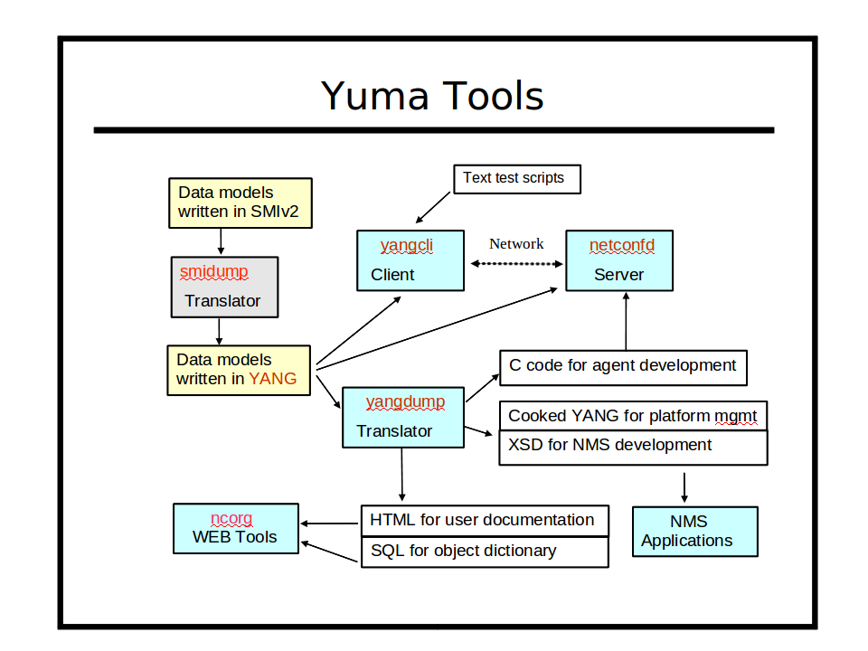
Refer to section 3 of the Yuma User Manual for a complete introduction to Yuma Tools.
This section focuses on the client and server tools within the Yuma Tools programs.

Intended Audience
This document is intended for users of the Yuma Tools NETCONF client and server programs. It covers the installation of the Yuma Tools packages.

Yuma Packages
The Yuma Tools programs are divided into several packages, depending on the version of Yuma Tools that was purchased:
- yuma-shlibs: Contains the libncx shared library used by all Yuma Tools programs
- yuma-client: Includes the NETCONF client program, and programs to process YANG files
- yuma-server: Includes the NETCONF server programs
- yuma-dev: Includes tools, make files, and header files needed for a developer to create server instrumentation libraries for use with the yuma-server package
- yuma-sdk: Includes the complete Yuma Tools source code, and tools for customizing the NETCONF server for use in embedded operating systems

Installation Requirements
The following requirements must be met for Yuma Tools to be installed.

Supported Platforms
The following platforms are supported at this time for the Yuma binary packages:
- Ubuntu version 9.10 (32 bit x86 and 64-bit AMD)
- Fedora version 10 and 12 (32 bit x86)
- MacOSX version 10.5 (Leopard)
The yuma-sdk package contains source code which can be built on many other platforms that support the Gnu C compiler.

External Packages
The following programs and libraries need to be available for Yuma Tools to work.

libxml2
The libxml2 package is needed by the yuma-shlibs package for some of the XML parsing tasks.

libssh2
The libssh2 package is need by the yuma-client package for client-side SSH protocol support.

ncurses
The curses library is needed by the yuma-client package for some terminal support.

libssl
The SSL library is needed by libssh2 package to process the SSH protocol.

Quick Installation
This section describes how to use the platform package manager program to install the Yuma Tools programs.

Ubuntu 9.10
First, make sure the external libraries are installed.

mydir> sudo apt-get install libxml2 libssh2 ncurses

Next, install the Yuma Tools shared libraries:

Fedora 12

Fedora 10

MacOsX 10.5

