YangTools® User Manual
Table Of Contents
Maxwell Network Emulator and Impairment System Guide
Legal Statements 4
Restricted Rights Legend 4
Additional Resources 4
Preface 1
What is YangTools? 1
Intended Audience 1
Conventions used in this document 2
Terms used in this document 2
Introduction 2
System Components 2
YANG 3
NETCONF 4
YANG-based Automation 6
YangTools Programs 7
YANG Module Library 7
YANG Files 11
NETCONF Client 12
NETCONF Server 12
Additional Resources 12
WEB Sites 12
Mailing Lists 12
FAQ 12
Reporting Problems 12
System Configuration 12
Environment Variables 13
$HOME 14
$YANG_HOME 14
$YANG_INSTALL 15
$YANG_MODPATH 15
$YANG_DATAPATH 16
$YANG_RUNPATH 17
Searching for YANG Files 18
Parameter Searches 20
Import/Include Searches 20
File Search Paths 22
Configuration Files 24
XML Configuration Files 25
Text Configuration Files 26
Bootstrap CLI 28
CLI Parameters 29
Parameter Syntax 29
ncx:cli Extension 30
ncx:default-parm Extension 30
yangdump User Guide 31
yangdiff User Guide 31
yangcli User Guide 31
Introduction 31
yangcli Features 32
Running yangcli 33
Built-in Commands 34
System Variables 36
User Variables 36
File Variables 36
Handling Bad Data 36
Configuration Parameter List 36
Invoking Commands 36
Getting Help 37
Command Prompt 37
Command Name 37
Command Parameters 37
Saving and Displaying Command Output 37
Command Completion 37
Command History 37
NETCONF Sessions 37
Command Reference 37
cd 38
close-session 38
commit 38
connect 38
copy-config 38
create 38
create-subscription 38
delete 38
delete-config 38
discard-changes 38
edit-config 38
fill 39
get 39
get-config 39
get-schema 39
help 39
history 39
insert 39
kill-session 39
list 39
load 39
load-config 39
lock 40
merge 40
mgrload 40
no-op 40
pwd 40
quit 40
recall 40
replace 40
restart 40
run 40
save 40
sget 41
sget -config 41
show 41
shutdown 41
unlock 41
validate 41
xget 41
xget -config 41
Usage Examples 41
netconfd User Guide 41
netconf-central User Guide 42
Command Line Interface Reference 42

Legal Statements
Copyright 2009 InterWorking Labs, Inc. All Rights Reserved.
Patents Pending.
YangTools is a trademark of InterWorking Labs, Inc.
All other trademarks belong to their respective owners.

Restricted Rights Legend
This software is provided with RESTRICTED RIGHTS.
Use, duplication, or disclosure by the U.S. Government is subject to restrictions set forth in subparagraph (c)(1)(ii) of the Rights in Technical Data and Computer Software clause at DFARS 252.227-7013 or subparagraphs(c)(1) and (2) of the Commercial Computer Software - Restricted Rights at 48 CFR 52.227-19, as applicable.

The “Manufacturer” for purposes of these regulations is InterWorking Labs, 303 Potrero Street, Suite 52, Santa Cruz, California 95060 U.S.A.

Additional Resources
The file system directory /usr/local/iwl/docs/ on your YangTools® Configuration Management machine contains this and other documentation. This document assumes you have successfully set up the hardware as described in the printed document:

YangTools® Installation and Quickstart Guide

Depending on the version of YangTools you purchased, other documentation includes:

YangTools® Manager Developer's Guide
YangTools® Agent Developer's Guide
YANG User Handbook

To obtain additional support you may email InterWorking Labs at the e-mail address maxwell-support@iwl.com

Preface

What is YangTools?

YangTools is a set of programs providing a complete network management system and development environment, which implements the following standards:
- Network Configuration Protocol (RFC 4741)
- NETCONF over SSH (RFC 4742)
- NETCONF Notifications (RFC 5277)
- SSH2 (RFC 4252 - 4254)
- XML 1.0
- XPath 1.0
- YANG Data modeling language (RFC xxxx)

The following programs are included in the YangTools suite:
- yangdump: validates YANG modules and uses them to generate other formats, such as HTML, XSD, SQL, and C source code
- yangdiff: reports semantic differences between two revisions of a YANG module, and generates YANG revision statements
- yangcli: NETCONF over SSH client, providing a simple but powerful command line interface for management of any NETCONF content defined in YANG
- netconfd: NETCONF over SSH server, providing complete and automated support for the YANG content accessible with the NETCONF protocol
- netconf-subsystem: thin client used to allow OpenSSH to communicate with the netconfd program. This is documented as part of the netconfd program, since they must be used together.
- netconf-central: Intranet version of the www.netconfcentral.org NETCONF/YANG documentation WEB server

Intended Audience

This document is intended for users of the programs in the YangTools suite.
It contains the following information:

- Introduction to YANG and NETCONF based Network Management
- YangTools Configuration
- YangTools User Guides
- YangTools CLI Reference
- Troubleshooting Guide

Conventions used in this document

Icons and explanations TBD

Terms used in this document

Introduction

The YangTools suite provides automated support for development and usage of network management information. All management data is defined with the YANG data modeling language. All management operations are encoded in XML and performed with standard NETCONF protocol operations.

System Components

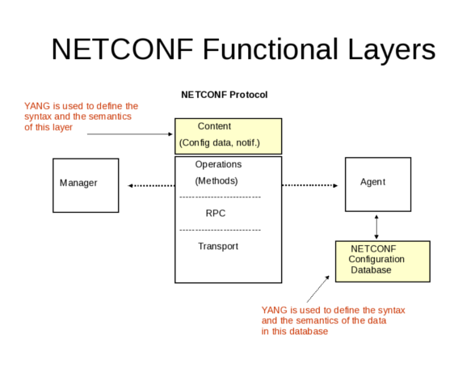

YANG

A YANG module define the semantics and syntax of a specific management feature. They are similar to SMIv2 (MIB) modules, but much more powerful and extensible. YANG provides the ability to define a detailed programmatic interface utilizing all protocol features:
- reusable derived data types
- reusable groupings of objects
- RPC operations
- database objects
- notifications

Network management software developers creating a new feature start by defining the YANG module(s) for the NETCONF representation of the feature. This can include any mixture of new operations, data, and notifications. Existing YANG modules can be augmented as well.

YANG provides complex nested data structures and choices, which allows data modelers to design management interfaces which closely resemble the native data structures within the agent implementation. It is easy to get started with YANG, and there are many optional advanced features that can be utilized as well. YANG provides many machine-readable constructs which allow YangTools to automate many aspects of network management software development.

Semantics and details that are usually only found in 'description' clauses can be understood and implemented automatically by the software tools.

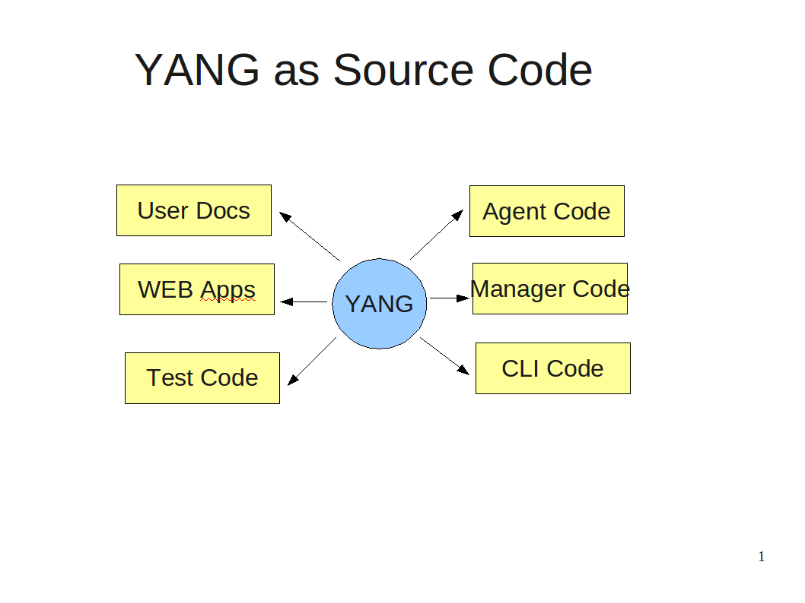

NETCONF

The NETCONF protocol is used to provide secure access all YANG content. The agent maintains a database which is accessed as an XML instance document. Data can be retrieved with XML (subtree) or XPath filters. Changes can be validated before being activated. Databases can be locked to prevent multiple managers from interfering with each other. Custom operations can be used to perform complex actions and perhaps return some data as well.

NETCONF can utilize several secure transport protocols. The mandatory transport (SSH2) is used by YangTools. The OpenSSH server is used in the netconfd implementation, and libssh2 library is used in the yangcli implementation, to provide all SSH2 layer support. By default, TCP port 830 (netconf-over-ssh) is used for all NETCONF communications between yangcli and netconfd. TCP port 22 (ssh) is also supported by default, and additional TCP ports can be configured.

NETCONF security is session-based. Privileges are granted to a session based on the username provided in the SSH connection setup. Access control is configurable (via nacm.yang), based on group membership. The access control rules permit or deny access to one or more groups, to a subset of the YANG content. Seperate defaults for read, write, and exec (RPC operation) access are provided.

YANG-based Automation

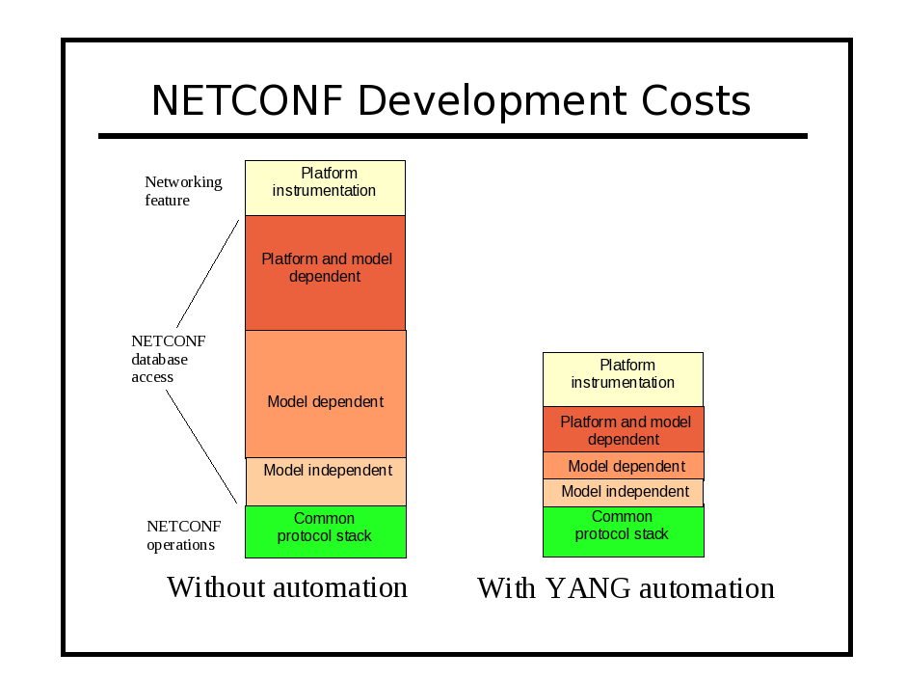

YangTools Programs

The following diagram shows how the three main YangTools programs relate to each other:
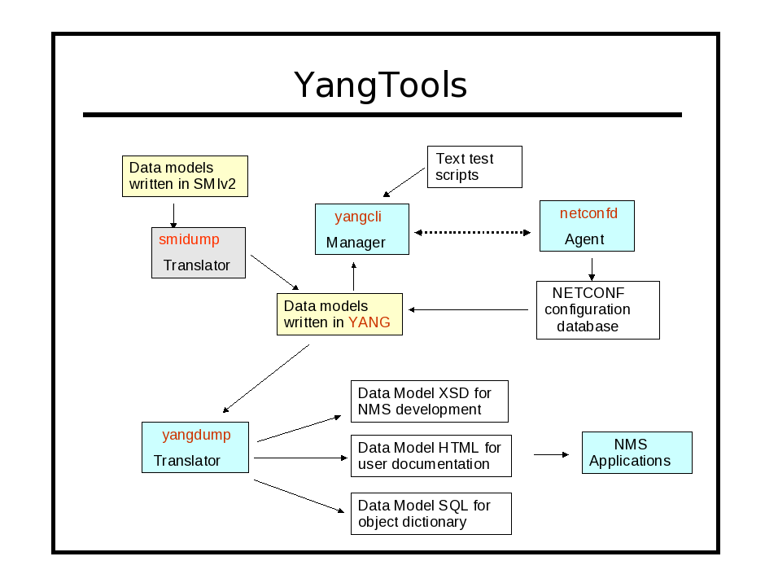
Note that smidump is not part of YangTools, but it can be utilized to convert MIB modules written in SMIv2 into YANG modules, which can be implemented in netconfd, and managed with yangcli. The freely available libsmi library contains the smidump program.

YANG Module Library

The central system component is the set of YANG data model modules which define all available management information. This set of modules is expected to grow over time, and there is usually a high degree of reuse and inter-dependence between the modules.

YANG modules can import other modules to reuse any definitions, and to augment objects in other modules. Each module represents one unique XML namespace used within the NETCONF protocol. A module can be partitioned into any number of submodules, each in a separate YANG file. The submodules are conceptually combined, and only the entire module is accessible to other modules.

Directory Layout

YangTools can utilize several directories to store files used during operation. By default, a 'root' directory and all of its sub-directories are searched for these files. Several different roots can be searched. Generally, there is one centralized root (YANG_INSTALL) shared by all users, and one or more 'project' roots (YANG_HOME), which can be shared but may belong to a single user.

The YangTools programs need to find and store the following types of files during operations:
- YANG modules and submodules (*.yang):
- XML and text data files (usually *.txt or *.xml)
- command scripts for yangcli
- command-line-history file for yangcli

The search paths used to find these files are discussed in detail in the System Configuration section.
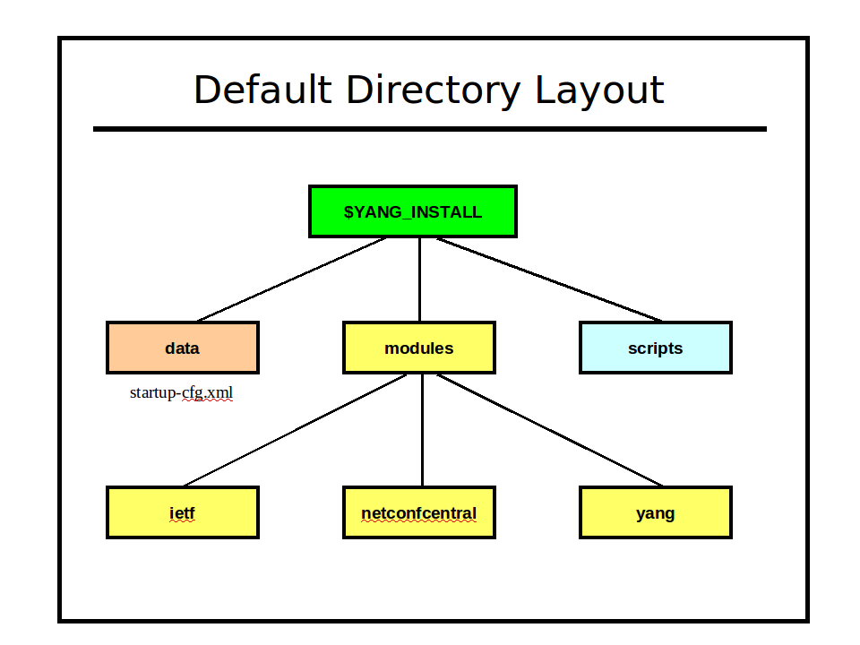
Module Revisions

YANG has extensive module lifecycle support. Each module or submodule has a revision date, and multiple revisions of the same module or submodule may be used at once within the same agent.

The YANG module repository is the authoritative source of common management information for the netconfd server. However, different platform implementations of the same data model need to be 'adjusted' slightly to reflect differences in the feature support available on each platform. YangTools has an extensive set of mechanisms to automate the maintenance of these platform-specific 'special requirements'. A single YANG module (plus 'patches' and deviations as needed for each platform) can be published, instead of a separate version of the YANG module for each platform.

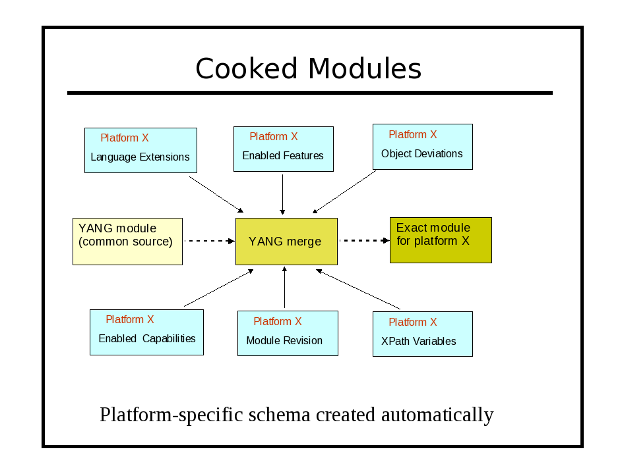
Module Naming Conventions

YANG module names are usually lower-case. Hyphen (-), underscore (_) and period (.) characters are allowed, after the first character, which must be a letter. It is suggested that only the hyphen (-) character be used as a separator between module name string components. YANG files must use the suffix '.yang'.

There are two forms of YANG file names: with and without a revision date.

module.yang
ietf-netconf-state.yang (no revision or unspecified revision)

module.revision-date.yang
ietf-netconf-state.2009-04-17.yang (must be the 2009-04-17 version)

These naming conventions are important when YangTools needs to resolve an 'import' or 'include' statement in a YANG file. Refer to section X.X for more details on YANG module search paths and the 'import-by-revision' feature of YANG.

YANG Files

YANG modules and submodules are text files encoded in UTF-8.
A module can be validated and checked for possible programming mistakes, by using the yangdump program. Many 'reports' can also be generated:
- exported symbols (--exports)
- imported modules (--dependencies)
- object identifiers (--identifiers)

The yangdump program is also used to generate other files, derived from the YANG content:
- XML Schema Document (XSD): extends the NETCONF XSD with the YANG content layer definitions (--format=xsd)
- HTML <div> or full file output: hyper-linked, color-coded formatting of YANG modules to support netconf-central or other WEB-based documentation system. There are several options for configuring the output, and all formatting is done with Cascading style-sheets (CSS) (--format=html)
- netconf-central documentation SQL database input file: supports the automated online documentation of YANG content (--format=sqldb). Refer to the netconfcentral.sql file for details on this output, in section X.X.
- agent instrumentation codestubs: the instrumentation callback functions, used in netconfd for activating specific YANG content, can be generated. This procedure is described in more detail in section X.X (--format=h, --format=c)
- canonical YANG: a YANG file can be reformatted so all statements are indented uniformly, and always appear in the same order. Objects maked as hidden (see the 'hidden' extension in ncx.yang) will not be generated. (--format=yang)
- copy-YANG-and-set-name: A YANG module can be validated and then copied (if no errors) to another location, adding the revision-date to the file name. (--format=copy)

NETCONF Client

NETCONF Server

Additional Resources

WEB Sites

Mailing Lists

FAQ

Reporting Problems

System Configuration

The YangTools programs use YANG to define its configuration parameters.
The 'cli' extension is used within a container with the same name as the program to define all CLI parameters. Some parameters are shared (see ncx-app-common.yang), so they are not located directly in the container.

container yangcli {
ncx:cli;

// yangcli CLI parameters defined as choices and leafs here

}

The following YANG modules are provided, which contain all the configuration parameters for YangTools:
- ncx-types.yang: contains common data types used in the YangTools applications
- ncx-app-common.yang: contains common CLI parameters used in all YangTools applications
- ncx.yang: contains YANG extensions used in any YANG module, including YangTools application modules
- yangdump.yang: configuration parameters for the yangdump application
- yangdiff.yang: configuration parameters for the yangdiff application
- yangcli.yang: configuration parameters and local commands for the yangcli application
- netconfd.yang: configuration parameters for the netconfd server

Notes:
- The netconf-subsystem program does not have any configuration parameters at this time, so there is no YANG file defined for it.
- The openssh SSH server is configured separately, using the sshd_config file.
- The libtecla library, used by the yangcli program for command line editing support, has its own configuration file ~/.tecla, to override the default (emacs) editing key assignments.

YangTools applications can accept configuration parameters from three sources, checked in the following order:
- environment variables
- command line parameters
- configuration files

Environment Variables

The YangTools programs utilize system environment variables to customize and simplify configuration and operation of the programs. Usually, these just specify file search paths or default directory locations. However, these environment variables are among the program, script, and XPath accessible variables used by the yangcli and netconfd programs at runtime.
Any environment variable can be imported as a 'read only system variables' within yangcli, and can be accessed in XPath expression variables with the <get> and <get-config> NETCONF operations in netconfd.

$HOME

The $HOME environment variable contains the directory specification of the user's home directory, and is expected to be set by the system shell before use. The YangTools programs expect (by default) that sub-directories and files contained in this directory will be readable and writable.

Default value: none
CLI override: none
C shell example:

setenv $HOME /home/andy

Bash shell example:

set $HOME=/home/andy
export HOME

$YANG_HOME

The $YANG_HOME environment variable contains the directory specification of the current YangTools project root directory.

Default value: none
CLI override: --yang-home
CLI example:

--yang-home=/home/andy/swdev/yangtools/trunk/netconf

C shell example:

setenv $YANG_HOME /home/andy/swdev/yangtools/trunk/netconf

Bash shell example:

set $YANG_HOME=/home/andy/swdev/yangtools/trunk/netconf
export YANG_HOME

$YANG_INSTALL

The $YANG_INSTALL environment variable contains the directory specification of the YangTools installation root directory.

Default value: /usr/share/yang
CLI override: none
C shell example:

setenv $YANG_INSTALL /usr/lib/yangtools

Bash shell example:

set $YANG_INSTALL=/usr/lib/yangtools
export YANG_INSTALL

$YANG_MODPATH

The $YANG_MODPATH environment variable contains a list of directory specifications that should be searched (in order) to find YANG modules and submodules. It can be used to extend the search path beyond the default locations.

The syntax for this parameter is a string containing the desired directory paths, separated by colon (:) characters. If the trailing forward slash (/) character is missing, then it will be added when searching for files.

By default, each entire directory and all its sub-directory contents will be searched for the requested file. This can be overridden with the 'no-subdirs' parameter. Refer to the Command Line Parameter Reference for more details. If –no-subdirs is used, then only the specified directory will be searched instead.

Note: This parameter specifies the exact directory locations when searching for files. This is different than the $HOME, $YANG_HOME, and $YANG_INSTALL environment variables, which specify a YangTools root directory.

Default value: none
CLI override: --modpath
CLI example:

--modpath=”$HOME/modules2:/usr/local/modules”

C shell example:

setenv $YANG_MODPATH “$HOME/modules2:/usr/local/modules”

Bash shell example:

set $YANG_MODPATH=“$HOME/modules2:/usr/local/modules”
export YANG_MODPATH

$YANG_DATAPATH

The $YANG_DATAPATH environment variable contains a list of directory specifications that should be searched (in order) to find data files used by YangTools applications. It can be used to extend the search path beyond the default locations.

Data files used by the yangcli program are affected by this environment variable.

The location where the netconfd program keeps the file startup-cfg.xml is also affected by this environment variable. This file contains the contents of the non-volatile <startup> database, which is loaded into the <running> database when the agent boots.

The syntax for this parameter is a string containing the desired directory paths, separated by colon (:) characters. If the trailing forward slash (/) character is missing, then it will be added when searching for files.

By default, each entire directory and all its sub-directory contents will be searched for the requested file. This can be overridden with the 'no-subdirs' parameter. Refer to the Command Line Parameter Reference for more details. If –no-subdirs is used, then only the specified directory will be searched instead.

Note: This parameter specifies the exact directory locations when searching for files. This is different than the $HOME, $YANG_HOME, and $YANG_INSTALL environment variables, which specify a YangTools root directory.

Default value: none
CLI override: --datapath
CLI example:

--datapath=”$HOME/modules2:/usr/local/modules”

C shell example:

setenv $YANG_MODPATH “$HOME/modules2:/usr/local/modules”

Bash shell example:

set $YANG_MODPATH=“$HOME/modules2:/usr/local/modules”
export YANG_MODPATH

$YANG_RUNPATH

The $YANG_RUNPATH environment variable contains a list of directory specifications that should be searched (in order) to find script files used by YangTools applications. It can be used to extend the search path beyond the default locations.

Script files used by the yangcli program are affected by this environment variable.

The syntax for this parameter is a string containing the desired directory paths, separated by colon (:) characters. If the trailing forward slash (/) character is missing, then it will be added when searching for files.

By default, each entire directory and all its sub-directory contents will be searched for the requested file. This can be overridden with the 'no-subdirs' parameter. Refer to the Command Line Parameter Reference for more details. If –no-subdirs is used, then only the specified directory will be searched instead.

Note: This parameter specifies the exact directory locations when searching for files. This is different than the $HOME, $YANG_HOME, and $YANG_INSTALL environment variables, which specify a YangTools root directory.

Default value: none
CLI override: --runpath
CLI example:

--runpath=”$HOME/scripts:/usr/local/scripts”

C shell example:

setenv $YANG_RUNPATH “$HOME/scripts:/usr/local/scripts”

Bash shell example:

set $YANG_RUNPATH=“$HOME/scripts:/usr/local/scripts”
export YANG_RUNPATH

Searching for YANG Files

All YangTools programs search for YANG files in the same manner, using the same configuration parameters. The current working directory is included in this search path, so it is important to consider the directory in which a YangTools program is invoked. The search ends as soon as a suitable matching file is found.

There are two types of module searches:
- searches on behalf of configuration parameters
- searches on behalf of YANG import or include statements

The first term in a path specification may contain special character sequences:

- If the first character is the forward slash ('/'), then the entire path specification is used as an absolute path specification.

/usr/share/yang/modules

- If the first character is not the forward slash ('/'), and no special characters are found instead, then the entire path specification is used as an relative path specification, starting from the current working directory.

../more-modules/test7.yang
./this-dir/my-module.yang
testmodule.yang
old-modules/version7/

- If the first character is the tilde ('~') character, followed by the forward slash ('/') character, then the file search will start in the current user's $HOME directory .

~/modules/test/test.yang

- If the first character is the tilde ('~') character, followed by a user name, and then the forward slash ('/') character, then the file search will start in the specified user's $HOME directory . If the user is unknown, then the path specification is invalid.

~andy/modules/test/test.yang
~fred/scripts

- If the first character is the dollar sign ('$') character, followed by an environment variable name, and then the forward slash ('/') character, then the file search will start in the directory indicated by the contents of the environment variable. If the variable is unknown, or its contents do not represent a valid directory location, then the path specification is invalid.

$WORKDIR/tests/test-all-interfaces
$YANG_HOME/data/startup-cfg.xml

Note: Whenever YangTools searches a directory, it checks for the expected file type, but ignores the following:
- all files and sub-directories that begin with the period (.) character
- any directory named 'CVS'
- symbolic links for regular files

The following environment variables affect file searches:
- $HOME
- $YANG_HOME
- $YANG_MODPATH
- $YANG_DATAPATH
- $YANG_RUNPATH

The following configuration parameters affect file searches:
- --yang-home
- --modpath
- --datapath
- --runpath
- --no-subdirs

Parameter Searches

A parameter search is started on behalf of a CLI parameter, such as the –-module parameter, used by the yangdump program. A search of this type can include directory path and file extension in the search parameter. If a filename with a file extension (must be '.yang') is given, then only that exact file will be checked. The current working directory will be used in this case, if no directory path (or a relative directory path) is provided.

--module=test.yang
--module=../more-modules/test3.2009-04-01.yang
If the exact filename is not found, then the search failed.

If a parameter based search does not have any directory path or file extension fields present, then a parmeter search is the same as an import/include search.

Import/Include Searches

An import or include search is started on behalf of a YANG 'import' or 'include' statement. A search of this type includes only the module or submodule name, with no directory or file extension present. An optional 'revision-date' statement can be used in YANG, which means only a version of the YANG file with that exact current revision date will be used.
There are separate search algorithms, depending on whether the revision-date is used in the YANG import or include statement, and whether the imported or included module has a current revision statement.

Mode 1: import-by-revision

In this example, an import statement is causing a search for a module named 'foo' with a revision date of '2009-01-15'.

If a revision-date is used in the import or include statement, then the module search path will be checked as follows:

- First, find a file with the same revision-date in the file name:

import foo {
revision-date “2009-01-15”;
prefix foo;
}

If the file 'foo.2009-01-15.yang' is found, and the current revision statement in the module is equal to '2009-01-15', then the search is successfully terminated.

// file foo.2009-01-15.yang
module foo {

namespace “http://example.com/ns/foo”;
prefix foo;

// rest of header follows

revision 2009-01-15 {
description “Initial version.”;
}

// rest of module follows
}

If the file is not found, or the most current revision date is not correct, then the module search is repeated for 'foo.yang'. If the file 'foo.yang' is found, and the current revision statement in the module is equal to '2009-01-15', then the search is successfully terminated.

// file foo.yang
module foo {

namespace “http://example.com/ns/foo”;
prefix foo;

// rest of header follows

revision 2009-01-15 {
description “Initial version.”;
}

// rest of module follows
}

If the file is not found, or the most current revision date is not correct, then the module search failed.

Mode 2: import any revision

If no file name with the specified revision-date value is found, then the module search path is checked for a file with no revision-date in the file name:

import foo {
prefix foo;
}

If the file 'foo.yang' is found, then it is used, regardless of the most current revision date (if any) found in the module. If it is not found then the module search failed.

Note: The first instance of 'foo.yang' in the module search path will be used, even if a more current version is available, later in the search path.

File Search Paths

YangTools uses configurable search paths to find the various files that are needed during operation.

Module Search Path

- If the module parameter is specified with a path or file suffix, the that filespec is tried, relative to the current working directory. If it is not found, or not the correct revision date, then the search terminates in failure.

--module=../test.yang

- If the module is specified without any path or file extension fields, then the module search path is checked, in order. The first step which produces a match terminates the search successfully. If all steps are exhauted and no match is found then the search terminates in failure.

--module=foo

  - The current working directory is checked. No sub-directories are checked, if any are present.
  - Each directory specified in the $YANG_MODPATH environment variable, or set with the –modpath configuration parameter, is checked.
    - If the –-no-subdirs parameter is set, then only each top-level directory will be checked. If it is not set, then sub-directories will be searched.
  - The $HOME/modules directory is checked.
    - If the –-no-subdirs parameter is set, then only each top-level directory will be checked. If it is not set, then sub-directories will be searched.
  - The $YANG_HOME/modules directory is checked.
    - If the –-no-subdirs parameter is set, then only each top-level directory will be checked. If it is not set, then sub-directories will be searched.
  - The $YANG_INSTALL/modules directory is checked.
    - If the –-no-subdirs parameter is set, then only each top-level directory will be checked. If it is not set, then sub-directories will be searched.

Data Search Path

YangTools programs can store data used during operation.

An example of a data file is the startup configuration file used by netconfd, usually called startup-cfg.xml.

- If the file name has an absolute path specification, then that exact file location is tried. If no match is found, then the search will terminate in failure.
- The current working directory is checked. No sub-directories are checked, if any are present.
- Each directory specified in the $YANG_DATAPATH environment variable, or set with the –datapath configuration parameter, is checked.
    - If the –-no-subdirs parameter is set, then only each top-level directory will be checked. If it is not set, then sub-directories will be searched.
- The $HOME/data directory is checked.
    - If the –-no-subdirs parameter is set, then only each top-level directory will be checked. If it is not set, then sub-directories will be searched.
- The $YANG_HOME/data directory is checked.
    - If the –-no-subdirs parameter is set, then only each top-level directory will be checked. If it is not set, then sub-directories will be searched.

Script Search Path

The yangcli program can store script files used during operation.

- If the file name has an absolute path specification, then that exact file location is tried. If no match is found, then the search will terminate in failure.
- The current working directory is checked. No sub-directories are checked, if any are present.
- Each directory specified in the $YANG_RUNPATH environment variable, or set with the –runpath configuration parameter, is checked.
    - If the –-no-subdirs parameter is set, then only each top-level directory will be checked. If it is not set, then sub-directories will be searched.
- The $HOME/scripts directory is checked.
    - If the –-no-subdirs parameter is set, then only each top-level directory will be checked. If it is not set, then sub-directories will be searched.
- The $YANG_HOME/scripts directory is checked.
    - If the –-no-subdirs parameter is set, then only each top-level directory will be checked. If it is not set, then sub-directories will be searched.
- The $YANG_INSTALL/scripts directory is checked.
    - If the –-no-subdirs parameter is set, then only each top-level directory will be checked. If it is not set, then sub-directories will be searched.

Configuration Files
The YangTools program configuration parameters can be stored in text or XML files.

The -–config parameter is used to specify that configuration parameters should be retrieved from a file instead of the command line.
Any other configuration parameter (except -–config) can be stored in a configuration file used for program input.

XML Configuration Files

The XML format for these files follows the structure of the NETCONF <config> element. Each parameter is stored within a container identifying the application which it is being configured. The netconfd stores its non-volatile <startup> database in this format. XML configuration file contents can appear in any order.

The following configuration parameters affect the generation and display of XML configuration files by netconfd:
- --indent
- --with-defaults

The following configuration parameter affects the location of XML configuration files by netconfd:
- --datapath
- $YANG_DATAPATH environment variable

Note : The IETF may standardize this container format soon. Do not rely on the top-level namespace URI. Any top-level element name <config>, in any namespace (even none), should be expected to contain a complete NETCONF database, or a subset of a NETCONF database.

The following example show some database objects from the NETCONF Access Control Model (nacm.yang), in XML configuration file format.

// file startup-cfg.xml
<?xml version="1.0" encoding="UTF-8"?>
<nd:config xmlns:nd="http://netconfcentral.com/ns/netconfd">
<nacm:nacm xmlns:nacm="http://netconfcentral.com/ns/nacm">
<nacm:groups>
<nacm:group>
<nacm:groupIdentity>nacm:admin</nacm:groupIdentity>
<nacm:userName>andy</nacm:userName>
<nacm:userName>fred</nacm:userName>
<nacm:userName>barney</nacm:userName>
</nacm:group>
</nacm:groups>
<nacm:rules>
<nacm:moduleRule>
<nacm:moduleName>netconf</nacm:moduleName>
<nacm:allowedRights>read write exec</nacm:allowedRights>
<nacm:allowedGroup>nacm:admin</nacm:allowedGroup>
</nacm:moduleRule>
</nacm:rules>
</nacm:nacm>
</nd:config>

Text Configuration Files

The YangTools text configuration file format is based on some common Unix .conf file formats:
- A hash mark until EOLN is treated as a comment

# this is a comment
log-level info # this is also a comment

- All text is case-sensitive
- Whitespace before or within a line is not significant
- The 'end a line' (EOLN) character ('\n') is used to end a command, so whitespace at the end of a line is significant.

- To enter a command on multiple lines, use an escaped EOLN (backslash-EOLN) for all but the last line

this is a command line
this is the start \
of a long \
three line command
this is a new command

- A YANG container parameter is represented by the container name, followed by a left curly brace ('{'), zero or more child nodes, and then a right curly brace ('}').

yangdump {
# set some display control parameters
log-level debug2
warn-linelen 72
indent 4
}

- A YANG list parameter is represented by the list name, followed by a whitespace separated sequence of key leaf values, followed by a left curly brace ('{'), zero or more child nodes, and then a right curly brace ('}').

ifStackEntry 11 42 {
# the key leafs will also printed here
ifStackHigherLayer 11
ifStackLowerLayer 42
ifStackStatus active
}

- Configuration files which are used with command line parameters may include program parameters for multiple applications.
  - Only the top-level container that matches the name of the program will be used.
  - Any other top-level containers will be ignored
  - Only the first instance of the desired program container will be used. Any additional containers will be ignored.

// test.conf
yangdump {
# common yangdump parameters here
}

yangdiff {
# common yangdiff parameters here
}
- Configuration file parameters can appear in any order. Only list index strings need to appear in their defined order.

The qualified names (identifiers, idenitityref, XPath) within a text configuration can be generated several ways. This is needed because sibling nodes in different XML namespaces can have the same name.

The –display-mode configuration parameter is used to control how textual display of values is done. It is an enumeration with four value:

enum value | description | example
plain | no prefix, just local-name | sysBootError
prefix | XML prefix and local-name | sys:sysBootError
module | module name and local name | system:sysBootError
xml | XML format | <sys:sysBootError>

When saving configuration files in non-volative storage, then it is suggested that only 'modprefix' or 'xml' mode be used, since these are the only deterministic modes. The set of XML prefixes in use at any one time is not persistent, and cannot be relied upon, unless the namespace declarations are saved as well (xml mode).

The following configuration parameters affect generation and display of text configuration files
- --indent
- --with-defaults
- --display-mode

Bootstrap CLI
Since YangTools programs use YANG to define CLI parameters, there needs to be an initial bootstrap CLI phase, in order to process parameters which affect the way YANG files are processed.
The bootstrap CLI is not as flexible as the main CLI processor, and trhe syntax is more strict. Parameters must be entered in the following forms:
- --name
- --name=value

If parameters are not entered in this format, then they will be skipped until the main CLI parameter processing is done. This may cause undesirable changes in key parameters, such as the module search path.
The following configuration parameters are also bootstrap parameters, and will take affect immediately, if entered from the command line:
- --log: log messages to the specified file instead of STDOUT
- --log-level: set the logging verbosity level
- --log-append: use the existing log file (if any) instead of overwriting it
- --modpath: use the specified module search path. This will override the $YANG_MODPATH environment variable, if it is set
- --yang-home: use the specified project root. This will override the $YANG_HOME environment variable, if it is set

Refer to the YangTools CLI Reference for more details. on these configuration parameters.

CLI Parameters

Command line parameters are used to provide input to YangTools programs when they are invoked. They are also used extensively by the yangcli program, to represent RPC method input parameters and database nodes which are part of NETCONF operation content, such as the <config> parameter within the <edit-config> operation.

Parameter Syntax

A CLI parameter has 2 forms:
- Parameter contains a YANG type of 'empty' or a zero-length 'string':
<prefix><parameter-name>
- Everything else:
<prefix><parameter-name><separator><value>

There are up to 4 components in a CLI parameter:
- prefix: consists of 0, 1, or 2 consecutive dash characters.
- parameter name: name of the parameter. A partial name may be used if it is unique.
- separator: either consists of the 'equals sign' character ('='), which may be preceded or followed by whitespace, or just whitespace with no equals sign character.
- value: a quoted or unquoted string, an empty string is only allowed if quotes are entered.

The following example shows some ways the leaf 'foo' could be entered as a CLI parameter:

leaf foo {
type uint32;
}

foo=7
-foo=7
--foo=7
--foo =7
foo 7
-foo 7
-foo = 7
--foo 7
--foo "7"
foo 7

ncx:cli Extension

The ncx:cli extension is used in in YANG container definitions, which represent the program CLI parameters, not NETCONF database parameters. It does not take any parameters, and is defined in ncx.yang.

container yangcli {
ncx:cli;

// all the yangcli CLI parameters
}

If this extension is present, then netconfd will ignore the container when loading the database object definitions. Only the program with the same name as the container will use the CLI parameter definition.

ncx:default-parm Extension
The ncx:default-parm extension is used within a container with an ncx:cli extension, or within an 'input' section of an RPC operation definition. It is defined in ncx.yang.

If no parameter name is found when processing CLI parameter input, and the ncx:default-parm extension is present in the container or RPC input being processed, then the specified parameter name will be used instead of generating an error. The value must be valid for the parameter syntax, according to its YANG definition. This means that for the default parameter, only the <value> component of the complete parameter syntax may be used, as well as the normal forms.

container yangdump {
ncx:cli;
ncx:default-parm module;

// all the yangdump CLI parameters
}

When invoking the yang dump program, the default CLI parameter is --module. These two command lines are equivalent:

yangdump –-module=test1 –-module=test2
yangdump test1 test2

A string that does not start with any dashes will still be tried as a parameter name, before trying the default parameter. If the value used for a default parameter conflicts with another parameter name, then the normal form must be used, instead of this form.

yangdump log-app test1

Even if there was a module named 'log-app', it would not be tried as a --module parameter, since it also matches the --log-append parameter.

Note: the default parameter form is can be used in conjunction with shell wildcard characters, depending on the shell.

yangdump *.yang

yangdump --subtree=.

These commands are equivalent in the yangdump program.

yangdump User Guide

yangdiff User Guide

yangcli User Guide

Introduction

The yangcli program is a NETCONF over SSH manager application. It is driven directly by YANG modules, and provides a simple but powerful application interface for any YANG file. There is no configuration required at all to use any YANG file, although there are some YANG extensions that will be utilized if present.

yangcli Features
- Automatic support for all NETCONF protocol operations, including several 'short-hand' commands for the most common operations, like <edit-config> and <get-config>.
- Supports NETCONF notifications, including :interleave capability
- Full XPath 1.0 and subtree filtering support
- Automatic support for all YANG language mechanisms, including extensions
- Any YANG <rpc> operation is automatically available as a yangcli command
- Uses YANG files directly as input, so no pre-processing or configuration needed to use a new module
- Can be called from unix scripts in 'batch-mode' to automatically establish a NETCONF session, issue a command or invoke a yangcli script, close the session, and return the results.
- Extensive interactive shell environment, including user variables, file variables, smart parameter set completion, and a simple scripting environment for automatic operation
- Automatic, context-sensitive (tab key) command-line completion
- Full support for XPath, instance-identifier, leafref, and identityref parameters
- Automatic, context-sensitive help system, based completely on YANG files and using the exact modules supported by the current NETCONF session, if connected
- Full, customizable command line editing, using emacs by default, but vi or a custom set of keystroke bindings are also supported
- Command line history and command recall
- Store and recall command line history files for later use
- Automatic NETCONF session management, including support for all YANG extensions to the <capability> element.
- Automatic recognition and support for all NETCONF 'capability' related operations.
- Automatic support for all YANG additions to the NETCONF protocol, such as the insert operation
- Unlimited nested scripts with up to 10 parameters each can automate testing and other management tasks

Running yangcli
The current working directory in use when yangcli is invoked is important. It is most convenient to run yangcli from a work directory, rather than the installation directory or within the module library.

The yangcli program can be invoked several ways:

- To get the current version and exit:

yangcli --version

- To get program help and exit:

yangcli --help
yangcli --help --brief
yangcli --help --full

- To start an interactive session with the default parameters:

yangcli

- To start an interactive session with a new log file:

yangcli --logfile=mylogfile

- To start an interactive session and append to an existing log file:

yangcli --logfile=mylogfile --log-append

- To get parameters from a configuration file:

yangcli --config=~/yangcli.conf

- To begin to connect to an agent upon startup, provide the --agent parameter. The connect command will be started upon startup and the user willl be prompted to enter the rest of the mandatory parameters to the connect command.

yangcli agent=myagent.example.com

- To connect to an agent and automatically connect without any interactive interruption, enter the --agent, --user, and --password parameters. A session startup will be attempted right away, using these parameters. Any optional parameters for the connect command (--port or --timeout) may be entered as well. All parameters can be entered from a config file, and/or the command line.
yangcli --agent=myagent.example.com --user=andy --password=yangrocks

- To automatically connect to an agent, run a script in non-interactive mode, and then emain connected to the agent, add the --run-script parameter to the connection parameters. The --runpath parameter can also be entered, if needed.

yangcli --agent=myagent.example.com --user=andy --password=yangrocks \
--batch-mode --run-script=mytestscript

- To automatically connect to an agent, run a script in non-interactive mode, and then exit the program, add the --batch-mode and --run-script parameters to the connection parameters. The --runpath parameter can also be entered, if needed.

yangcli --agent=myagent.example.com --user=andy --password=yangrocks \
--batch-mode --run-script=mytestscript

- To automatically connect to an agent, and run a single command instead of a script, and then exit, use the --run-command parameter instead of the --run-script parameter. The --batch-mode parameter can be left out to remain in the current session (in interactive mode) after the command is invoked.

yangcli --agent=myagent.example.com --user=andy --password=yangrocks \
--batch-mode --run-command=”sget /system”

Built-in Commands
The yangcli program has several built-in commands, defined in yangcli.yang, netconf.yang. and notifications.yang.

The YANG rpc statement is used to define the syntax and behavior of each command.

There are 2 types of yangcli commands:
- local: the command is executed within the yangcli application, and can be invoked at any time
- remote: the command is executed on the remote agent, and is only available when a NETCONF session is active.

Local Commands

command name | description
cd | change the current working directory
connect | connect to an agent and start a NETCONF session
fill | fill a user variable
help | get context-sensitive help
history | manage the command history buffer
list | list modules, objects, or other properties of the session
mgrload | load a YANG file into the manager only
pwd | print the current working directoty
quit | exit the program
recall | recall a line from the command history buffer
run | run a script
show | show variables and objects currently available

System Variables

User Variables

File Variables

Handling Bad Data

Configuration Parameter List

Invoking Commands

Command Prompt

Command Name

Command Parameters

Getting Help

Saving and Displaying Command Output

Command Line Editing

Command Completion
The 'tab' key is used for context-sensite command completion:
- If no command has been started, a list of available commands is printed
- If a partial command is entered, a list of commands which match the characters entered so far is printed
- If a command is entered, but no parameters, then a list of available parameters is printed
- If a command is entered, and the cursor is within a command name, then a list of parameters which match the characters entered so far is printed
- If a command is entered, and the cursor is after a command name, but not witrhin a value string, then a list of available parameters is printed
- If a command is entered, and the cursor is within a command value, then a list of possible values which match the characters entered so far is printed. Note that not all data types support value completion at this time.
- If no values are available, but a default value is known, that value will be printed

Command list example: no NETCONF session is active:

yangcli> <hit tab key>
cd fill history mgrload quit run
connect help list pwd recall show

Command list example: NETCONF session is active

yangcli andy@myagent.example.com> <hit tab key>
cd get-schema recall
close-session help replace
commit history restart
connect insert run
copy-config kill-session save
create list sget
create-subscription load sget-config
delete load-config show
delete-config lock shutdown
discard-changes merge unlock
edit-config mgrload validate
fill no-op xget
get pwd xget-config
get-config quit

Command History

NETCONF Sessions

The --xmlorder configuration parameter can be used to force canonical order, according to the YANG definition. Otherwise, the order parameters are entered will be their NETCONF PDU order as well.

Command Reference

cd

close-session

commit

connect

copy-config

create

create-subscription

delete

delete-config

discard-changes

edit-config

fill

get

get-config

get-schema

help

history

insert

kill-session

list

load

load-config

lock

merge

mgrload

no-op

pwd

quit

recall

replace

restart

run

save

sget

sget -config

show

shutdown

unlock

validate

xget

xget -config

Usage Examples

netconfd User Guide

netconf-central User Guide

Command Line Interface Reference

