Yuma Tools® User Manual

YANG-Based Unified Modular Automation Tools

Common User Manual
Table Of Contents
Yuma Tools User Manual
1 Preface 3
1.1 Legal Statements 3
1.2 Additional Resources 3
1.2.1 WEB Sites 3
1.2.2 Mailing Lists 4
1.3 Conventions Used in this Document 4
2 Summary 4
2.1 What is Yuma? 4
2.2 Intended Audience 6
3 Introduction 7
3.1 System Components 7
3.1.1 YANG 9
3.1.2 NETCONF 11
3.1.3 YANG-based Automation 14
3.1.4 YANG Language Extensions 19
3.1.5YANG Compiler 20
3.1.6 YANG Module Library 20
3.1.7 YANG Files 22
3.1.8 NETCONF Managers 23
3.1.9 NETCONF Agents 23
4 System Configuration 24
4.1 Environment Variables 24
4.1.1 $HOME 25
4.1.2 $YUMA_HOME 25
4.1.3 $YUMA_INSTALL 26
4.1.4 $YUMA_MODPATH 26
4.1.5 $YUMA_DATAPATH 27
4.1.6 $YUMA_RUNPATH 28
4.2 Searching for Files 28
4.2.1 Yuma Work Directory 30
4.2.2 Parameter Searches 30
4.2.3 Import/Include Searches 30
4.2.4 File Search Paths 32
4.3 Configuration Files 34
4.3.1 XML Configuration Files 35
4.3.2 Text Configuration Files 36
4.4 Bootstrap CLI 38
4.5 Configuration Parameters 38
4.5.1 Parameter Syntax 39
4.5.2 ncx:cli Extension 39
4.5.3 ncx:default-parm Extension 40
5 XPath Reference 41
5.1 XPath 1.0 41
5.1.1 XML Namespaces 41
5.2 YANG Specific XPath Behavior 42
5.3 Custom XPath Variables 42
5.3.1 user 43
5.4 Custom XPath Functions 43
5.4.1 module-loaded 43
5.4.2 feature-enabled 43
6 Error Reference 45
6.1 Error Messages 45

Preface

Legal Statements
Copyright 2009 - 2010, Andy Bierman., All Rights Reserved.

Additional Resources
This document assumes you have successfully set up the software as described in the printed document:
Yuma Tools® Installation Guide

Depending on the version of Yuma you purchased, other documentation includes:
Yuma Tools® Quickstart Guide
Yuma Tools® netconfd Manual
Yuma Tools® yangcli Manual
Yuma Tools® yangdiff Manual
Yuma Tools® yangdump Manual
Yuma Tools® Developer Manual

To obtain additional support you may send email to this e-mail address:
support@netconfcentral.org

There are several sources of free information and tools for use with YANG and/or NETCONF.
The following section lists the resources available at this time.

WEB Sites
- Netconf Central
  - http://www.netconfcentral.org/
  - Yuma Tools Home Page
    - Free information on NETCONF and YANG, tutorials, on-line YANG module validation and documentation database
- Yang Central
  - http://www.yang-central.org
  - Free information and tutorials on YANG, free YANG tools for download
- NETCONF Working Group Wiki Page
  - http://trac.tools.ietf.org/wg/netconf/trac/wiki
  - Free information on NETCONF standardization activities and NETCONF implementations
- NETCONF WG Status Page
  - http://tools.ietf.org/wg/netconf/
  - IETF Internet draft status for NETCONF documents
- libsmi Home Page
  - http://www.ibr.cs.tu-bs.de/projects/libsmi/
  - Free tools such as smidump, to convert SMIv2 to YANG

Mailing Lists
- NETCONF Working Group
  - http://www.ietf.org/html.charters/netconf-charter.html
  - Technical issues related to the NETCONF protocol are discussed on the NETCONF WG mailing list. Refer to the instructions on the WEB page for joining the mailing list.
- NETMOD Working Group
  - http://www.ietf.org/html.charters/netmod-charter.html
  - Technical issues related to the YANG language and YANG data types are discussed on the NETMOD WG mailing list. Refer to the instructions on the WEB page for joining the mailing list.

Conventions Used in this Document
The following formatting conventions are used throughout this document:

Documentation Conventions

Convention | Description
--foo | CLI parameter foo
<foo> | XML parameter foo
foo | yangcli command or parameter
$$FOO | Environment variable FOO
$$foo | yangcli global variable foo
some text | Example command or PDU
some text | Plain text

Summary

What is Yuma?
Yuma is a set of programs providing a complete network management system and development environment, which implements the following standards:
- Network Configuration Protocol (RFC 4741)
- NETCONF over SSH (RFC 4742)
- NETCONF Notifications (RFC 5277)
- Partial Lock RPC for NETCONF (RFC 5717)
- SSH2 (RFC 4252 - 4254)
- XML 1.0
- XPath 1.0
- YANG Data modeling language (RFC xxxx) [draft-ietf-netmod-yang-13.txt]

The following programs are included in the Yuma suite:
- yangdump: validates YANG modules and uses them to generate other formats, such as HTML, XSD, SQL, and C source code
- yangdiff: reports semantic differences between two revisions of a YANG module, and generates YANG revision statements
- yangcli: NETCONF over SSH client, providing a simple but powerful command line interface for management of any NETCONF content defined in YANG
- netconfd: NETCONF over SSH server, providing complete and automated support for the YANG content accessible with the NETCONF protocol
- netconf-subsystem: thin client used to allow OpenSSH to communicate with the netconfd program. This is documented as part of the netconfd program, since they must be used together.

Although any arbitrary YANG file can be automatically supported by Yuma, the following content (YANG modules) is built into the netconfd server, and supported by the yangcli client:
- yuma-netconf.yang: all the NETCONF protocol operations, including all YANG extensions to the NETCONF protocol (RFC 4741). This file contains meta-data used in the yangcli and netconfd programs, which is not available in the ietf-netconf.yang version.
- ietf-yang-types.yang: the standard derived types library in progress for YANG. This module is being developed by the NETMOD WG. (draft-ietf-netmod-types-09.txt)
- ietf-inet-types.yang: the standard Internet address types library in progress for YANG. This module is being developed by the NETMOD WG. (draft-ietf-netmod-types-09.txt)
- ietf-netconf-monitoring.yang: the standard NETCONF monitoring module in progress by the NETCONF WG (draft-ietf-netconf-monitoring-15.txt)
- ietf-netconf-partial-lock.yang: the standard NETCONF module for multiple concurrent partial database locks (RFC 5717).
- ietf-with-defaults.yang: the standard NETCONF default value control module in progress by the NETCONF WG (draft-ietf-netconf-with-defaults-07.txt)
- yuma-interfaces.yang: interfaces monitoring and configuration scaffolding.
- yuma-mysession.yang: NETCONF session customization operations
- notifications.yang: the standard NETCONF create-subscription command to start receiving NETCONF notifications (RFC 5277)
- nc-notifications.yang: the standard NETCONF notifications (RFC 5277)
- yuma-proc.yang: /proc file system monitoring information
- yuma-system.yang: Proprietary system group and common notifications
- yuma-nacm.yang: Proprietary NETCONF Access Control Model
- test/*.yang: Several modules are included for testing YANG and NETCONF behavior.

Intended Audience
This document is intended for users of the programs in the Yuma suite.
It contains the following information:
- Introduction to YANG and NETCONF based Network Management
- Yuma Configuration
- Yuma User Guides
- Yuma CLI Reference
- Yuma Error Reference

Introduction
The Yuma Tools suite provides automated support for development and usage of network management information.
All management data is defined with the YANG data modeling language.
All management operations are encoded in XML 1.0 and performed with standard NETCONF protocol operations.

System Components

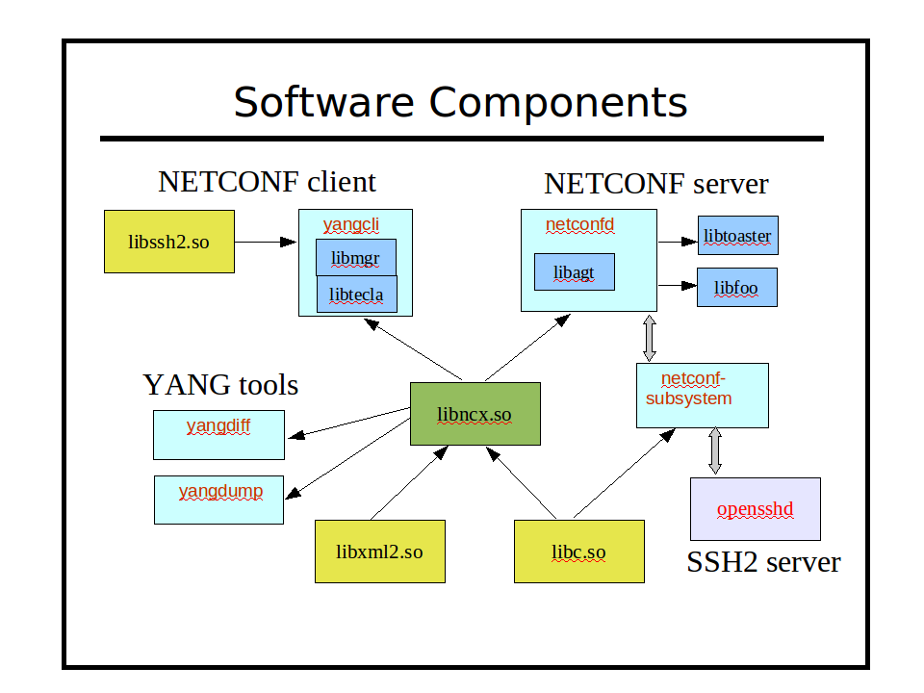
The following external program is used by Yuma, and needs to be pre-installed:
- opensshd
  - The SSH2 server code does not link with Yuma. Instead, the netconf-subsystem program is invoked, and local connections are made to the netconfd server from this SSH2 subsystem.
The following external libraries are used by Yuma, and need to be pre-installed. They are usually installed by default and do not need to be installed by you:
- libc6
  - unix system library
- ncurses
  - Curses terminal support (needed on Fedora platforms only)
- libxml2
  - xmlTextReader XML parser
  - pattern support

The following external library is built within Yuma and does not need to be pre-installed:
- libtecla
  - command line support for yangcli
The following shared (or static) library is built by Yuma and used by almost all of its programs:
- libncx
  - YANG parser
  - YANG validation
  - basic NETCONF support
  - XPath support
  - configuration database support
The following libraries are built by Yuma, and used within executables:
- libagt
  - NETCONF server support
- libmgr
  - NETCONF client support
- libydump
  - yangdump translation functionality
The following binaries are built by Yuma:
- netconfd
  - NETCONF server
- netconf-subsystem
  - thin client between opensshd and NETCONF server
- yangcli
  - NETCONF client
- yangdump
  - YANG validation
- yangdumpcode
  - YANG validation and code generation (available in Yuma Tools SDK)
- yangdiff
  - YANG compare
The following sample netconfd module instrumentation library is provided as an example. These libraries (e.g., libfoo.so) can only be created with the Yuma SDK. Refer to the Yuma Developer's Guide for details on creating server instrumentation libraries.
- libtoaster
- Server instrumentation code for the YANG module libtoaster.yang.

YANG
A YANG module define the semantics and syntax of a specific management feature. They are similar to SMIv2 (MIB) modules, but much more powerful and extensible. YANG provides the ability to define a detailed programmatic interface utilizing all protocol features:
- reusable derived data types
- reusable groupings of objects
- RPC operations
- database objects
- notifications
Network management software developers creating a new management feature start by defining the YANG module(s) for the NETCONF representation of the feature. This can include any mixture of new operations, data, and notifications. Existing YANG modules can be augmented as well.
YANG provides complex nested data structures and choices, which allows data modelers to design management interfaces which closely resemble the native data structures within the server implementation.
It is easy to get started with YANG, and there are many optional advanced features that can be utilized as well. YANG provides many machine-readable constructs which allow Yuma to automate many aspects of network management software development.
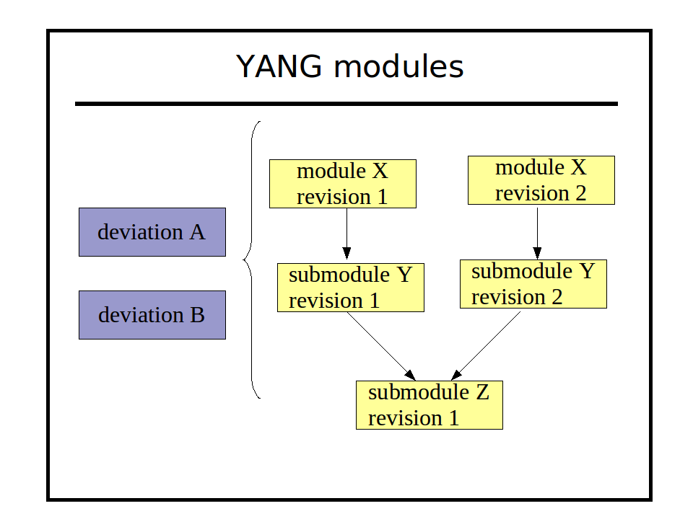
Semantics and details that are usually only found in 'description' clauses can be understood and implemented automatically by the software tools.
A YANG module can be a single file, or it can be split into an arbitrary number of files, using sub-modules. A YANG submodule is essentially the same as a main module, except that the namespace URI value is shared between the main module and all its submodules.
A submodule is referenced with the include statement instead of the import statement.
Submodules can also include other submodules, except a loop may not be formed by the include statements.
Conceptually, the module is not nested. All definitions in submodules appear at the top level of the YANG module, even submodules included by other submodules.
All YANG modules and submodules have revision dates. The example shows a simple version number, but the actual revision strings are date strings in the form 'YYYY-MM-DD'.
Yuma programs support concurrent usage of different revisions of the same module or submodule. This can occur via groupings from external modules within the YANG language. Only one revision of a module can be imported into a single module or submodule, but any of these files may in turn import other modules. It is possible that a different version of the same module could be indirectly imported in this case.
Deviation modules are normal YANG modules, except they only contain deviation statements. These deviation statements are used to alter (patch) the YANG modules with implementation-specific differences.
A deviation module can contain any number of deviation statements, and they can apply to an arbitrary number of objects, from any module. Multiple deviation statements for the same target will be combined by the server before using them, and all deviate statements for the same object will be validated together, as if they were all contained in the same deviation statement. The order of the deviation statements is irrelevant.
Deviations modules are processed first, and the deviation statements save for later. The import statements are ignored, unlike real module processing.
Since deviation modules are not identified in any way, Yuma programs use the --module parameter to refer to a normal YANG module or submodule, and the --deviation parameter to refer to a deviation module.

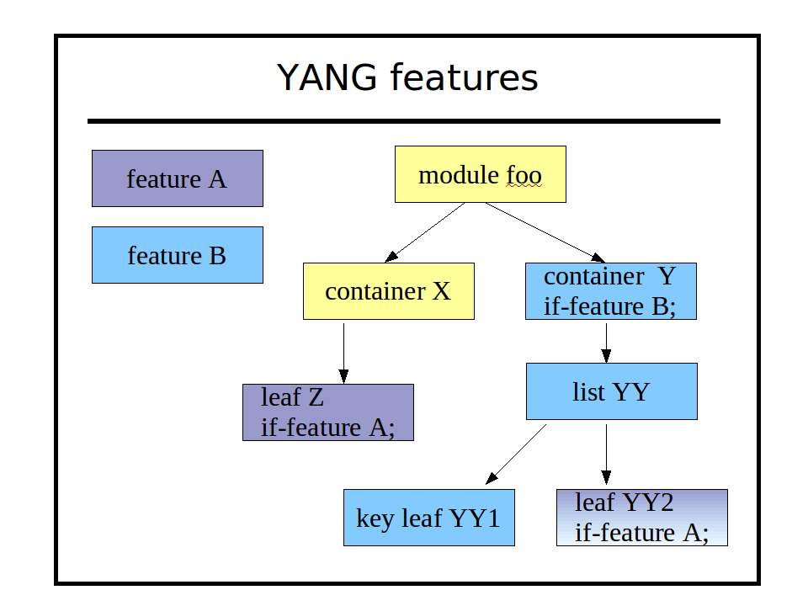
The YANG feature statement is used to define a conceptual partition within the module.
Objects that contain the if-feature statement for the corresponding feature are part of the feature.
If the server does not advertise a feature in its <capabilities>, then it is not supported, and all the objects that are part of the feature are not supported.
Multiple if-feature statements form a logical AND expression. All the referenced features must be enabled for the object to be available. In the example above, leaf 'YY2' is not present unless feature A and B are both advertised by the server.

NETCONF
The mandatory components of the NETCONF protocol are defined in RFC 4741 and RFC 4742.

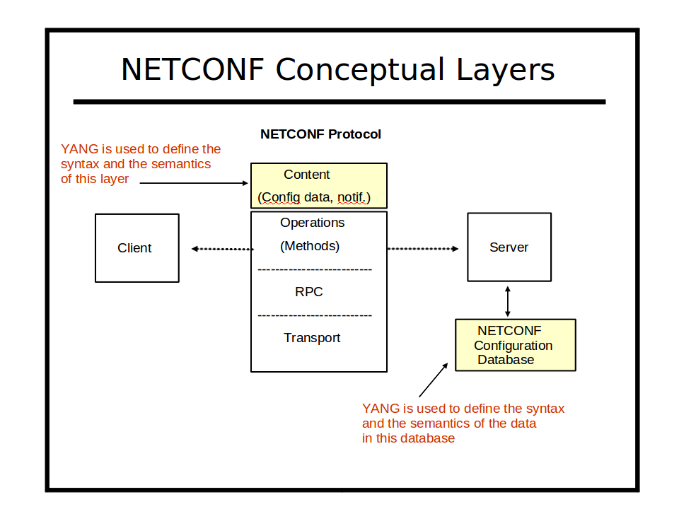
The NETCONF protocol is used to provide secure access all YANG content. The server maintains a database which is accessed as if it was an XML instance document.

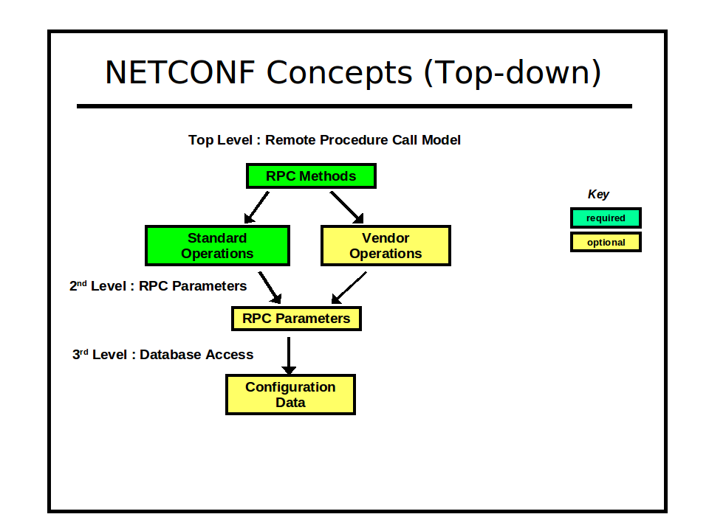
Data can be retrieved with XML (subtree) or XPath filters. Changes can be validated before being activated. Databases can be locked to prevent multiple managers from interfering with each other. Custom operations can be used to perform complex actions and perhaps return some data as well.

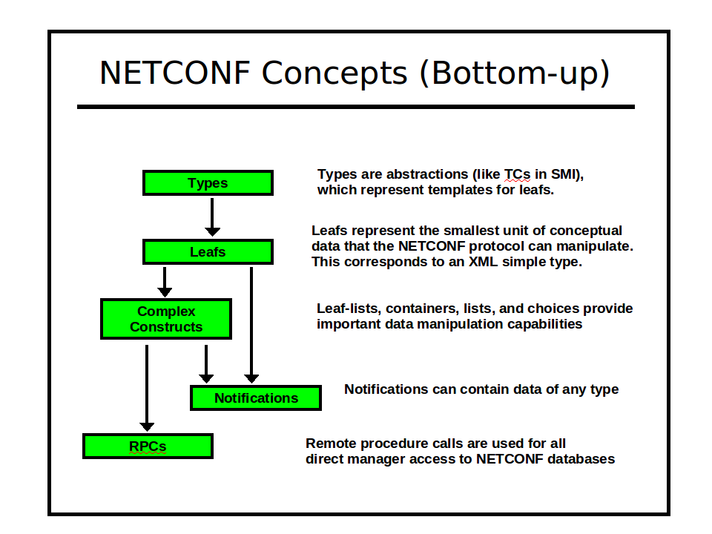
NETCONF can utilize several secure transport protocols. The mandatory transport (SSH2) is used by Yuma. The OpenSSH server is used in the netconfd implementation, and libssh2 library is used in the yangcli implementation, to provide all SSH2 layer support.
By default, TCP port 830 (netconf-over-ssh) is used for all NETCONF communications between yangcli and netconfd. TCP port 22 (ssh) is also supported by default, and additional TCP ports can be configured.
NETCONF security is session-based. Privileges are granted to a session based on the username provided in the SSH connection setup.
Access control is configurable (via yuma-nacm.yang), based on group membership. The access control rules permit or deny access to one or more groups, to a subset of the YANG content. Separate defaults for read, write, and exec (RPC operation) access are provided.

YANG-based Automation
Yuma is a 100% “native YANG” implementation. This means that YANG modules are used directly by all the tools to control all aspects of NETCONF protocol usage. There are no lossy translations, or complicated configuration steps, in order to use a YANG module. Simply load a module and start using it.
The automation concepts will be familiar to SNMP developers who use SMIv2 to write MIB modules. The SMIv2 language contains enough machine-readable clauses so a client and server can automate certain aspects of the SNMP protocol implmentation.
YANG does the same thing for NETCONF developers, only 10 times better.

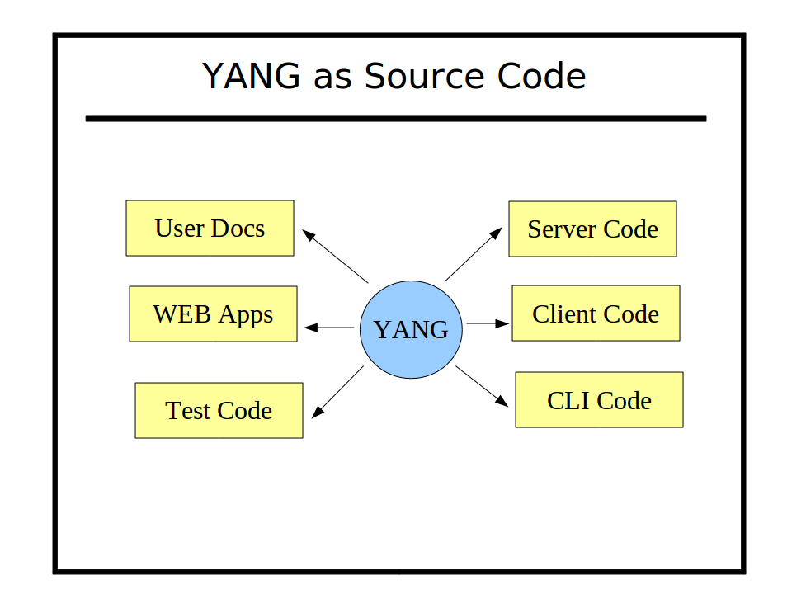
There are many more machine-readable constructs in YANG, and more powerful data modeling features. The complicated YANG features are optional, so traditional 'DESCRIPTION clause' based semantics are still supported.
The more machine-readable YANG clauses that are used, the more the yangcli client and netconfd server can automate the entire NETCONF protocol implementation.

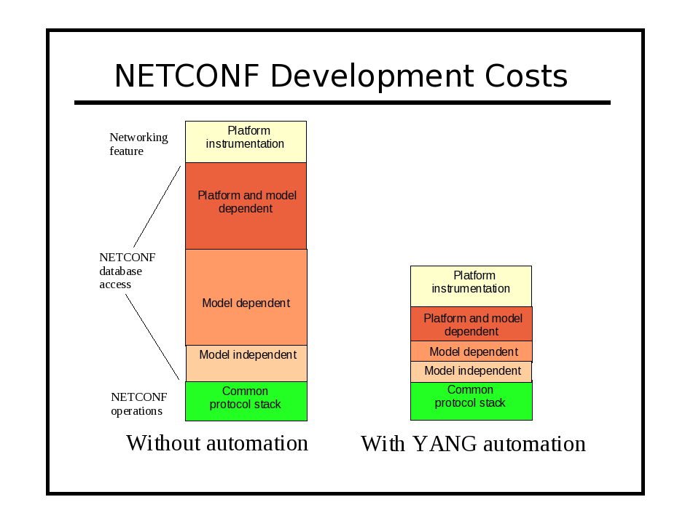
The YANG language includes many ways to specify conditions for database validity, which traditionally are only documented in DESCRIPTION clauses:

YANG Automation Constructs

YANG statement | description
config boolean; | The config statement indicates if the object is writable, or read-only. The server uses this information when automatically skipping config=false entries for the <get-config> operation.
default string; | The default statement specifies the mandatory-to-use default value, if no leaf is provided. Unlike SMIv2 DEFVAL, it is not a suggestion, and the client can rely on it. Defaults can be specified in typedef or leaf statements. If both are defined, then the leaf default will be used.
deviation deviation-target-path { … } | The deviation statement allows any YANG object be customized for a particular platform or implementation.. The tools can automatically support the altered objects, based on the sub-statements within the deviation statement. These changes can be of any nature, even those normally not allowed in YANG. The intent of the deviation statement os to accurately describe the object implementation, so the tools can automate the protocol operations correctly, even for non-standard implementations.
error-app-tag apptag-string; | The error-app-tag statement can be used within the range, length, and pattern statements. If a value is invalid due to the corresponding error, then the <error-app-tag> field in the <rpc-error> sent by the server will be set to the 'apptag-string' value.
error-message errmsg-string; | The error-message statement can be used within the range, length, and pattern statements. If a value is invalid due to the corresponding error, then the <error-message> field in the <rpc-error> sent by the server will be set to the 'errmsg-string' value.
extension | The extension statement allows a vendor to add language extensions, and all YANG implementations must be able to parse the extension correctly. However, only implementations which actually understand the extension will support it. All others will simply ignore the extension.
feature | The feature statement allows a module to be conceptually partitioned into mandatory and conditional object groups. All objects with the corresponding if-feature statement will be present only if the feature is supported by the server.
if-feature feature-name; | Construct containing the if-feature statement is only included if the specified feature is supported by the server. Otherwise, the object does not exist on the server.
import (by revision) | The import statement allows definitions from other modules to be used. A specific revision date can be used within the entire module. However, it is possible that different versions of imported typedefs and groupings can be used, if one imported module also imports some modules.
include (by revision) | The include statement provides the exact same features as the import statement, except it applied to sub-modules included within a module (or other sub-modules), instead of other modules. It allows multiple sub-modules to be combined to create one conceptual YANG module.
key key-leaf-list; | The key statement indicates a set of one or more top-level leafs within the list that are used to name a specific instance of the particular list object. All protocol operations, such as <edit-config>, can be fully automated, based on the information in this statement.
length length-spec-string; | The length statement is exactly like the range statement, except it limits the length of string leaf and leaf-list objects.
mandatory boolean; | The mandatory statement indicates that the choice, list or leaf must be provided by the client. It will not be created by the server. Most parameters are not mandatory however, so the default is 'false' if this statement is missing.
max-elements  number | 'unbounded' ; | Specifies the maximum number of instances that a list or leaf-list object can have in a valid database. The default is 'unbounded', if this statement is not present.
min-elements number; | Specifies the minimum number of instances that a list or leaf-list object must have in a valid database. The default is zero, if this statement is not present.
must xpath-expr; | If the object containing the must statement exists, then the XPath expression must evaluate to 'true' for the database to be valid. This provides referential integrity checks among related parameters.
pattern pattern-string ; | The pattern statement specifies a regular expression that must evaluate to 'true' in order for the corresponding string leaf or leaf-list object to be valid. Multiple patterns encountered in a nested typedef chain must all evaluate to 'true' for the object to be valid.
range range-spec-string ; | The type statement can specify the range of a numeric type. Since typedefs can be nested in YANG, the range statements are nested also, and constitute an AND expression (i.e., all the range tests must pass in the chain of type definitions.) THe keywords 'min' and 'max' indicate the minimum and maximum values from the parent typedef (if any), not the built-in type.
refine refine-target-path { … } | The refine statement is defined within a uses statement, and allows the specific grouping to be customized for each individual copy of the grouping contents. The tools can automatically support the refined objects, based on the sub-statements within the refine statement.
revision revision-date { … } | The revision statement identifies the most current version of a YANG module or sub-module. Multiple versions at once are supported in YANG.
unique unique-node-list; | The unique statement indicates an arbitrary tuple of descendant nodes within a list, which have to be unique within the list. These nodes are not keys, and can be nested anywhere within a single list entry.
uses grouping-name; | The uses statement inserts an instance of a reusable grouping, replacing the uses node within the conceptual data tree.
when xpath-expr; | The object containing the when statement is only allowed to exist if the XPath expression evaluates to 'true'. This provides a SPARSE AUGMENTS capability when combined with the augment statement.

YANG Language Extensions
There are several YANG extensions that are supported by Yuma. They are all defined in the YANG file named yuma-ncx.yang. They are used to 'tag' YANG definitions for some sort of automatic processing by Yuma programs. Extensions are position-sensitive, and if not used in the proper context, they will be ignored. A YANG extension statement must be defined (somewhere) for every extension used in a YANG file, or an error will be occur.
Most of these extensions apply to netconfd server behavior, but not all of them. For example, the ncx:hidden extension will prevent yangcli from displaying help for an object containing this extension. Also, yangdump will skip this object in HTML output mode.
The following table describes the supported YANG language extensions. All other YANG extension statements will be ignored by Yuma, if encountered in a YANG file:

YANG Language Extensions

extension | description
ncx:hidden; | Declares that the object definition should be hidden from all automatic documentation generation. Help will not be available for the object in yangcli.
ncx:metadata  “attr-type  attr-name”; | Defines a qualified XML attribute in the module namespace.  Allowed within an RPC input parameter.  attr-type is a valid type name with optional YANG prefix.  attr-name is the name of the XML attribute.
ncx:no-duplicates; | Declares that the ncx:xsdlist data type is not allowed to contain duplicate values. The default is to allow duplicate token strings within an ncx:xsdlist value.
ncx:password; | Declares that a string data type is really a password, and will not be displayed or matched by any filter.
ncx:qname; | Declares that a string data type is really an XML qualified name. XML prefixes will be properly generated by yangcli and netconfd.
ncx:root; | Declares that the container parameter is really a NETCONF database root, like <config> in the <edit-config> operations. The child nodes of this container are not specified in the YANG file. Instead, they are allowed to contain any top-level object from any YANG file supported by the server.
ncx:schema-instance; | Declares that a string data type is really an special schema instance identifier string. It is the same as an instance-identifier built-in type except the key leaf predicates are optional. For example, missing key values indicate wild cards that will match all values in nacm <data-rule> expressions.
nacm:secure; | Declares that the database object is a secure object.  If the object is an rpc statement, then only the netconfd 'superuser' will be allowed to invoke this operation by default.  Otherwise, only read access will be allowed to this object by default, Write access will only be allowed by the 'superuser', by default.
nacm:very-secure; | Declares that the database object is a very secure object.  Only the 'superuser' will be allowed to access the object, by default.
ncx:xsdlist “list-type”; | Declares that a string data type is really an XSD style list.  list-type is a valid type name with optional YANG prefix.  List processing within <edit-config> will be automatically handled by netconfd.
ncx:xpath; | Declares that a string data type is really an XPath expression. XML prefixes and all XPath processing will be done automatically by yangcli and netconfd.

YANG Compiler
The Yuma programs all use the same centralized YANG language parser.
The complete YANG language is supported, as defined in the latest version (draft-ietf-netmod-yang-13.txt). The file naming conventions defined in this specification must be used, along with all the language definition rules.
Definitions can be contained in modules and/or sub-modules.
Any number of revisions of a module or submodule can be used concurrently, The import-by-revision and include-by-revision features of YANG are fully supported, Refer to the section 'Searching for Files' for more details.
All extension usage within YANG files is supported and saved. The application data is available to all Yuma programs, including netconfd server instrumentation. Refer to the 'YANG User Guide' for details on writing YANG files and using the extensions built into Yuma.
Note: The smidump is not part of Yuma, but it can be utilized to convert MIB modules written in SMIv2 into YANG modules, which can then be implemented in netconfd, and managed with yangcli. The freely available libsmi library contains the smidump program.

YANG Module Library
The central system component is the set of YANG data model modules which define all available management information. This set of modules is expected to grow over time, and there is usually a high degree of reuse and inter-dependence between the modules.
YANG modules can import other modules to reuse any definitions, and to augment objects in other modules. Each module represents one unique XML namespace used within the NETCONF protocol. A module can be partitioned into any number of submodules, each in a separate YANG file. The submodules are conceptually combined, and only the entire module is accessible to other modules.

Directory Layout

Yuma can utilize several directories to store files used during operation. By default, a 'root' directory and all of its sub-directories are searched for these files. Several different roots can be searched. Generally, there is one centralized root (YUMA_INSTALL) shared by all users, and one or more 'project' roots (YUMA_HOME), which can be shared but may belong to a single user.
The Yuma programs need to find and store the following types of files during operations:
- YANG modules and submodules (*.yang):
- XML and text data files (usually *.txt or *.xml)
- command scripts for yangcli
- command-line-history file for yangcli
The search paths used to find these files are discussed in detail in the System Configuration section.
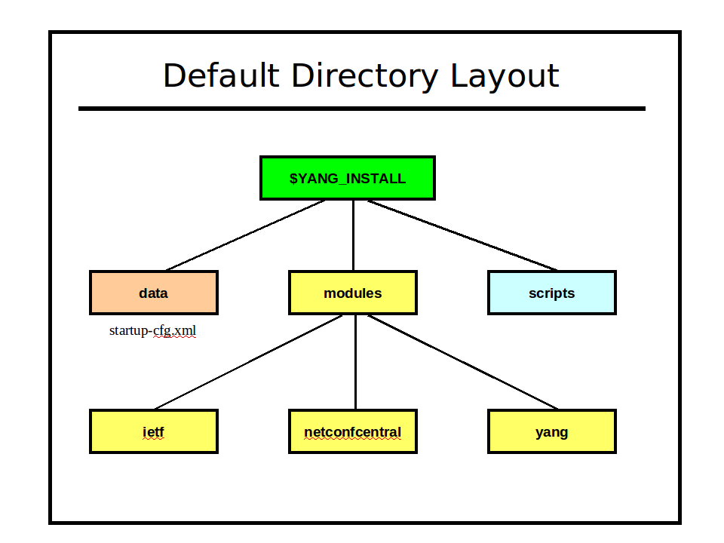
Module Revisions
YANG has extensive module lifecycle support. Each module or submodule has a revision date, and multiple revisions of the same module or submodule may be used at once within the same server.
The YANG module repository is the authoritative source of common management information for the netconfd server. However, different platform implementations of the same data model need to be 'adjusted' slightly to reflect differences in the feature support available on each platform.
Yuma has an extensive set of mechanisms to automate the maintenance of these platform-specific 'special requirements'. A single YANG module (plus 'patches' and deviations as needed for each platform) can be published, instead of a separate version of the YANG module for each platform.
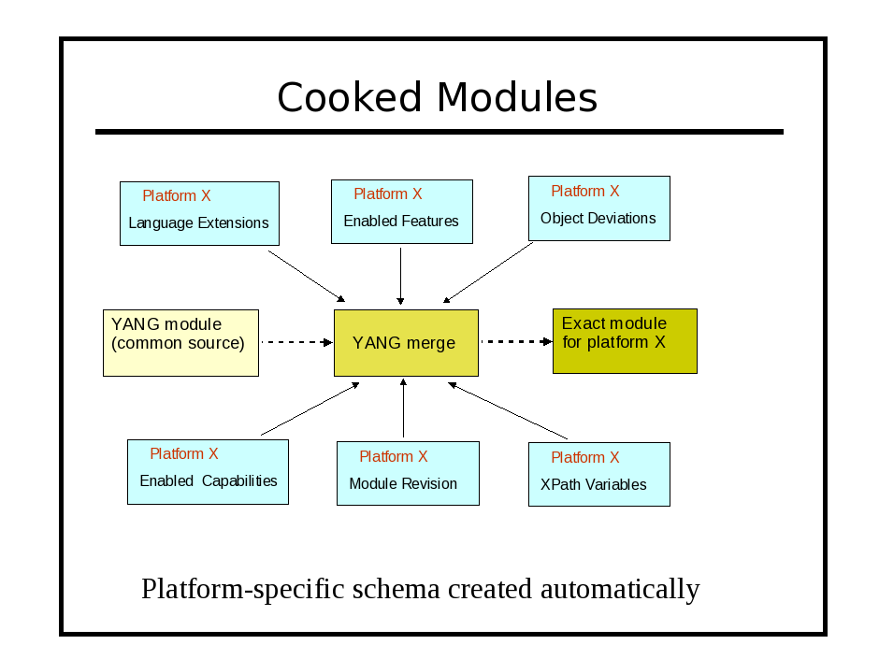
Module Naming Conventions

YANG module names are usually lower-case. Hyphen (-), underscore (_) and period (.) characters are allowed, after the first character, which must be a letter. It is suggested that only the at sign (@) character be used as a separator between module name string components. YANG files must use the suffix '.yang'. YIN files must use the suffix 'yin'.
There are two forms of YANG file names: with and without a revision date.

module.yang
ietf-netconf-monitoring.yang (no revision or unspecified revision)

module@revision-date.yang
ietf-netconf-monitoring@2009-04-17.yang (must be the 2009-04-17 version)

These naming conventions are important when Yuma needs to resolve an 'import' or 'include' statement in a YANG file. Refer to section 4.2 for more details on YANG module search paths and the 'import-by-revision' feature of YANG.

YANG Files
YANG modules and submodules are text files encoded in UTF-8. . There is also an alternate XML encoding called YIN. Sometimes the term YANG module is used to refer to the conceptual module, whether it is encoded in YANG format or YIN format.
All Yuma Tools programs will accept either encoding format, however line and column numbers are not correct in log messages for YIN encoded modules. Instead, each XML node is given a monotonically increasing value, and the XML document order is used instead of line numbers in error/warning messages for YIN files. The column number is always '1' for YIN files.
A module can be validated and checked for possible programming mistakes, by using the yangdump program. Many 'reports' can also be generated:
- exported symbols (--exports)
- imported modules (--dependencies)
- object identifiers (--identifiers)
The yangdump program is also used to generate other files, derived from the YANG content:
- XML Schema Document (XSD): extends the NETCONF XSD with the YANG content layer definitions (--format=xsd)
- HTML <div> or full file output: hyper-linked, color-coded formatting of YANG modules to support netconf-central or other WEB-based documentation system. There are several options for configuring the output, and all formatting is done with Cascading style-sheets (CSS) (--format=html)
- netconf-central documentation SQL database input file: supports the automated online documentation of YANG content (--format=sqldb). Refer to the netconfcentral.sql file for details on this output, in the Developer Manual.
- server instrumentation code-stubs: the instrumentation callback functions, used in netconfd for activating specific YANG content, can be generated. This procedure is described in more detail in the Developer Manual.
- canonical YANG: a YANG file can be reformatted so all statements are indented uniformly, and always appear in the same order. Objects maked as hidden (see the 'hidden' extension in yuma-ncx.yang) will not be generated. (--format=yang)
- copy-YANG-and-set-name: A YANG module can be validated and then copied (if no errors) to another location, adding the revision-date to the file name. (--format=copy)

NETCONF Managers
The NETCONF client is an application that initiates and utilizes NETCONF sessions to control and monitor a NETCONF server.
Yuma includes the yangcli application for this purpose. It can be used as a stand-alone tool with any NETCONF server.

NETCONF Agents
The NETCONF server is a server application that is always running on the managed device. It listens for NETCONF session requests from a NETCONF client, and allows specific users to access specific subsets of the available content (operations, database access, and notifications). It processes all incoming protocol operation requests from the client, and insulates all the instrumentation code from these protocol operations.
Yuma includes the netconfd application for this purpose. It can be run on several different platforms, or easily adapted to embedded platforms.

System Configuration
The Yuma programs use YANG to define its configuration parameters.
The 'ncx:cli' extension is used within a container with the same name as the program to define all CLI parameters. Some parameters are shared (see yuma-app-common.yang), so they are not located directly in the container.

container yangcli {
ncx:cli;
// yangcli CLI parameters defined as choices and leafs here
}

The following YANG modules are provided, which contain all the configuration parameters for Yuma:
- yuma-types.yang: contains common data types used in the Yuma applications
- yuma-app-common.yang: contains common CLI parameters used in all Yuma applications
- yuma-ncx.yang: contains YANG extensions used in any YANG module, including Yuma application modules
- yangdump.yang: configuration parameters for the yangdump application
- yangdiff.yang: configuration parameters for the yangdiff application
- yangcli.yang: configuration parameters and local commands for the yangcli application
- netconfd.yang: configuration parameters for the netconfd server

Note:
- The netconf-subsystem program does not have any configuration parameters at this time, so there is no YANG file defined for it.
- The openssh SSH server is configured separately, using the sshd_config file.
- The libtecla library, used by the yangcli program for command line editing support, has its own configuration file ~/.tecla, to override the default (emacs) editing key assignments.

Yuma applications can accept configuration parameters from 3 sources, checked in the following order:
- environment variables
- command line parameters
- configuration file

Environment Variables
The Yuma programs utilize system environment variables to customize and simplify configuration and operation of the programs.
These environment variables typically specify file search paths or default directory locations.
The following environment variables are used within Yuma:
- HOME
- YUMA_HOME
- YUMA_INSTALL
- YUMA_MODPATH
- YUMA_DATAPATH
- YUMA_RUNPATH

$HOME
The $HOME environment variable contains the directory specification of the user's home directory, and is expected to be set by the system shell before use. The Yuma programs expect (by default) that sub-directories and files contained in this directory will be readable and writable.
Default value: none
CLI override: none
C shell example:
setenv $HOME /home/andy
Bash shell example:
set $HOME=/home/andy
export HOME

$YUMA_HOME
The $YUMA_HOME environment variable contains the directory specification of the current Yuma project root directory. This is the path to the 'netconf' directory, within a Yuma source tree.

Default value: none
CLI override: --yuma-home
CLI example:
--yuma-home=/home/andy/swdev/yuma/trunk/netconf
C shell example:
setenv $YUMA_HOME /home/andy/swdev/yuma/trunk/netconf
Bash shell example:
set $YUMA_HOME=/home/andy/swdev/yuma/trunk/netconf
export YUMA_HOME

$YUMA_INSTALL
The $YUMA_INSTALL environment variable contains the directory specification of the Yuma installation root directory.

Default value: /usr/share/yuma
CLI override: none
C shell example:
setenv $YUMA_INSTALL /sw/yuma
Bash shell example:
set $YUMA_INSTALL=/sw/yuma
export YUMA_INSTALL

$YUMA_MODPATH
The $YUMA_MODPATH environment variable contains a list of directory specifications that should be searched (in order) to find YANG or YIN modules and submodules. It can be used to extend the search path beyond the default locations.
The syntax for this parameter is a string containing the desired directory paths, separated by colon (:) characters. If the trailing forward slash (/) character is missing, then it will be added when searching for files.
By default, each entire directory and all its sub-directory contents will be searched for the requested file. This can be overridden with the --subdirs parameter. Refer to the Command Line Parameter Reference for more details. If --subdirs=false is used, then only the specified directory will be searched instead.
Note: This parameter specifies the exact directory locations when searching for files. This is different than the $HOME, $YUMA_HOME, and $YUMA_INSTALL environment variables, which specify a Yuma root directory.

Default value: none
CLI override: --modpath
CLI example:
--modpath=”$HOME/modules2:/usr/local/modules”
C shell example:
setenv $YUMA_MODPATH “$HOME/modules2:/usr/local/modules”
Bash shell example:
set $YUMA_MODPATH=“$HOME/modules2:/usr/local/modules”
export YUMA_MODPATH

$YUMA_DATAPATH
The $YUMA_DATAPATH environment variable contains a list of directory specifications that should be searched (in order) to find data files used by Yuma applications. It can be used to extend the search path beyond the default locations.
Data files used by the yangcli program are affected by this environment variable.
The location where the netconfd program keeps the file startup-cfg.xml is also affected by this environment variable. This file contains the contents of the non-volatile <startup> database, which is loaded into the <running> database when the server boots.
The syntax for this parameter is a string containing the desired directory paths, separated by colon (:) characters. If the trailing forward slash (/) character is missing, then it will be added when searching for files.
By default, each entire directory and all its sub-directory contents will be searched for the requested file. This can be overridden with the --subdirs parameter. Refer to the Command Line Parameter Reference for more details. If –-subdirs=false is used, then only the specified directory will be searched instead.
Note: This parameter specifies the exact directory locations when searching for files. This is different than the $HOME, $YUMA_HOME, and $YUMA_INSTALL environment variables, which specify a Yuma root directory.

Default value: none
CLI override: --datapath
CLI example:
--datapath=”$HOME/mydata:$HOME/project1/data”
C shell example:
setenv $YUMA_DATAPATH “$HOME/mydata:$HOME/project1/data”
Bash shell example:
set $YUMA_DATAPATH=“$HOME/mydata:$HOME/project1/data”
export YUMA_DATAPATH

$YUMA_RUNPATH
The $YUMA_RUNPATH environment variable contains a list of directory specifications that should be searched (in order) to find script files used by Yuma applications. It can be used to extend the search path beyond the default locations.
Script files used by the yangcli program are affected by this environment variable.
The syntax for this parameter is a string containing the desired directory paths, separated by colon (:) characters. If the trailing forward slash (/) character is missing, then it will be added when searching for files.
By default, each entire directory and all its sub-directory contents will be searched for the requested file. This can be overridden with the --subdirs parameter. Refer to the Command Line Parameter Reference for more details. If --subdirs=false is used, then only the specified directory will be searched instead.
Note: This parameter specifies the exact directory locations when searching for files. This is different than the $HOME, $YUMA_HOME, and $YUMA_INSTALL environment variables, which specify a Yuma root directory.

Default value: none
CLI override: --runpath
CLI example:
--runpath=”$HOME/scripts:/usr/local/scripts”
C shell example:
setenv $YUMA_RUNPATH “$HOME/scripts:/usr/local/scripts”
Bash shell example:
set $YUMA_RUNPATH=“$HOME/scripts:/usr/local/scripts”
export YUMA_RUNPATH

Searching for Files
All Yuma programs search for YANG and other files in the same manner, using the same configuration parameters. The current working directory is included in this search path, so it is important to consider the directory in which a Yuma program is invoked. The search ends as soon as a suitable matching file is found.
There are two types of module searches:
- searches on behalf of configuration parameters
- searches on behalf of YANG import or include statements

The first term in a path specification may contain special character sequences:
- If the first character is the forward slash ('/'), then the entire path specification is used as an absolute path specification.
/usr/share/yang/modules
- If the first character is not the forward slash ('/'), and no special characters are found instead, then the entire path specification is used as an relative path specification, starting from the current working directory.
../more-modules/test7.yang
./this-dir/my-module.yang
testmodule.yang
old-modules/version7/
- If the first character is the tilde ('~') character, followed by the forward slash ('/') character, then the file search will start in the current user's $HOME directory .
~/modules/test/test.yang
- If the first character is the tilde ('~') character, followed by a user name, and then the forward slash ('/') character, then the file search will start in the specified user's $HOME directory . If the user is unknown, then the path specification is invalid.
~andy/modules/test/test.yang
~fred/scripts
- If the first character is the dollar sign ('$') character, followed by an environment variable name, and then the forward slash ('/') character, then the file search will start in the directory indicated by the contents of the environment variable. If the variable is unknown, or its contents do not represent a valid directory location, then the path specification is invalid.
$WORKDIR/tests/test-all-interfaces
$YUMA_HOME/data/startup-cfg.xml
Note: Whenever Yuma searches a directory, it checks for the expected file type, but ignores the following:
- all files and sub-directories that begin with the period (.) character
- any directory named 'CVS'
- symbolic links for regular files
The following environment variables affect file searches:
- $HOME
- $YUMA_HOME
- $YUMA_MODPATH
- $YUMA_DATAPATH
- $YUMA_RUNPATH
The following configuration parameters affect file searches:
- --yuma-home
- --modpath
- --datapath
- --runpath
- --subdirs

Yuma Work Directory
There is a directory ($HOME/.yuma) created by yangcli or netconfd for data files and temporary files. It is called .yuma, and it is created in the users home directory, if the $HOME environment variable is defined.
This directory will be used as the default location to save the startup-cfg.xml file by netconfd, if no startup file is specified in the CLI parameters, and no existing startup file is found in the data file search path.
This directory is also used as the default location to store the .yangcli_history file for yangcli command line history recall.
The $HOME/.yuma/tmp directory is used by yangcli to create session-specific sub-directories where all the YANG modules from the server for the current session are stored. If the --autoload=false parameter is used, then these temporary directories will not be created by yangcli.

Parameter Searches
A parameter search is started on behalf of a CLI parameter, such as the –-module parameter, used by the yangdump program. A search of this type can include directory path and file extension in the search parameter. If a filename with a file extension (must be '.yang') is given, then only that exact file will be checked. The current working directory will be used in this case, if no directory path (or a relative directory path) is provided.

--module=test.yang
--module=../more-modules/test3@2009-04-01.yang
If the exact filename is not found, then the search failed.
If a parameter based search does not have any directory path or file extension fields present, then a parameter search is the same as an import/include search.

Import/Include Searches
An import or include search is started on behalf of a YANG 'import' or 'include' statement. A search of this type includes only the module or submodule name, with no directory or file extension present. An optional 'revision-date' statement can be used in YANG, which means only a version of the YANG file with that exact current revision date will be used.
There are separate search algorithms, depending on whether the revision-date is used in the YANG import or include statement, and whether the imported or included module has a current revision statement.

Mode 1: import-by-revision

In this example, an import statement is causing a search for a module named 'foo' with a revision date of '2009-01-15'.
If a revision-date is used in the import or include statement, then the module search path will be checked as follows:
First, find a file with the same revision-date in the file name:

import foo {
revision-date “2009-01-15”;
prefix foo;
}

If the file 'foo.2009-01-15.yang' is found, and the current revision statement in the module is equal to '2009-01-15', then the search is successfully terminated.
// file foo.2009-01-15.yang
module foo {

namespace “http://example.com/ns/foo”;
prefix foo;

// rest of header follows

revision 2009-01-15 {
description “Initial version.”;
}

// rest of module follows
}

If the file is not found, or the most current revision date is not correct, then the module search is repeated for 'foo.yang'. If the file 'foo.yang' is found, and the current revision statement in the module is equal to '2009-01-15', then the search is successfully terminated.

// file foo.yang
module foo {

namespace “http://example.com/ns/foo”;
prefix foo;

// rest of header follows

revision 2009-01-15 {
description “Initial version.”;
}

// rest of module follows
}

If the file is not found, or the most current revision date is not correct, then the module search failed.

Mode 2: import any revision

If no file name with the specified revision-date value is found, then the module search path is checked for a file with no revision-date in the file name:

import foo {
prefix foo;
}

If the file 'foo.yang' is found, then it is used, regardless of the most current revision date (if any) found in the module. If it is not found then the module search failed.
Note: The first instance of 'foo.yang' in the module search path will be used, even if a more current version is available, later in the search path.

File Search Paths
Yuma uses configurable search paths to find the various files that are needed during operation.

Module Search Path

- If the module parameter is specified with a path or file suffix, the that filespec is tried, relative to the current working directory. If it is not found, or not the correct revision date, then the search terminates in failure.

--module=../test.yang

- If the module is specified without any path or file extension fields, then the module search path is checked, in order. The first step which produces a match terminates the search successfully. If all steps are exhauted and no match is found then the search terminates in failure.

--module=foo

  - The current working directory is checked. No sub-directories are checked, if any are present.
  - Each directory specified in the $YUMA_MODPATH environment variable, or set with the –modpath configuration parameter, is checked.
    - If the –-subdirs=false parameter is set, then only each top-level directory will be checked. If it is not set, then sub-directories will be searched.
  - The $HOME/modules directory is checked.
    - If the –-subdirs=false parameter is set, then only each top-level directory will be checked. If it is not set, then sub-directories will be searched.
  - The $YUMA_HOME/modules directory is checked.
    - If the –-subdirs=false parameter is set, then only each top-level directory will be checked. If it is not set, then sub-directories will be searched.
  - The $YUMA_INSTALL/modules directory is checked.
    - If the –-subdirs=fasle parameter is set, then only each top-level directory will be checked. If it is not set, then sub-directories will be searched.

Data Search Path

Yuma programs can store data used during operation.

An example of a data file is the startup configuration file used by netconfd, usually called startup-cfg.xml.

- If the file name has an absolute path specification, then that exact file location is tried. If no match is found, then the search will terminate in failure.
- Each directory specified in the $YUMA_DATAPATH environment variable, or set with the –datapath configuration parameter, is checked.
    - If the –-subdirs=false parameter is set, then only each top-level directory will be checked. If it is not set, then sub-directories will be searched.
- The current working directory is checked. No sub-directories are checked, if any are present
- The $HOME/data directory is checked.
    - If the –-subdirs=false parameter is set, then only each top-level directory will be checked. If it is not set, then sub-directories will be searched.
- The $YUMA_HOME/data directory is checked.
    - If the –-subdirs=false parameter is set, then only each top-level directory will be checked. If it is not set, then sub-directories will be searched.
- The $HOME/.yuma directory is checked.
- The $YUMA_INSTALL/data directory is checked.
  - If the –-subdirs=false parameter is set, then only each top-level directory will be checked. If it is not set, then sub-directories will be searched.
- The /usr/share/yuma/data directory is checked.
    - If the –-subdirs=false parameter is set, then only each top-level directory will be checked. If it is not set, then sub-directories will be searched.
- The /etc/yuma directory is checked.

Script Search Path

The yangcli program can store script files used during operation.

- If the file name has an absolute path specification, then that exact file location is tried. If no match is found, then the search will terminate in failure.
- The current working directory is checked. No sub-directories are checked, if any are present.
- Each directory specified in the $YUMA_RUNPATH environment variable, or set with the –runpath configuration parameter, is checked.
    - If the –-subdirs=false parameter is set, then only each top-level directory will be checked. If it is not set, then sub-directories will be searched.
- The $HOME/scripts directory is checked.
    - If the –-subdirs=false parameter is set, then only each top-level directory will be checked. If it is not set, then sub-directories will be searched.
- The $YUMA_HOME/scripts directory is checked.
    - If the –-subdirs=false parameter is set, then only each top-level directory will be checked. If it is not set, then sub-directories will be searched.
- The $YUMA_INSTALL/scripts directory is checked.
    - If the –-subdirs=false parameter is set, then only each top-level directory will be checked. If it is not set, then sub-directories will be searched.

Configuration Files
The Yuma program configuration parameters can be stored in text or XML files.
The -–config parameter is used to specify that configuration parameters should be retrieved from a file instead of the command line.
Any other configuration parameter (except -–config) can be stored in a configuration file used for program input.

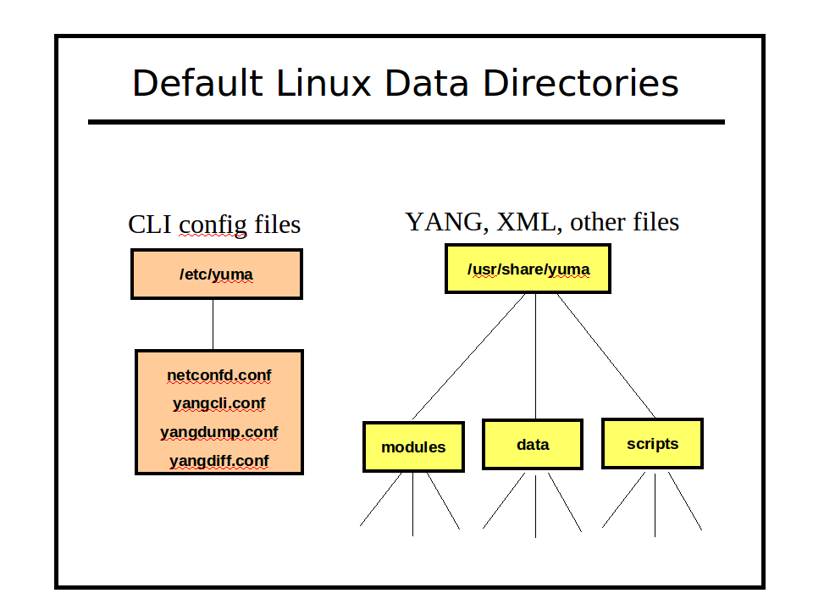

XML Configuration Files
The XML format for these files follows the structure of the NETCONF <config> element. Each parameter is stored within a container identifying the application which it is being configured. The netconfd stores its non-volatile <startup> database in this format. XML configuration file contents can appear in any order.
The following configuration parameters affect the generation and display of XML configuration files by netconfd:
- --indent
- --with-defaults

The following configuration parameter affects the location of XML configuration files by netconfd:
- --datapath
- $YUMA_DATAPATH environment variable

Note : The IETF may standardize this container format soon. Do not rely on the top-level namespace URI. Any top-level element name <config>, in any namespace (even none), should be expected to contain a complete NETCONF database, or a subset of a NETCONF database.
The following example show some database objects from the NETCONF Access Control Model (yuma-nacm.yang), in XML configuration file format.

// file startup-cfg.xml
<?xml version="1.0" encoding="UTF-8"?>
<nd:config xmlns:nd="http://netconfcentral.org/ns/netconfd">
<nacm:nacm xmlns:nacm="http://netconfcentral.org/ns/yuma-nacm">
<nacm:groups>
<nacm:group>
<nacm:groupIdentity>nacm:admin</nacm:groupIdentity>
<nacm:userName>andy</nacm:userName>
<nacm:userName>fred</nacm:userName>
<nacm:userName>barney</nacm:userName>
</nacm:group>
</nacm:groups>
<nacm:rules>
<nacm:moduleRule>
<nacm:moduleName>netconf</nacm:moduleName>
<nacm:allowed-rights>read write exec</nacm:allowed-rights>
<nacm:allowed-group>nacm:admin</nacm:allowed-group>
</nacm:moduleRule>
</nacm:rules>
</nacm:nacm>
</nd:config>

Text Configuration Files
The Yuma text configuration file format is based on some common Unix .conf file formats:
- A hash mark until EOLN is treated as a comment

# this is a comment
log-level info # this is also a comment

- All text is case-sensitive
- Whitespace before or within a line is not significant
- The 'end a line' (EOLN) character ('\n') is used to end a command, so whitespace at the end of a line is significant.

- To enter a command on multiple lines, use an escaped EOLN (backslash-EOLN) for all but the last line

this is a command line
this is the start \
of a long \
three line command
this is a new command

- A YANG container parameter is represented by the container name, followed by a left curly brace ('{'), zero or more child nodes, and then a right curly brace ('}').

yangdump {
# set some display control parameters
log-level debug2
warn-linelen 72
indent 4
}

- A YANG list parameter is represented by the list name, followed by a whitespace separated sequence of key leaf values, followed by a left curly brace ('{'), zero or more child nodes, and then a right curly brace ('}').

ifStackEntry 11 42 {
# the key leafs will also printed here
ifStackHigherLayer 11
ifStackLowerLayer 42
ifStackStatus active
}

- Configuration files which are used with command line parameters may include program parameters for multiple applications.
  - Only the top-level container that matches the name of the program will be used.
  - Any other top-level containers will be ignored
  - Only the first instance of the desired program container will be used. Any additional containers will be ignored.

// test.conf
yangdump {
# common yangdump parameters here
}

yangdiff {
# common yangdiff parameters here
}

- Configuration file parameters can appear in any order. Only list index strings need to appear in their defined order.
- The following configuration parameters affect generation and display of text configuration files
  - --indent
  - --with-defaults
  - --display-mode

Bootstrap CLI
Since Yuma programs use YANG to define CLI parameters, there needs to be an initial bootstrap CLI phase, in order to process parameters which affect the way YANG files are processed.
The bootstrap CLI is not as flexible as the main CLI processor, and the syntax is more strict. Parameters must be entered in either of the following forms:
- --name
- --name=value
If parameters are not entered in this format, then they will be skipped until the main CLI parameter processing is done. This may cause undesirable changes in key parameters, such as the module search path.
The following configuration parameters are also bootstrap parameters, and will take affect immediately, if entered from the command line:
- --log: log messages to the specified file instead of STDOUT
- --log-level: set the logging verbosity level
- --log-append: use the existing log file (if any) instead of overwriting it
- --modpath: use the specified module search path. This will override the $YUMA_MODPATH environment variable, if it is set
- --yuma-home: use the specified project root. This will override the $YUMA_HOME environment variable, if it is set

Refer to the Yuma CLI Reference for more details. on these configuration parameters.

Configuration Parameters
Command line parameters are used to provide input to Yuma programs when they are invoked. They are also used extensively by the yangcli program, to represent RPC method input parameters and database nodes which are part of NETCONF operation content, such as the <config> parameter within the <edit-config> operation.

Parameter Syntax
A CLI parameter has 2 forms:
- Parameter contains a YANG type of 'empty' or a zero-length 'string':
<prefix><parameter-name>
- Everything else:
<prefix><parameter-name><separator><value>

There are up to 4 components in a CLI parameter:
- prefix: consists of 0, 1, or 2 consecutive dash characters.
- parameter name: name of the parameter. A partial name may be used if it is unique.
- separator: either consists of the 'equals sign' character ('='), which may be preceded or followed by whitespace, or just whitespace with no equals sign character.
- value: a quoted or unquoted string, an empty string is only allowed if quotes are entered.

The following example shows some ways the leaf 'foo' could be entered as a CLI parameter:

leaf foo {
type uint32;
}

foo=7
-foo=7
--foo=7
--foo =7
foo 7
-foo 7
-foo = 7
--foo 7
--foo "7"
foo 7

ncx:cli Extension
The ncx:cli extension is used in in YANG container definitions, which represent the program CLI parameters, not NETCONF database parameters. It does not take any parameters, and is defined in yuma-ncx.yang.

container yangcli {
ncx:cli;

// all the yangcli CLI parameters
}

If this extension is present, then netconfd will ignore the container when loading the database object definitions. Only the program with the same name as the container will use the CLI parameter definition.

ncx:default-parm Extension
The ncx:default-parm extension is used within a container with an ncx:cli extension, or within an 'input' section of an RPC operation definition. It is defined in yuma-ncx.yang.
If no parameter name is found when processing CLI parameter input, and the ncx:default-parm extension is present in the container or RPC input being processed, then the specified parameter name will be used instead of generating an error. The value must be valid for the parameter syntax, according to its YANG definition. This means that for the default parameter, only the <value> component of the complete parameter syntax may be used, as well as the normal forms.

container yangdump {
ncx:cli;
ncx:default-parm module;

// all the yangdump CLI parameters
}

When invoking the yangdump program, the default CLI parameter is --module. These two command lines are equivalent:

yangdump –-module=test1 –-module=test2
yangdump test1 test2

A string that does not start with any dashes will still be tried as a parameter name, before trying the default parameter. If the value used for a default parameter conflicts with another parameter name, then the normal form must be used, instead of this form.

yangdump log-app test1

Even if there was a module named 'log-app', it would not be tried as a --module parameter, since it also matches the --log-append parameter.
Note: the default parameter form is can be used in conjunction with shell wildcard characters, depending on the shell.

yangdump *.yang

yangdump --subtree=.

These commands are equivalent in the yangdump program.

XPath Reference
The XPath 1.0 path specification language is supported in all Yuma Tools programs, as specified in the YANG language specification. There are also some additional variables and XPath functions, available in all XPath expressions.
A custom XPath implementation is used, which is based on the internal data structures maintained within the program (i.e., object tree or data tree). No CPU or memory is wasted converting these data structures to actual XML documents for XPath processing.

XPath 1.0
All functionality defined in the XPath 1.0 specification is supported.
There are some restrictions, which are specific to the YANG standard:
- The 'attribute' and 'processing-instruction' axes are always empty.
- YANG identityref leaf values need to be entered within quotes or they will be interpreted as XML qualified node names.
- The server may not maintain consistent XML document order for system-ordered data. This affects expressions which rely on XML document order to be precise and completely static. A NETCONF server is only required to maintain XML document order for user-ordered lists and leaf-lists, and only relative to a particular object, not the entire document.

XML Namespaces
The XPath implementation allows a more liberal syntax than the XPath 1.0 specification allows.
Specifically, if a node identifier does is unqualified (i.e., there is no namespace specified with a default namespace or an explicit namespace declaration), then all known XML namespaces known by the program will be checked for a top-level element with the same name.

- If XML namespaces are used, they must be used correctly.

Example request using XML namespaces in an XPath expression:
<?xml version="1.0" encoding="UTF-8"?>
<nc:rpc xmlns:nc="urn:ietf:params:xml:ns:netconf:base:1.0"
message-id="2"
xmlns:sys="http://netconfcentral.org/ns/yuma-system">
<nc:get>
<nc:filter type="xpath" select="/sys:system"/>
</nc:get>
</nc:rpc>
Note the text:
xmlns:sys="http://netconfcentral.org/ns/yuma-system"
This 'xmlns' attribute does not have to appear exactly as specified, or within the <rpc> element. It can appear in any legal manner. Refer to the XML Namespaces 1.0 specification for more details.

Example request not using XML namespaces in an XPath expression:
<?xml version="1.0" encoding="UTF-8"?>
<nc:rpc xmlns:nc="urn:ietf:params:xml:ns:netconf:base:1.0"
message-id="3">
<nc:get>
<nc:filter type="xpath" select="/system"/>
</nc:get>
</nc:rpc>
If the 'yuma-system.yang' module is loaded within the program, and if the 'system' node is enabled (e.g., not removed via a YANG deviation), then the XML prefix ('sys:' in this example) can be omitted.

YANG Specific XPath Behavior
The YANG language requires some minor changes and additions to the XPath 1.0 specification:
- The 'current' function from XPath 2.0 is supported.
- The NULL XML namespace is mapped to the current YANG module XML namespace, when processing an XPath expression within a YANG module (e.g., must statement).
- A NETCONF database is treated as a conceptual XML instance document with zero or more top-level elements. This is consistent with XSLT behavior. XML 1.0 requires a single top-level element,so external XML documents representing a NETCONF database always start with the <nc:config> element (config element in the NETCONF XML namespace).

Custom XPath Variables
The XPath specification supports system variables to be accessed within XPath expressions.
Within the yangcli program, all user and system variables available to a script are also available as XPath variables within XPath expression evaluation (e.g., if, eval, and while commands).
For example, a variable named 'myvar' would be accessed within an XPath expression as '$myvar'.

user
An XPath variable called 'user' is supported in the yangcli and netconfd programs. It is equal to the NETCONF user name associated with the session evaluating the XPath expression. It is provided to be used in data rules within the NETCONF Access Control Model (NACM).

Custom XPath Functions
The following XPath functions are added to the XPath 1.0 Function Library, in addition to the 'current' function from XPath 2.0.

module-loaded
The module-loaded function tests whether the specified module is loaded within the program.
boolean module-loaded (module-name [, revision-date])
Parameters:
- Parameter 1:
  - Type: String
  - Usage: Mandatory
  - Purpose: Specifies the module name to check.
- Parameter 2:
  - Type: String
  - Usage: Optional
  - Purpose: Specifies the YANG revision date string for module indicated by parameter 1.
Returns: Boolean
- true: the specified module is loaded
- false: the specified module is not loaded, possibly not known
Errors:
- Missing parameter error if no parameters provided.
- Extra parameters error if more than 2 parameters provided.
- All unknown parameter values cause a 'false' result.
Example:
yangcli> if "module-loaded('yuma-system', '2009-12-27')"
yangcli> log-info 'correct yuma-system module loaded'
yangcli> else
yangcli> log-error 'Wrong yuma-system module loaded'
yangcli> end

feature-enabled
The feature-enabled function tests whether the specified YANG feature is enabled within the program.
boolean feature-enabled (module-name, feature-name)
Parameters:
- Parameter 1:
  - Type: String
  - Usage: Mandatory
  - Purpose: Specifies the module name to check.
- Parameter 2:
  - Type: String
  - Usage: Mandatory
  - Purpose: Specifies the YANG feature name defined within the module indicated by parameter 1.
Returns: Boolean
- true: the specified feature is enabled
- false: the specified feature is not enabled, possibly not known
Errors:
- Missing parameter error if less than 2 parameters provided.
- Extra parameters error if more than 2 parameters provided.
- All unknown parameter values cause a 'false' result.
Example:
yangcli> if "feature-enabled('mymodule', 'myfeature')"
yangcli> log-info 'myfeature is enabled'
yangcli> else
yangcli> log-error 'myfeature is not enabled'
yangcli> end

Error Reference
All Yuma programs use the same set of error numbers and error messages.
Error numbers are 3 digit unsigned integers in the range 1 to 999. The number 0 is reserved for the NO_ERR constant, which is the same as the <ok/> status returned by the server.

Error Number Types

range | description
100 to 199 | system errors
200 to 399 | user errors
400 to 899 | warnings
900 to 999 | informational messages

Error Messages

The current list of error numbers and default error messages can be obtained with the yangdump program --show-errors parameter.
The default error message can be replaced for some error conditions with the YANG error-message statement.
The following list shows the default error messages for all error numbers currently in use.

0 ok
1 EOF reached
2 NULL pointer
3 malloc failed
4 invalid internal value
5 internal buffering failed
6 invalid queue deletion
7 wrong init sequence
8 queue node not header
9 queue node not data
10 invalid queue header
11 entry already queued
12 too many entries
13 libxml2 operation failed
100 cannot open file
101 cannot read file
102 cannot close file
103 cannot write file
104 cannot change directory
105 cannot stat file
106 buffer overflow error
107 cannot delete file
108 cannot access file
109 db connect failed
110 db entry exists
111 db not found
112 db query failed
113 db delete failed
114 wrong checksum
115 wrong tag type
116 db read failed
117 db write failed
118 db init failed
119 beep init failed
120 beep init nc failed
121 xml reader internal
122 open directory failed
123 read directory failed
200 no config file
201 no source file
202 POST read input
203 bad drive
204 bad path
205 bad filename
206 duplicate value pair
207 page not handled
208 page access denied
209 missing form params
210 invalid form state
211 duplicate namespace
212 xml reader start failed
213 xml reader read failed
214 wrong XML node type
215 xml reader null name
216 xml reader null value
217 xml reader wrong name
218 xml reader wrong value
219 xml reader wrong element
220 xml reader extra nodes
221 xml reader EOF
222 wrong length
223 entry exists
224 duplicate entry
225 not found
226 missing file
227 unknown parameter
228 invalid name
229 unknown namespace
230 wrong namespace
231 wrong data type
232 wrong value
233 missing parameter
234 extra parameter
235 empty value
236 module not found
237 max length exceeded
238 invalid token
239 unended quoted string
240 read failed
241 invalid number
242 invalid hex number
243 invalid real number
244 EOF reached
245 wrong token type
246 wrong token value
247 buffer overflow
248 invalid range
249 overlapping range
250 definition not found
251 definition segment not found
252 type not allowed in index
253 index type not found
254 type not mdata
255 meta-data not allowed
256 top not found
257 resource in use
258 invalid value
259 too big
260 missing attribute
261 bad attribute
262 unknown attribute
263 missing element
264 bad element
265 unknown element
266 unknown namespace
267 access denied
268 lock denied
269 resource denied
270 rollback failed
271 data exists
272 data missing
273 operation not supported
274 operation failed
275 partial operation
276 wrong namespace
277 wrong node depth
278 wrong owner
279 wrong element
280 wrong order
281 extra node
282 wrong node type
283 expecting complex node type
284 expecting string node type
285 wrong data type
286 wrong data value
287 invalid number length
288 value not in range
289 wrong number type
290 invalid enum value
291 value not in set
292 extra list string found
293 unknown object
294 extra parameter instance
295 extra case in choice
296 missing mandatory choice
297 wrong config state
298 unknown application
299 unknown data type
300 access control violation
301 config locked
302 wrong config state
303 max-access exceeded
304 wrong index type
305 wrong instance type
306 missing index component
307 config not found
308 extra attribute instance(s) found
309 required attribute not found
310 required value instance not found
311 extra value instance(s) found
312 target is read only
313 invalid pattern
314 wrong version
315 connect failed
316 unknown host
317 session failed
318 authentication failed
319 end of comment not found
320 invalid string concatenation
321 import not found
322 missing typedef sub-section
323 restriction not allowed for this type
324 specified refinement not allowed
325 definition loop detected
326 default case contains mandatory object(s)
327 import loop
328 include loop
329 expecting module
330 expecting submodule
331 undefined prefix
332 imported module has errors
333 pattern match failed
334 invalid data type change
335 mandatory object not allowed
336 unique-stmt test failed
337 max-elements exceeded
338 min-elements not reached
339 must-stmt test failed
340 data restriction violation
341 missing instance for insert operation
342 object not config
343 invalid conditional object
344 using obsolete definition
345 invalid augment target
346 duplicate refine sub-clause
347 invalid deviate sub-clause
348 invalid XPath expression syntax
349 invalid instance-identifier syntax
350 require-instance test failed
351 key or select attribute not allowed
352 invalid unique-stmt node
353 invalid duplicate import-stmt
354 invalid duplicate include-stmt
355 ambiguous command
356 unknown module
357 unknown version
358 value not supported
359 leafref path loop
360 variable not found
361 variable is read-only
362 decimal64 base number overflow
363 decimal64 fraction precision overflow
364 when-stmt tested false
365 no matches found
366 missing refine target
367 candidate cannot be locked, discard-changes needed
368 timeout occurred
369 multiple module revisions exist
370 XPath result not a nodeset
371 XPath node-set result is empty
372 node is protected by a partial lock
373 cannot start a partial lock with confirmed-commit pending
400 duplicate source
401 include file not found
402 invalid command line value
403 invalid command line option
404 command line option unknown
405 invalid command line syntax
406 missing command line value
407 invalid form input
408 invalid form
409 no instance found
410 session closed by remote peer
411 duplicate import
412 duplicate import with different prefix value
413 local typedef not used
414 local grouping not used
415 import not used
416 duplicate unique-stmt argument
417 statement ignored
418 duplicate include
419 include not used
420 revision date before 1970
421 revision date in the future
422 enum value order
423 bit position order
424 invalid status for child node
425 duplicate sibling node name from external augment
426 duplicate if-feature statement
427 using deprecated definition
428 XPath object predicate check limit reached
429 empty XPath result in must or when expr
430 no ancestor node available
431 no parent node available
432 no child node available
433 no descendant node available
434 no nodes available
435 bad revision-stmt order
436 duplicate prefix
437 identifier length exceeded
438 display line length exceeded
439 received unknown capability
440 invalid module capability URI
441 unknown child node, using anyxml
442 invalid value used for parm
443 changing object type to string
444 using a reserved name
445 conf file parm already exists
446 no valid revision statements found
447 dependency file has errors
448 top-level object is mandatory

