LOADED TOPPING PIZZA



1. Prawn Sensation

Loaded with 20% more prawns. Shrimply sensational!

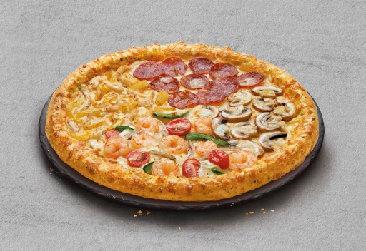

2. Signature Quattro Beef

4-in-1 goodness with loaded Beef Pepperoni, Aloha Chicken, Prawn Sensation and Simply Cheese with mushrooms!

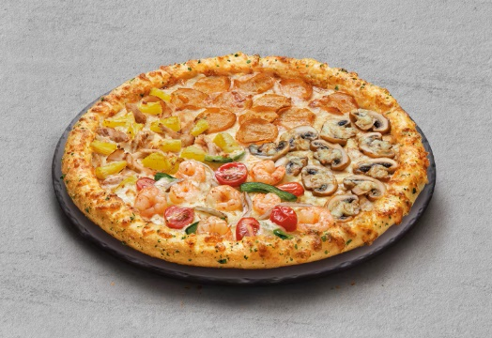

3. Signature Quattro Chicken

4-in-1 goodness loaded with Chicken Pepperoni, Aloha Chicken, Prawn Sensation and Simply Cheese with mushrooms!

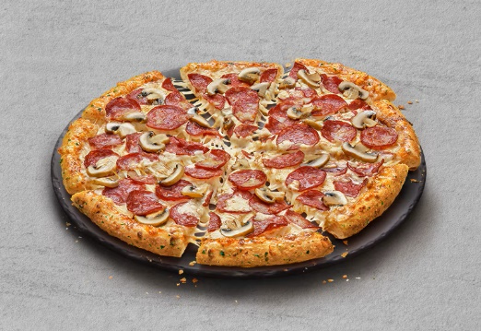

4. Smoky Pepperoni Mushroom

Loaded with 50% more beef pepperoni and 100% more mushrooms on smoky BBQ sauce. Go on, get a slice!

CHEESE VOLCANO



1. Cheese Volcano Beef Pepperoni

Dive into a delicious melty cheese with the ultimate hot liquid cheese dip on your all time favorite Beef Pepperoni Pizza.



2. Cheese Volcano Chicken Pepperoni

Dive into a delicious melty cheese with the ultimate hot liquid cheese dip on your all time favorite Chicken Pepperoni Pizza.

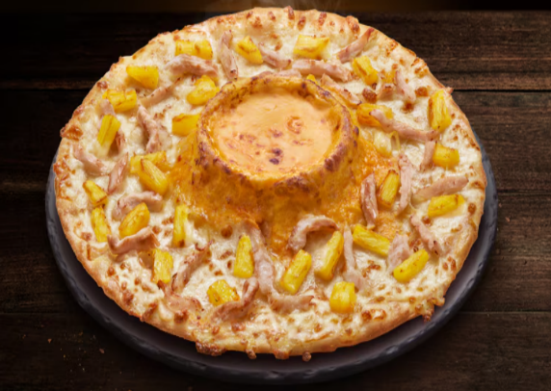

Cheese Volcano Aloha Chicken

Speciality Cheese Pizza

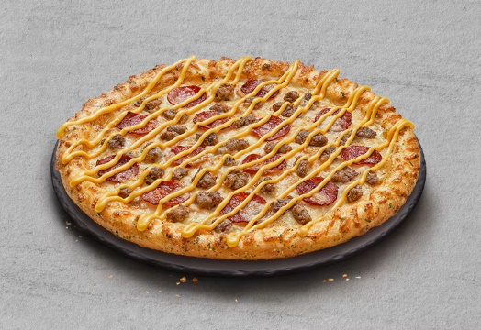

1. Beef Feast Pepperoni

A beef lover's must-have with extra cheesy beef pepperoni topped with more cheese sauce and ground beef.



3. Chicken Feast Pepperoni

An extra cheesy chicken pepperoni, topped with more cheese sauce and sausages to satisfy your cravings!

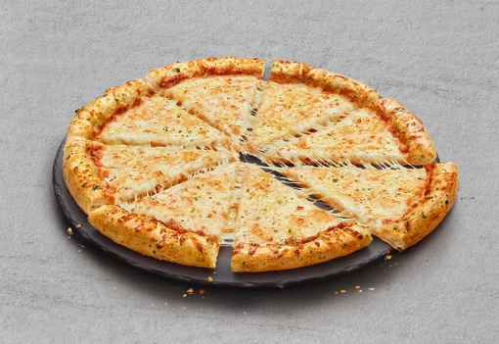

5. Simply Cheese

A cheesy perfection with 100% mozzarella cheese and parmesan cheese on signature pizza sauce.

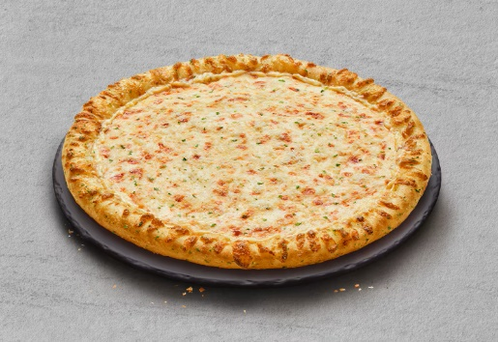

6. Super Cheese

Ultimate cheesy goodness with 30% extra mozzarella cheese on creamy garlic butter Top Secret Sauce!

Signature Pizza

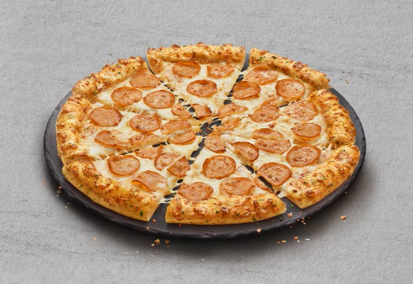

1. Chicken Pepperoni

Satisfy adults and kids alike with crispy and flavorful chicken pepperoni.

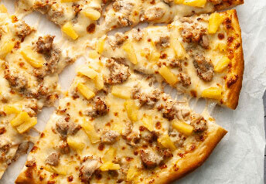

2. Hawaiian Chicken

with tomato sauce, chicken meat, pineapples, mozzarella cheese.

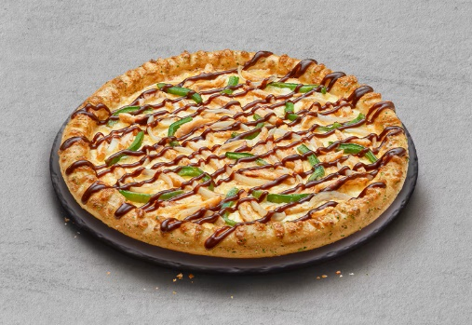

3. BBQ Chicken

BBQ lovers' go-to with tender shredded chicken and fresh green peppers topped with smoky BBQ sauce!

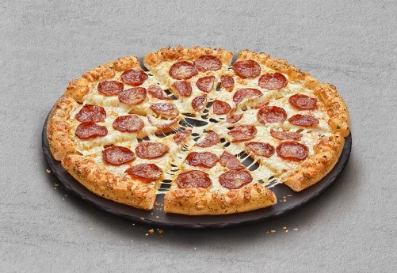

4. Beef Pepperoni

Filled with juicy beef pepperoni. Mmm, definitely a classic for every pepperoni lover!

Vegie Pizza

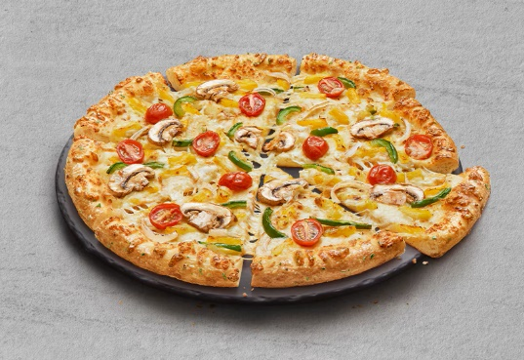

1. Vegie Fiesta

Veggie-licious fiesta with juicy pineapples, mushrooms, fresh onions and green peppers!

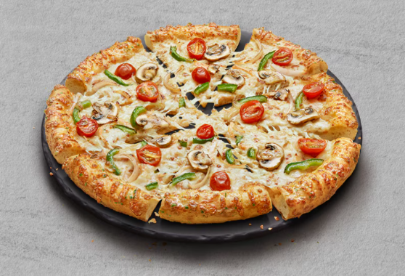

Vegie Galore

SOUP & BREAD

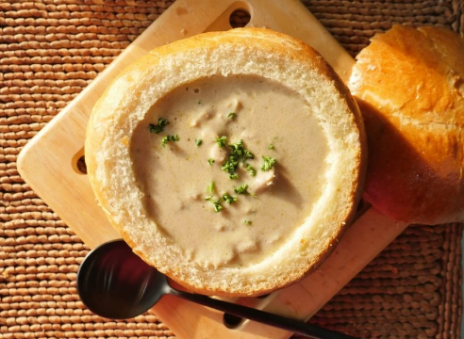

1. Mushroom soup

Creamy mushroom soup that complements your meal.



2.Garlic bread



3. Garlic Twisty Bread

Enjoy freshly-baked twisty garlic wholesomeness

BEVERAGES

* Pepsi

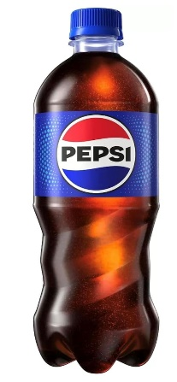

* Twister Orange

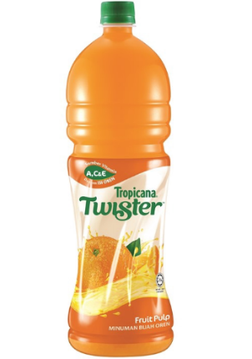

* Ice Lemon Tea

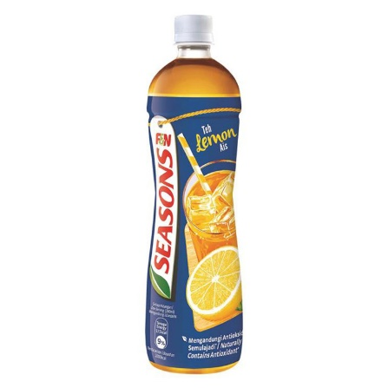

* 100 Plus

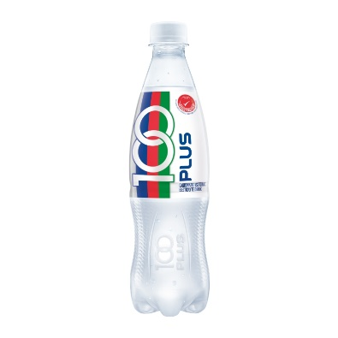

* Mineral Water

