JIRA Ticket Triage Agent
Architecture & Implementation Guide
Automated Triage & Resolution for Data Service Incidents
Data Services: IPAS | IADS | TADS
Data & Analytics Office
April 2026

1. Executive Summary
This document outlines the architecture for an AI-powered agent that automates JIRA ticket triage and resolution for data service incidents. The system targets tickets raised by downstream consumers of data services (IPAS, IADS, TADS, and others) maintained by the Data Science team within the Data & Analytics Office.
The agent classifies incoming tickets, assembles relevant context from multiple sources, reasons over the information, and either auto-resolves the issue, suggests a resolution for human review, or escalates with a comprehensive context summary.

2. Problem Statement
Downstream systems and consumers of our data services frequently raise JIRA tickets when data is incorrect, delayed, or missing. These tickets require manual triage, investigation, and resolution by the data science team. Common issues include:
- Data delays: Scheduled data feeds not arriving on time due to pipeline failures or upstream delays
- Data quality issues: Incorrect values, schema drift, or data type mismatches
- Missing data: Expected records not present in downstream tables
- Schema changes: Upstream schema modifications breaking downstream consumers
- Access/permissions: Users unable to access data due to permission changes
Many of these tickets follow recurring patterns and have well-established resolution paths, making them ideal candidates for AI-assisted automation.

3. Architecture Overview
The system follows a pipeline architecture with five key stages: ticket intake, classification, context assembly, reasoning and resolution, and feedback. The diagram below illustrates the end-to-end flow.
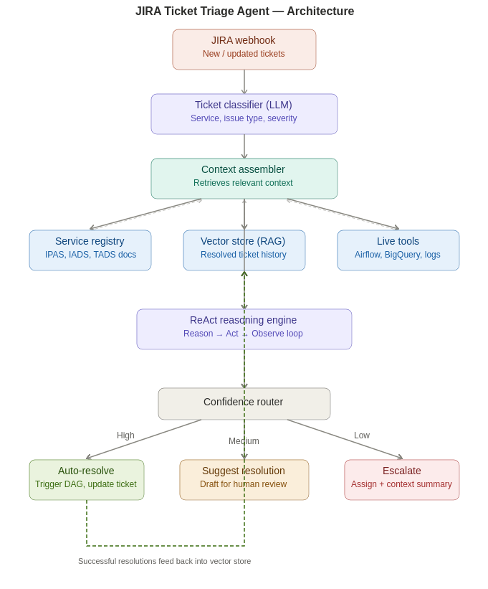
Figure 1: JIRA Ticket Triage Agent — End-to-End Architecture

4. Component Details

4.1 Ticket Intake & Webhook
JIRA webhooks trigger on ticket creation or update events, filtered to the team’s project and relevant issue types. The webhook handler runs on Cloud Run and parses the ticket payload (summary, description, reporter, labels, priority) into a structured format for downstream processing.

4.2 Ticket Classifier (LLM)
An LLM call with structured output classifies each ticket along three dimensions:
Dimension | Values
Service | IPAS, IADS, TADS, or other identified services
Issue Type | Data delay, data quality, missing data, schema change, access issue
Severity | Critical, high, medium, low (based on impact and SLA)

4.3 Context Assembly
This is the most critical component. Based on the classified service and issue type, the assembler pulls context from three sources:

4.3.1 Service Registry (Static Knowledge Base)
A structured knowledge base containing a “service card” for each data service. Each card includes:
- Service name, description, and business purpose
- Upstream data sources (inbound feeds, APIs, databases)
- Downstream consumers and their dependencies
- Expected data flow schedules and SLA thresholds
- Schema details and key fields
- Known failure modes and their standard resolution steps
- Team ownership and escalation contacts
These cards are stored as structured JSON or YAML files in a GCS bucket or Firestore collection. Only the relevant service card is retrieved at inference time to keep the prompt focused.

4.3.2 Vector Store (RAG — Resolved Ticket History)
Historical resolved JIRA tickets (summary + description + resolution comments) are embedded using a text embedding model (e.g. text-embedding-004) and indexed in a vector store such as Vertex AI Vector Search. When a new ticket arrives, the top 3–5 most similar resolved tickets are retrieved and injected into the agent’s prompt as few-shot examples. This gives the agent pattern-matching capability from the team’s actual resolution history.

4.3.3 Live Operational Tools
Python functions the agent can invoke to check real-time operational state:
- Airflow DAG Status: Query the Airflow REST API to check whether the relevant DAG ran successfully and on schedule
- BigQuery Data Checks: Query BigQuery for row counts, data freshness timestamps, and schema validation
- Monitoring & Alerting: Check GCP Monitoring or Datadog for active alerts on the relevant pipeline
- JIRA History: Look up the ticket history for the reporter or the same service to identify repeat issues

4.4 ReAct Reasoning Engine
The agent follows a ReAct-style loop (Reason → Act → Observe). Given the assembled context, the LLM reasons about the likely root cause, decides whether it needs to call any live tools for additional information, observes the results, and iterates until it reaches a conclusion. The loop is bounded to prevent runaway iterations (typically 3–5 cycles maximum).

4.5 Confidence Router & Resolution Paths
The agent’s conclusion is routed through a confidence-based decision layer:
Confidence | Action | Details
High | Auto-resolve | Execute the fix (e.g. trigger DAG rerun), update the JIRA ticket with resolution details, and transition to resolved
Medium | Suggest resolution | Draft a resolution comment for human review. A team member approves, edits, or rejects the suggestion
Low | Escalate | Assign to the appropriate team member with a pre-drafted summary of findings and context gathered

4.6 Feedback Loop
Successfully auto-resolved tickets are fed back into the vector store corpus, continually improving the agent’s pattern-matching ability. This creates a virtuous cycle: the more tickets the agent resolves, the better it gets at recognising and resolving similar issues in the future.

5. Technology Stack (GCP)
Component | Technology
Webhook Handler | Cloud Run (Python / FastAPI)
LLM Orchestration | LangGraph or custom ReAct loop (Python)
LLM Provider | Vertex AI (Gemini) or Anthropic Claude API
Vector Store | Vertex AI Vector Search
Embeddings | text-embedding-004 via Vertex AI
Service Registry | Firestore or GCS (structured JSON/YAML)
Data Platform | BigQuery
Pipeline Orchestration | Cloud Composer (Airflow)
Monitoring | GCP Cloud Monitoring / Datadog
JIRA Integration | JIRA REST API / jira Python library

6. Implementation Roadmap

Phase 1: Foundation (Weeks 1–4)
- Build the service registry with cards for IPAS, IADS, and TADS
- Set up the JIRA webhook handler on Cloud Run
- Implement the ticket classifier with structured LLM output
- Embed historical resolved tickets into Vertex AI Vector Search

Phase 2: Agent Core (Weeks 5–8)
- Build the ReAct reasoning loop with LangGraph
- Implement live tools (Airflow status, BigQuery checks, monitoring)
- Build the confidence router and resolution action handlers
- Test with one service (e.g. IPAS) and one issue type (data delay)

Phase 3: Expansion & Feedback (Weeks 9–12)
- Extend to all services and issue types
- Implement the feedback loop (auto-resolved tickets → vector store)
- Add monitoring dashboards for agent performance metrics
- Tune confidence thresholds based on observed accuracy

7. Key Considerations

7.1 Start Narrow
Begin with one service (e.g. IPAS) and one issue type (e.g. data delay). Get this working end-to-end before expanding. This approach reduces risk and provides fast learnings about prompt design and failure modes.

7.2 Confidence Thresholds
The agent should only auto-resolve when confidence is high. For ambiguous tickets, it drafts a response for human review rather than acting autonomously. Start with conservative thresholds and relax them as accuracy data accumulates.

7.3 Prompt Design
The system prompt should be a modular template that slots in the relevant service card, similar tickets, and live tool results. Avoid monolithic prompts that include all context regardless of relevance. Structured output schemas ensure the agent’s responses are machine-parseable for downstream action.

7.4 Observability
Log every decision the agent makes: classification output, retrieved context, reasoning trace, confidence score, and action taken. This audit trail is essential for debugging, improving the system, and building trust with the team.

