SKILL.md and the Context Window
A heap allocator analogy for progressive disclosure
The context window of an AI coding agent can be understood through the lens of a heap memory allocator. Skills are loaded progressively — only the metadata is allocated at startup, and the full skill body is loaded on demand when a match is found. This three-step walkthrough shows how the context window fills as a session progresses.

Step 1: Session start — initial context allocation
When an agent session begins, the context window is like freshly allocated heap memory. The system prompt takes a large contiguous block upfront — containing safety rules, persona definition, and tool configurations.
Each installed skill then gets a tiny metadata allocation — just the name and description from the YAML frontmatter, roughly 100 tokens per skill. These are the “headers” of our heap: they store the equivalent of next, size, and isFree pointers, telling the LLM what’s available without loading the full content. This is Level 1 of progressive disclosure.
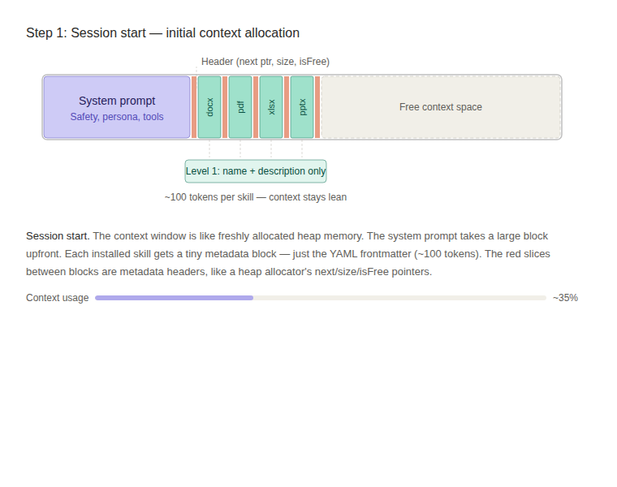
Figure 1: Context window at session start. Skill metadata blocks (green) are tiny; most space remains free.
Key insight: You can install dozens of skills and the overhead is negligible. The body content is NOT loaded yet — the context window stays lean.

Step 2: User prompt arrives — malloc(user_prompt)
When the user sends a message, a new block is allocated in the context window — malloc(user_prompt). The user’s request now sits alongside the system prompt and skill metadata.
The LLM’s forward pass now acts as the routing function. It walks the skill metadata headers (our “linked list” of name + description blocks) and evaluates the request semantically. For example, it sees “.docx” and “formatting” in the user’s message and routes to the docx skill. Crucially, there is no regex matching, no embedding similarity search, and no classifier — the LLM itself is the routing engine, using pure semantic reasoning.
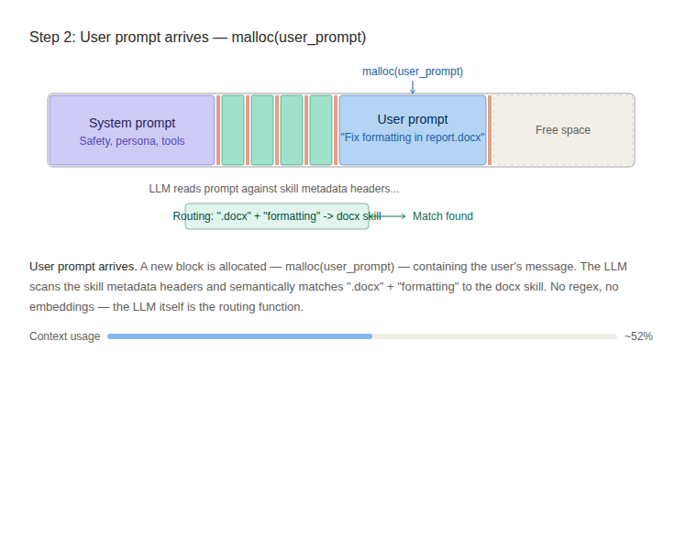
Figure 2: User prompt allocated as a new block. The LLM scans skill headers and finds a semantic match.
Key insight: The routing decision happens inside the LLM’s transformer forward pass. The skill descriptions are carefully engineered with trigger words and negative boundaries to guide this semantic matching accurately.

Step 3: Skill loaded — realloc() expands the matched skill
Once the routing decision is made, the matched skill’s metadata block gets realloc()’d — it expands from ~100 tokens to ~3,000+ tokens as the full SKILL.md body loads into the context window. This is Level 2 of progressive disclosure.
The full body now provides the agent with step-by-step workflows, code patterns, validation rules, and domain-specific gotchas. The other installed skills (pdf, xlsx, pptx) remain as tiny metadata stubs — they don’t pay any extra context cost because they weren’t matched.
If the task requires even deeper reference material, Level 3 resources (scripts, references, assets from the skill’s subdirectories) load on demand — like dynamically linking a shared library into heap memory at runtime.
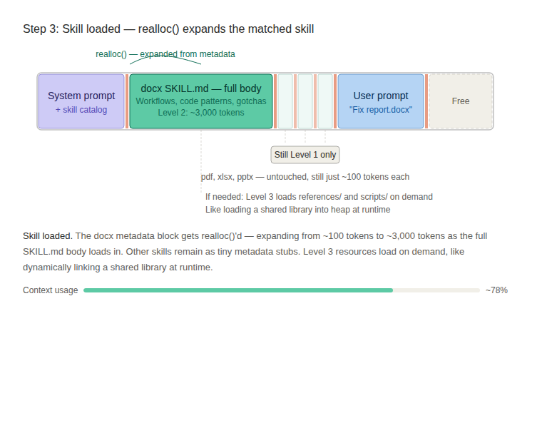
Figure 3: The docx skill expands via realloc(). Other skills remain as compact metadata. Free space shrinks but remains available.
Key insight: Progressive disclosure means only the matched skill pays the context cost. Without it, loading all skill bodies upfront would consume the context budget before the user even types anything. This is what makes the skills architecture scalable to dozens or hundreds of installed skills.

