Anatomy of a SKILL.md File
Understanding the structure that powers AI agent skills
A SKILL.md file is a Markdown file that starts with YAML frontmatter (the content between --- markers) followed by the actual instructions in regular Markdown. Think of the frontmatter as the skill’s ID card — it tells the system “what this skill is” and “when to use it.” The Markdown body is the playbook: it tells the agent “what to actually do.” Supporting directories provide scripts, references, and assets that load on demand.
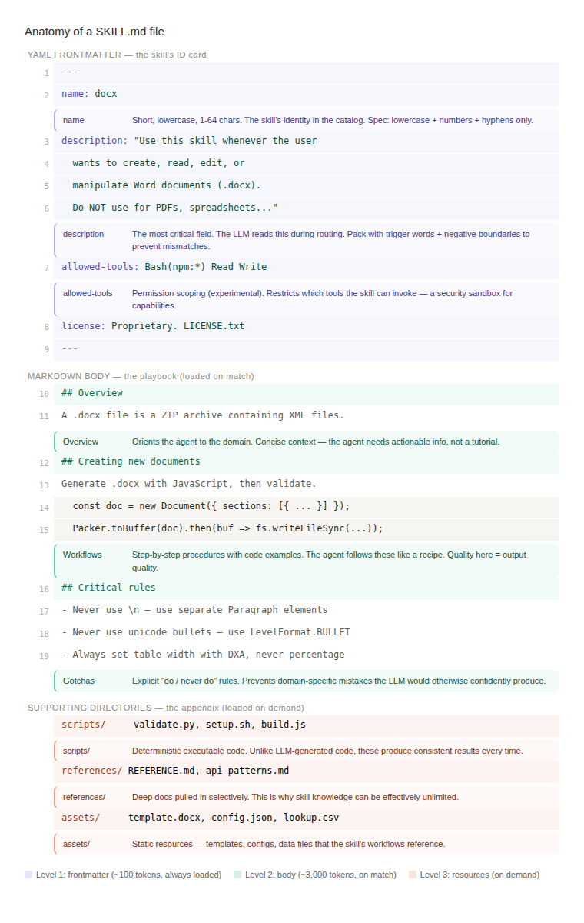
Figure 1: Annotated anatomy of a SKILL.md file showing the three progressive disclosure levels.

Level 1: YAML Frontmatter — the skill’s ID card
The frontmatter is the only part loaded at session start, costing roughly 100 tokens per skill. It gets embedded into the agent’s system prompt as part of the skill catalog. This is what makes progressive disclosure scalable — you can have dozens of skills installed with negligible overhead.

name
Short, lowercase identifier (1–64 characters). Only lowercase letters, numbers, and hyphens are permitted. This is how the agent refers to the skill internally and how it appears in the system prompt catalog. Examples: docx, deploy-pipeline, pdf-reading.

description — the most critical field
This is the routing trigger. The LLM reads this description during its forward pass to decide if the skill matches the user’s request. Two principles make descriptions effective:
Positive triggers: Pack with specific trigger words, synonyms, and use cases. “Word doc”, “.docx”, “formatting”, “tracked changes”, “letterheads” — the more specific terms, the better the LLM can match.
Negative boundaries: “Do NOT use for PDFs, spreadsheets, Google Docs” prevents the skill from firing when it shouldn’t. A missing negative boundary leads to overtriggering — the skill activating for tasks it can’t handle.

allowed-tools — the security sandbox
Declares exactly which tools the skill needs (experimental). For example, Bash(npm:*) Read Write restricts the skill to npm commands and file operations. If a Word document skill suddenly requests shell access to curl or network tools, that’s a red flag. This is the skill’s capability sandbox.

license — provenance signal
Beyond legal clarity, this signals trust and provenance. A skill marked “Proprietary” from Anthropic carries very different trust signals than an unlicensed community skill. For enterprise deployments, treat skills like codebase dependencies — review, pin versions, and audit changes.

Level 2: Markdown Body — the playbook
The body loads into context only when the LLM routes to this skill. It typically costs under 5,000 tokens and contains the agent’s step-by-step instructions. The spec doesn’t impose formatting rules, but real-world usage has surfaced patterns that work well.

Overview section
Orients the agent to the domain. Explains what the skill handles and the general approach. Keep it concise — the agent doesn’t need a tutorial, it needs actionable context to start working.

Workflows and code patterns
The core value of the skill. Step-by-step procedures, code examples, setup instructions, and API usage patterns. The agent follows these like a recipe. The quality of these instructions directly determines how well the agent performs — this is where domain expertise gets encoded into the skill. Use concrete examples, not abstract guidelines.

Critical rules and gotchas
Explicit “do this, never do that” rules that prevent domain-specific mistakes the LLM would otherwise confidently produce. For the docx skill, examples include: “never use \n”, “never use unicode bullets”, “always set table width with DXA, never percentage.” Making the implicit explicit is what separates a good skill from a great one.

Level 3: Supporting Directories — the appendix
Beyond the SKILL.md file, skills can include three categories of supporting files. These load only when the body’s instructions reference them — never automatically. This is why a skill’s total knowledge can be effectively unlimited.
Directory | Purpose | Examples
scripts/ | Executable code that runs deterministically. Unlike LLM-generated code, these produce consistent results. | validate.py, setup.sh, build.js
references/ | Deep technical documentation pulled in selectively when a task needs more detail than the body provides. | REFERENCE.md, api-patterns.md, domain-guide.md
assets/ | Static resources that the skill’s workflows reference — templates, configs, and data files. | template.docx, config.json, lookup-table.csv

Key design insight: The three-level structure degrades gracefully. A simple skill with just a SKILL.md and no extra files works perfectly — just two levels instead of three. A skill with a massive reference library costs nothing extra until those references are actually needed. Everything operates through standard filesystem reads, so there is no caching layer to maintain, no separate service to run, and no startup penalty beyond reading a few hundred bytes of YAML per installed skill.

