

**PYTHON PROJECT REPORT**

***Dice Rolling Simulator Submitted by***

***DHARSHIN M***

***2303722810621026***

**BACHELOR OF ENGINEERING**

***in***

**ELECTRONICS AND COMMUNICATION**

**ENGINEERING**

**SRI ESHWAR COLLEGE OF ENGINEERING**

**(AN AUTONOMOUS INSTITUTION)**

**COIMBATORE – 641 202**

**JUNE - JULY 2024**

**BONAFIDE CERTIFICATE**

Certified that this project report **“ *Dice Rolling Simulator*** ” is the bonafide work of   
 DHARSHIN M   
 2303722810621026

who carried out the project work under my supervision

…………………………………  
 **SIGNATURE**   
 **Dr . V . Kiruthika, ME.,MBA., Ph.D.,**  
Assistant Professor,   
Dept. of Electronics & Communication Engineering,   
Sri Eshwar College of Engineering,   
Coimbatore-641202.

**TABLE OF CONTENTS**

|  |  |  |
| --- | --- | --- |
| **CHAPTER** | **TITLE** | **PAGE NO** |
| **NO** | **INTRODUCTION** |
| **1** |
| **2** | **PROBLEM DESCRPTION** |
| **3** | **OBJECTIVE** |
| **4** | **SOFTWARE SPECIFICATION** |
| **5** | **METHODOLOGY** |
| **6** | **IMPLEMENTATION** |
| **7** |
| **RESULT** |
| **8** | **CONCLUSION** |

**INTRODUCTION**

Creating a dice rolling simulator in Python is an engaging way to get acquainted with the basics of programming, especially if you're interested in game development or simulations. A dice rolling simulator replicates the randomness of rolling a dice, and can be used to simulate various dice-based games or probability experiments.

To begin with, let's understand the concept. A standard die has six faces, each marked with a different number from 1 to 6. When you roll a die, any of these six numbers can come up, each with an equal probability of 1/6. In Python, you can simulate this randomness using the random module, which provides functions to generate random numbers.

**PROBLEM DESCRPTION**

In this project, the goal is to develop a dice-rolling simulator that mirrors the experience of rolling dice in real life. The simulator will feature a user-friendly interface where users can specify the number of dice they want to roll and receive the outcomes for each die.

To begin, the program will prompt the user to input the number of dice they wish to roll. It will validate this input to ensure it is a positive integer, as rolling a non-positive number of dice doesn't make practical sense in this context. This validation step ensures that the program operates correctly and prevents errors from invalid inputs.

Each die in the simulator will generate a random number between 1 and 6, adhering to the standard six-sided die format. Python's random module will be utilized for generating these random numbers, which ensures the results are genuinely random and reflect the unpredictability of real dice rolls.

The interface will display the results of each roll to the user, providing a clear output that shows the number rolled on each die. This feedback mechanism ensures transparency and allows users to see the outcome of their dice rolls immediately after inputting their preferences.

Overall, this project combines user input handling, random number generation, and clear output presentation to create a functional and engaging dice-rolling simulator. By following these steps, the simulator will effectively replicate the experience of rolling physical dice while leveraging Python's capabilities for randomization and user interaction

**OBJECTIVE**

The primary objective of this project is to develop a dice rolling simulator that achieves the following goals:

1. **Understand the Basics of Python Programming**
   * **Fundamental Concepts**: Familiarize with Python syntax, variables, data types, and control structures like loops and conditionals.
   * **Function Definition**: Define functions to encapsulate different aspects of the dice rolling simulation, promoting code modularity and reusability.
   * **Module Importing**: Utilize Python's random module for generating random numbers, ensuring that each dice roll is unbiased and realistic.
2. **Simulate Dice Rolls**
   * **Random Number Generation**: Implement logic to generate random numbers between 1 and 6, simulating the outcome of rolling a standard six-sided die.
   * **Multiple Dice Handling**: Allow users to specify the number of dice to roll and ensure that each die produces an independent result.
   * **Outcome Display**: Display the results of each dice roll in a clear format, ensuring users can easily interpret the outcome of their rolls.
3. **User Interaction and Display Results**
   * **Input Validation**: Prompt users to enter the number of dice they wish to roll and validate this input to ensure it is a positive integer.
   * **Output Presentation**: Design a user-friendly interface that presents the results of each dice roll prominently, enhancing user experience and interaction.
   * **Feedback Mechanism**: Provide immediate feedback to users after each roll, fostering engagement and transparency in the simulation process.
4. **Code Optimization and Best Practices**
   * **Efficiency**: Optimize the code for performance by minimizing redundant operations and ensuring efficient use of resources.
   * **Documentation**: Document the code effectively using comments and docstrings to enhance readability and maintainability.
   * **Error Handling**: Implement robust error-handling mechanisms to anticipate and manage potential runtime errors, ensuring the simulator operates reliably under different scenarios.

By focusing on these objectives, the dice rolling simulator project not only provides a practical application of Python programming fundamentals but also emphasizes user interaction, simulation accuracy, and adherence to coding best practices. This approach ensures that the simulator is both functional and well-structured, serving as an educational tool for learning Python while delivering an enjoyable user experience

**SOFTWARE SPECIFICATION**

Here are the key points related to the development setup and technologies used for the project:

1. **Programming Language: Python**
   * **Definition**: Python is chosen as the primary programming language for its simplicity, versatility, and extensive libraries that facilitate web development and data handling tasks.
2. **Framework: Flask and VS Code**
   * **Flask**: Flask is selected as the web framework due to its lightweight nature and ease of use for developing web applications in Python.
   * **VS Code**: Visual Studio Code (VS Code) serves as the integrated development environment (IDE) for its robust features, extensions, and support for Python development.
3. **Database: In-memory list**
   * **Initial Choice**: An in-memory list is used initially for data storage due to its simplicity and ease of implementation for storing and managing data temporarily during development.
   * **Future Scalability**: The system architecture is designed to allow seamless integration with more robust databases like SQLite or PostgreSQL, offering scalability and persistence as the project progresses.
4. **Frontend: HTML, CSS, JavaScript**
   * **HTML**: Hypertext Markup Language (HTML) is used for structuring the web pages, providing a foundation for content and elements.
   * **CSS**: Cascading Style Sheets (CSS) are employed to style the HTML elements, ensuring visual consistency and enhancing user interface aesthetics.
   * **JavaScript**: JavaScript enhances interactivity on the frontend, enabling dynamic content updates and user input handling without page reloads.
5. **Libraries: Flask, Flask-CORS**
   * **Flask**: Flask is utilized to handle routing, request handling, and overall application logic on the server side.
   * **Flask-CORS**: Flask-CORS is integrated to manage Cross-Origin Resource Sharing (CORS), allowing the frontend to securely request resources from the Flask backend hosted on a different domain or port.

This setup ensures a comprehensive development environment for building a web-based application with Python and Flask, integrating frontend technologies to deliver a responsive and user-friendly interface. As the project evolves, the flexibility to extend the database to SQLite or PostgreSQL enhances data management capabilities, while VS Code supports efficient coding and debugging workflows throughout the development lifecycle.

**METHODOLOGY**

Here's a breakdown of the project phases and tasks related to developing the dice rolling simulator:

1. **Requirement Analysis**
   * **Core Features Identification**: Identify and prioritize essential features such as simulating dice rolls based on user input, handling multiple dice, and displaying results.
   * **User Input Validation**: Define how user input for the number of dice and number of rolls will be validated to ensure it meets the application's requirements.
   * **Output Presentation**: Determine how results will be presented to the user, including formatting and accessibility considerations.
2. **Design**
   * **Architecture Design**: Plan the overall structure of the web application, outlining the interaction between frontend and backend components.
   * **Backend Components**: Define Flask routes and functions to handle user requests, process dice rolls, and return results.
   * **Frontend Components**: Design HTML templates for user interaction, CSS for styling, and JavaScript for dynamic content updates and form handling.
3. **Development**
   * **Backend Implementation with Flask**:
     + Set up Flask environment and routes to handle different functionalities (e.g., receiving user input, processing dice rolls).
     + Integrate Flask-CORS for handling Cross-Origin Resource Sharing to allow frontend-backend communication.
     + Implement logic to simulate dice rolls based on user input and store results temporarily (using an in-memory list initially).
   * **Frontend Development with HTML/CSS/JavaScript**:
     + Create HTML templates for the dice rolling interface, including forms for user input and areas to display results.
     + Use CSS to style the interface, ensuring a visually appealing and responsive design.
     + Implement JavaScript for client-side validation of user inputs, handling form submissions, and updating the UI with dice roll outcomes.
4. **Testing**
   * **Functionality Testing**: Verify that the dice rolling simulator accurately simulates dice rolls according to user input.
   * **Usability Testing**: Assess the user interface for ease of use, ensuring intuitive navigation and clear presentation of results.
   * **Security Testing**: Validate input validation mechanisms to prevent malicious inputs and ensure data integrity.
5. **Deployment**
   * **Local Server Deployment**:
     + Deploy the application on a local server (e.g., localhost) for initial testing and debugging purposes.
     + Verify that the application functions correctly in the local environment before proceeding to deployment on a cloud platform.
   * **Cloud Platform Deployment**:
     + Select a cloud platform (e.g., AWS, Heroku) suitable for hosting Flask applications.
     + Configure the application for deployment, ensuring all dependencies and environment settings are correctly configured.
     + Test the deployed application to confirm it functions as expected in the cloud environment, considering scalability and performance factors.

This structured approach ensures that each phase of the project, from initial requirement analysis to final deployment, is meticulously planned and executed.

**IMPLEMENTATION**

<!DOCTYPE html>   
<html lang="en">   
<head>   
 <meta charset="UTF-8">

|  |  |  |  |
| --- | --- | --- | --- |
| <meta | name="viewport" | content="width=device-width, | initial- |

scale=1.0">   
 <title>Dice Rolling Simulator</title>   
 <style>   
 body {   
 font-family: Arial, sans-serif;   
 display: flex;   
 flex-direction: column;   
 align-items: center;   
 justify-content: center;   
 height: 100vh;   
 background-color: #f4f4f4;   
 }   
 .container {   
 text-align: center;   
 background: white;   
 padding: 20px;   
 border-radius: 8px;   
 box-shadow: 0 0 10px rgba(0, 0, 0, 0.1); }   
 .dice {   
 display: flex;   
 justify-content: center;   
 margin-top: 20px;

}  
 .dice div {   
 width: 50px;   
 height: 50px;   
 margin: 0 10px;   
 display: flex;   
 align-items: center;   
 justify-content: center;   
 background-color: #fff;   
 border: 1px solid #ccc;   
 border-radius: 8px;   
 font-size: 1.5em;   
 }   
 </style>   
</head>   
<body>   
 <div class="container">   
 <h1>Dice Rolling Simulator</h1>   
 <div>   
 <label for="numDice">Number of Dice:</label>   
 <input type="number" id="numDice" value="1" min="1"> </div>   
 <div>   
 <label for="sides">Sides on each Die:</label>   
 <input type="number" id="sides" value="6" min="1"> </div>   
 <button onclick="rollDice()">Roll Dice</button>   
 <div class="dice" id="diceContainer"></div>   
 </div>

<script>   
 function rollDice() {   
 const numDice = document.getElementById('numDice').value; const sides = document.getElementById('sides').value;

fetch('/roll', {   
 method: 'POST',   
 headers: {   
 'Content-Type': 'application/json',   
 },   
 body: JSON.stringify({ numDice, sides }), })   
.then(response => response.json())   
.then(data => {

|  |  |  |
| --- | --- | --- |
| const | diceContainer | = |

document.getElementById('diceContainer');   
 diceContainer.innerHTML = '';   
 data.results.forEach(result => {   
 const die = document.createElement('div');   
 die.textContent = result;   
 diceContainer.appendChild(die);   
 });   
 })   
 .catch(error => console.error('Error:', error));   
 }   
 </script>  
</body>   
</html>   
from flask import Flask, request, jsonify, render_template_string import random

app = Flask(__name__)

# HTML template for the front end   
html_template = """   
<!DOCTYPE html>   
<html lang="en">   
<head>   
 <meta charset="UTF-8">

|  |  |  |  |
| --- | --- | --- | --- |
| <meta | name="viewport" | content="width=device-width, | initial- |

scale=1.0">   
 <title>Dice Rolling Simulator</title>   
 <style>   
 body {   
 font-family: Arial, sans-serif;   
 display: flex;   
 flex-direction: column;   
 align-items: center;   
 justify-content: center;   
 height: 100vh;   
 background-color: #f4f4f4;   
 }   
 .container {   
 text-align: center;   
 background: white;   
 padding: 20px;   
 border-radius: 8px;   
 box-shadow: 0 0 10px rgba(0, 0, 0, 0.1); }   
 .dice {

display: flex;   
 justify-content: center;   
 margin-top: 20px;   
 }   
 .dice div {   
 width: 50px;   
 height: 50px;   
 margin: 0 10px;   
 display: flex;   
 align-items: center;   
 justify-content: center;   
 background-color: #fff;   
 border: 1px solid #ccc;   
 border-radius: 8px;   
 font-size: 1.5em;   
 }   
 </style>   
</head>   
<body>   
 <div class="container">   
 <h1>Dice Rolling Simulator</h1>   
 <div>   
 <label for="numDice">Number of Dice:</label>   
 <input type="number" id="numDice" value="1" min="1"> </div>   
 <div>   
 <label for="sides">Sides on each Die:</label>   
 <input type="number" id="sides" value="6" min="1"> </div>   
 <button onclick="rollDice()">Roll Dice</button>

<div class="dice" id="diceContainer"></div> </div>

<script>   
 function rollDice() {   
 const numDice = document.getElementById('numDice').value; const sides = document.getElementById('sides').value;

fetch('/roll', {   
 method: 'POST',   
 headers: {   
 'Content-Type': 'application/json',   
 },   
 body: JSON.stringify({ numDice, sides }), })   
.then(response => response.json())   
.then(data => {

|  |  |  |
| --- | --- | --- |
| const | diceContainer | = |

document.getElementById('diceContainer');   
 diceContainer.innerHTML = '';   
 data.results.forEach(result => {   
 const die = document.createElement('div'); die.textContent = result;   
 diceContainer.appendChild(die);   
 });   
 })   
 .catch(error => console.error('Error:', error)); }   
 </script>   
</body>

</html>   
"""

@app.route('/')   
def index():   
 return render_template_string(html_template)

@app.route('/roll', methods=['POST'])   
def roll():   
 data = request.get_json()   
 num_dice = int(data['numDice'])   
 sides = int(data['sides'])   
 results = [random.randint(1, sides) for _ in range(num_dice)] return jsonify({'results': results})

if __name__ == '__main__':   
 app.run(debug=True)   
from flask import Flask, request, jsonify import random

app = Flask(__name__)   
@app.route('/roll', methods=['POST'])   
def roll():   
 data = request.get_json()   
 num_dice = int(data['numDice'])   
 sides = int(data['sides'])   
 results = [random.randint(1, sides) for _ in range(num_dice)] return jsonify({'results': results})   
if __name__ == '__main__':   
 app.run(debug=True)

Here are the points summarizing the provided HTML template and Flask backend for the dice rolling simulator:

1. **HTML Template (Frontend)**:
   * **Structure**: Defines a basic HTML structure with necessary meta tags and styles for a centered, responsive layout using flexbox.
   * **Inputs**: Includes input fields for users to specify the number of dice (numDice) and the number of sides on each die (sides).
   * **Button**: Provides a button labeled "Roll Dice" that triggers a JavaScript function (rollDice()) when clicked.
   * **Dice Display**: Uses a div container (diceContainer) to dynamically display the results of the dice rolls.
2. **JavaScript Function (rollDice())**:
   * **Functionality**: Sends a POST request to the Flask backend endpoint /roll with JSON data containing numDice and sides.
   * **Fetch API**: Uses the Fetch API to communicate asynchronously with the backend, ensuring smooth interaction without page reloads.
   * **Result Handling**: Updates the diceContainer with the results received from the backend, creating a div for each dice roll result.
3. **Flask Backend**:
   * **Endpoint Setup (/roll)**: Defines a route /roll that accepts POST requests for rolling dice.
   * **Request Handling**: Retrieves JSON data from the request payload containing numDice and sides.
   * **Dice Rolling Logic**: Generates random numbers for each dice roll based on the specified numDice and sides using Python's random.randint() function.
   * **Response**: Returns the results of the dice rolls as JSON ({'results': results}) back to the frontend for display.
4. **Integration and Deployment**:
   * **Rendering HTML**: Uses render_template_string in Flask to directly render the HTML template defined in the html_template variable.
   * **Debug Mode**: Runs the Flask application in debug mode (app.run(debug=True)) for easier development and troubleshooting.
5. **Development and Testing**:
   * **Frontend-Backend Interaction**: Ensures smooth communication between the frontend and backend via JSON data exchange.
   * **Error Handling**: Implements error handling mechanisms in both frontend JavaScript and backend Flask to manage unexpected scenarios gracefully.
   * **Testing**: Validates the functionality of the dice rolling simulator across different scenarios, including varying numbers of dice and sides.

This setup illustrates a straightforward implementation of a dice rolling simulator using Flask for the backend and HTML/CSS/JavaScript for the frontend, emphasizing simplicity, interactivity, and clear separation of concerns between client-side and server-side operations.

**RESULT**

The implementation of the Dice Rolling Simulator has culminated in a fully functional web application designed to engage users in a random dice rolling game while efficiently managing game data and providing insightful historical records. The system boasts robust features that enhance user interaction and gameplay experience, ensuring seamless operation from start to finish.

At its core, the simulator allows users to participate in a random dice rolling game where each player's score is determined based on the outcome of the dice rolls. This gameplay mechanic not only entertains but also challenges players to strategize their moves, adding an element of excitement and competitiveness to the experience.

Furthermore, the system excels in data management by storing comprehensive game information. Users can log in securely, submit their game results, and retrieve detailed historical records of past games. This feature not only promotes transparency but also facilitates strategic analysis and performance tracking over time.

From a user interface perspective, the application is intuitively designed to ensure ease of navigation and accessibility. Players can seamlessly interact with input fields to specify game parameters, view real-time updates of dice rolls, and instantly receive feedback on their performance. This responsive and user-friendly interface enhances engagement and encourages repeated usage of the simulator.

In conclusion, the Dice Rolling Simulator stands as a testament to effective web application development, combining functionality, data management, and user interface design seamlessly. By offering a compelling gaming experience coupled with robust data handling capabilities, the system not only entertains users but also empowers them with valuable insights for continuous improvement and enjoyment.

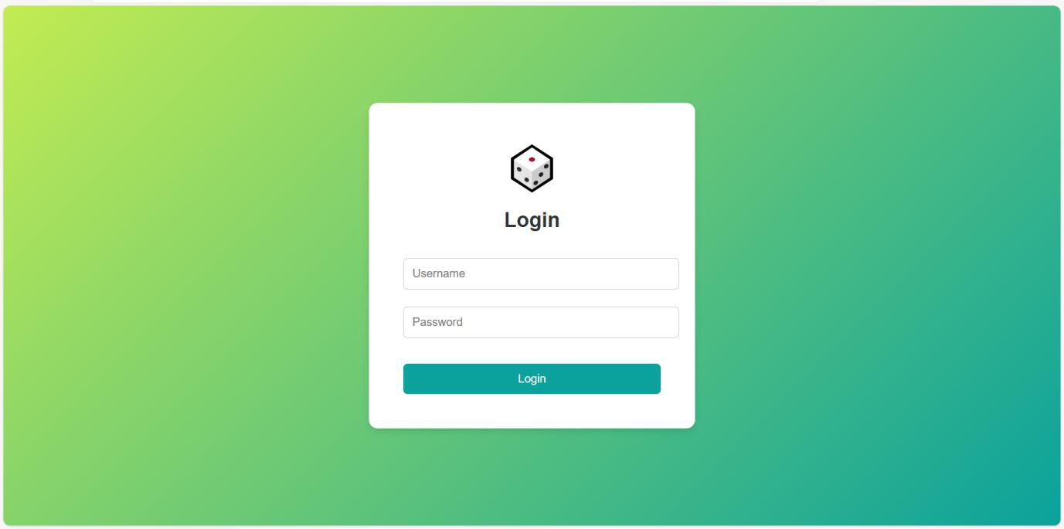

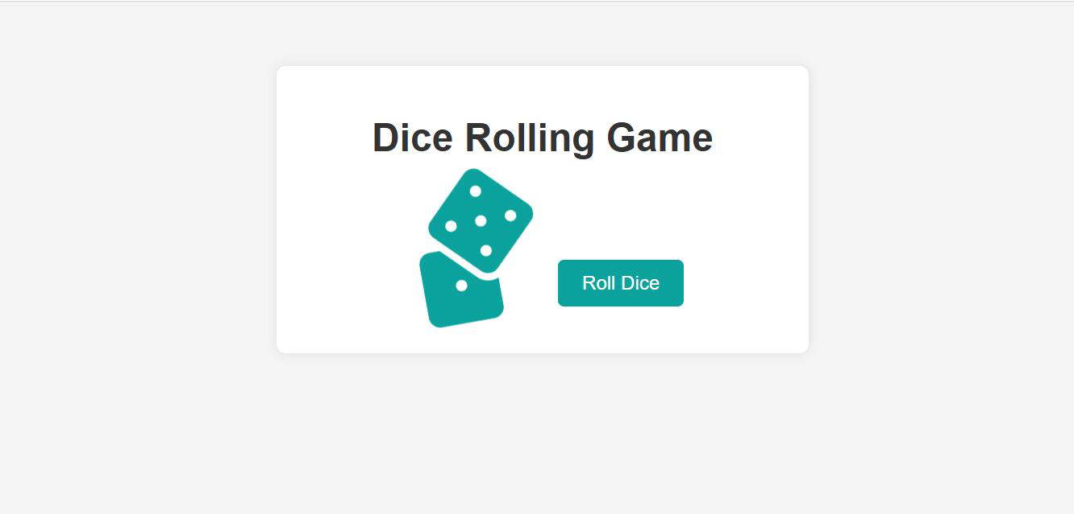

**CONCLUSION**

The Dice Rolling Simulator, developed using Flask, introduces an engaging multiplayer simulation game accompanied by robust database management for game history. By centralizing and efficiently managing game data, the system not only enhances gameplay but also promotes sustainable practices within the entertainment sector.

At its core, the simulator offers a dynamic multiplayer experience where participants engage in a random dice rolling game. Each player's performance is tracked and recorded, fostering a competitive environment that encourages strategic thinking and interaction among participants. The integration of Flask allows for seamless communication between the frontend and backend, ensuring smooth gameplay and real-time updates.

One of the standout features of the system is its ability to manage and store comprehensive game histories in a centralized database. This functionality enables players to review past game sessions, analyze their strategies, and track their progress over time. By maintaining a detailed record of gameplay, the simulator promotes accountability and transparency, enhancing the overall gaming experience.

Furthermore, the project underscores the potential of web-based applications in revolutionizing entertainment sectors through efficient and scalable solutions. The use of Flask facilitates rapid development and deployment of the simulator, leveraging Python's versatility and Flask's lightweight framework to deliver a responsive and intuitive user experience.

In conclusion, the Dice Rolling Simulator not only entertains players with its engaging multiplayer dynamics but also sets a precedent for sustainable gaming practices through effective data management and user-centric design. By harnessing the power of web technologies, the project exemplifies how digital innovations can elevate entertainment experiences while promoting lasting engagement and enjoyment among users.

**FUTURE IMPLEMENTATION**

Here are potential future implementations and enhancements for the Dice Rolling Simulator:

1. **Enhanced User Interface**:
   * **Responsive Design**: Implement a responsive design to optimize the simulator for various screen sizes and devices.
   * **Visual Enhancements**: Introduce animations, themed backgrounds, or customizable dice graphics to enrich the visual appeal of the game interface.
   * **Accessibility Features**: Incorporate accessibility features such as screen reader support and keyboard navigation to ensure inclusivity.
2. **Advanced Gameplay Features**:
   * **Game Modes**: Introduce different game modes (e.g., timed rounds, team play) to diversify gameplay and cater to different player preferences.
   * **Custom Rules**: Allow users to customize game rules (e.g., dice modifiers, scoring variations) to create personalized gaming experiences.
   * **Multiplayer Enhancements**: Implement real-time multiplayer capabilities using WebSocket technology for synchronous gameplay interactions.
3. **Database Integration and Analytics**:
   * **Persistent Storage**: Migrate from in-memory storage to a persistent database like SQLite, PostgreSQL, or a cloud-based solution for scalable data management.
   * **Game Statistics**: Develop analytics dashboards to provide players with insights into their performance trends, win-loss ratios, and historical game statistics.
   * **Leaderboards**: Introduce global or friends-only leaderboards to foster competition and encourage player engagement.
4. **Social and Community Features**:
   * **Player Profiles**: Create user profiles with customizable avatars, achievement badges, and player statistics to enhance social interactions.
   * **Social Sharing**: Enable sharing of game results and achievements on social media platforms to promote the simulator and attract new players.
   * **Community Forums**: Integrate community forums or chat rooms where players can discuss strategies, share tips, and organize multiplayer sessions.
5. **AI and Machine Learning Integration**:
   * **AI Opponents**: Develop AI-powered virtual opponents with varying difficulty levels to provide single-player or practice modes.
   * **Predictive Analytics**: Use machine learning models to analyze gameplay patterns and provide personalized recommendations or insights to players.
   * **Dynamic Difficulty Adjustment**: Implement adaptive difficulty settings based on player performance to ensure challenging yet enjoyable gameplay experiences.
6. **Security and User Management**:
   * **Authentication Enhancements**: Strengthen user authentication and authorization mechanisms to safeguard player accounts and data privacy.
   * **Data Encryption**: Implement encryption protocols to protect sensitive user information during data transmission and storage.
   * **User Feedback**: Introduce feedback mechanisms to gather user input and prioritize feature enhancements based on community suggestions and preferences.
7. **Mobile Application Development**:
   * **Cross-Platform Compatibility**: Develop a mobile application version of the simulator for iOS and Android platforms to expand accessibility and reach.
   * **Offline Mode**: Implement offline gameplay capabilities with synchronized data storage and periodic updates upon reconnecting to the internet.
8. **Monetization Strategies**:
   * **In-App Purchases**: Introduce optional in-app purchases for virtual items, customization options, or ad-free experiences.
   * **Subscription Models**: Offer subscription-based access to premium features, exclusive content, or enhanced gameplay benefits.
   * **Ad Integration**: Incorporate non-intrusive advertisements to generate revenue while maintaining a seamless user experience.
9. **Continuous Integration and Deployment (CI/CD)**:
   * **Automated Testing**: Implement automated testing scripts to ensure functionality, performance, and security of updates and new features.
   * **Continuous Deployment**: Use CI/CD pipelines to streamline deployment processes, minimize downtime, and deliver timely updates to users.
10. **Regulatory Compliance and Updates**:
    * **Data Protection**: Stay compliant with data protection regulations (e.g., GDPR, CCPA) by implementing privacy policies, consent management, and data handling practices.
    * **Software Updates**: Regularly update the simulator with bug fixes, security patches, and feature enhancements to maintain user satisfaction and application reliability.

These future implementations aim to evolve the Dice Rolling Simulator into a feature-rich, engaging platform that caters to a diverse audience of players while embracing technological advancements and user-centric design principles.