1. Fix the bugs in below snippet

<html lang="en">

<head>

  <title>Document</title>

</head>

<body>

  <div>

    guvi

    <div>

      Lorem ipsum dolor sit amet consectetur adipisicing elit.

      <div>

        Guvi Geek Network

      </div>

    </div>

  </div>

</body>

</html>

1. Try the below one

<html lang="en">

<head>

  <title>Document</title>

</head>

<body>

  <div>guvi</div>

  <div>

    Lorem ipsum dolor sit amet consectetur adipisicing elit.

    <div>

      Guvi Geek Network

    </div>

  </div>

</body>

</html>

1. Design a contact us form with all fields as required.

<!DOCTYPE html>

<html lang="en">

<head>

  <meta charset="UTF-8">

  <meta http-equiv="X-UA-Compatible" content="IE=edge">

  <meta name="viewport" content="width=device-width, initial-scale=1.0">

  <title>Contact Us</title>

  <style>

    body{

      background-color:gray;

    }

    form{

      background-color:darkgrey;

    }

    h1,

    p {

      text-align: center;

    }

  </style>

</head>

<body>

  <h1>Contact Us</h1>

  <form>

    <p>

      <label for="name">Name</label>

      <input type="text" id="" name="name" required>

    </p>

    <p>

      <label for="email">Email</label>

      <input type="email" id="" name="email" required>

    </p>

    <p>

      <label for="message">Message</label>

      <input type="text" id="" name="message" required>

    </p>

    <p>

      <input type="submit" value="Submit">

    </p>

  </form>

  <section>

    <div>

      <div>

        <h3>Contact:  987654321 </h3>

      </div>

      <div>

        <h3>Address:  24,Porur,Chennai</h3>

      </div>

      <div>

        <h3>Email:   Sample@gmail.com</h3>

      </div>

    </div>

  </section>

</body>

</html

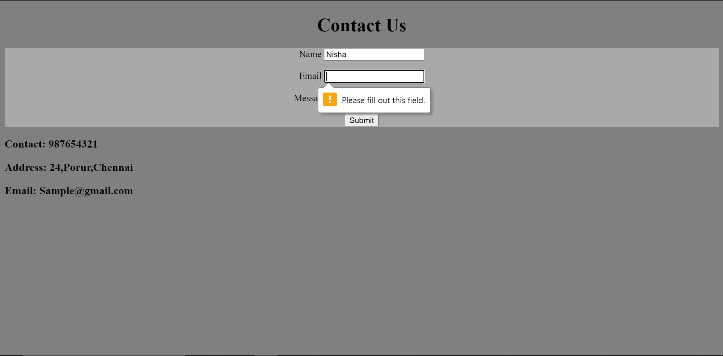

1. Use certain HTML elements to display the following in a HTML page.

<!DOCTYPE html>

<html lang="en">

<head>

  <meta charset="UTF-8">

  <meta http-equiv="X-UA-Compatible" content="IE=edge">

  <meta name="viewport" content="width=device-width, initial-scale=1.0">

  <title>Document</title>

</head>

<body>

  <ul>

    <li>Programmimg language</li>

    <ul>

      <li>JavaScript</li>

      <ol type="a">

        <li>Angular</li>

        <li>React</li>

        <li>Vue.js</li>

      </ol>

      <li>Python</li>

      <ol type="a">

        <li>Django Framework</li>

        <li>Flask Framework</li>

      </ol>

      <li>Java</li>

      <ol type="a">

        <li>Spring</li>

        <li>Maven</li>

        <li>Hibernate</li>

      </ol>

    </ul>

    <li>Database</li>

    <ul>

      <li>MySQL</li>

      <li>MongoDB</li>

      <li>Cansandra</li>

    </ul>

  </ul>

</body>

</html

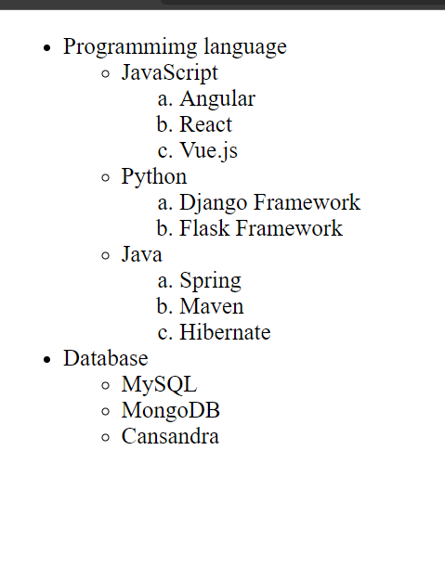

1. Create an element that helps you to open the [https://google.com](https://google.com/) in separate new tab.

 <a href="https://google.com" target="_blank">Click here to google</a>

1. In the form, add two radio buttons with grouping them for employee type(Salaried and own business)

<!DOCTYPE html>

<html lang="en">

<head>

  <meta charset="UTF-8">

  <meta http-equiv="X-UA-Compatible" content="IE=edge">

  <meta name="viewport" content="width=device-width, initial-scale=1.0">

  <title>Document</title>

  <style>

    form{

      text-align: center;

      background-color:khaki;

    }

  </style>

</head>

<body>

  <form>

    <p>

      <div>

        <label for="name">Name</label>

        <input type="text" name="" id="name">

      </div>

    </p>

  <span>

        <label for="salaried">Salaried</label>

    <input type="radio" name="" id="salaried">

  </span>

  <span>

    <label for="own">Owns Business</label>

      <input type="radio" name="" id="own">

  </span>

  <p>

    <div>

      <input type="submit" value="Submit">

    </div>

  </p>

    </form>

</body>

</html



1. Design form shown in the link (<http://evc-cit.info/cit040/formguide/card_0.png>)

<!DOCTYPE html>

<html lang="en">

<head>

    <meta charset="UTF-8">

    <meta http-equiv="X-UA-Compatible" content="IE=edge">

    <meta name="viewport" content="width=device-width, initial-scale=1.0">

    <title>Document</title>

    <link rel="stylesheet" href="https://cdn.jsdelivr.net/npm/bootstrap@4.6.1/dist/css/bootstrap.min.css">

    <style>

        h2 {

            text-align: center;

            background-color: red;

            color: white;

        }

        body {

            padding: 20px;

            margin: 50px;

            border: 4px solid black;

        }

        input[type=text] {

            border: none;

            border-bottom: 3px solid #000000;

            font-style: italic;

            font-weight: bold;

            text-align: center;

            width: 100%;

        }

    </style>

</head>

<body>

    <form>

        <h2>Yes!I want to subscribe to Mag-O-Zine</h2>

        <div class="container">

            <div class="row">

                <div class="col-6">

                    <input type="text" name="" id="fname">

                    <label for="fname">First Name</label>

                </div>

                <div class="col-6">

                    <input type="text" name="" id="lname">

                    <label for="lname">Last Name</label>

                </div>

            </div>

            <div class="row">

                <div class="col-12">

                    <input type="text" name="" id="add">

                    <label for="add">Address</label>

                </div>

            </div>

            <div class="row">

                <div class="col-4">

                    <input type="text" name="" id="city">

                    <label for="city">City</label>

                </div>

                <div class="col-4">

                    <input type="text" name="" id="state">

                    <label for="state">State</label>

                </div>

                <div class="col-4">

                    <input type="text" name="" id="zip">

                    <label for="zip">Zip</label>

                </div>

            </div>

        </div>

        <div class="container">

            <h4>Subscribe for:

                <span>

                    <input type="checkbox" name="" id="1">

                    <label for="1">1 year ($19.95)</label>

                    <input type="checkbox" name="" id="2">

                    <label for="2">2 years ($35.00)</label>

                </span>

            </h4>

            <h4>Send me more information about:

                <div>

                    <input type="checkbox" name="" id="cz">

                    <label for="cz">Computer-Zine</label>

                </div>

                <div>

                    <input type="checkbox" name="" id="fz">

                    <label for="fz">Fishing-Zine</label>

                </div>

                <div>

                    <input type="checkbox" name="" id="coz">

                    <label for="coz">Cat-0-Zine</label>

                </div>

            </h4>

        </div>

    </form>

</body>

</html

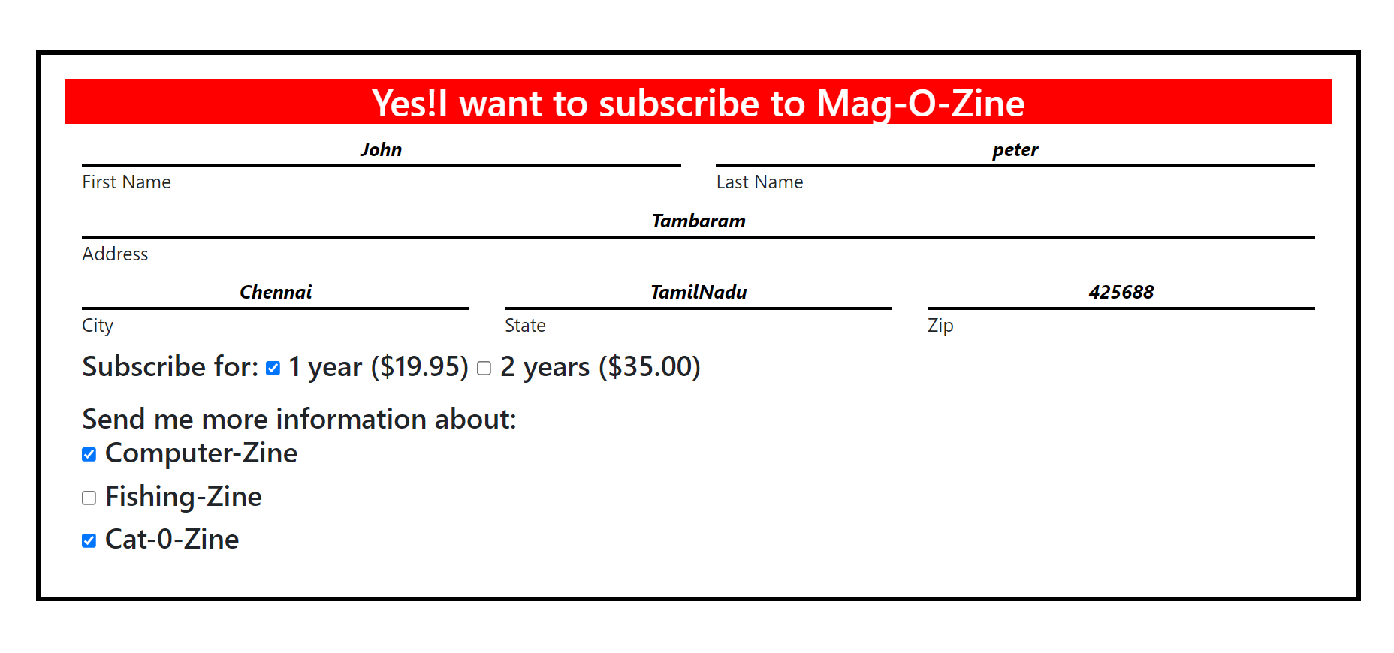

8. Use the table tag to design given image

<!DOCTYPE html>

<html lang="en">

<head>

  <meta charset="UTF-8">

  <meta http-equiv="X-UA-Compatible" content="IE=edge">

  <meta name="viewport" content="width=device-width, initial-scale=1.0">

  <title>Document</title>

</head>

<style>

table,th,td,tr{

  margin-left: auto;

  margin-right: auto;

  border: 2px solid black;

  border-collapse: collapse;

  text-align: center;

}

h4{

  text-align:center;

  font-weight: normal;

}

</style>

<body>

  <h4>Health Chart</h4>

  <table>

    <thead></thead>

    <tbody>

      <tr>

        <td rowspan=2>State of Health</td>

        <td colspan=2>Fasting Value</td>

        <td>After Eating</td>

      </tr>

      <tr>

        <td>Minimum</td>

        <td>Maximum</td>

        <td>2 hours after eating</td>

      </tr>

      <tr>

        <td>Healthy</td>

        <td>70</td>

        <td>100</td>

        <td>Less than 140</td>

      </tr>

      <tr>

        <td>Pre-Diabetes</td>

        <td>101</td>

        <td>126</td>

        <td>140 to 200</td>

      </tr>

      <tr>

        <td>Diabetes</td>

        <td>More than 126</td>

        <td>N/A</td>

        <td>More than 200</td>

      </tr>

    </tbody>

  </table>

</body>

</html>

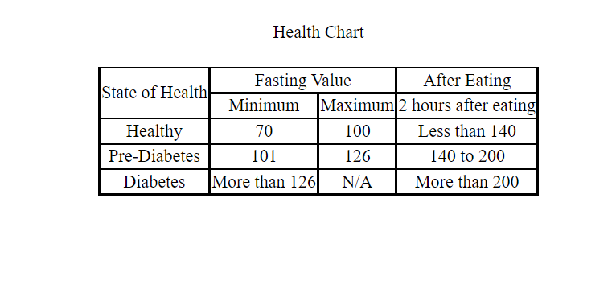

1. Write HTML input tags snippet to show default values for all Form elements.

input.html:

<!DOCTYPE html>

<html lang="en">

<head>

    <meta charset="UTF-8">

    <meta http-equiv="X-UA-Compatible" content="IE=edge">

    <meta name="viewport" content="width=device-width, initial-scale=1.0">

    <title>Passenger Details</title>

    <link rel="stylesheet" href="https://cdn.jsdelivr.net/npm/bootstrap@4.6.1/dist/css/bootstrap.min.css">

    <link rel="stylesheet" href="input.css">

    <script src="input.css"></script>

</head>

<body>

    <div class="row">

    <form class="col-md-7">

        <h1 class="header">Passenger Details</h1>

        <label for="name"> Name:</label>

        <input type="text" name="name" id="name" value="Nisha"><br>

        <label for="gender">Gender:</label>

        <input type="radio" name="gender" value="male">Male

        <input type="radio" name="gender" value="female" checked> Female<br>

        <label for="dob">Date of Birth:</label>

        <input type="date" name="dob" id="dob" value="1995-06-20"><br>

        <label for="color">Select your favourite colour:</label>

        <input type="color" name="color" id="color" value="#FFA07A"><br>

        <label for="email">Email:</label>

        <input type="email" name="email" id="email" value="abc@gmail.com"><br>

        <label for="pass">Password:</label>

        <input type="password" name="pass" id="pass" value="nisha"><br>

        <label for="phone">Phone Number:</label>

       <input type="tel" name="phone" id="phone" value="123-456-789"><br>

       <label for="dandt">Date and Time:</label>

       <input type="datetime-local" name="dandt" id="dandt" value="2021-12-16T10:30:23"><br>

       <label for="month">Chosse the month of travel:</label>

       <input type="month" name="month" id="month" value="2022-01"><br>

       <label for="dweek">Departure Week:</label>

       <input type="week" name="dweek" id="dweek" value="2022-W01"><br>

       <label for="dtime">Departure Time:</label>

       <input type="time" name="dtime" id="dtime" value="10:30"><br>

       <label for="seat">Give your preferred seat number:</label>

        <input type="number" name="seat" id="seat" value="6"><br>

        <label for="prange">Price Range:</label>

        2000<input type="range" min="2000" max="10000" value="2000" name="prange" id="prange" >100000<br>

        <label for="file">Choose a file to upload:</label>

        <input type="file" name="file" id="file"><br>

        <label for="Search">Search:</label>

        <input type="search" name="search" id="search" value="PR Travels"><br>

        <label for="url">URL:</label>

        <input type="url" name="url" id="url" value="https://google.com"><br>

        <input type="checkbox" name="confirm" id="confirm" class="extra" checked>

        <label for="confirm" style="margin-left:0px;">I agree that the file/proof submitted by me is true to my knowledge</label><br>

        <input type="hidden" name="stay" value="LeePalace">

        <input type="reset" value="Reset" class="extra">

        <input type="submit" value="Submit" class="extra">

        <input type="button" value="Cancel" class="extra">

    </form>

    <div class="col-md-5" style="margin-top:250px;">

        <img src="https://image.shutterstock.com/image-illustration/travel-world-monument-concept-260nw-97739021.jpg" alt="image" >

    </div>

</div>

</body>

</html>

Input.css:

label{

margin:10px 50px;

margin-right:0px;

}

input{

margin:10px;

}

body{

background: linear-gradient(rgb(224, 147, 59),rgb(93, 41, 153));

font-weight: bold;

font-size: 15px;

}

.header{

margin:30px;

text-align: center;

}

.extra{

margin-left:50px;

}

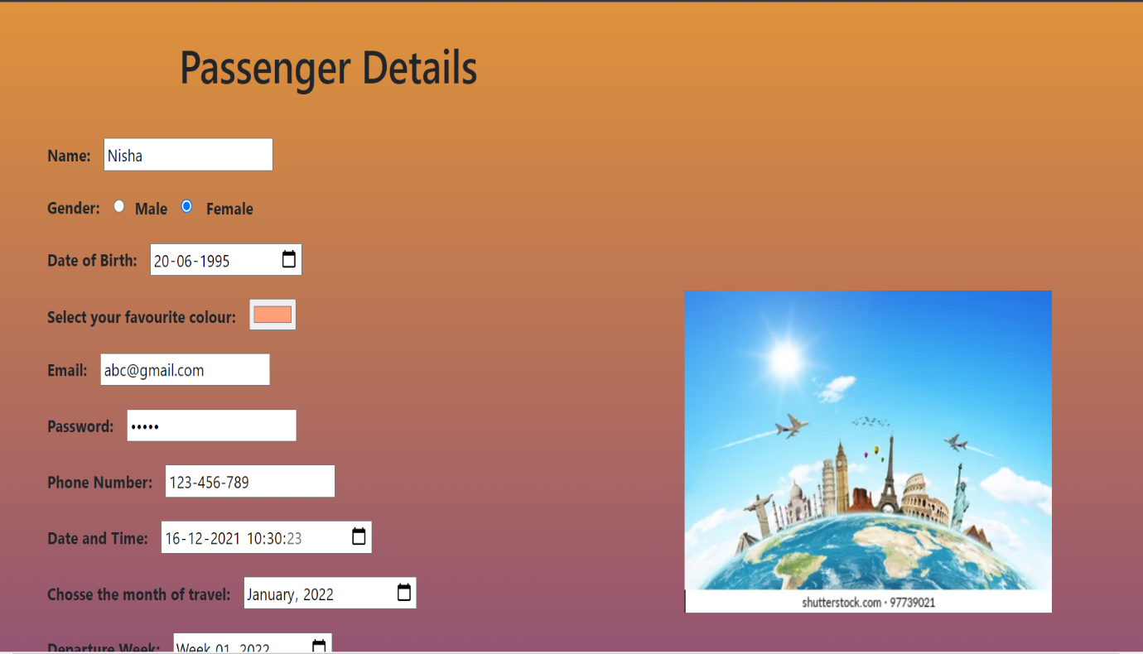

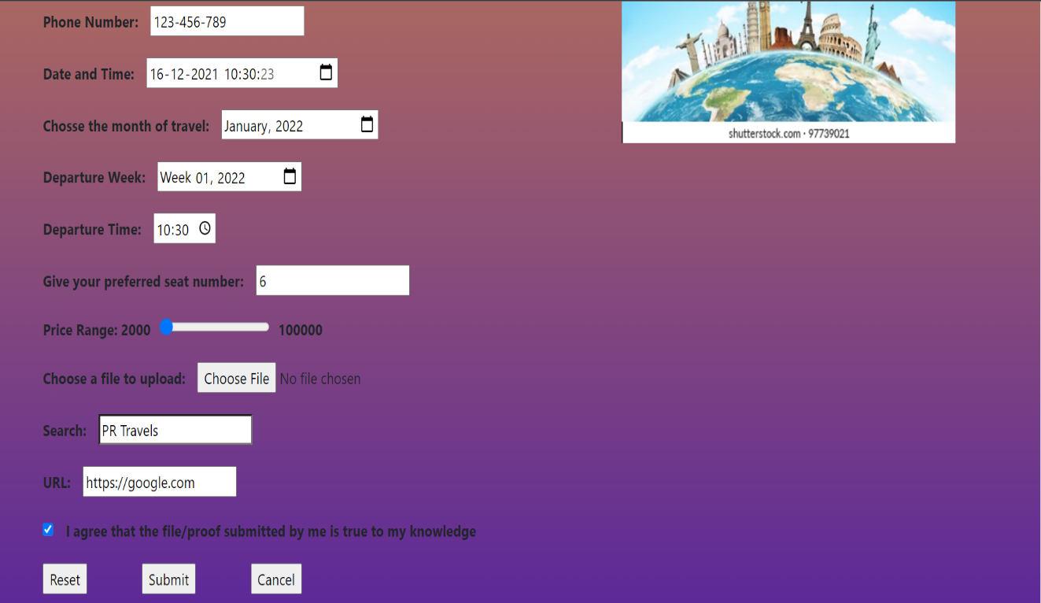

1. In your, HTML page add the below line and Highlight it without using any CSS.

* "HTML & CSS is awesome"

<!DOCTYPE html>

<html lang="en">

<head>

    <meta charset="UTF-8">

    <meta http-equiv="X-UA-Compatible" content="IE=edge">

    <meta name="viewport" content="width=device-width, initial-scale=1.0">

    <title>Document</title>

</head>

<body>

   <mark>"HTML & CSS is awesome"</mark>

</body>

</html>

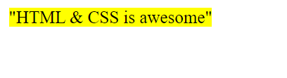

1. Create an HTML page, which should contain all types of input elements.

input.html:

<!DOCTYPE html>

<html lang="en">

<head>

    <meta charset="UTF-8">

    <meta http-equiv="X-UA-Compatible" content="IE=edge">

    <meta name="viewport" content="width=device-width, initial-scale=1.0">

    <title>Passenger Details</title>

    <link rel="stylesheet" href="https://cdn.jsdelivr.net/npm/bootstrap@4.6.1/dist/css/bootstrap.min.css">

    <link rel="stylesheet" href="input.css">

    <script src="input.css"></script>

</head>

<body>

    <div class="row">

    <form class="col-md-7">

        <h1 class="header">Passenger Details</h1>

        <label for="name"> Name:</label>

        <input type="text" name="name" id="name"><br>

        <label for="gender">Gender:</label>

        <input type="radio" name="gender" value="male">Male

        <input type="radio" name="gender" value="female"> Female<br>

        <label for="dob">Date of Birth:</label>

        <input type="date" name="dob" id="dob"><br>

        <label for="color">Select your favourite colour:</label>

        <input type="color" name="color" id="color"><br>

        <label for="email">Email:</label>

        <input type="email" name="email" id="email"><br>

        <label for="pass">Password:</label>

        <input type="password" name="pass" id="pass"><br>

        <label for="phone">Phone Number:</label>

       <input type="tel" name="phone" id="phone"><br>

       <label for="dandt">Date and Time:</label>

       <input type="datetime" name="dandt" id="dandt"><br>

       <label for="month">Chosse the month of travel:</label>

       <input type="month" name="month" id="month"><br>

       <label for="dweek">Departure Week:</label>

       <input type="week" name="dweek" id="dweek"><br>

       <label for="dtime">Departure Time:</label>

       <input type="time" name="dtime" id="dtime"><br>

       <label for="seat">Give your preferred seat number:</label>

        <input type="number" name="seat" id="seat"><br>

        <label for="prange">Price Range:</label>

        2000<input type="range" min="2000" max="100000" value="2000" name="prange" id="prange">100000<br>

        <label for="file">Choose a file to upload:</label>

        <input type="file" name="file" id="file"><br>

        <label for="Search">Search:</label>

        <input type="search" name="search" id="search"><br>

        <label for="url">URL:</label>

        <input type="url" name="url" id="url"><br>

        <input type="checkbox" name="confirm" id="confirm" class="extra">

        <label for="confirm" style="margin-left:0px;">I agree that the file/proof submitted by me is true to my knowledge</label><br>

<input type="hidden" name="stay" value="LeePalace">

        <input type="reset" value="Reset" class="extra">

        <input type="submit" value="Submit" class="extra">

<input type="button" value="Cancel" class="extra">

    </form>

    <div class="col-md-5" style="margin-top:250px;">

        <img src="https://image.shutterstock.com/image-illustration/travel-world-monument-concept-260nw-97739021.jpg" alt="image" >

    </div>

</div>

</body>

</html>

input.css:

label{

    margin:10px 50px;

    margin-right:0px;

}

input{

    margin:10px;

}

body{

    background: linear-gradient(rgb(224, 147, 59),rgb(93, 41, 153));

    font-weight: bold;

    font-size: 15px;

}

.header{

    margin:30px;

    text-align: center;

}

.extra{

    margin-left:50px;

}

