SOLUTION ARCHITECTURE · VERSION 1.0 · DRAFT FOR CLIENT REVIEW
Vendor Onboarding Platform
How the platform is built, what it connects to, where data lives, and how it is secured and kept available. Written for business, security, infrastructure and audit stakeholders.
Prepared for | [Hero FinCorp, Hero Housing]
Prepared by | [Ernst and Young]
Date | 22 October 2026
Contents
1 Summary
2 System boundary and consuming applications
3 Application and service layers
4 Data and process flow
5 Data storage
6 Integration points with external systems
7 Security and authentication
8 Infrastructure and deployment
9 Logging and monitoring
10 High availability and disaster recovery
11 Decisions we need from the client

1 Summary
The Vendor Onboarding Platform (VOMT) takes a new vendor from request to approved record. A business user raises a case, the platform checks the vendor's tax and bank details against government registries, specialist teams review in parallel, and a final confirmation activates the vendor in the ERP. Every step is recorded in a tamper-evident audit trail.
AREA | APPROACH
Application | Web portal (Next.js) and REST API (NestJS), both stateless containers that scale horizontally.
Structured data | PostgreSQL holds users, roles, cases, workflow definitions, review outcomes, notifications and the audit log.
Documents | Object storage. Amazon S3 is used as-is if the client already has it; Azure blob Storage/GCP Storage and others are supported by configuration.
Sign-in | Enterprise single sign-on (OIDC or SAML 2.0, for example Microsoft Entra ID). Access is controlled by roles, denied by default.
Deployment | Containers on Kubernetes (Helm chart provided) in the client's cloud account or data centre. No cloud-specific code in the application.

2 System boundary and consuming applications
Everything inside the dashed boundary is delivered and operated as part of VOMT. Everything outside it is an existing client system or a third-party service that VOMT connects to.
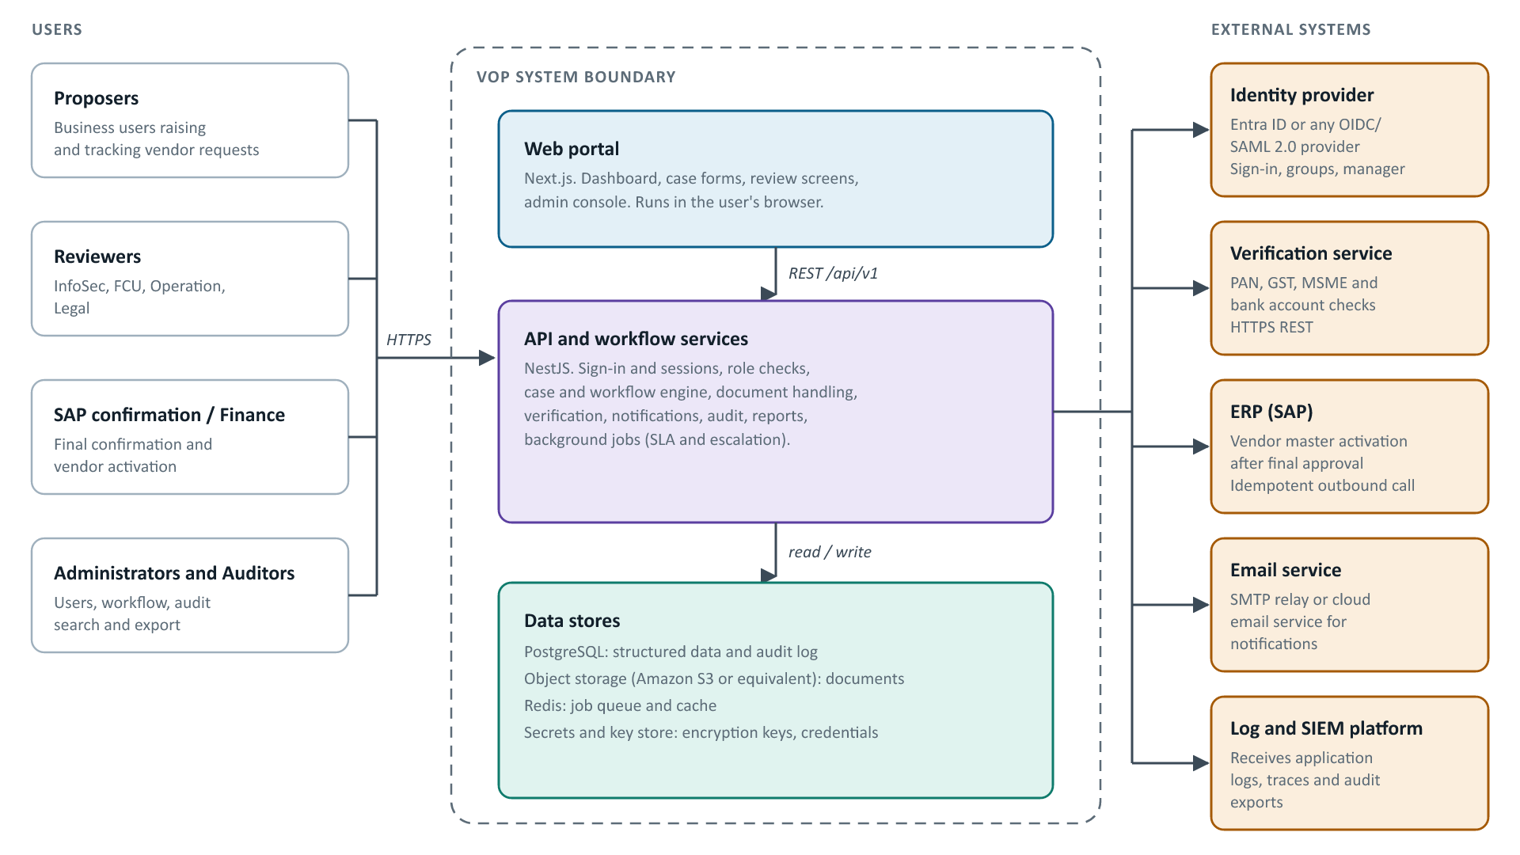
Figure 1. Users, the VOMT boundary and the external systems it integrates with. Users reach VOMT only through the web portal and API over HTTPS.
Colour key: blue = presentation, purple = application, green = data, orange = external to VOMT.

3 Application and service layers
The platform is a modular application. Each concern is a separate module, and every external dependency sits behind an adapter, so a storage, email or queue service can be swapped by configuration without code changes.
Presentation  Browser, Next.js | Dashboard – Role-aware KPIs and queues  Case forms – Intake, resubmit, review  Admin console – Users, roles, workflow, categories  Audit viewer – Search, verify, export
Edge  Ingress / load balancer | TLS termination – HTTPS only, HSTS  Routing – / to web, /api to API  WAF and rate limits – Throttling on public endpoints
Application services  NestJS API, stateless | Identity and sessions – SSO, cookies, lockout  Access control – Role guard, deny by default  Cases and workflow – Risk tiering, parallel stages  Documents – Validate, scan, store, serve  Verification – Registry checks, red flags  Notifications – In-app and email  Audit – Append-only, hash-chained  Reporting – Dashboards and exports  Background jobs – SLA timers, escalation
Provider adapters  Replaceable by configuration | Storage – S3, R2, MinIO, local  Secrets and keys – Vault or cloud KMS  Email – SMTP or cloud email  Queue – Redis (BullMQ)  Malware scan – ClamAV  Verification – Registry aggregator
Data  Persistent stores | PostgreSQL – Structured data  Object storage – Documents  Redis – Queue and cache  Key store – Master key, secrets  Security (all layers) – SSO, role checks, field encryption, input validation, secure headers  Logging and observability (all layers) – JSON logs with correlation IDs, traces, metrics, health probes
Across all layers | Security (all layers) – SSO, role checks, field encryption, input validation, secure headers  Logging and observability (all layers) – JSON logs with correlation IDs, traces, metrics, health probes
Figure 2. Layers from the user's browser down to storage. Dashed boxes are concerns that apply to every layer.

4 Data and process flow
A vendor case moves through one submission, a set of parallel reviews and one final confirmation. A reviewer who sends a case back reopens only that review stage; the others keep their result.
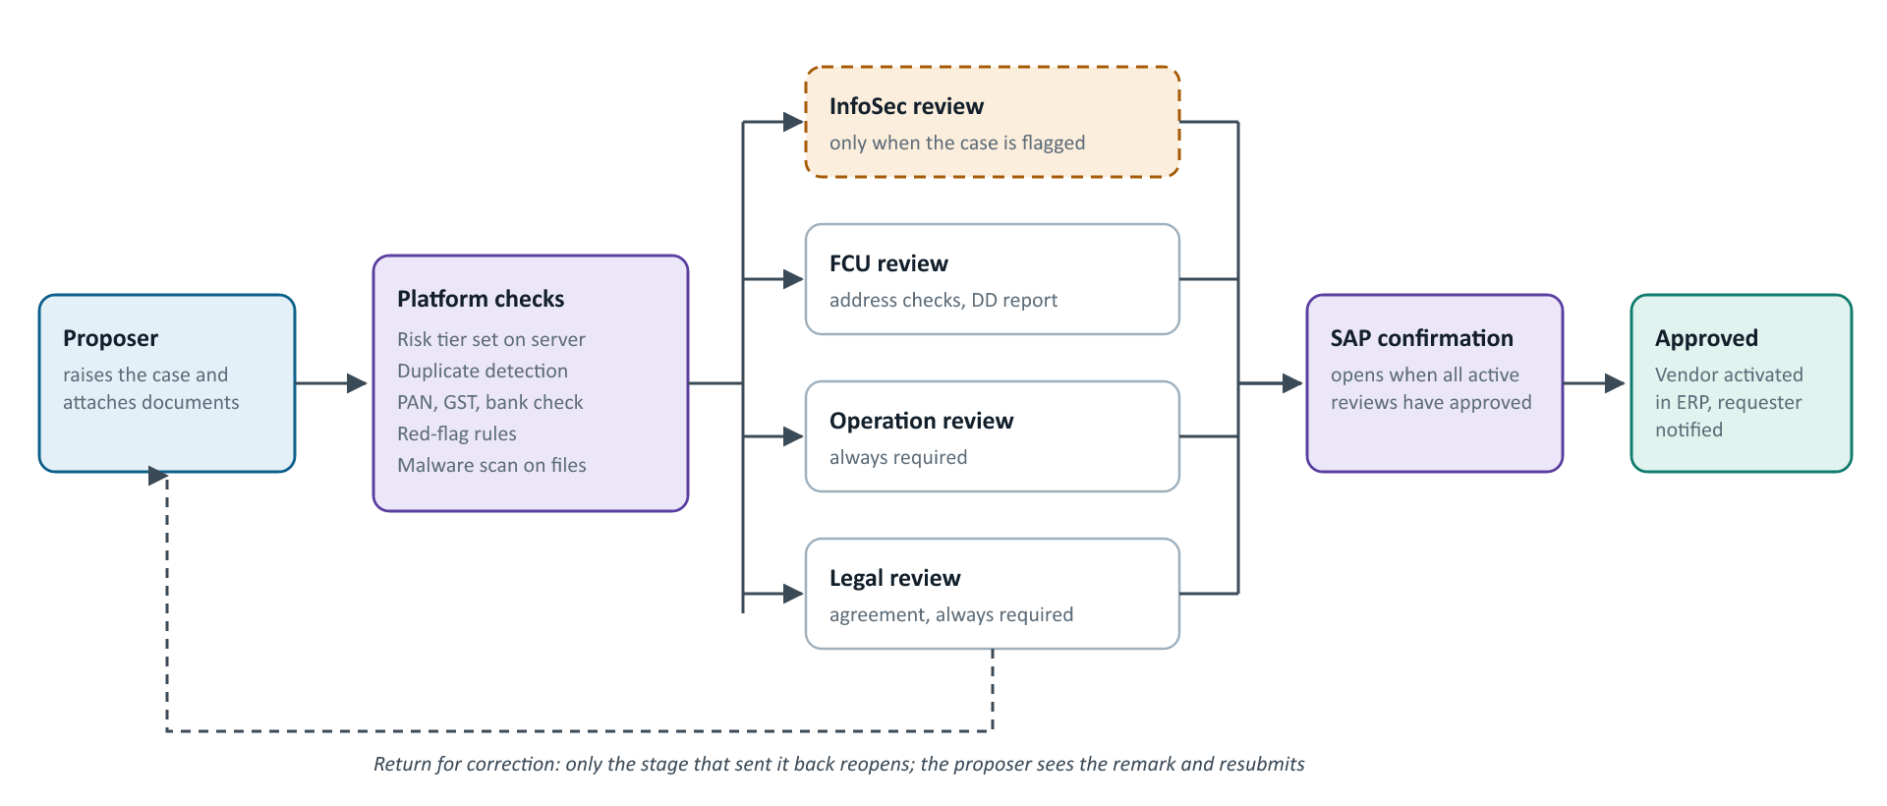
Figure 3. Case lifecycle. Solid arrows are the forward path; the dashed arrow is the return loop. Rejection by any reviewer ends the case.

What happens to the data at each step
- Intake. The proposer's form is sent over HTTPS to the API. Input is validated on the server. PAN, bank account number and signatory PAN are encrypted before they reach the database, and a keyed hash is stored alongside so duplicates can be found without decrypting.
- Documents. Each upload is checked by file signature, scanned for malware, fingerprinted with SHA-256 and written to object storage under a random key. An infected file is rejected and never stored. The original filename is kept only in the database.
- Verification. The API calls the registry service for PAN, GST and bank checks, compares names, and evaluates red-flag rules. If the registry is unavailable the case continues and the check is marked pending. The response is stored encrypted.
- Routing. The workflow engine picks the stages from the risk tier and the information-security answers, notifies each reviewing team, and starts the SLA timers.
- Review. Reviewers approve, reject or return their own stage with a remark. Every action writes an audit entry linked to the one before it.
- Activation. When every active review has approved, SAP confirmation completes the case. The platform sends the vendor to the ERP once (safe to retry) and notifies the proposer.

5 Data storage
Structured data and files are stored separately, each in a component the client can choose and operate to its own standards.

Structured data: PostgreSQL
PostgreSQL 15 or later is the system of record. It can run as a managed service (Amazon RDS or Aurora PostgreSQL, Azure Database for PostgreSQL, Google Cloud SQL) or self-hosted. Schema changes are versioned and applied by a migration job before each release.
DATA | EXAMPLES | PROTECTION
Identity and access | Users, roles, permissions, sessions, delegations | Session tokens stored as hashes; sessions revoked on logout, role change or deactivation
Vendor cases | Case header, general details, one table per review stage, checklists, comments, activity | PAN, bank account and signatory PAN encrypted per field; keyed hashes for duplicate search
Verification results | Registry responses and cross-checks | Payloads encrypted at rest
Configuration | Workflow versions, categories, SLA settings, identity provider settings | Published workflow versions are immutable
Audit log | Who did what, when, from where, outcome | Append-only, each row hashed with the previous row; the application database role cannot update or delete it

Documents: object storage, chosen by the client
Documents such as PAN cards, GST certificates, cancelled cheques and FCU reports go to an object store behind a single storage interface. If the client already runs Amazon S3, VOMT uses that bucket directly and no other storage service is needed.
Amazon S3 (Preferred when the client has AWS)
The client's own bucket and account. Use a private bucket, server-side encryption (SSE-KMS), versioning and an IAM role limited to this bucket.
On-premises object store (MinIO)
For data-centre deployments with no public cloud. S3-compatible, runs inside the client network.
Cloudflare R2
S3-compatible, no egress fees. Suited to cloud deployments outside AWS.
Azure Blob / Google Cloud Storage
Planned adapters, built when the client's cloud is confirmed.
The choice is a configuration setting, not a code change. For Amazon S3 it looks like this:
VOMT_STORAGE_DRIVER=s3
VOMT_STORAGE_ENDPOINT=https://s3.ap-south-1.amazonaws.com
VOMT_STORAGE_BUCKET=<client bucket name>
VOMT_STORAGE_REGION=ap-south-1
# Credentials come from the secrets store, not from the code or image

- Files are saved under random keys, never user-supplied names, and are served only through the API after a permission check. Each download is audited.
- Recommended bucket settings: block all public access, encryption at rest, versioning, and a lifecycle rule that matches the client's retention period (8 years by default).
- The bucket region is set to an Indian region to meet data-residency requirements.

Supporting stores
Redis carries the background job queue and short-lived cache; it holds no data that cannot be rebuilt. The secrets and key store (HashiCorp Vault on-premises, or the cloud's key management service) holds the master encryption key and service credentials.

6 Integration points with external systems
SYSTEM | PURPOSE | DIRECTION | METHOD | FAILURE BEHAVIOUR
Identity provider | Sign-in, group and manager information | Both | OIDC or SAML 2.0 | Existing sessions continue; new sign-ins wait for the provider
Verification service | PAN, GST, MSME and bank account checks | Outbound | HTTPS REST with retry and back-off | Case continues; check marked pending
ERP (SAP) | Create or activate the vendor master after final approval | Outbound | Idempotent call; payload to be agreed | Retried safely; no duplicate vendor
Email | Notifications to proposers and reviewers | Outbound | SMTP or cloud email API | In-app notification still delivered
Malware scanner | Scan every uploaded file | Internal | ClamAV service | Upload refused rather than stored unscanned
Log and SIEM platform | Central monitoring and audit export | Outbound | JSON logs, OpenTelemetry, CSV export | Logs buffered by the log agent

The ERP payload and the registry service contract are confirmed with the client during build. Until then the registry connection runs against a test double and the ERP call is a stub, so no unconfirmed interface is assumed.

7 Security and authentication
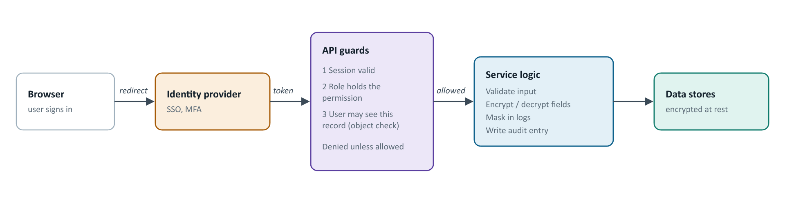
Figure 4. Every request passes three checks before data is touched. The session is an httpOnly cookie, so scripts in the browser cannot read it.
CONTROL | HOW IT IS MET
Authentication | Enterprise SSO through OIDC or SAML 2.0. New users are created on first sign-in and wait for manager approval. A local break-glass login is off by default and requires MFA when enabled.
Authorisation | Role-based, with every endpoint denied unless a role grants it. Roles: Proposer, InfoSec, FCU, Operation, Legal, SAP, Finance, Compliance, Auditor, Admin. Users see only the cases they are entitled to, and changing an ID in a URL does not reveal another record.
Segregation of duties | Nobody approves their own access request or review. Review stages are owned by separate teams.
Sensitive data | PAN, bank account and signatory PAN are encrypted with AES-256-GCM using envelope encryption. Full values show only to roles holding the sensitive-view permission, and each reveal is audited.
Transport | TLS for all traffic into the platform and to external services. Network policy inside the cluster allows only the connections the application needs.
Sessions | Idle timeout, absolute timeout, revocation on logout, role change or deactivation. Lockout and rate limits against brute force.
Files | Type checked by content, malware scanned, stored under random keys, served only after a permission check.
Secrets | No credentials in code or images. They come from the secrets store at start-up.
Containers | Run as non-root with a read-only filesystem, dropped capabilities and a default seccomp profile.
Supply chain | Pipeline runs lint, type checks, tests, static analysis, dependency and image scans, and secret scanning on every change.

8 Infrastructure and deployment
VOMT ships as container images with a Helm chart for Kubernetes. The same chart runs in a data centre or on any managed Kubernetes service, with infrastructure code (Terraform) to create the surrounding resources.
COMPONENT | RUNS AS | SCALING
Web portal | Stateless container | Horizontal pod autoscaling on load
API | Stateless container | Horizontal pod autoscaling on load
Background worker | Container consuming the Redis queue | Scale by queue depth
Database migration | One-off job before each upgrade | n/a
PostgreSQL | Managed service or self-hosted primary with standby | Vertical, plus read replicas if reporting grows
Redis | Managed service or in-cluster with persistence | Vertical
Object storage | Amazon S3, MinIO, R2 or equivalent | Provider-managed
Malware scanner | ClamAV container | Replicas as upload volume requires

Environments are separate for development, staging and production, each with its own database, bucket and keys. Configuration is read from environment variables and validated at start-up, and the application refuses to start if it is misconfigured. The design target is a large enterprise workload of around 500 concurrent users.

9 Logging and monitoring
Application logs
Structured JSON with a correlation ID on every request, so one user action can be followed across services. Personal and secret values are redacted before they are written, and a test enforces this.
Audit trail
A separate, hash-chained table of business events: sign-ins, role changes, case actions, document downloads, sensitive-data reveals, exports. An auditor can run a tamper check from the console and export results as CSV; the export is itself audited.
Metrics and traces
OpenTelemetry traces and metrics sent to the client's monitoring stack, with dashboards and alerts on error rate, latency, queue depth and SLA breaches.
Health checks
Liveness and readiness endpoints. Readiness confirms the database, Redis, storage and secrets store are reachable, so traffic is held back from an instance that cannot serve it.
Logs are shipped to the client's SIEM. Retention follows the client's policy; the audit table is kept for the 8-year default retention period.

10 High availability and disaster recovery
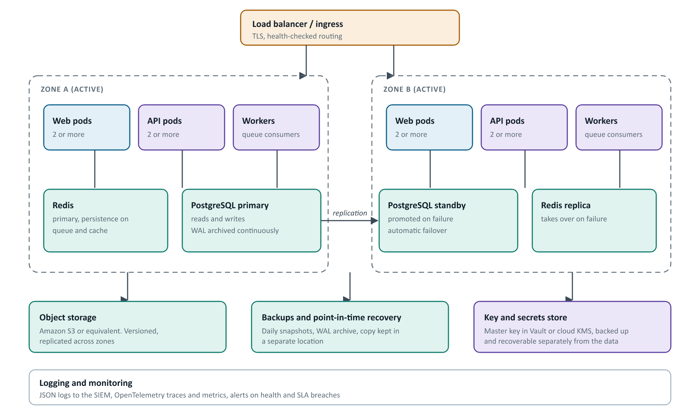
Figure 5. Reference deployment across two availability zones. A single-site on-premises deployment follows the same layout with two racks or hosts in place of zones.
ASPECT | DESIGN
Application availability | At least two replicas of web and API spread across zones, a pod disruption budget so upgrades never remove all replicas, and rolling releases with readiness checks.
Database availability | Primary with a synchronous or asynchronous standby in another zone and automatic failover. Managed PostgreSQL services provide this as a setting.
Recovery targets | Recovery point objective 15 minutes, recovery time objective 2 hours, using continuous WAL archiving and point-in-time recovery. Targets are confirmed with the client.
Key recovery | The master encryption key is backed up separately. Without it, encrypted fields cannot be read, so key recovery is part of every restore test.
Disaster recovery | Backups and object versions are copied to a second location within India. A runbook covers restore and cut-over, with a restore drill each quarter.
Degraded operation | If the registry, ERP or email service is down, cases continue and the dependent step is retried later. Only a database outage stops the platform.

11 Decisions we need from the client
DECISION | OPTIONS | EFFECT
Document storage | Amazon S3 (preferred if available), MinIO, Cloudflare R2 | Sets one configuration value and the access policy
PostgreSQL hosting | Managed service or self-hosted | Decides who operates failover and backups
Hosting platform | Client data centre or cloud Kubernetes | Decides the infrastructure code used
Identity provider | Entra ID or another OIDC/SAML provider | Sign-in setup and group-to-role mapping
Registry service | Provider and sandbox credentials | Enables live PAN, GST and bank checks
ERP interface | Target system and payload format | Enables vendor activation
Recovery targets and retention | Confirm 15 min / 2 h and 8 years | Sizes backups and standby

