**CLEANING SERVICES**

**---------------------------------**

**CLEANEX**

**ALL CEANING SERVICE**

**COMPANY**

**WEBSITE**

**DEVOLOPED BY :-**

**VISHAL KUMAR MAURYA**

**Cleaning services brochure pdf**

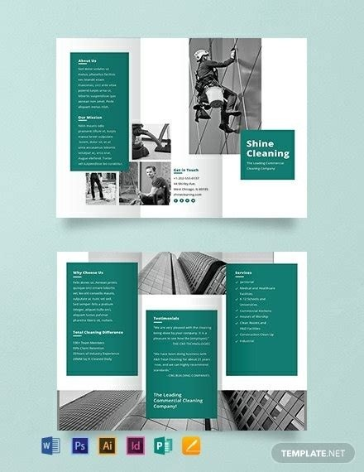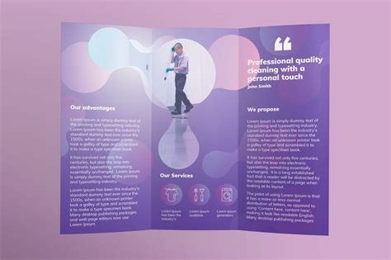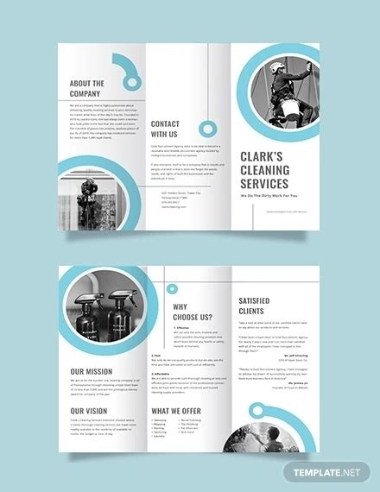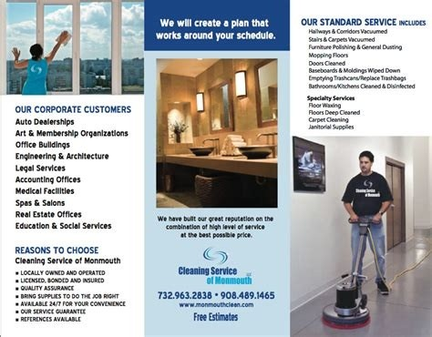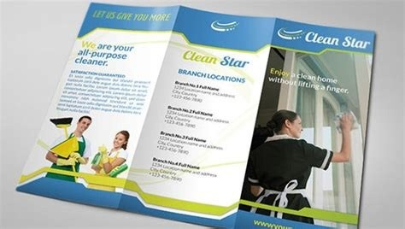

That's it for the best cleaning brochure examples from Envato Elements. Head on over to the site and download your favourite template today.If you are interested in seeing more brochure templates available at Envato Elements, check out these super helpful articles below: 35+ Best Hotel Brochure Templates (Wedding, Spa, Resort, and More) 25+ Best Professional Brochure Templates 20+ Best Brochure Design Tutorials (Adobe Creative Cloud and Affinity Publisher!) 35+ Best Digital Brochure Templates (For InDesign, Word, PDF, PSD) 25 Best Photoshop Brochure Design Templates (PSD Downloads 2023) 44 Best Creative InDesign Brochure Templates (New for 2023) 20+ Best Modern Corporate Brochure Templates With Clean Designs for 2023 What Is a Brochure? Does your business specialize in providing cleaning services? Do you have difficulty in promoting your business? If you do, then you have come to the right place. It is no wonder that you are experiencing difficulties in promoting your cleaning business, considering that there is a tough competition in the industry. But how about you try a cleaning company brochure? It is the perfect solution for your troubles in promoting your cleaning company. 11+ Cleaning Company Brochure Examples1. Cleaning Company Bi-Fold Brochure TemplateDetailsFile FormatMS WordPSDAIInDesignGoogle DocsPagesDownload2.

Cleaning Company Tri-Fold Brochure TemplateDetailsFile FormatMS WordPSDAIInDesignGoogle DocsPagesDownload3. Commercial Cleaning Company Tri-Fold BrochureDetailsFile FormatMS WordPSDAIInDesignGoogle DocsPagesDownload4. Commercial Cleaning Company Bi-Fold BrochureDetailsFile FormatMS WordPSDAIInDesignGoogle DocsPagesDownload5. Modern Cleaning Company Tri-Fold BrochureDetailsFile FormatMS WordPSDAIInDesignGoogle DocsPagesDownload6. Modern Cleaning Company Bi-Fold BrochureDetailsFile FormatMS WordPSDAIInDesignGoogle DocsPagesDownload7. Cleaning Services Company Tri-Fold BrochureDetailsFile FormatMS WordPSDAIInDesignGoogle DocsPagesDownload8. Cleaning Service Company Tri-Fold BrochureDetailsFile FormatMS WordPSDAIInDesignGoogle DocsPagesDownload9.

Cleaning Service Company BrochureDownload10. Cleaning Company Profile BrochureDownload 11. Cleaning Service Company Brochure A5Download12. Clean Landscape Company BrochureDownloadWhat Is a Cleaning Company Brochure?Cleaning companies are establishments that offer residential and commercial cleaning services. Many people require their services. Some individuals don’t have the time to clean their household because they are too busy doing other important things. A cleaning company must acquire a good number of customers so that they can profit. There are also challenges that the staff of a cleaning business experience as they do their job. A statista survey revealed that sand and debris are a challenge to clean according to 53.7% of cleaning facilities.There are a lot of cleaning companies in the industry; that’s why some of them have difficulties in acquiring customers. Even though a particular company utilizes digital marketing, it is still going to be difficult since other cleaning companies also use it.

But, there is one thing that is rarely used in promoting a cleaning business, and that is a brochure.A cleaning company brochure design can be the right solution for a business who face difficulties in promoting their cleaning services. It contains the list of cleaning services that the company offers, and it can be appropriately designed to catch the attention of potential customers. Brochures are pretty scarce these days since most businesses use online platforms for advertising their companies easier.

Hence, it is the perfect time to use brochures in promoting your cleaning business.Significance of a Brochure TodayBrochures are one of the first promotional tools that have been used by our industry back in the old days. It is one of the effective ways of letting the public know about your cleaning business. Brochures have been rarely used ever since technology modernized our economy, but even though technology has made things easier for us, we should never stop using brochures. In fact, it is a perfect time to use them since a lot of businesses are so focused on using online advertising platforms. Today, a brochure is significant to bring back the old but effective way of advertising.How To Create a Cleaning Company BrochureCrafting a cleaning company brochure is not an easy task. You need to incorporate the right materials and designs into it so that you can catch the attention of your potential customers. There are sample templates for a cleaning company brochure online. But if you want to create your very own brochure, you will find the steps and guidelines in this section that will help you craft a captivating brochure.1. Quality MattersThe materials that you’re going to use for your brochure needs to have a good quality so that your brochure can’t be easily damaged. From the paper to the ink, you must ensure that it is of excellent quality. Keep in mind that brochures are often stored in places where sunlight can easily reach it, so it is essential to use materials that have good quality. If you are not sure about which products to use, you can ask an individual who is an expert in printing promotional tools.2. Colors and Graphics Are Your BuddiesIn crafting your cleaning company brochure, colors and graphics are the elements that are going to make your brochure stand out. You must make use of the right colors, images, patterns, and fonts so that your brochure will have a great design. But, you also need to set limits in incorporating these elements because you need to aim for a professional look.

If you include too much of it, your brochure may look unprofessional and overwhelming to gaze upon.3. Provide a List of Your Cleaning ServicesYour cleaning company brochure should have the list of the cleaning services that your company offers, such as janitorial services, office cleaning, and house cleaning. You should also include a short description of how the staff will implement the cleaning services. You may, or you may not include the prices of the cleaning services offered by your company, but keep in mind that it is good to let your potential customers know about the cost of your services so that they can set up a budget.4. Don’t Forget About Your Contact DetailsYou should never forget to include your contact information in your cleaning company brochure. It is how your customers can contact you if they require your services. But, you can always attach a business card into your brochure to ensure that the customer can contact you anytime. Aside from phone numbers, you can also include the website and email address of your company so that the customer will have different ways on how to contact your cleaning company.FAQsYou can make use of pamphlets, flyers, posters, and roll up banners in promoting your company. Just like the brochure, these materials are also useful in advertising the cleaning services of your company. They are almost the same as the brochure, but they vary in sizes and styles.You can give out your cleaning company brochure where there is heavy foot traffic, such as malls, parks, and sidewalks. But make sure to be polite in handing out your brochures so that your potential customers will engage in receiving your company brochure.Yes, you can include your company slogan in your cleaning company brochure. In fact, it is one of the ways of catching the attention of your customers since slogans are catchy phrases that intend to grab customer attention.As you can see, a cleaning company brochure is a great tool in promoting your cleaning business in the industry. Now is the absolute time to use them since other businesses are so focused on using online platforms. Brochures may be old, but it will never be outdated as a promotional tool. Now that you know how to craft a cleaning company brochure, you can now start making your very own brochure for your cleaning business. Do you have a residential or commercial cleaning service business? With Template.net's free Cleaning Services Brochure Template, you can create a brochure that could attract potential customers. Choose an A4 tri-fold or bi-fold layout with original content included and download the template compatible with applications like Adobe Photoshop. Edit the outline and design by adding your company name and logo. Consider including colorful vectors and photos too. Print and distribute or upload and share online. Our brochures are ideally used by housekeeping, gardening, carpet cleaning, janitorial, sofa restoring, office space cleaning, and street cleaning services. Customize Cleaning Company Brochure Online for Free and Download Brochures are a great way to conveniently advertise and pack information for potential clients. These can be distributed physically or posted on digital platforms. Template.net offers free professional, blank full customizable Cleaning Services Brochure Templates that are used for shop-keeping, office cleaning, commercial cleaning, and home-keeping services.

These designs can also be used to introduce cleaning products and new methods of cleaning. Download a modern template to get started; our templates are compatible with programs like Apple Pages and MS Publisher. Edit the content by adding your company's logo, name, and testimonial of previous customers. Afterwards, download in PDF or PNG format to upload on social media or print copies to distribute. Some examples of such services include: Dishwashing Dusting Mopping Sweeping Vacuuming Here’s a list containing a few examples of such occupations: Carwasher Housekeeper Janitor Dishwasher There are over 30 downloadable cleaning services brochures at Template.net. Below are a few examples: Cleaning Company Tri-Fold Brochure Commercial Cleaning Brochure Office Cleaning Brochure The following are compatible: Adobe Illustrator Adobe InDesign Adobe Photoshop Apple Pages Microsoft Publisher Microsoft Word