CYB631 Automating Information Security with Python and Shell Scripting
Lab 1: PowerShell Basics and Gathering Host Information
Your Name: VAIBHAV AVINASH MAYEKAR

Goals: This lab will guide you through basic PowerShell commands and use them to gather host information from Windows 10 OS.
Readings and References: The contents of this lab are adapted from Part I, Chapter 18.1, and Chapter 24 of the Windows PowerShell Cookbook by Lee Holmes.

Exercises:
[Exercise I: Starting with PowerShell and Simple PS Commands]
- Launch Windows PowerShell. Click Start->Run, and then type PowerShell.
- Alternatively, you can also use Windows PowerShell ISE. Click Start->Run, and then type PowerShell ISE and run as an administrator.
Note: you might need to open PowerShell and run as an administrator first and then open PowerShell ISE by typing “powershell ise” in the command line.
- Windows 10 environment is needed for the lab. A PowerShell prompt window opens with a command prompt like the one below. All the commands in this lab should be typed and run after PowerShell command prompt.
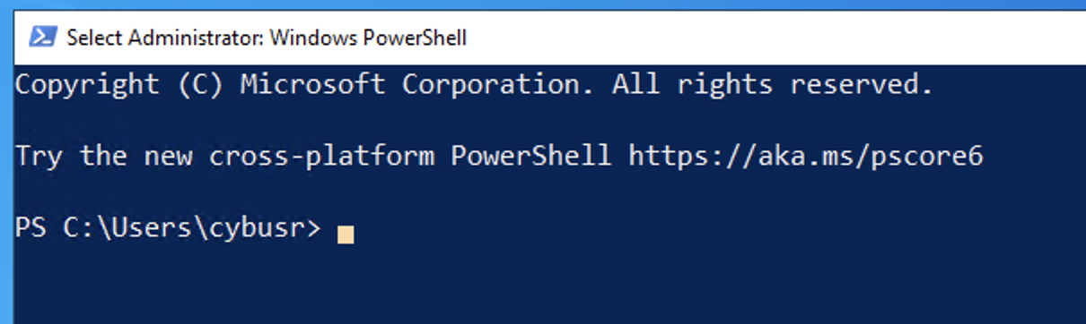
- Move to your working directory.
cd \\pace.edu\shares\users\your_user_id\Desktop
- Let us simplify the command prompt.
function Prompt { "PS > " }
- Exam login user.
whoami
- Review files under your current directory.
dir
- Examine your current directory. What is your current directory? C:\Users\mayek\OneDrive\Desktop\python shell scripting
pwd
- We can also use a PowerShell cmdlet to obtain the same information.
get-location
- We will try pushd and popd commands. The command pushd stores the current directory to a stack for use later by popd, and then changes to the specified directory. The command popd changes the current directory to the most recent directory stored by pushd.
pushd .
pwd
cd ..
popd
pwd
- Provide a screenshot of the results from the last step.
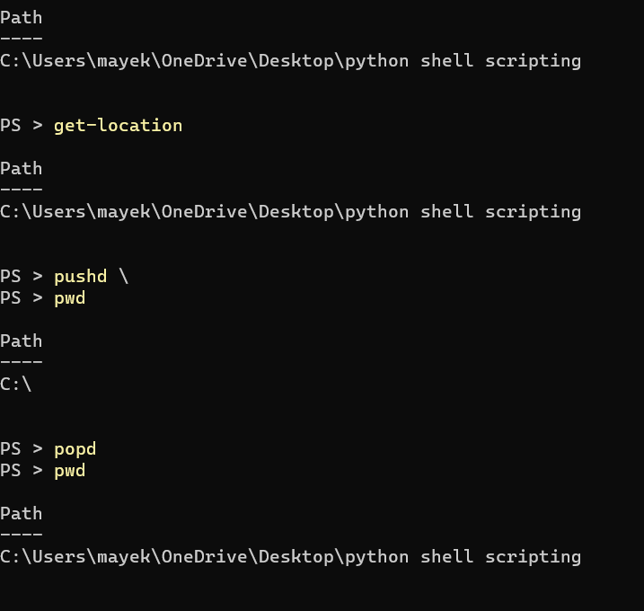
- Let us create a folder to store all of the files for this class. First of all, make sure that you are in your home directory (such as C:\Users\cybusr). Create the folder and go into the folder. All of the files you created will be stored here.
mkdir cyb631
dir
cd cyb631
- The folder should be empty now. Let us create a new file in the folder using PowerShell cmdlet new-item.
new-item -path . -name “test1.txt” -itemtype “file” -value “Hello World.”
- Now, you should be able to see the new file test1.txt under cyb631 folder. What is the content of this file? Hello World
dir
cat test1.txt
- We will store the file name in a variable and then later use it in the command.
$filename=”C:\Users\cybusr\cyb631\test1.txt”
- To see the value of the variable to make sure that it has the value you want.
get-variable filename
- Let change test1.txt to a different file attribute. The current attribute is a (archive). Let us change it to r (read-only).
dir
attrib +R $filename
dir
- You should see that the mode is listed differently. Paste a screenshot of your results after the change of attribute.
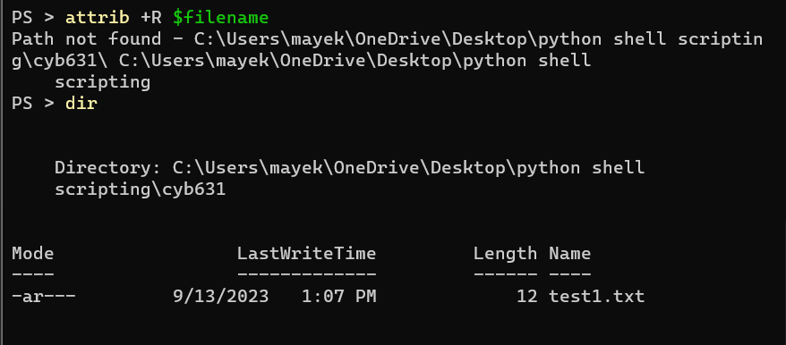
- Try changing the content of the file test1.txt. Are you able to do so? NO
- Now, change the attribute back to where it was. Are you able to change the content of the file now? YES
attrib -R $filename

[Exercise II: Simple Object Operation]
- Let us create a simple command below. The result is an object with a string.
“Hello” + “ World”
- We can assign the object to a variable and then find out what properties and members are associated with it.
$s1 = “Hello” + “ World”
get-variable s1
$s1| get-member

- From the results above, you can tell that this class has only one property- length. Let see the value of it. What is the result? 11
$s1.Length
- We can also try one of the methods associated with this class. ToLower method lowers every character to the lower case.
$s1.ToLower()

[Exercise III: Gather Process Information]
We will investigate processes running on the system and gather information about them.

- Now, let us find out what processes are running on the machine.
get-process
- It is a very long list. Let us find only the processes that starts with “w” and uses its alias gps.
gps -n w*
- Now, open a notepad and find the information about the process for notepad.
gps -n notepad*
- Let us store the information in a variable prs.
$prs= gps -n notepad*
- Stop the notepad process by killing it. You will find an “Access Denied” error message. This is because you did not have enough privilege.
$prs.kill()
- Now, open another PowerShell but run ad the Administrator. Repeat step 29 to 31. You should be able to kill the process. If successful, what happened to the notepad window that you opened earlier? CLOSED
- Connect several cmdlet together to analyze the results from get-process. This will show you a table with processes that have their handles >=500.
get-process |
where-object { $_.handles -ge 500 } |
sort-object handles |
format-table handles, name, description -auto

- Paste the screenshot of your results above.
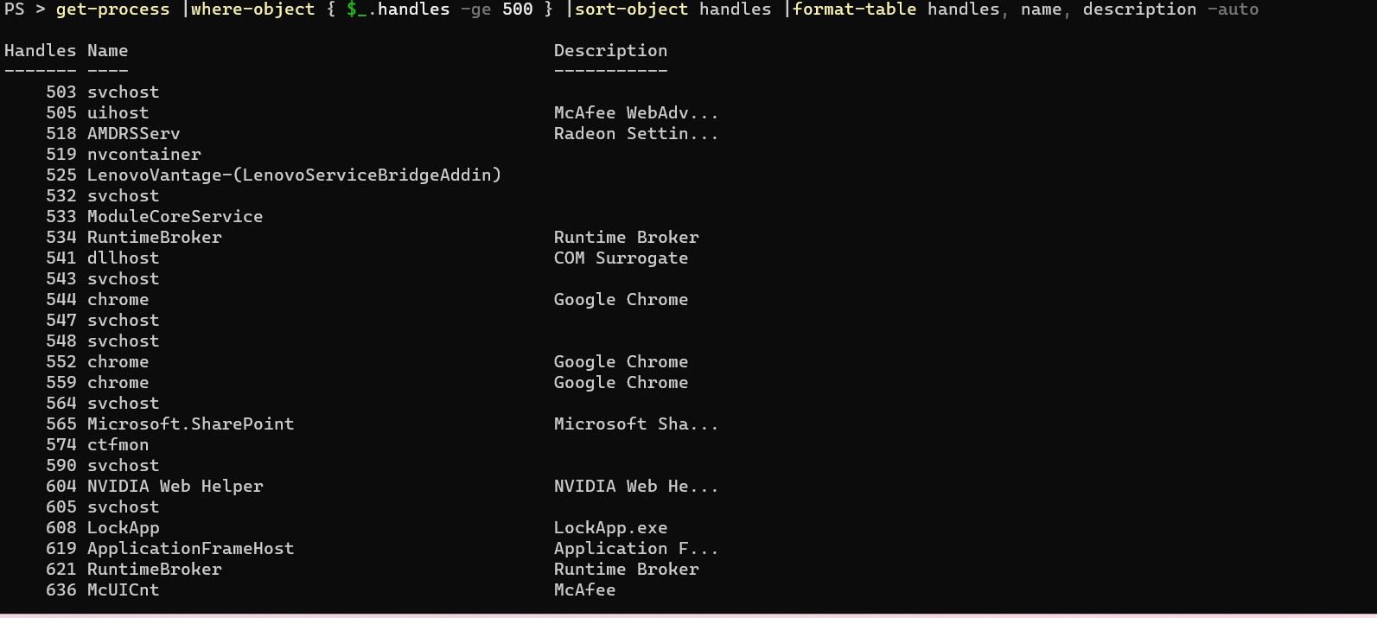

- Now modify the statement above to show processes that have identifiers (id) larger or equal to 10000. Paste the screenshot of your results.
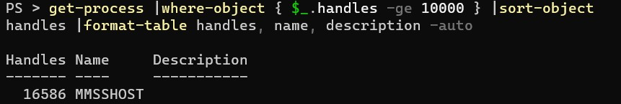

[Exercise IV: Useful PowerShell Commands]
There are commands to discover what you can use under PowerShell. Also, please refer to this list, https://devblogs.microsoft.com/scripting/table-of-basic-powershell-commands/ , for commands to use.
- To see all the command available under PowerShell
get-command
- To see all the options available for the cmdlet.
get-help get-process
- To see all the members associated with an object returned by a cmdlet, such as get-process class.
get-process | get-member

[Exercise V: First PowerShell Script]
We will create a simple PowerShell script.
- Our goal is to sum up the handles in the selected processes.
get-process -n n*
- Paste a screenshot of your results above.
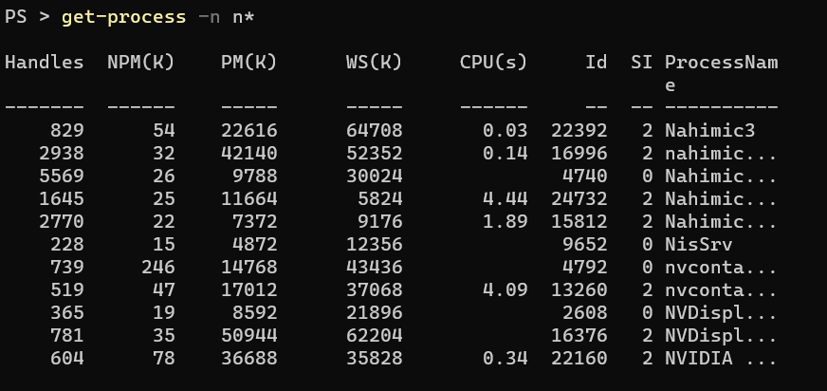
- We will first run commands separately and then put them together as a script.
$hcount=0
- Sum up the handles in the process being selected.
foreach($process in get-process -n n*) {$hcount+=$process.handles}
- Show the result.
$hcount
- What is your result from above? 17125
- Let us create our first PowerShell script using PowerShell ISE.
powershell ise
- You can use the editor provided by PowerShell ISE to create a new PowerShell script. Every PowerShell script has a .ps1 extension. Please enter the three commands for counting process handles (from step 42 to 44).
- Run the script1.ps1. Most likely, you will find that an error message “… script1.ps1 cannot be loaded because running scripts is disabled on this system….”
.\script1.ps1
- You cannot run the script because the security policy of the system is blocking scripting. To enable it, we would like to make sure that the policy is not wide open for other malicious scripts from the Internet. To see the current policy,
Get-ExecutionPolicy
What is the current Execution Policy? _Restricted_______

- Now, open a new PowerShell ISE and run as an administrator. Make sure that you navigate to the directory where your script is. Change the executive policy to RemoteSigned.
cd C:\Users\cybusr\cyb631
Set-ExecutionPolicy remotesigned

- Now, you can run the script. Paste a screenshot showing that you run the script and the results.
.\script1.ps1

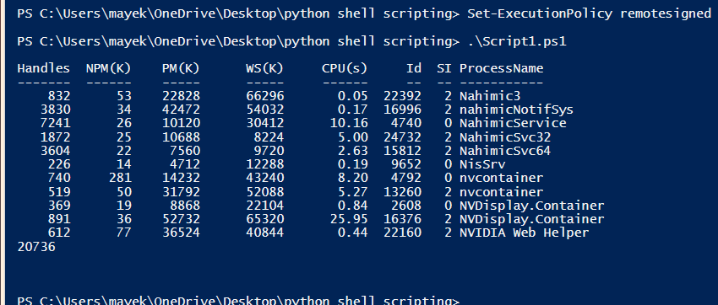

[Exercise VI: Develop Your Own PowerShell Script – CPU Time]
- It is important for a system administrator/security analyst to know what processes consume the most CPU resources. Write a PowerShell script, cputime.ps1, to achieve the following goal.
  - Sort processes by CPU time used.
  - Output the process ID and process names of top five processes that consume the most CPU time.

- Submit cputime.ps1 in additional to the lab1 report.

- Paste a screenshot of running the program and shows its results.

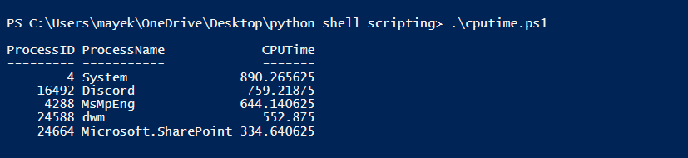

[Exercise VII: Lab and Class Reflection]
Please reflect on what you have completed and learned (Required).
- What do you like about this lab? Interesting
- What are the challenges that you have encountered in this lab? No
- Do you have additional suggestions for this class to help you learn better? NO
- If you are using Windows virtual machine on the server, please turn off your virtual machines once you are done.

[Sign White Hat Oath & Fill-up Student Information]

Please read the White Hat Oath and Code of Ethics. Sign the White Hat Agreement and fill up student information sheet on the last two pages of this lab.

The White Hat Oath & Code of Ethics
Pace University

(Special thanks to Michael Whitman and Avi Rubin for providing the source of this agreement)

This is a working document that provides further guidelines for Information Assurance courses taught at Pace University. If you have questions about any of these guidelines, please contact the course instructors. When in doubt, the default action should be to ask the instructors.

1) The course project may require technical means of discovering information about others with whom you share a computer system. As such, non-technical means of discovering information are disallowed (e.g., posing as system administrator over the phone to ask for user passwords).

2) ANY data that is stored outside of the course accounts can be used only if it has been explicitly and intentionally published, (e.g. on a web page), or if it is in a publicly available directory, (e.g. /etc, /usr ).

3) Gleaning information about individuals from anyone outside of the course is disallowed.

4) Impersonation, e.g. forgery of electronic mail, is disallowed.

5) If you discover a way to gain access to any account other than your own (including root), do NOT access that account, but immediately inform the course instructors of the vulnerability. If you have inadvertently already gained access to the account, IMMEDIATELY exit the account and inform the course instructors.

6) All explorations should be targeted specifically to the assigned course accounts. ANY tool that indiscriminately explores non-course accounts for vulnerabilities is specifically disallowed.

7) Using the web to find exploration tools and methods is allowed. In your reports, provide full attribution to the source of the tool or method.

8) If in doubt at all about whether a given activity falls within the letter or spirit of the course exercise, discuss the activity with the instructors BEFORE exploring the approach further.

9) You can participate in the course exercise only if you are registered for a grade in the class. ANY violation of the course guidelines may result in disciplinary or legal action.

10) Any academic misconduct or action during the course of the class can result in failure of and dismissal from the course.

Code of Ethics

Code of Ethics Preamble: (Source www.isc2.org Code of ethics)
Safety of the commonwealth, duty to our principals, and to each other requires that we adhere, and be seen to adhere, to the highest ethical standards of behavior.
Therefore, strict adherence to this code is a condition of laboratory admission.

Code of Ethics Canons:
Protect society, the commonwealth, and the infrastructure.
Act honorably, honestly, justly, responsibly, and legally.
Provide diligent and competent service to principals.
Advance and protect the profession.

The following additional guidance is given in furtherance of these goals.

Objectives for Guidance

Protect society, the commonwealth, and the infrastructure
Promote and preserve public trust and confidence in information and systems.
Promote the understanding and acceptance of prudent information security measures.
Preserve and strengthen the integrity of the public infrastructure.
Discourage unsafe practice.

Act honorably, honestly, justly, responsibly, and legally
Tell the truth; make all stakeholders aware of your actions on a timely basis.
Observe all contracts and agreements, express or implied.
Treat all constituents fairly. In resolving conflicts, consider public safety and duties to principals, individuals, and the profession in that order.
Give prudent advice; avoid raising unnecessary alarm or giving unwarranted comfort. Take care to be truthful, objective, cautious, and within your competence.
When resolving differing laws in different jurisdictions, give preference to the laws of the jurisdiction in which you render your service.

Provide diligent and competent service to principals
Preserve the value of their systems, applications, and information.
Respect their trust and the privileges that they grant you.
Avoid conflicts of interest or the appearance thereof.
Render only those services for which you are fully competent and qualified.

Advance and protect the profession
Sponsor for professional advancement those best qualified. All other things equal, prefer those who are certified and who adhere to these canons. Avoid professional association with those whose practices or reputation might diminish the profession.
Take care not to injure the reputation of other professionals through malice or indifference.
Maintain your competence; keep your skills and knowledge current. Give generously of your time and knowledge in training others.

White Hat Agreement

As part of this course, you may be exposed to systems, tools and techniques related to Information Security. With proper use, these components allow a security or network administrator better understand the vulnerabilities and security precautions in effect. Misused, intentionally or accidentally, these components can result in breaches of security, damage to data or other undesirable results.

Since these lab experiments will be carried out in part in a public network that is used by people for real work, you must agree to the following before you can participate. If you are unwilling to sign this form, then you cannot participate in the lab exercises.

Student Agreement Form
I agree to:
- only examine the special course accounts for privacy vulnerabilities (if applicable).
- report any security vulnerabilities discovered to the course instructors immediately, and not disclose them to anyone else.
- maintain the confidentiality of any private information I learn through the course exercise.
- actively use my course account with the understanding that its contents and actions may be discovered by others.
- hold harmless the course instructors and Pace University for any consequences of this course.
- abide by the computing policies of Pace University and by all laws governing use of computer resources on campus.

I agree to NOT:
- attempt to gain root access or any other increase in privilege on any Pace University computers.
- disclose any private information that I discover as a direct or indirect result of this course exercise.
- take actions that will modify or deny access to any data or service not owned by me.
- attempt to perform any actions or use utilities presented in the laboratory outside the confines and structure of the labs.
- utilize any security vulnerabilities beyond the target accounts in the course or beyond the duration of the course exercise.
- pursue any legal action against the course instructors or Pace University for consequences related to this course.

Moreover, I consent for my course accounts and systems to be examined for security and privacy vulnerabilities by other students in the course, with the understanding that this may result in information about me being disclosed (if applicable).

This agreement has been explained to me to my satisfaction. I agree to abide by the conditions of the Code of Ethics and of the White Hat Agreement.

Signed, VAIBHAV (VAI)_ Date: 09/14/2023

Printed name: VAIBHAV A MAYEKAR E-mail address: vm81403n@pace.edu
CYB631: Automating Information Security with Python and Shell Scripting
Summer 2023
Pace University

Student Information Sheet

Name: VAIBHAV MAYEKAR Email : vm81403n@pace.edu
Job Title & Employer (optional, if employed full-time)
________________________________________________
Major: (* ) MS/CYB ( ) MS/CS ( ) MS/IS ( ) Others _______
Year (3), Graduation Date: MAY 2024

1. Please circle any computer acknowledge you know & your skill level:

(a) Operating Systems:
Windows Level: none, novice, intermediate, advanced
Linux Level: none, novice, intermediate, advanced
Mac Level: none, novice, intermediate, advanced
Other (_______) Level: none, novice, intermediate, advanced

(b) Networking:
ActiveDirectory Level: none, novice, intermediate, advanced
LinuxNetworking Level: none, novice, intermediate, advanced
TCP/IP Level: none, novice, intermediate, advanced
Other (_______) Level: none, novice, intermediate, advanced

(C) Programming:
Powershell Level: none, novice, intermediate, advanced
Linux shell scripting, Level: none, novice, intermediate, advanced
Python Level: none, novice, intermediate, advanced
Java Level: none, novice, intermediate, advanced
C Level: none, novice, intermediate, advanced
Other (_______) Level: none, novice, intermediate, advanced

2. Please list any work experience you have in the areas of Networking and/or Security.

NOT SO.

3. What is your grade expectation? What do you want to learn and achieve from this class? While I value receiving a A grade, my primary focus is on what I can achieve in this class

