CYB631 Automating Information Security with Python and Shell Scripting
Lab 5: Analyzing logs and network packets using Python
Your Name: Vaibhav Mayekar

Goals: This lab will guide you through basic PowerShell commands and use them to gather host information from Windows 10 OS.
Readings and References:
- The contents of this lab are adapted from
  - Chapter 5 of Jose Manuel Ortega’s Mastering Python for Networking and Security.
  - Pandas (https://pandas.pydata.org/)
  - Matplotlib (https://matplotlib.org/)
  - Scapy (https://scapy.net/)
- Please use the required Python textbook by Al Sweigart as a reference for general Python syntax.

Exercises:
[Environment: Starting with PowerShell ISE]
- Windows 10 environment is needed for the lab. Launch Windows PowerShell ISE. Click Start->Run, and then type PowerShell ISE.
- Now, open a new PowerShell ISE and run as an administrator. Make sure that you navigate to the directory where your script is. Change the executive policy to RemoteSigned.
cd C:\Users\cybusr\cyb631
Set-ExecutionPolicy remotesigned

[Exercise I: Export log files]
- Let us generate application log for the analysis. First, let us investigate the different types of event logs.
Get-WinEvent -ListLog * -ComputerName localhost | Where-Object { $_.RecordCount } > winevent.txt

Get-Content winevent.txt
- Review the contents inside one of the logs from the list. Pick one that has less than 50 entries. For example, you can review the Firewall log and see if you can make sense of the contents in the log.
Get-WinEvent -LogName “Microsoft-Windows-AppXDeployment-Server-UndockedDeh”
- Briefly describe what Firewall activities that you can observe from the contents in the event log above. ______________
Paste a snapshot of the results above.
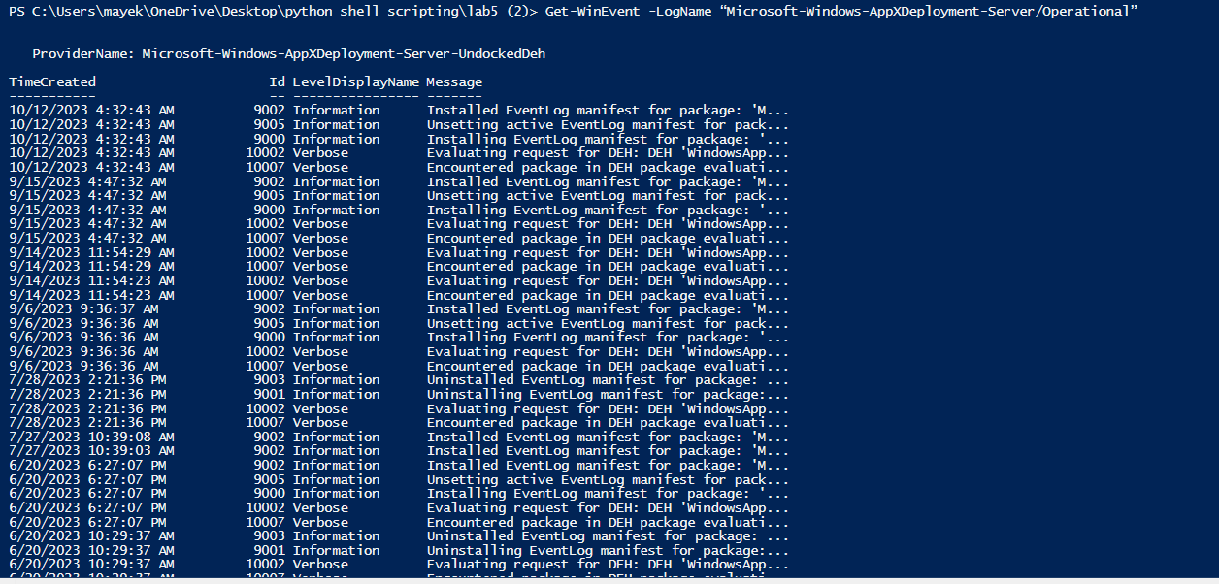-
- Get-Eventlog is similar to Get-WinEvent except that the previous one show Windows PowerShell events and the later one records all events.
- Investigate the results from above. You should see the different Windows event logs as well as the number of entries and the size of each log. We will use logs from Get-EventLog as inputs for Python programs later. Get-EventLog and Get-WinEvent cmdlets can export log entries from the same log but in slightly different data fields. When you analyze them later in Python scripts, please be mindful of the difference and modify the program accordingly if you use logs generated from Get-WinEvent.
Get-EventLog -LogName Application | Export-Csv -Path .\appevent.csv
- Investigate the log. Try to understand the meaning of each column in the log.
cat appevent.csv -head 3

[Exercise III: Python3 IDLE and Import Modules]
We will be using Python to analyze the log file since there are many data analytics modules that are useful for the analysis.
- We will use Python 3 and Python’s Integrated Development and Learning Environment (IDLE) for this lab. This instruction and video use Python 3.7.9. The Windows VM on Horizon Desktop has Python 3.10.4. It is fine if you use a different version as long as it is Python 3.
- If you do not have Python on your own computer, download and install it using the link below. The recent release is Python 3.x. When installing, please make sure that Add Python 3.x to Path is Check.
https://www.python.org/downloads/windows/ 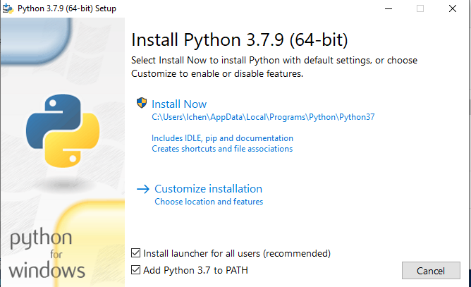
- Under PowerShell command prompt, use the command below to see the Python version.
python --version
- From Windows Start menu, look for Python and click IDLE (Python 3.x) to open it.
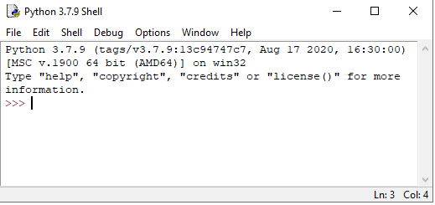
- This is an interactive command tool. It is good for testing simple codes to see if they work. For example, try
print(‘hello world’)
3+4
Paste a screenshot of the results from this step.
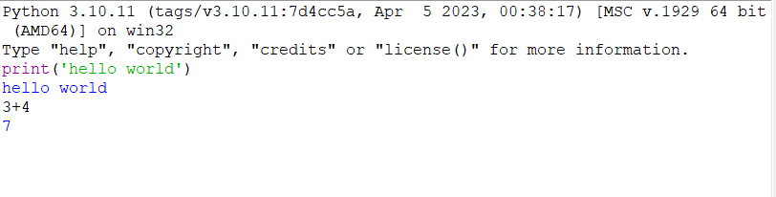
- Our goal is to create Python script program so that we can run it with other script programs such as PowerShell scripts. So, we will create a file. Click on File, New File. Type the simple Python codes as below and save it as test1.py (File, Save As). Please save it in your work folder, such as C:\Users\lchen\cyb631). Click on Run, Modules. This will show the results in another Python IDLE shell.
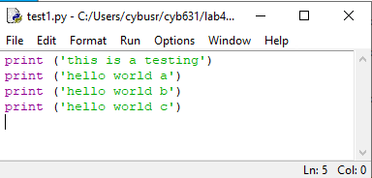
- In additional to the Python IDLE, you can also run the program under PowerShell command prompt. Important: Make sure that the directory you run the command has the Python file. If not, navigate to the directory you saved the file before you run the command.
python test1.py
- (Find your file - Only for Horizon Desktop Windows VM) Anything that you save on the desktop is under this path \\pace.edu\shares\users\lchen\Desktop (substitute lchen with your login user name). To navigate to this directory:
cd \\pace.edu\shares\users\lchen\Desktop
Windows command prompt would display a very long path. You can customize it. For example, using the PowerShell program below to display only the “Desktop” part.
function prompt {
$p = Split-Path -leaf -path (Get-Location)
"$p> "
}
- There are many existing Python modules that we can utilize. In this lab, we will be using Python modules. To use a module, you will have to install it first before you can import it in the program. We will use three Python modules in this exercise:
Pandas: a data analysis and manipulation tool (https://pandas.pydata.org/)
Matplotlib: a data visualization tool (https://matplotlib.org/)
Scapy: a packet manipulation tool (https://scapy.net/)
- To import Python module, type the following under PowerShell command prompt. These commands will download and install Python modules from the Internet. Make sure that you run PowerShell as an administrator, or you will not be able to install the Python modules.
python -m pip install pandas
python -m pip install matplotlib
In the command below, there are two dashes before the command option “pre”.
python -m pip install --pre scapy[complete]
- To test if Pandas is accessible, modify your testing program to the one below. Run the module. If it is successful, you should not have error messages and the information in the print function will be printed on the output window.
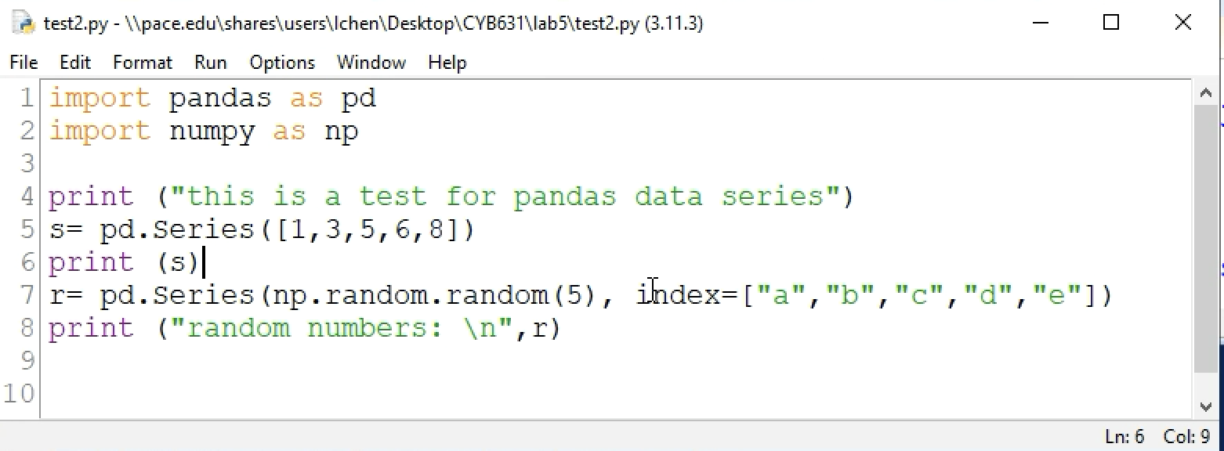
- Paste a screenshot of your results from the previous step to show that you are able to import pandas module.
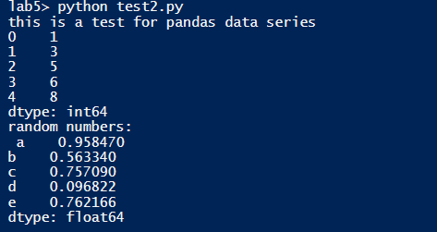

[Exercise IV: Basic log analysis using Pandas]
- Using Python IDLE, open applog.py. Review the codes and run the file to understand what it does. The program reads the application log (appevent.csv) generated in the previous exercise and group the logs by the Source of logs. We are using Pandas module for data processing here.
- Modify the program to show the logs by EntryType and by Category.
Show the revised program:
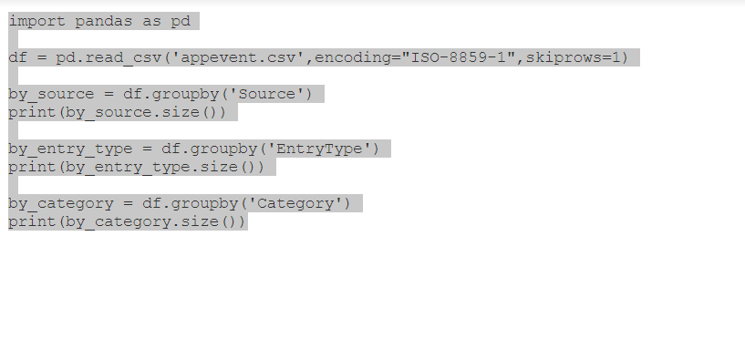
Run the revised program and paste the results.
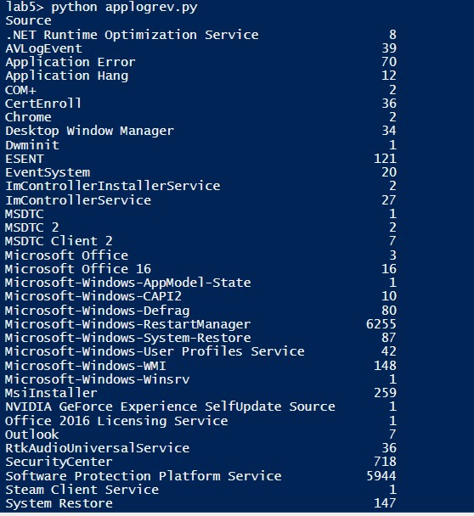
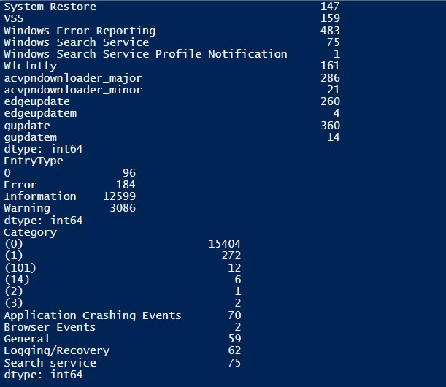
[Exercise V: Plotting Time Series using Dataframe.plot]
- Using Python IDLE, open logfreq.py. Review the codes and run the file to understand what it does. The program reads the application log (appevent.csv) generated in the previous exercise. It extracts TimeGenerated information from the log, converts it to DateTime format in Python, creates a frequency table grouped by Month, and plots the frequency table.
- Paste a screenshot of the plot.
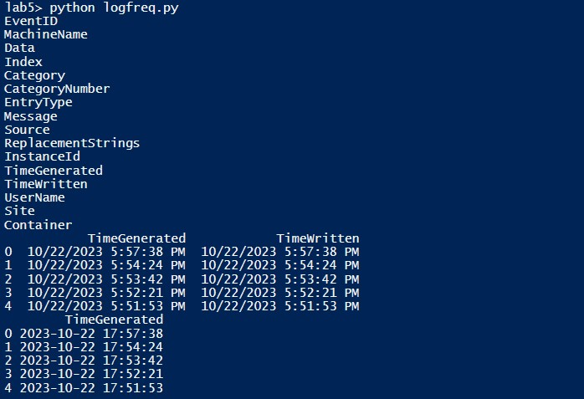
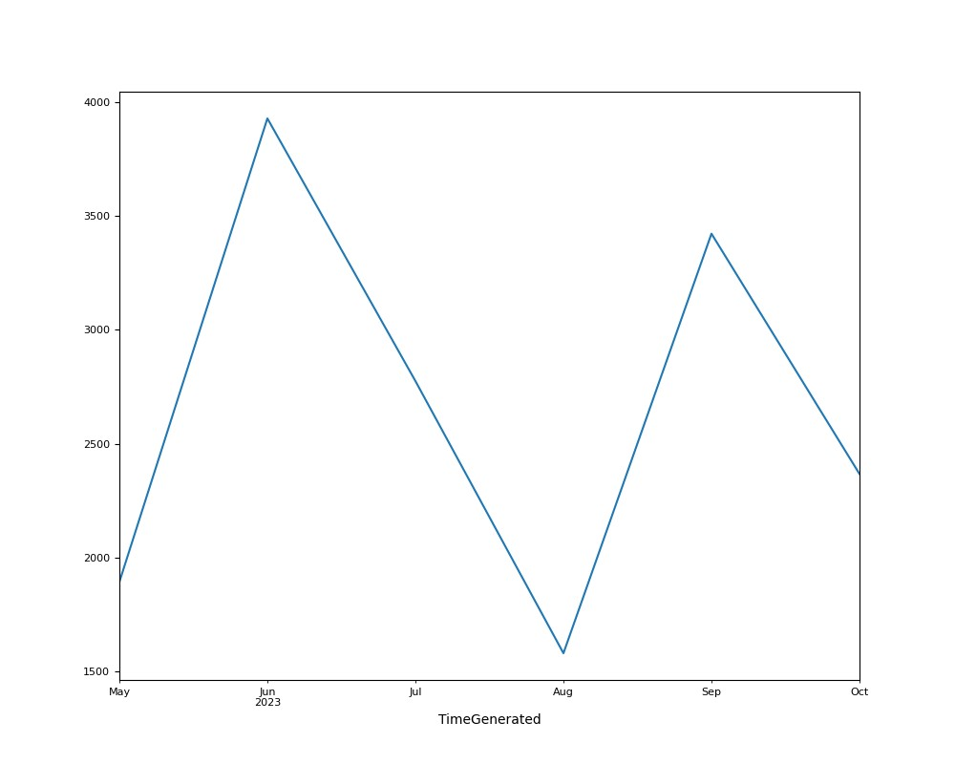
- Modify the program to show the number of log entries grouped by day instead of by month.
- Show the revised program:
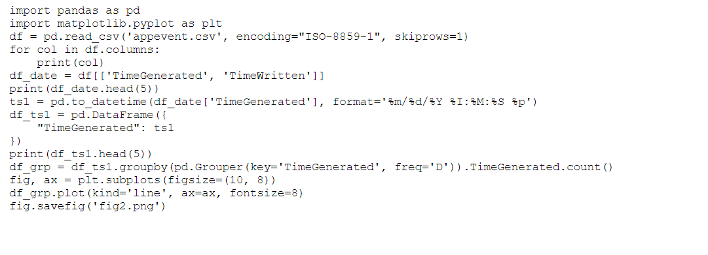
- Run the revised program and paste the plot by day.
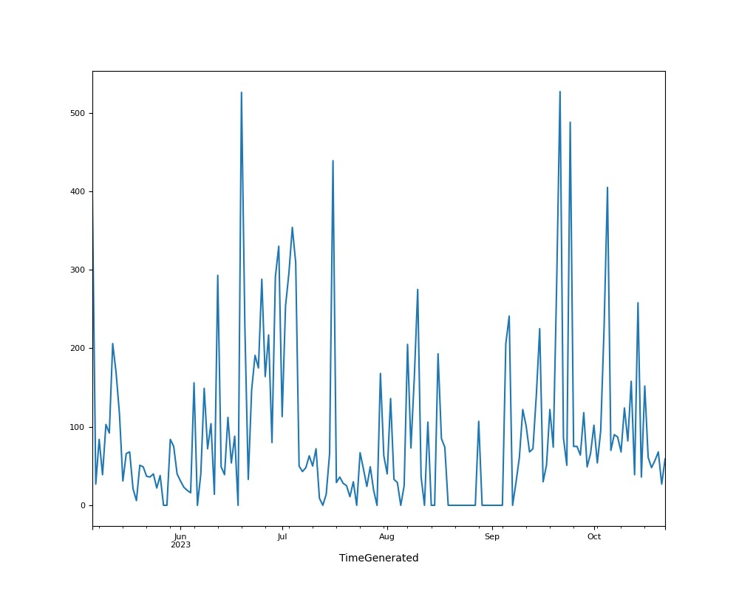

[Exercise VI: Sniffing Packets using Scapy]
- For packet manipulation, Scapy will need Npcap (https://nmap.org/npcap/#download ) and please install it. As an alternative, you can install Wireshark (https://www.wireshark.org/#download ) which installs Npcap by default. If you do not have Npcap, your program will have error messages like the one below.
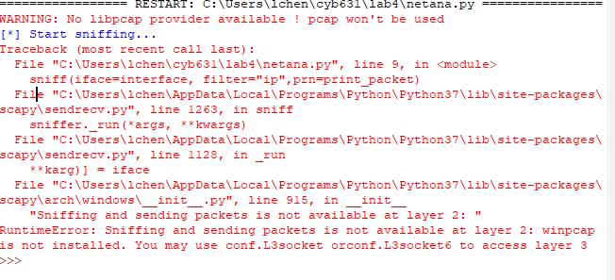

- Before we start packet manipulation, we will need to specify the network adapter where we are receiving or sending packets. Please use the following cmdlet in Powershell.
Get-NetAdapter
Paste a screenshot of your results from above:
- Using Python IDLE, open sniff.py. Review the codes. This program will sniff out 10 IP packets from your network adapter. Replace the network adapter with the one that you would like to sniff packet from.
- Run the program to understand what it does. For a mapping of protocol number and protocol name, see https://www.iana.org/assignments/protocol-numbers/protocol-numbers.xhtml.
What is the transport layer protocol used by the IP packets that you sniff out? Transmission Control Protocol(tcp)
Paste a screenshot of the results from the sniffing:
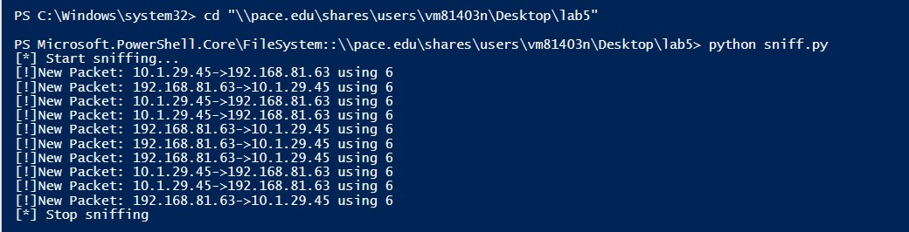
- Modify the program to sniff only TCP packets and show the TCP port numbers along with the IP addresses such as the format below:
[!]New Packet: 192.168.1.208:50593->172.217.12.174:443 using 6
- Show the revised program:
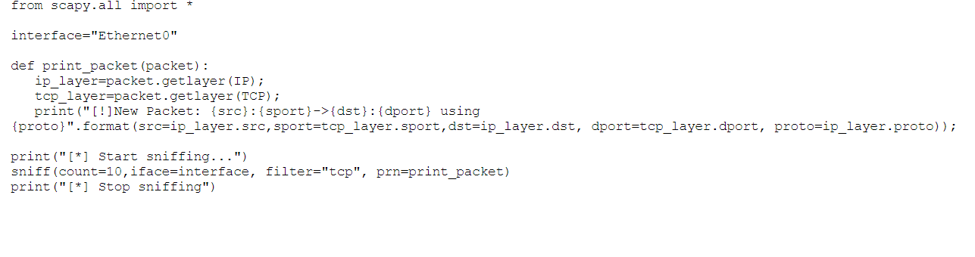
- Run the revised program and paste a screenshot of the results.
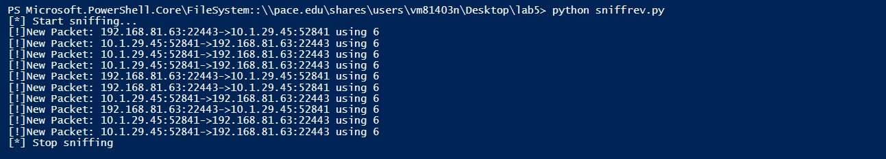

[Exercise VII: Generate Statistics of Network Traffic]
- Create a Python program to sniff and analyze packets. The programs will have to achieve the following goals:
  - Capture at least 5000 network packets while using a browser visiting websites, such as www.pace.edu so that the program can sniff out packets between the browser and the web sites.
- Group and tally source IP addresses in the packets sniffed out. Show the frequencies of unique source IP addresses accessed.
- Group and tally destination IP addresses in the packets sniffed out. Show the frequencies of unique destination IP addresses accessed.
- Timestamp every packet sniffed out, and plot the frequencies of packets over time grouped by either millisecond or second depending on how long it takes for you to capture the packets. If packets are captured within 1 or 2 seconds, showing the frequencies in millisecond or 10 millisecond may make more sense to see the changes over time.
- To achieve the goals, you can use either one program or multiple programs. Please describe the names of the programs that you develop and the purpose of each program.
from scapy.all import sniff, Packet
import time

def packet_handler(packet):
if 'www.pace.edu' in str(packet):
timestamp = time.time()
with open('captured_packets.txt', 'a') as file:
file.write(f'{timestamp} {packet}\n')

sniff(iface='Ethernet0', prn=packet_handler, count=5000)

print("Packet capture complete.")

for anaylze packet code:
1698354829.4382622 Ether / IP / UDP / DNS Qry "b'www.pace.edu.'"
1698354829.5914044 Ether / IP / UDP / DNS Qry "b'www.pace.edu.'"
1698355472.9487739 Ether / IP / UDP / DNS Qry "b'www.pace.edu.'"
1698362399.529816 Ether / IP / UDP / DNS Qry "b'www.pace.edu.'"
1698362399.6741374 Ether / IP / UDP / DNS Qry "b'www.pace.edu.'"
1698365858.3341696 Ether / IP / UDP / DNS Qry "b'www.pace.edu.'"
1698365858.3808446 Ether / IP / UDP / DNS Qry "b'www.pace.edu.'"

- Paste program codes here or submit program files as additional submission to the report.
from scapy.all import sniff, Packet
import matplotlib.pyplot as plt
import time
def packet_handler(packet):
if 'www.pace.edu' in str(packet):
timestamp = time.time()
with open('captured_packets.txt', 'a') as file:
file.write(f'{timestamp} {packet}\n')
sniff(iface='Ethernet0', prn=packet_handler, count=5000)
with open('captured_packets.txt', 'r') as file:
packet_counts = {}
timestamps = []
for line in file:
parts = line.split()
if len(parts) == 2:
timestamp, packet_data = parts
timestamp = float(timestamp)
timestamps.append(timestamp)
packet_counts[timestamp] = packet_counts.get(timestamp, 0) + 1

sorted_timestamps = sorted(timestamps)
counts = [packet_counts[timestamp] for timestamp in sorted_timestamps]

plt.figure(figsize=(10, 6))
plt.plot(sorted_timestamps, counts, marker='o', linestyle='-', color='b')
plt.title('Packet Frequency Over Time')
plt.xlabel('Timestamp')
plt.ylabel('Packet Count')
plt.grid(True)

plt.savefig("fig6.png")
plt.show()
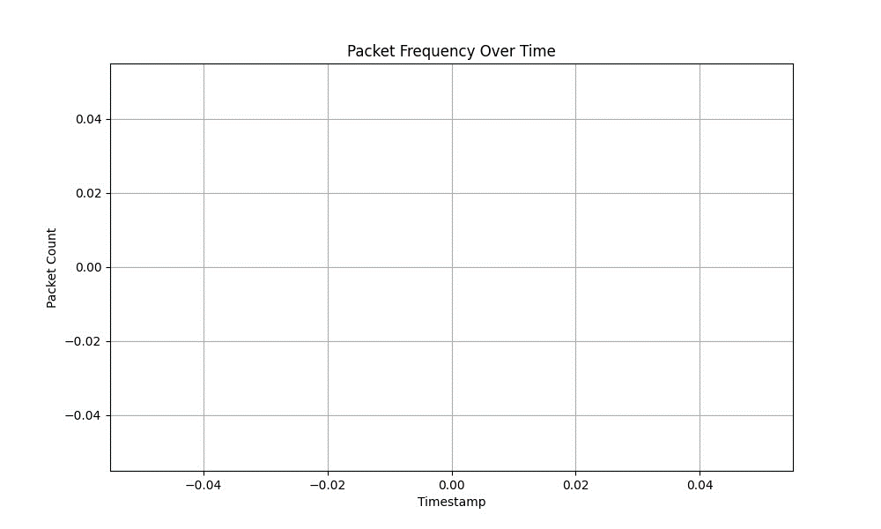
- Show the results of your programs, the frequency tables, and the plot if you choose to do it. If the results are too long, output them in a file and submit the file in additional to your report.

[Exercise VIII: Lab and Class Reflection]
Please reflect on what you have completed and learned.
- What do you like about this lab? New learning
- What are the challenges that you have encountered in this lab? Last part challenging
- Do you have additional suggestions for this class to help you learn better? No
- If you are using Windows virtual machine on the server, please turn off your virtual machines once you are done.

