CYB631 Automating Information Security with Python and Shell Scripting
Lab 6: Connecting Python with Security Tools
Your Name: Vaibhav mayekar

Goals: This lab will guide you through connecting Python with other system administration tasks and security tools.
Readings and References:
- The contents of this lab are adapted from
  - Chapter 2 and Chapter 8 of Jose Manuel Ortega’s Mastering Python for Networking and Security.
  - Python-nMap (https://pypi.org/project/python-nmap/
  - Python sys module https://docs.python.org/3/library/sys.html
  - Python subprocess module https://docs.python.org/3/library/subprocess.html.
- Please use the required Python textbook by Al Sweigart as a reference for general Python syntax.
Attention: This lab will ask you to setup a SSH server and install a port scanning tool on Windows. If you do not want to install those tools on your own computer, please use the Windows VM on Horizon Desktop for this lab. See PaceLabHowTo under Week1 for connecting to the Windows VM.

Exercises:
[Exercise I: Passing arguments from command line]
- We will learn how to pass arguments in python programs.
- Using Python IDLE, open systest.py. Review the codes to understand what it does. The program reads 3 arguments and then print them out. To run it, under PowerShell command line
python .\systest.py one two three
- Paste your results here:
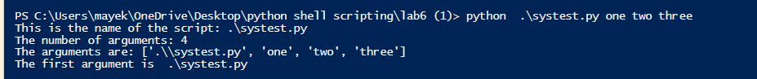
- What would be the value of sys.argv[3] in your command above? 3
- Now, let revise log frequency analysis program in the previous lab so that it can read the filename from command line to analyze log files.
- Please use Python IDLE to review the program logfreqbyname.py. The program has additional codes to read and process the first argument and pass it to the program as filename to read into the dataframe.
- Make sure that you have the application log file (appevent.csv) under your work folder from previous lab. If you do not, use the following PowerShell command to generate it.
Get-EventLog -logname Application -Newest 10000| Export-Csv -Path .\appevent.csv
cat appevent.csv -head 10
- Run the program under PowerShell command line
python logfreqbyname.py appevent.csv
- Paste your results here
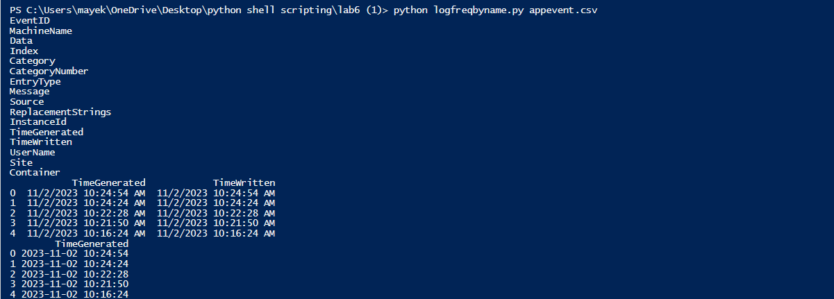.

[Exercise II: Run Terminal Command in Python]
- It is convenient to be able to run terminal command in Python. This will reply on two native Python modules: os and subprocess. Use Python IDLE, open and review syscall.py.
- Show an example of output from subprocess.check_output(‘dir’,shell=True) and explain what it is.

import subprocess

# Use subprocess to run the "dir" command
output = subprocess.check_output('dir', shell=True, encoding='utf-8')

# Print the output
print(output)
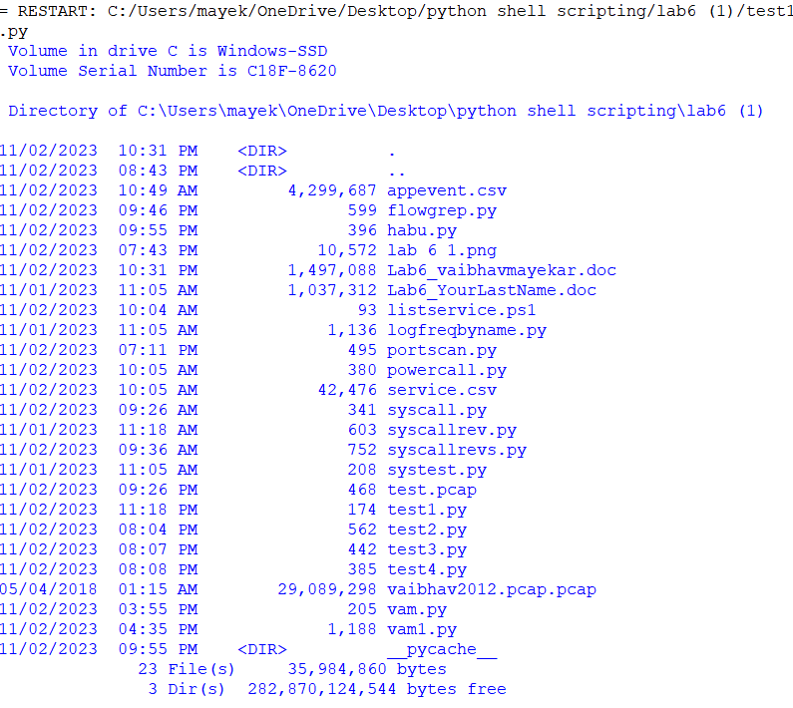

- Add codes in the program to show the status of services.
- Show your revised program here
import subprocess

print('Using subprocess for command execution:\n')
res = subprocess.check_output('echo Hello1\n', shell=True)
print(res)

print('\nUsing subprocess for command execution and service status checks:\n')

def check_service_status(service_name):
try:
status_output = subprocess.check_output(['sc', 'query', service_name], text=True)
if 'STATE' in status_output and 'RUNNING' in status_output:
print(f'{service_name} service is active')
else:
print(f'{service_name} service is not active')
except subprocess.CalledProcessError as e:
print(f'Failed to check {service_name} service status. Error: {e}')

# Check the status of the WpnService service
check_service_status('WpnService')

# Check the status of the BITS service
check_service_status('BITS')

- Show your results:
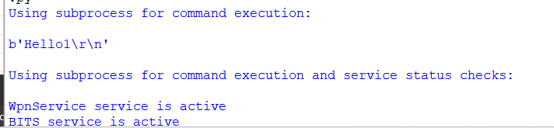

- Create a PowerShell program listservice.ps1 to list all of the running service in the system and this file outputs the results to service.csv.
Get-Service | Where-Object {$_.Status -EQ "Running"} | Export-Csv -Path .\service.csv
- Try running this program under PowerShell command line:
.\listservice.ps1
- [Debugging] You may run into problem when executing listservice.ps1 due to execution policy restriction. In this case, adjust the execution policy using Set-ExecutionPolicy cmdlet to either RemoteSigned or ByPass so that you can run it. Remember to set it back later so that your computer will not execute random scripts downloaded from the Internet. If none of them work, you will have to digitally sign listservice.ps1.
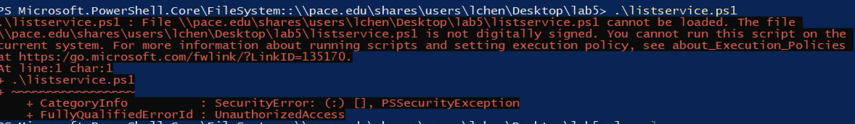
- Let us try to run this program from a Python program. Use Python IDLE, review powercall.py. This program will call listservice.ps1 inside the Python program and read the results into a dataframe. Run the program.
- Show the results here.
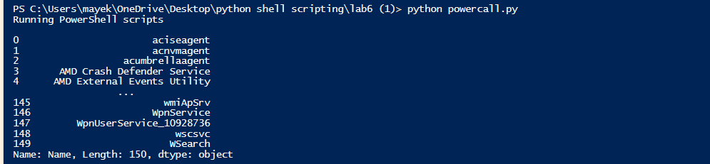

[Exercise III: Setup a OpenSSH server]
- To run our later exercises, we will need a OpenSSH server and a OpenSSH client on the Windows host. Instructions in this exercise follow Microsoft official documentation, https://learn.microsoft.com/en-us/windows-server/administration/openssh/openssh_install_firstuse?tabs=powershell#install-openssh-for-windows.
- Before starting, make sure that you have the administrator privilege to install software.
- First, check to see if the Windows machine has already installed OpenSSH. In PowerShell,
Get-WindowsCapability -Online | Where-Object Name -like 'OpenSSH*'
- The result from above will show if the OpenSSH server and client are either “Installed” or “NotPresent”. If either of them is “NotPresent”, you will need to install the server, the client, or both.
- Paste a screenshot of your results above to show OpenSSH status.
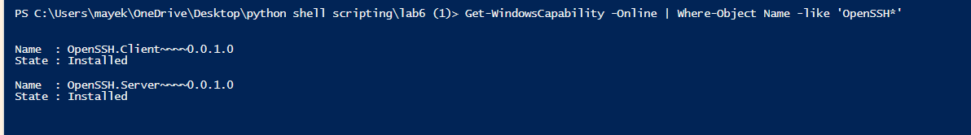
- Install OpenSSH on Windows. You can use whatever way that works for you. I would recommend either one of the following two ways.
Method 1- Use PowerShell to install on Windows server:
- Use the command below to install either the client, the server, or both.
# Install the OpenSSH Client
Add-WindowsCapability -Online -Name OpenSSH.Client~~~~0.0.1.0
# Install the OpenSSH Server
Add-WindowsCapability -Online -Name OpenSSH.Server~~~~0.0.1.0
- However, you might encounter error code below because the group policy does not allow you to add software.
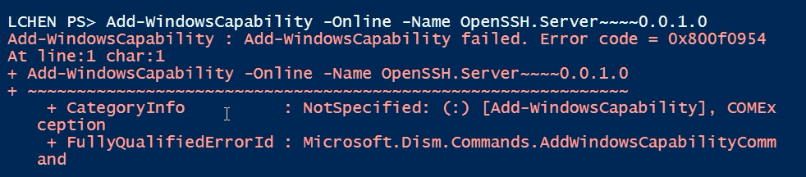
- In this case, you can solve the problem by changing that group policy as below.
  - Open local group policy editor, gpedit.msc
  - As the figure below, click on Computer Configuration, Administrative Templates, System.
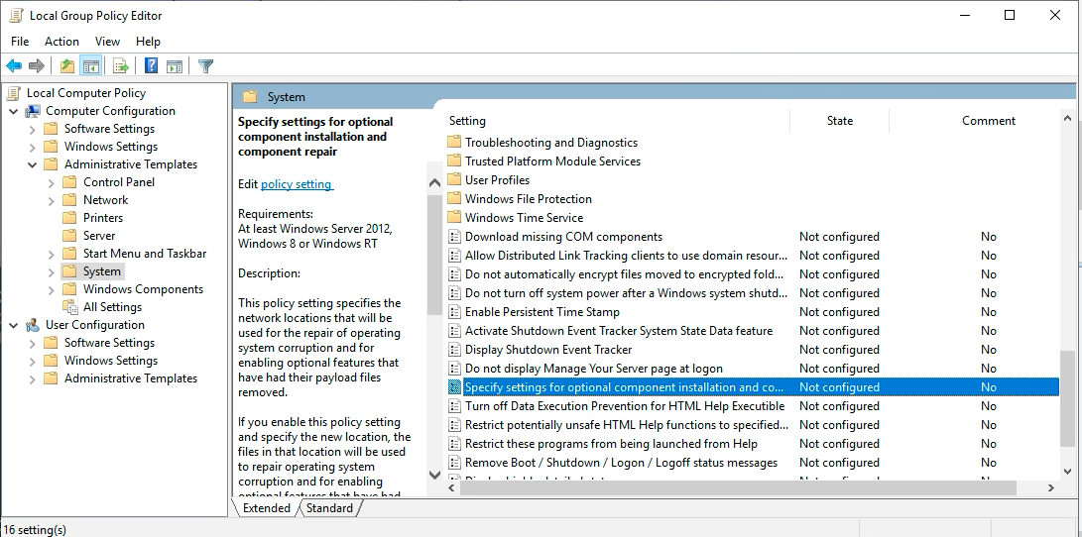
  - Open Specify settings for optional component installation and component repair. In this setting, select Enabled and check Download repair content and optional features directly from Windows Updates instead of Windows Server Updates Services (WSUS).
  - Close local group policy editor. Restart the machine.
  - Then, try install the client or the server again using Add-WindowsCapability.
- You can later remove OpenSSH by the following when you do not need them on your machine.
# Uninstall the OpenSSH Client
Remove-WindowsCapability -Online -Name OpenSSH.Client~~~~0.0.1.0
# Uninstall the OpenSSH Server
Remove-WindowsCapability -Online -Name OpenSSH.Server~~~~0.0.1.0

Method 2- Directly install OpenSSH from external sources:
- In Microsoft’s official document, the Github below is recommended and use as your own liability.
https://github.com/PowerShell/Win32-OpenSSH/releases
- You can download OpenSSH for Windows from the link below.
https://github.com/PowerShell/Win32-OpenSSH/releases/download/v9.4.0.0p1-Beta/OpenSSH-Win64.zip
- Extract the file, change the directory name to OpenSSH and then move the entire directory under C:\Program Files\ .
- Under PowerShell ISE, navigate to the OpenSSH-Win64 directory under OpenSSH. If you are using the Windows VM on Horizon Desktop, navigate to the directory using the command below:
Set-Location ‘C:\Program Files\OpenSSH\OpenSSH-Win64’
- You should find the installation PS script (install-sshd.ps1) under this directory. Let us run the PS script to install the server.
powershell.exe -ExecutionPolicy Bypass -File install-sshd.ps1
- You can later remove OpenSSH by the following when you do not need them.
powershell.exe -ExecutionPolicy Bypass -File uninstall-sshd.ps1

- Once both OpenSSH server and client are installed, check to see if OpenSSH server and client are running. They are most likely not running at this point.
Get-Service ‘ssh*’
- You should status of sshd (SSH server) and ssh-agent (SSH authentication agent). If none of them are running. Start openssh server.
Start-Service sshd
If you would like OpenSSH to run automatically every time you started the host, try
Set-Service -Name sshd -StartupType 'Automatic'
- Check to see if the server is running.
Get-Service ‘ssh*’
- It should show that the OpenSSH server is running. Paste your results from above.
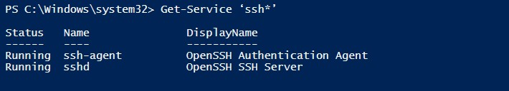
- Now, review firewall rules about SSH and add rules to allow SSH.
if ( !(Get-NetFirewallRule -Name "OpenSSH-Server-In-TCP" -ErrorAction SilentlyContinue | Select-Object Name, Enabled))
{
Write-Output "Firewall Rule 'OpenSSH-Server-In-TCP' does not exist, creating it..."
New-NetFirewallRule -Name 'OpenSSH-Server-In-TCP' -DisplayName 'OpenSSH Server (sshd)' -Enabled True -Direction Inbound -Protocol TCP -Action Allow -LocalPort 22
} else {
Write-Output "Firewall rule 'OpenSSH-Server-In-TCP' has been created and exists."
}

- Try connecting to the SSH server either from outside or from inside the host. Please be aware that we did not configure the authentication agent for this exercise. The service does not have secure communications. From inside the host and under command prompt,
ssh username@localhost
- Paste a screenshot here to show that you can successfully login the OpenSSH server.
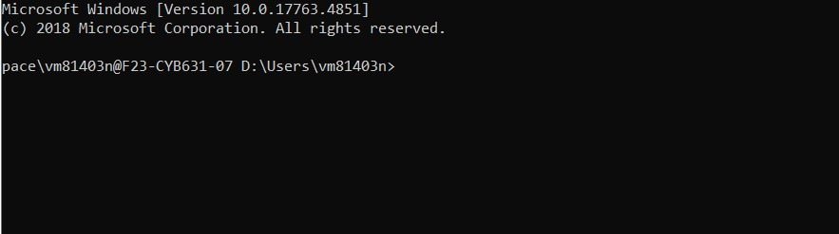

[Exercise IV: Host Scanning using Python-nMap]
- In this exercise, we will use Python to communicate with nMap.
- Download and install nMap for Windows.
https://nmap.org/dist/nmap-7.94-setup.exe
- Try nMap under PS command line.
nmap -v 127.0.0.1
- This will show you results of a regular nMap scan. You should see SSH is running on TCP port 22 along with other Windows services.
Paste your results here.
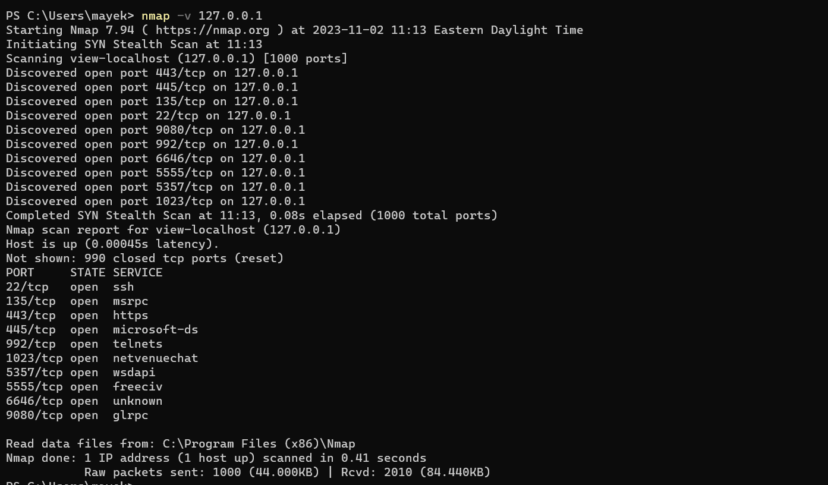
Based on your screenshot above, explain the meaning of each service discovered by nmap on the host. For example, 22/tcp ssh means OpenSSH, etc.
22/tcp - Secure Shell (SSH) - Used for secure logins, file transfers (scp, sftp) and port forwarding.
135/tcp - Microsoft Remote Procedure Call (RPC) - Used for various Windows services, including file sharing, printing, and remote administration.
443/tcp - Hypertext Transfer Protocol Secure (HTTPS) - Used for secure web browsing and other encrypted web traffic.
445/tcp - Microsoft-DS - Used for Samba file sharing and other Windows networking protocols.
992/tcp - Telnet over SSL (TLS) - A secure version of the Telnet protocol for remote administration.
1023/tcp - Reserved - This port is reserved for use by system services.
5357/tcp - OpenStack Compute (Nova) - Used for managing virtual machines in an OpenStack cloud environment.
6646/tcp - Internet Relay Chat (IRC) - Used for real-time text communication over the internet.
9080/tcp - Squid Proxy Server - A popular web proxy server that can be used for caching web content and improving performance and security
- [Debugging] Sometime, you might encounter problems with nMap scan due to Windows system update or installation of other software. For example, if you see the error below. It is often a result of lacking Npcap library which is needed for nMap. The problem can be solved by reinstalling nMap and replacing the existing Npcap library.
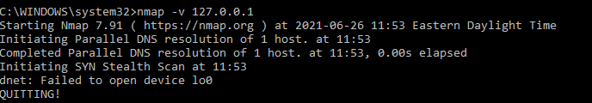
- Install python-nmap API module.
pip install python-nmap
- Using Python IDLE, open portscan.py. Review the codes and run the file to understand what it does. It will take a few minutes to run the program since it is scanning multiple TCP ports. Your results should show the open ports on this machine which should include the OpenSSH server (port 22).
- Paste your results here:
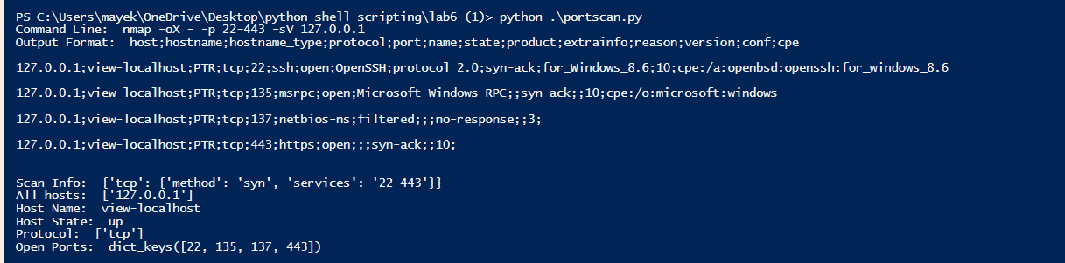
- You are welcome to review the python-nmap project site at http://xael.org/pages/python-nmap-en.html
- Here is a cheat sheet for nMap options that you can specify in the arguments in the nmap.scan function. https://github.com/jasonniebauer/Nmap-Cheatsheet
- Revised portscan.py to conduct a UDP port scan via nMap.
- Show your revised program here.
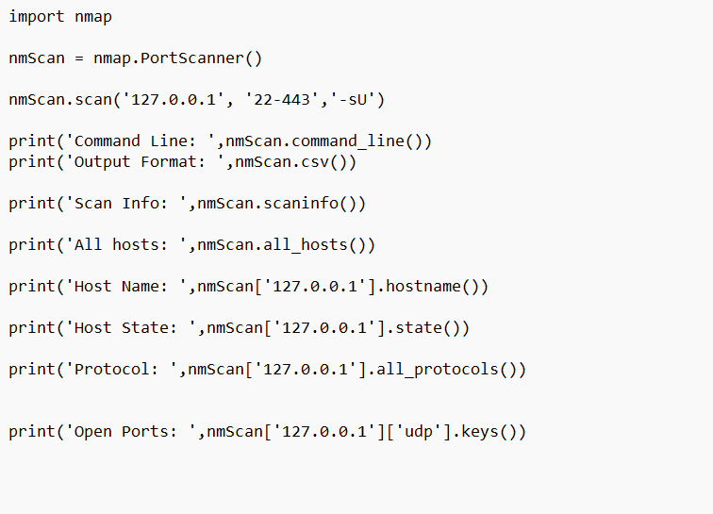
- Show the results from your revised program.
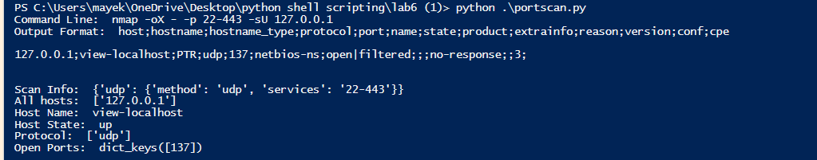

[Exercise V: Python Security Tools]
- Many developers have used Python to create security tools, such as https://github.com/dloss/python-pentest-tools). It is important that you develop the ability to follow instructions and install/test some of the tools that might be useful for you in conducting security tasks.
- Pick one tool (excluding Scapy since we did it in the previous lab) from the list (https://github.com/dloss/python-pentest-tools) to try. Some of the tools are more complicated than the other. The simplest one is probably dpkt which is like Scapy). What is the tool that you pick? Habu
- Show a Python program (either you wrote, or you use the one from the Github) or attach it as a separate submission to this lab.
from habu.lib.nmap import Nmap
from habu.lib.iface import Iface
import json

iface = Iface().get_working_iface()

nmap = Nmap()
result = nmap.ping('-n', '-v', '-v', '-v', 'scanme.nmap.org') # Replace with your target

print(json.dumps(result, indent=4))
Did you write the program above or the program was included in Github? No
Explain what the problem does briefly:
The program solves the problem of performing a non-intrusive ping scan of a network host. This can be useful for a variety of purposes, such as checking if a host is up, identifying active hosts on a network, or troubleshooting network connectivity issues.
- Open-source tools are typically not guaranteed for its quality. Some of experiments might not work as the project claims to be. Describe the experiments you tried.
I attempted to install and run a program, but Habu, a software package required to run the program, failed to install on my computer or in virtual machines. I received the same error message in both cases, indicating that there was a problem with the Habu installation packages.Paste screenshots of your results and explain them (either successfully or not successful results).
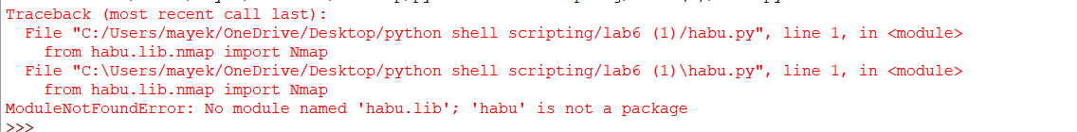

[Exercise VI: Lab and Class Reflection]
Please reflect on what you have completed and learned (required).
- What do you like about this lab? Leaning new things
- What are the challenges that you have encountered in this lab? Tough
- Do you have additional suggestions for this class to help you learn better? No
- If you are using Windows virtual machine on the server, please turn off your virtual machines once you are done.

