Set-Up:

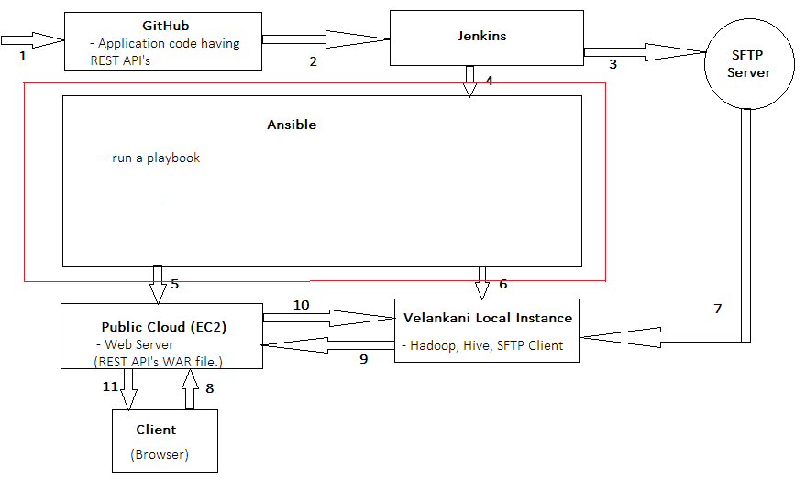

Workflow Over-View:
- Committing the code in GitHub Repository.
- Jenkins will fetch the code from GitHub repository and create a WAR file out of it.
- Jenkins will push the WAR to the SFTP-server.
- Jenkins will trigger an Ansible playbook.
- Ansible will provision a ec2 instance on Public Cloud.
- Ansible will provision Apache Hadoop, Apache Hive, SFTP-client and Test Application on the Velankani local instance.
- Rundeck will start the SFTP-client, which fetch CDR-Files from SFTP-server
- Velankani local instance will pass the data to EC-2 Instance through Rest API’s.
- Output is shown in the browser in the form of bar charts.

Steps to bring up the Set-Up:

- Create a GitHub account.

- Install and Configure Jenkins:

System Configuration:

- Ubuntu 14.04 (X86_64)
- IP : 10.0.12.48
- 1 GB RAM
- 20 GB HDD

1. Install Java 8:

- sudo add-apt-repository ppa:webupd8team/java
- sudo apt-get update
- sudo apt-get install oracle-java8-installer

While installation, you’ll be asked to agree the license and then the installer start downloading Java file from oracle website and install it on your system.

- java –version (To check if everything is working fine)

Output of the above command should be something like this –

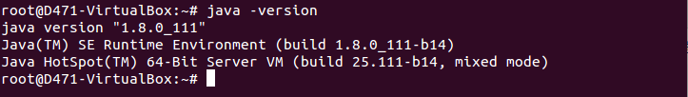

2. Install Jenkins:

- wget -q -O - http://pkg.jenkins-ci.org/debian-stable/jenkins-ci.org.key | sudo apt-key add -
- sudo sh -c 'echo deb http://pkg.jenkins-ci.org/debian-stable binary/ > /etc/apt/sources.list.d/jenkins.list'
- sudo apt-get update
- sudo apt-get install Jenkins

{After installation Jenkins start on port 8080. if in any case port 8080 is busy in some other process edit /etc/default/jenkins and update HTTP_PORT to 8081 and restart Jenkins service again.
- sudo service jenkins restart

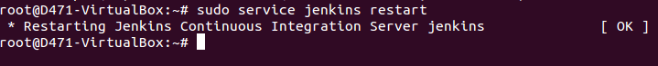

}

3. Access Web Interface:

- Access Jenkins server on port 8080 in any web browser. Default installation password can be found at /var/lib/jenkins/secrets/initialAdminPassword as showing in below image.

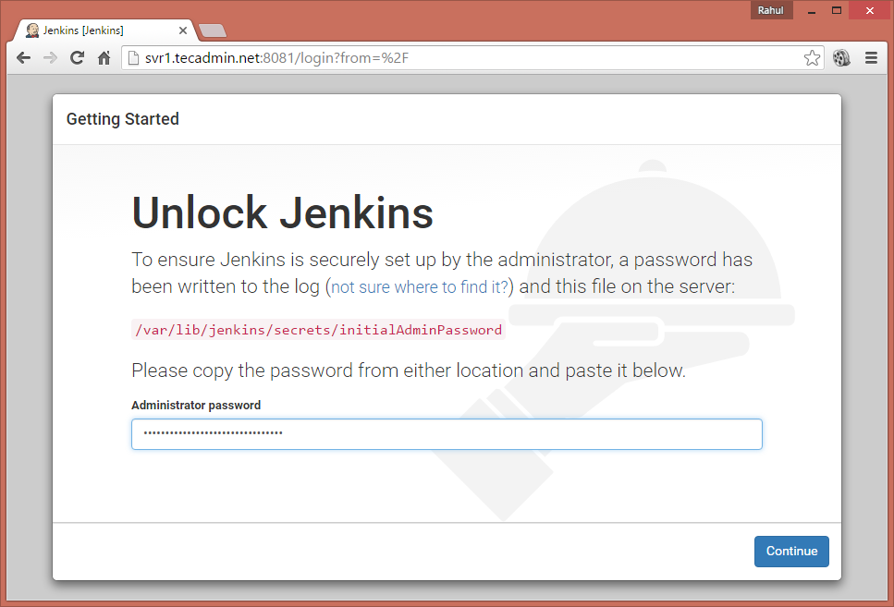

- Now select appropriate option to install plugin. You can choose to install suggested plugins or select required plugins options. (I have selected “install suggested plugins”)

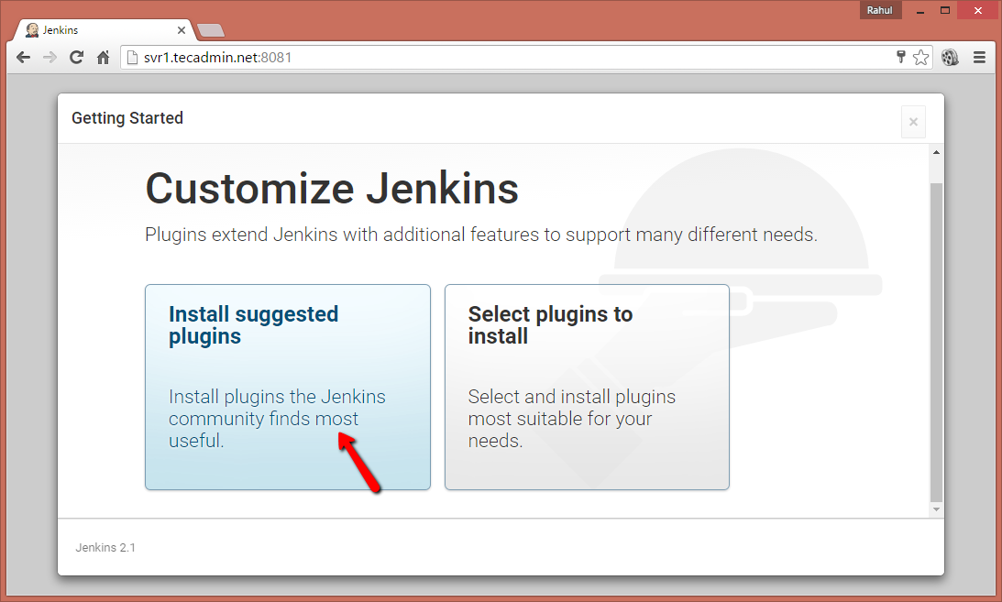

- Now create an admin account for your Jenkins setup. This will required to login to Jenkins.

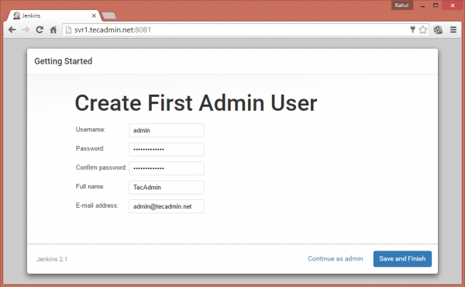

- After successful completion of Jenkins setup wizard, you will be redirected to Jenkins dashboard.

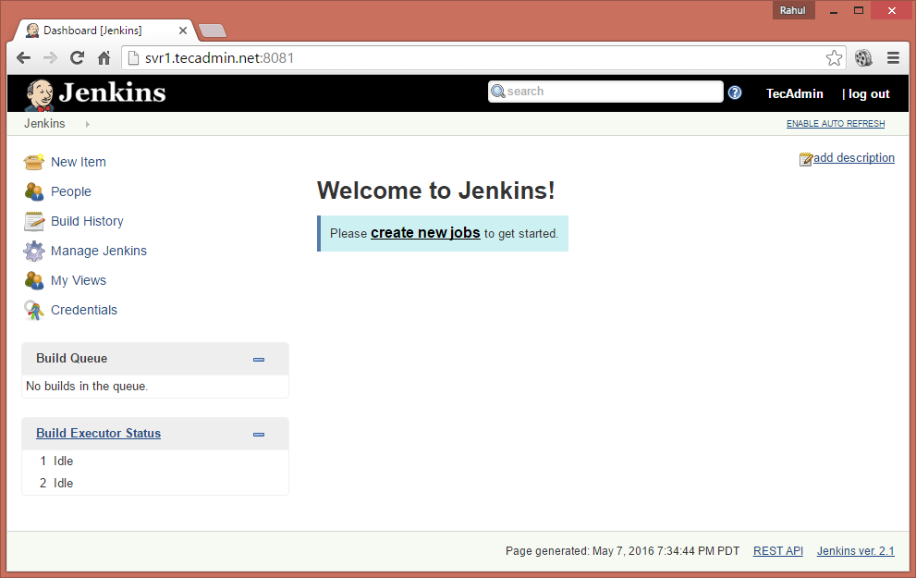

4. Configuring Jenkins:

- Configuration the JDK location:
Before using Jenkins to build Java applications, configure the location of JDK installation in Jenkins.

* Select Manage Jenkins and afterwards Global Tool Configuration.
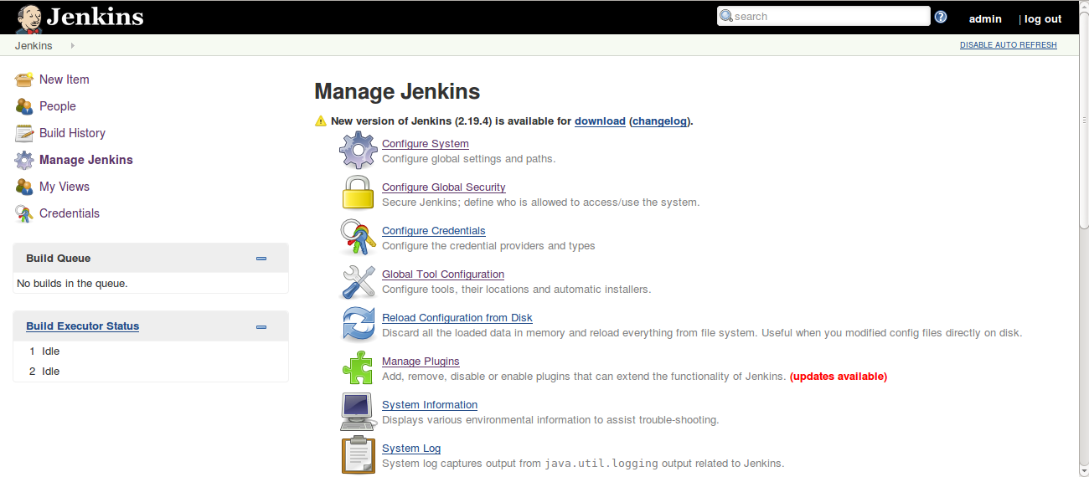

Enter the correct path to the JDK, Apache Ant and Maven and press the Save button below. Jenkins can also install these automatically.
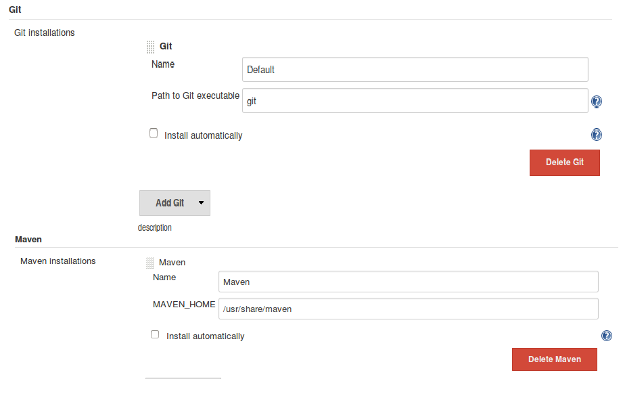

- Security Configuration:

* Click “Manage Jenkins”.
*Click on “Configure Global Security” and select “Enable Security” check-box.
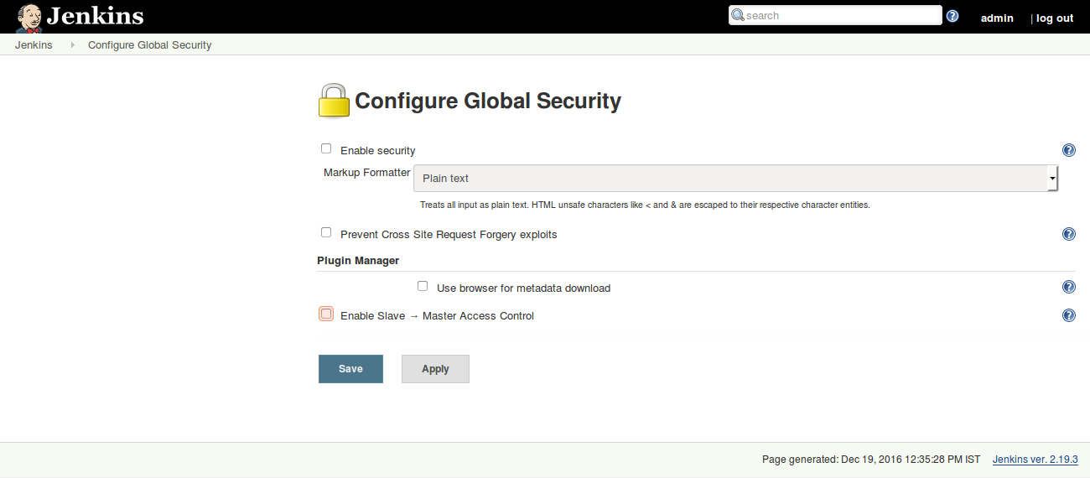
*Select “Jenkins own user database” and select “Allow users to sign up” option.
* Create at least one user with “read” authority in the “Authorization” section as shown below.
* Click “Apply” and then “Save” to set the setting changes made.
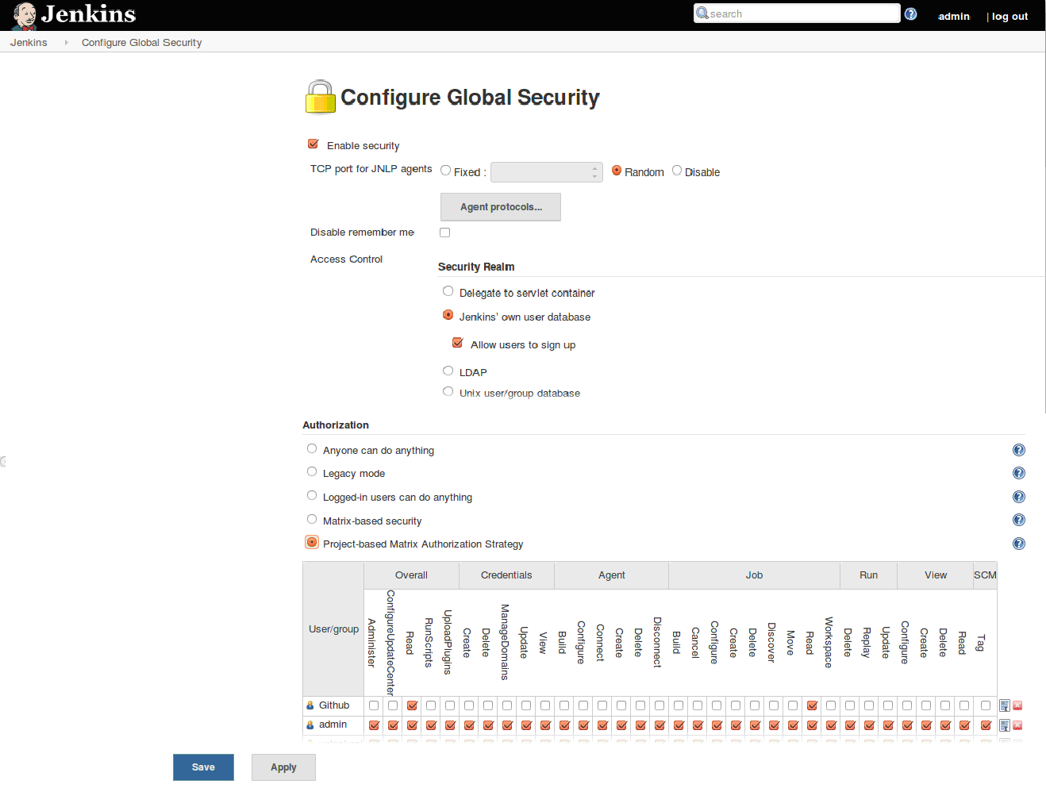
- Integrating Jenkins and GitHub:

- Change to Jenkins user in terminal using the command - sudo su -s /bin/bash jenkins

- Configuring SSH keys for secure connection between Jenkins and GitHub:
https://help.github.com/articles/generating-an-ssh-key/

- Integrating Jenkins with SFTP server:

- Copy the SSH key of Jenkins server system to SFTP server using command –
copy-ssh-id SFTP_Server_User_Name@SFTP_Server_Ip (e.g.:copy-ssh-id velankani@10.0.xx.xx)

- Now try to SSH to the SFTP server – SFTP_Server_User_Name@SFTP_Server_Ip (e.g.:ssh velankani@10.0.xx.xx)
(Successful connectivity via ssh to the SFTP server as “velankani” user)

- Managing plugins in Jenkins:

- To install Plugins:

- Jenkins can be extended via additional plug-ins with more functionality. To install plugins in Jenkins select Manage Jenkins ▸ Manage Plugins link.

- To install plugin search for the plugin you want to install in the “Available” tab (e.g.: Publish over SSH). Select it from the list and select to install it and restart Jenkins.
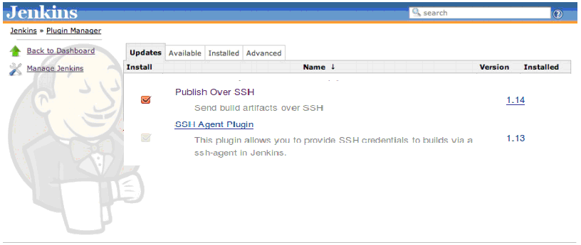

- To Configure Plugins (Publish over SSH):

- Click “Manage Jenkins”
- Click “Configure System”
- Go to “Publish over SSH” section
- Enter “/Users/Shared/Jenkins/.ssh/id_rsa” to “Path to Key”
- Click “Add” at “SSH Servers”
- Enter any logical name to “Name”
- Enter IP Address or Hostname of the server to “Hostname”
- Enter the user name to login to “Username”
- Enter any directory to “Remote Directory”
- Click “Test Configuration”
- Click “Save” at bottom of the page
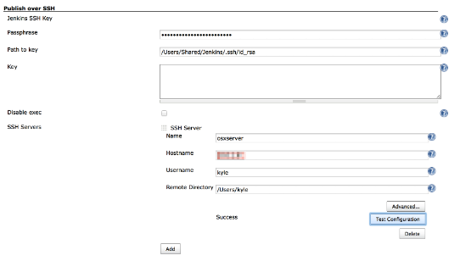

- Creating a Jenkins job:

The Jenkins job - build the GitHub sample code.
- send the .war file to SFTP server.
- run ansible playbook for making installation on localhost.

  - Click on the “New Job” link.
  - Enter a job name and select “Freestyle project”.
  - Click on “ok”.
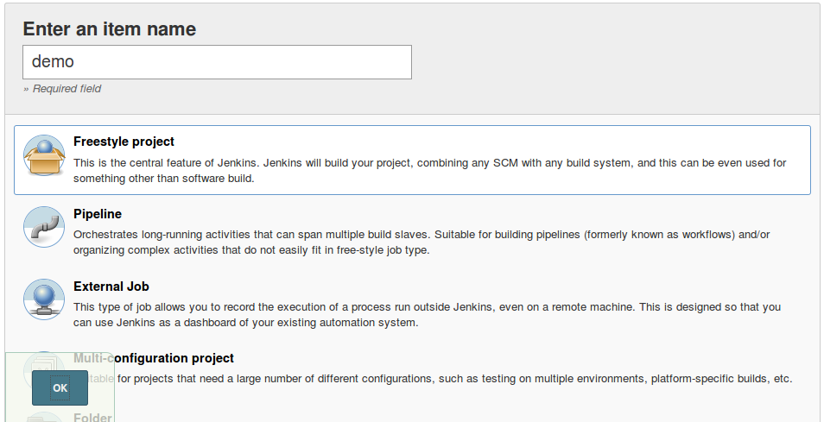

Once clicked on OK, Jenkins will display the project configuration screen.
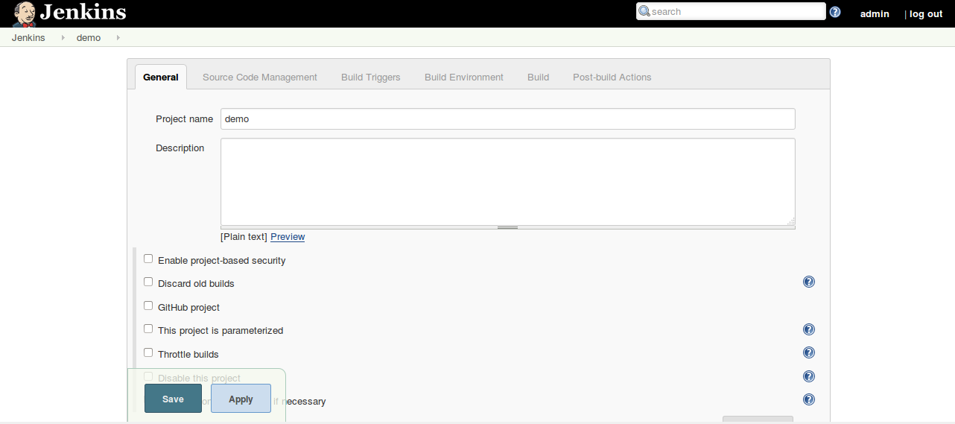

For this project, we will be getting the source code from the GitHub repository we set up earlier. On the Jenkins screen, choose “Git” and enter the Repository URL.

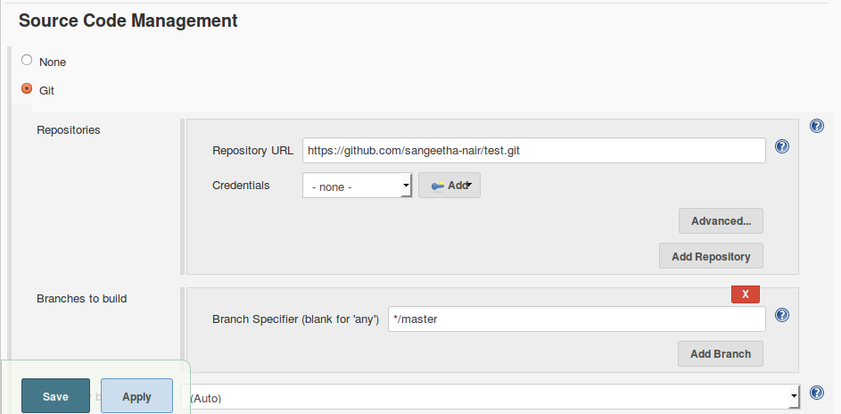

Once told Jenkins where to find the source code for the application, configure Jenkins to check for updates (time interval in which Jenkins should check Git for updates).The aim is for Jenkins to monitor the repository and start a build whenever any changes have been committed. This is a common way to set up a build job in a Continuous Integration context, as it provides fast feedback if the build fails. Configure all of this in the Build Triggers section. Pick the Poll SCM option and enter “* * * * *” (this makes Jenkins check for updates in Git every minute).
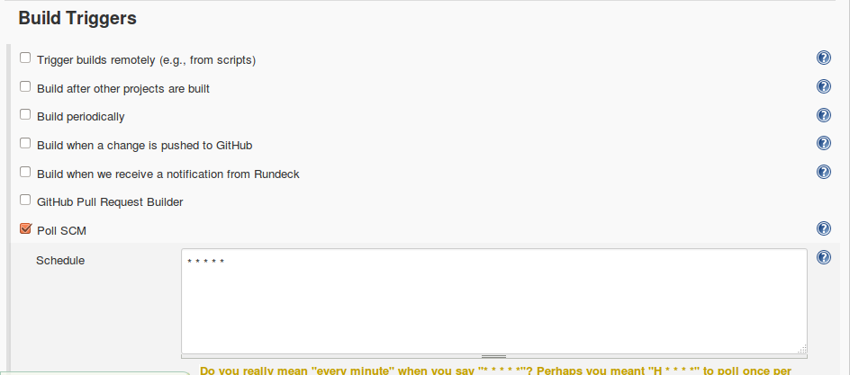

The next step is to configure the actual build itself. In technical terms, a build step might involve invoking an Ant task or a Maven target, or running a shell script. For now, we just want to run a simple Maven build. Scroll down to the Build section-
5. Click on the “Add build step” and choose “Invoke top-level Maven targets”.
6. Then enter “clean package” in the Goals field. If you are not familiar with Maven, this will delete any previous build artifacts, compile our code and generate a JAR file.

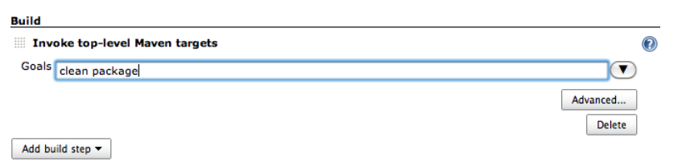

Next step is to send the .jar/.war file to the SFTP server. For this purpose use the “Publish over ssh” plugin.

- Click “Add post-build action”.
- Click “Send build artifacts over SSH”.
- Enter “Source files”.
- Enter “Remove prefix”.

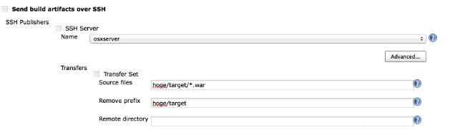

We also need to invoke Ansible playbook to run commands in the localhost. For this purpose also use the “Publish over ssh” plugin. Configure as shown in figure below-
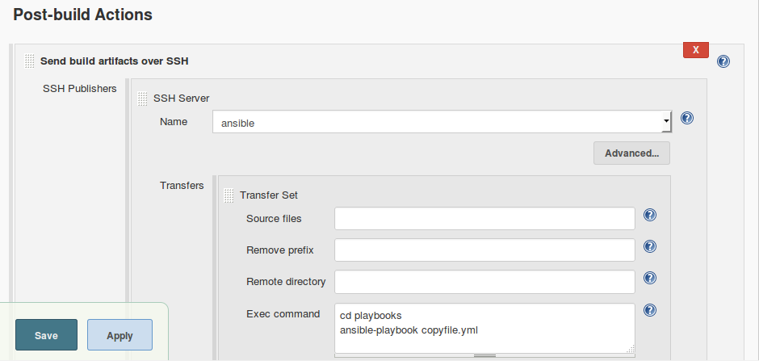

- Click “Save”.
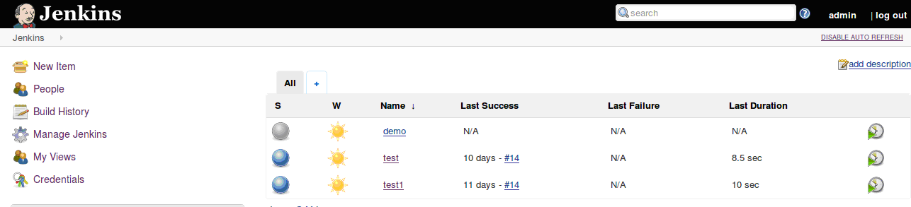
If you wait a minute or so, the build should kick off automatically—you can see the stripy progress bar in the Build History section in the bottom left hand corner. Your first build job running. Or you can also trigger the build manually using the Build Now button.

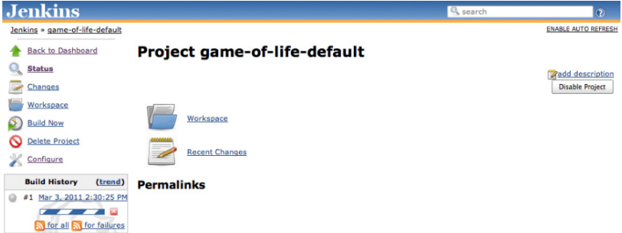

When the build finishes, the ball in the Build History box becomes solid blue. This means the build was a success. Build failures are generally indicated by a red ball. For some types of project, you can also distinguish between a build error (such as a compiler error), indicated by a red ball, and other sorts of build failures, such as unit test failures or insufficient code coverage, which are indicated by a yellow ball.

