Set-Up:

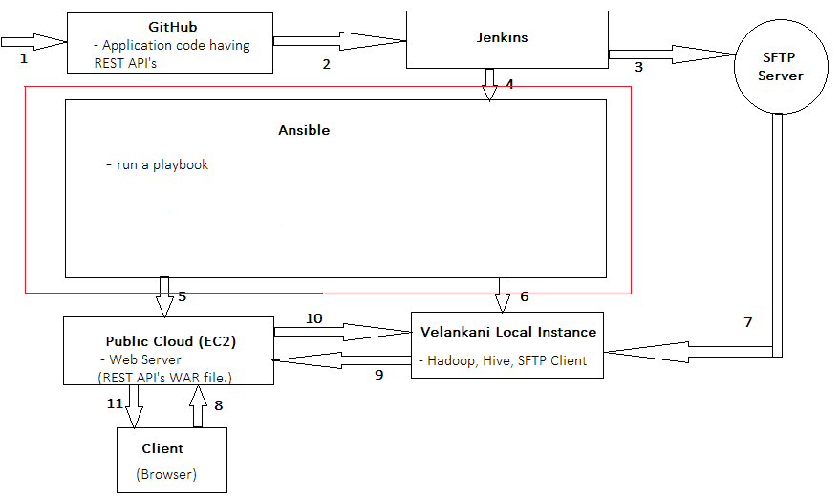

Workflow Over View:
- Committing the code in Git Hub Repository.
- Jenkins will fetch the code from Git Hub repository and create a WAR file out of it.
- Jenkins will push the WAR to the SFTP-server.
- Jenkins will trigger a Rundeck Job.
- Rundeck and Ansible will provision an ec2 instance on Public Cloud.
- Rundeck and Ansible will provision Apache Hadoop, Apache Hive, SFTP-client and Test Application on the Velankani local instance.
- Rundeck will start the SFTP-client, which fetch CDR-Files from SFTP-server
- Velankani local instance will pass the data to EC-2 Instance through Rest API’s.
- Output is shown in the browser in the form of bar charts.

Jenkins Installation & Configuration:

Follow steps in the following document to successfully install Jenkins in your system – The complete guide- (http://www.bogotobogo.com/DevOps/Jenkins/images/Intro_install/jenkins-the-definitive-guide.pdf )

Important steps and pre-requisites –

- Java 8 installed (http://ubuntuhandbook.org/index.php/2014/02/install-oracle-java-6-7-or-8-ubuntu-14-04/ )
- A GitHub account
- Install Jenkins (http://tecadmin.net/install-jenkins-in-ubuntu/ )
- Login as “Jenkins” user (Command: sudo su -s /bin/bash jenkins)
- Configure SSH to create a secure connection between Jenkins System and GitHub (https://help.github.com/articles/generating-an-ssh-key/ )
- Configure and Create Jobs in “Jenkins” as in the above mentioned guide (The complete Guide)

To Configure Jenkins to automatically trigger a job when a change is pushed into GitHub

Follows steps in this document:
https://learning-continuous-deployment.github.io/jenkins/github/2015/04/17/github-jenkins/
{The issue that we face here is- While creating a “New Job” we are unable to configure it to build a project automatically with the “Build trigger” option – “trigger when a change is pushed into GitHub”. In this case even if a change is pushed into Github the Job in Jenkins doesn’t run automatically}.

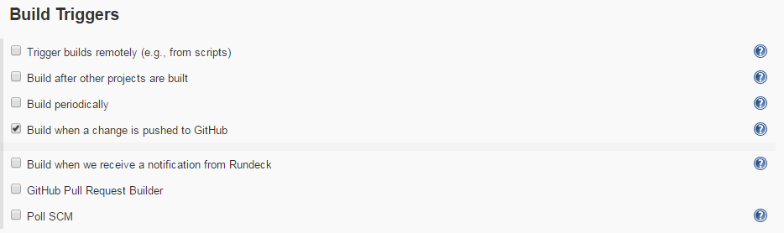

A work-around :

1. Configuration changes in Jenkins :

A work around for this issue is the “Poll SCM” option in “Build Triggers” section.
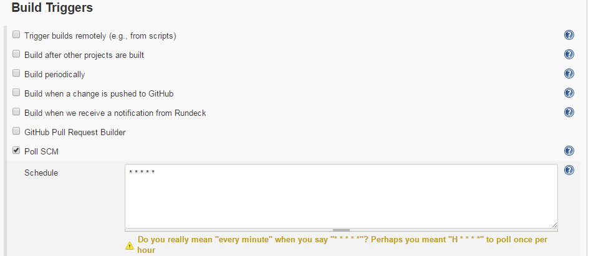
In the schedule section, we can configure Jenkins to poll changes from Github and build the project on a scheduled basis. (In the above example polling happens every minute).

2. Configuration changes in Github:

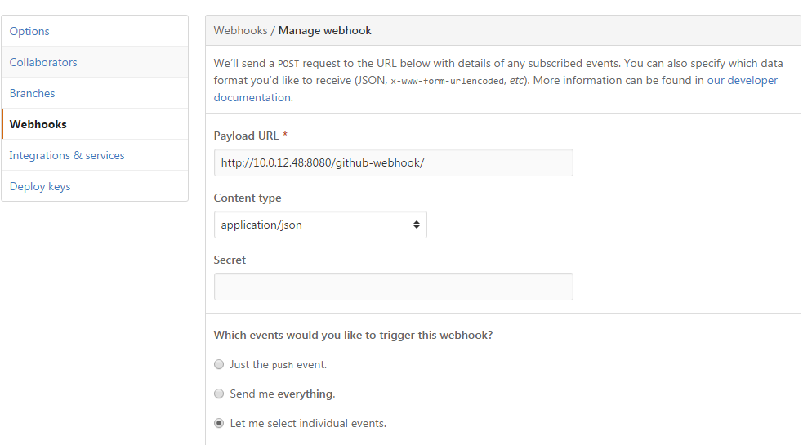

To configure Jenkins to communicate with Ansible to run Ansible playbooks:

1. Install Plugins:

- Share “SSH” keys between Jenkins system and Ansible system to create a secure connection.
- Install “SSH Plugin” into Jenkins.
{In Jenkins: Manage Jenkins > Manage Plugins > Available > Select “SSH Plugin” & install}

2. Configure Jenkins to use Plugins:

- Add “Ansible” system as an SSH server in Jenkins:

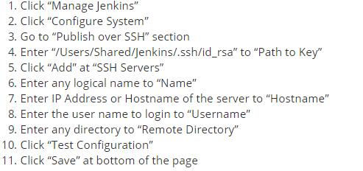

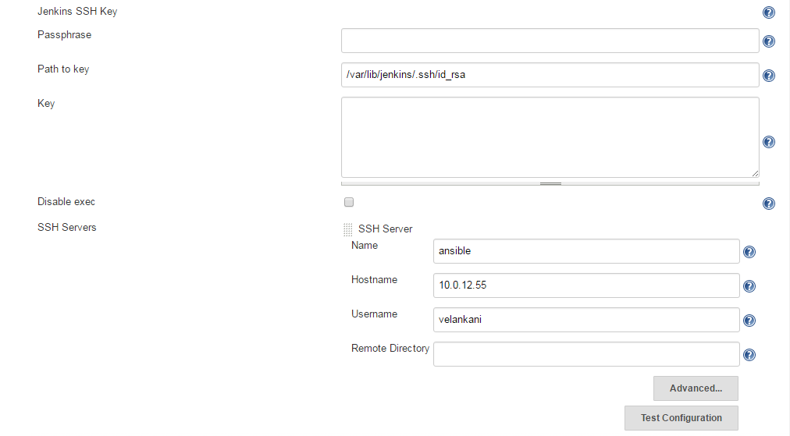

- Click on the job you have created
- Click on “Configure”
- Go to “Post Build” section and select “Send Build Artifacts over SSH” and in the “Exec Command” section write the command to run any “Ansible playbook” or any “Ansible Ad-hoc command”

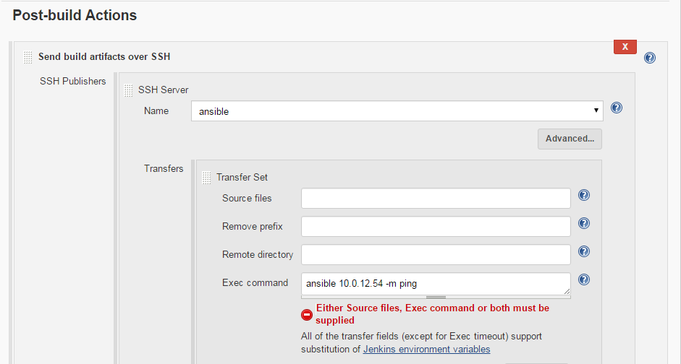

To Configure Jenkins to transfer “.war” file from Jenkins to “SFTP” server
(http://www.nailedtothex.org/roller/kyle/entry/articles-jenkins-sshdeploy )

{Jenkins URL: 10.0.12.48:8080
Username: admin
Password: admin123}

{Rundeck URL: 10.0.12.57:4440
Username: admin
Password: admin}

http://www.bogotobogo.com/DevOps/Jenkins/images/Intro_install/jenkins-the-definitive-guide.pdf : for jenkins
http://www.techpaste.com/2016/10/integrating-jenkins-with-rundeck/: jenkins and rundeck integration
https://help.github.com/articles/checking-for-existing-ssh-keys/ : github

