1. Which are the top three variables in your model which contribute most towards the probability of a lead getting converted?

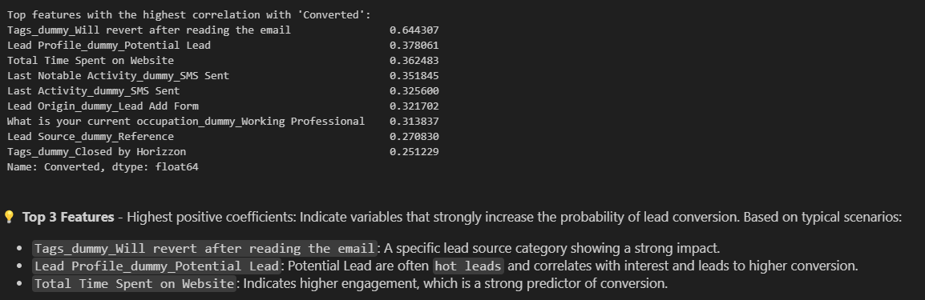

1. What are the top 3 categorical/dummy variables in the model which should be focused the most on in order to increase the probability of lead conversion?

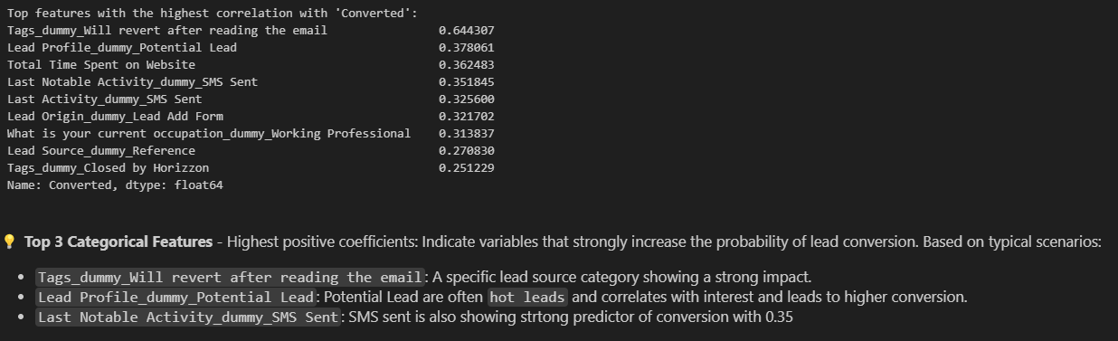

1. X Education has a period of 2 months every year during which they hire some interns. The sales team, in particular, has around 10 interns allotted to them. So during this phase, they wish to make the lead conversion more aggressive. So they want almost all of the potential leads (i.e. the customers who have been predicted as 1 by the model) to be converted and hence, want to make phone calls to as much of such people as possible. Suggest a good strategy they should employ at this stage.



**Prioritize High-Scoring Leads:** Focus on leads with a predicted probability of conversion > 80% (high confidence leads). **Action:** Assign high-probability leads to experienced sales agents or interns for immediate follow-up.

**Expand to Medium-Scoring Leads:** Include leads with scores between 50% and 80% to increase reach. **Action:** Distribute these leads among interns for personalized phone calls.

**Follow-Up Tracking:** Monitor engagement metrics post-phone calls to ensure effectiveness and identify further actionable steps.



1. Similarly, at times, the company reaches its target for a quarter before the deadline. During this time, the company wants the sales team to focus on some new work as well. So during this time, the company’s aim is to not make phone calls unless it’s extremely necessary, i.e. they want to minimize the rate of useless phone calls. Suggest a strategy they should employ at this stage.

**Sales Process Optimization and Efficient Use of CRM Tools:** Integrate the lead scoring system into the CRM and tag leads by probability tiers to streamline follow-up.

**Leverage Automated Campaigns:** For medium and low-probability leads, send targeted emails or SMS instead of direct calls.