Name: Vaibhav Malhotra
Section: F
University ID: 582047495

Lab 3 Report

Summary:
10pts
This lab thought me a lot about mutex lock and threads. This concept was taught in class but I did not have any first-hand experiences in using lock and threads. I learned how the threads were working in the first exercises and how different processes execute at different times if you use pthread_join. Also, the hello world again exercise gave me first-hand experience on how the lock and mutexes work. Overall, I think the join function helped me a lot to understand how thread processes work when the join function is present and not present.

Lab Questions:
3.1:
6pts To make sure the main terminates before the threads finish,
add a sleep(5) statement in the beginning of the thread functions.
Can you see the threads' output? Why?
2pts Add the two pthread_join statements just before the printf statement in
No, you cannot see the output from the thread function. The only output you can see is “I am main process”. The reason this is happening when the main function calls each thread, each thread will wait for 5 seconds. But the main function does not wait for the thread to finish and finished itself first. Thus, the only aforementioned output.
main. Pass a value of NULL for the second argument. Recompile and rerun the program. What is the output? Why?
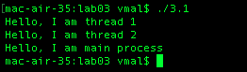
The reason this happens is because the main function now waits for the thread functions to execute before main executes.

2pts Include your commented code.
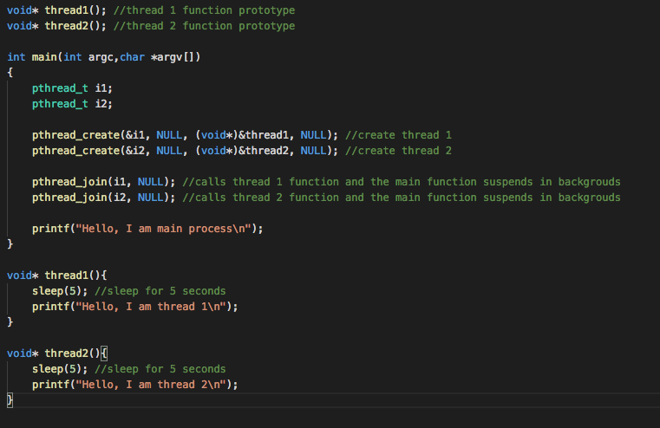
3.2:
3.2.1:
2pts Compile and run t1.c, what is the output value of v?
The value of v is 0.

8pts Delete the pthread_mutex_lock and pthread_mutex_unlock statement in both increment and decrement threads. Recompile and rerun t1.c, what is the output value of v? Explain why the output is the same, or different.
3.2.2:
The value of v switches between -990 to 990 most of the times and sometimes even outputs -970, -980,970 and 980. The reason this is happening is because both the threads are running back to back. The increment thread will run first and move the value upto 990. Once increment is done then the decrement will lock it and move the value back to 0. But
10pts Include your modified code with your lab submission and comment
on what you added or changed.
/* t2.c
synchronize threads through mutex and conditional variable
To compile use: gcc -o t2 t2.c -lpthread
*/

#include <stdio.h>
#include <pthread.h>

void hello(); // define two routines called by threads
void world();
void again();

/* global variable shared by threads */
pthread_mutex_t mutex; // mutex
pthread_cond_t done_hello; // conditional variable
int done = 0; // testing variable

int main (int argc, char *argv[]){
pthread_t tid_hello, tid_world, tid_again;
/* initialization on mutex and cond variable */
pthread_mutex_init(&mutex, NULL);
pthread_cond_init(&done_hello, NULL);

pthread_create(&tid_hello, NULL, (void*)&hello, NULL); //thread creation
pthread_create(&tid_world, NULL, (void*)&world, NULL); //thread creation
pthread_create(&tid_again, NULL, (void*)&again, NULL); //thread creation

/* main waits for the two threads to finish */
pthread_join(tid_hello, NULL);
pthread_join(tid_world, NULL);
pthread_join(tid_again, NULL);//added this

printf("\n");
return 0;
}

void hello() {
pthread_mutex_lock(&mutex);
printf("hello ");
fflush(stdout); // flush buffer to allow instant print out
done = 1;
pthread_cond_signal(&done_hello); // signal world() thread
pthread_mutex_unlock(&mutex); // unlocks mutex to allow world to print
return ;
}

void world() {
pthread_mutex_lock(&mutex);

while(done == 0 || done == 2)//have another done state to worry about
pthread_cond_wait(&done_hello, &mutex);

printf("world ");
fflush(stdout);
done = 2;//mark done for this one
pthread_cond_signal(&done_hello);//you have to signal again
pthread_mutex_unlock(&mutex); // unlocks mutex
return ;
}

void again(){//basically this was same as world() except done has to be 2
pthread_mutex_lock(&mutex);

while(done == 0 || done == 1) //have to wait for done=2
pthread_cond_wait(&done_hello, &mutex);

printf("again");//print
fflush(stdout);
pthread_mutex_unlock(&mutex); // unlocks mutex
}

3.3:
20pts Include your modified code with your lab submission and comment on what you added or changed.

/*
* Fill in the "producer" function to satisfy the requirements
* set forth in the lab description.
*/

#include <pthread.h>
#include <stdio.h>
#include <stdlib.h>
#include <time.h>

/*
* the total number of consumer threads created.
* each consumer thread consumes one item
*/
#define TOTAL_CONSUMER_THREADS 100

/* This is the number of items produced by the producer each time. */
#define NUM_ITEMS_PER_PRODUCE 10

/*
* the two functions for the producer and
* the consumer, respectively
*/
void *producer(void *);
void *consumer(void *);

/********** global variables begin *******/

pthread_mutex_t mut;
pthread_cond_t producer_cv;
pthread_cond_t consumer_cv;
int supply = 0; /* inventory remaining */

/*
* Number of consumer threads that are yet to consume items. Remember
* that each consumer thread consumes only one item, so initially, this
* is set to TOTAL_CONSUMER_THREADS
*/
int num_cons_remaining = TOTAL_CONSUMER_THREADS;

/************** global variables end ****************************/

int main(int argc, char * argv[])
{
pthread_t prod_tid;
pthread_t cons_tid[TOTAL_CONSUMER_THREADS];
int thread_index[TOTAL_CONSUMER_THREADS];
int i;

/********** initialize mutex and condition variables ***********/
pthread_mutex_init(&mut, NULL);
pthread_cond_init(&producer_cv, NULL);
pthread_cond_init(&consumer_cv, NULL);
/***************************************************************/

/* create producer thread */
pthread_create(&prod_tid, NULL, producer, NULL);

/* create consumer thread */
for (i = 0; i < TOTAL_CONSUMER_THREADS; i++)
{
thread_index[i] = i;
pthread_create(&cons_tid[i], NULL,
consumer, (void *)&thread_index[i]);
}

/* join all threads */
pthread_join(prod_tid, NULL);
for (i = 0; i < TOTAL_CONSUMER_THREADS; i++)
pthread_join(cons_tid[i], NULL);

printf("All threads complete\n");

return 0;
}

/***************** Consumers and Producers ******************/

void *producer(void *arg)
{
int producer_done = 0;

while (!producer_done)
{
pthread_mutex_lock(&mut); //lock

while(supply > 0)// wait until it hits 0
pthread_cond_wait(&producer_cv, &mut);

if(num_cons_remaining == 0){//if there are no more consumers then you are done
producer_done = 1;
pthread_mutex_unlock(&mut);
break;
}

printf("Producer thread produced 10 items\n");//otherwise go ahead and start
fflush(stdin);//producing more items

supply +=10;//add them

if(supply>0)//then call the consumer to work
pthread_cond_broadcast(&consumer_cv);

pthread_mutex_unlock(&mut);//unlock
}

return NULL;
}

void *consumer(void *arg)
{
int cid = *((int *)arg);

pthread_mutex_lock(&mut);
while (supply == 0)
pthread_cond_wait(&consumer_cv, &mut);

printf("consumer thread id %d consumes an item\n", cid);
fflush(stdin);

supply--;
if (supply == 0)
pthread_cond_broadcast(&producer_cv);

num_cons_remaining--;

pthread_mutex_unlock(&mut);

return NULL;
}

