Portal

DP102 - Software Requirements Specification

**Portal-SRS**

**Version 4.0**

**Classified: Confidential**

Contents

1 Introduction 3

1.1 Objectives and Scope 3

1.2 Terms, abbreviation and definitions 3

2 Overall Description 3

2.1 Product Perspective 3

2.2 Product Functions 3

2.3 Operating Environment 4

2.4 Design and Implementation Constraints 4

3 System Features 5

3.1 Create task feature 5

3.1.1 Description and Priority 5

3.1.2 Stimulus/Response Sequences 5

3.2 Create group feature 5

3.2.1 Description and Priority 5

3.2.2 Stimulus/Response Sequences 5

3.3 Assign student to a task feature 5

3.3.1 Description and Priority 5

3.3.2 Stimulus/Response Sequences 5

3.4 Assign student to a task feature 5

3.4.1 Description and Priority 5

3.4.2 Stimulus/Response Sequences 5

3.5 Remove student from a task feature 6

3.5.1 Description and Priority 6

3.5.2 Stimulus/Response Sequences 6

3.6 Remove group from a task feature 6

3.6.1 Description and Priority 6

3.6.2 Stimulus/Response Sequences 6

3.7 Remove student from a group feature 6

3.7.1 Description and Priority 6

3.7.2 Stimulus/Response Sequences 6

4 Non-Functional Requirements 6

4.1 Performance Requirements (PR.PE) 6

4.2 Security Requirements (PR.SE) 7

# Introduction

## Objectives and Scope

The purpose of this document is to present a detailed description of the Educational Web Portal. This document is intended for both the stakeholders and the developers of the system. The software will facilitate communication between teacher and student. By maximizing the user’s work efficiency and production the system will meet the user’s needs while remaining easy to understand and use. More specifically, this system is designed to allow a user with role a teacher to create classes, tasks and assign a task to user or a class and a user with role student change status of assigned to him/her task. The system also contains a relational database containing a list of Users, Classes and Tasks.

## Terms, abbreviation and definitions

|  |  |
| --- | --- |
|  | [this subsection should provide the definition of all terms, acronyms and abbreviations required to properly interpret the document. This information may be provided by reference to a glossary.] |
| Teacher | User with a role ‘teacher’ |
| Student | User with a role ‘student’ |
| Stakeholder | Any person with an interest in a project, who is not developer |
| Class | Group of users |

# Overall Description

## Product Perspective

Portal is a task manager, which is developed to avoid barriers to efficient remote communication in teacher-student relationship. As a prototype was used classroom.google.com.

The Portal 1.0.0 provides basic functionality for Teacher to create and manipulate tasks and classes. Also it helps Student to get the tasks and notify a Teacher as soon as task was done. This simple feature set leave developer an options how to use the application in future. For instance, it can be used not only as platform for schools, universities, but also system for courses or mentor-mentee communication all over the world. The direction can be defined by some addition functions and entities for each option.

## Product Functions

A user of the Portal is going to have one of two roles: Teacher or Student.  
As Teacher:

* user is able to log in
* user is able to create task
* user is able to create class of Students
* user is able to assign task to Student
* user is able to assign task to group of Student
* user is able to edit a task
* user is able to check status of created by him/her task
* user is able to remove task

As Student:

* user is able to be notified about assigned task
* user is able to see assigned to him/her tasks
* user is able to check tasks details
* user is able to change the status of task (from ‘open’ to ‘done’)

There are several possible scenarios of system usage. Reader can get familiar with Teacher user flow diagram (Pic. 2.1).

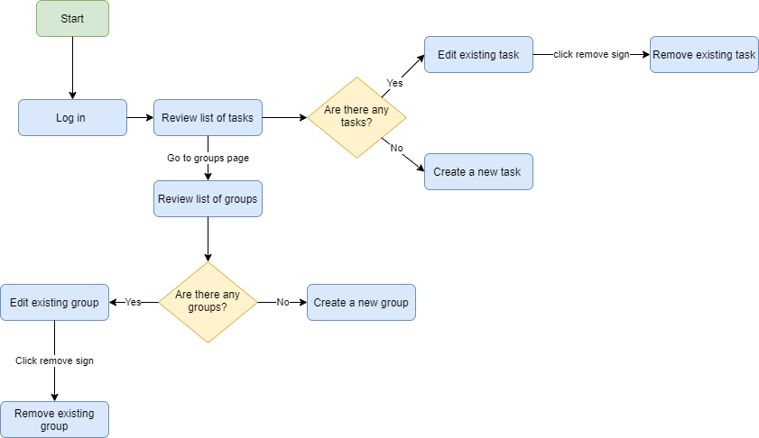

Pic. 2.1. Teacher User Flow Diagram

## Operating Environment

Application is to be run on Windows 10, Linux, or Mac OS with installed Java 1.8+ and NodeJS 14.

## Design and Implementation Constraints

The system is designed as client-server application with request-response http communication between frontend and backend. Also contains designed database and implemented schema on H2. (Pic.2.2)

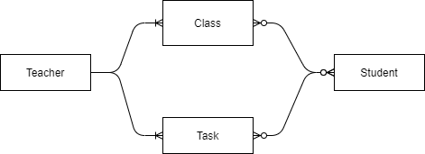

Pic.2.2 Entity-Relationship diagram

Application is based on Java 1.8+, ReactJS and Axios for request-response communication between frontend and backend (Pic. 2.3).

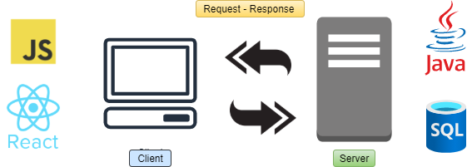

Pic. 2.3 Client-server diagram

# System Features

## Create task feature

### Description and Priority

Feature with high priority. The main goal of the system – to manipulate tasks, so extremely important to create the task.

### Stimulus/Response Sequences

Assumptions: Teacher is logged into the system and is on page ‘Tasks’  
Sequence:

* Teacher clicked button ‘New Task’ on Tasks page
* New task page is opened
* Teacher inputs title, description and/or assigned task to Student or Group
* Teacher click ‘Save’

## Create group feature

### Description and Priority

Feature with medium priority. It is convenient to assign task on the group of people, so it good to have, but not vital for the concept of system itself

### Stimulus/Response Sequences

Assumptions: Teacher is logged into the system and is on page ‘Groups’  
Sequence:

* Teacher clicked button ‘New Group’ on Groups page
* New group page is opened
* Teacher inputs name and adds Student to the Group
* Teacher click ‘Save’

## Assign student to a task feature

### Description and Priority

Feature with high priority. The main goal of the system – to manipulate tasks, so extremely important to give the task to a person who is responsible for it.

### Stimulus/Response Sequences

Assumptions: Teacher is logged into the system and is on page ‘Tasks’  
Sequence:

* Teacher clicked on a Task from the list
* Edit task page is opened
* Teacher clicks on ‘assign to’ area
* System shows ‘Assign to’ forms
* Teacher choose a Student from the list
* Teacher click ‘Save’

## Assign student to a task feature

### Description and Priority

Feature with medium priority. Feature allows to assign task to the group of people instead of one person.

### Stimulus/Response Sequences

Assumptions: Teacher is logged into the system and is on page ‘Tasks’  
Sequence:

* Teacher clicked on a Task from the list
* Edit task page is opened
* Teacher clicks on ‘assign to’ area
* System shows ‘Assign to’ forms
* Teacher choose a Group from the list
* Teacher click ‘Save’

## Remove student from a task feature

### Description and Priority

Feature with high priority. Feature allows to remove student from the task.

### Stimulus/Response Sequences

Assumptions: Teacher is logged into the system and is on page ‘Tasks’  
Sequence:

* Teacher clicked on a Task from the list
* Edit task page is opened
* Teacher clicks on ‘assign to’ area
* System shows ‘Assign to’ forms
* Teacher removed Student from the list of Assignees
* Teacher click ‘Save’

## Remove group from a task feature

### Description and Priority

Feature with high priority. Feature allows to remove student from the task.

### Stimulus/Response Sequences

Assumptions: Teacher is logged into the system and is on page ‘Tasks’  
Sequence:

* Teacher clicked on a Task from the list
* Edit task page is opened
* Teacher clicks on ‘assign to’ area
* System shows ‘Assign to’ forms
* Teacher removed Group from the list of Assignees
* Teacher click ‘Save’

## Remove student from a group feature

### Description and Priority

Feature with medium priority. Feature allows manipulate groups.

### Stimulus/Response Sequences

Assumptions: Teacher is logged into the system and is on page ‘Groups’  
Sequence:

* Teacher clicked on a Group from the list
* Edit group page is opened
* Teacher removed Student from the list
* Teacher click ‘Save’

# Non-Functional Requirements

## Performance Requirements (PR.PE)

Application includes the latest Frameworks and libraries optimized out-of-the-box. Also database was implemented according to normalization rules (Pic.4.1)

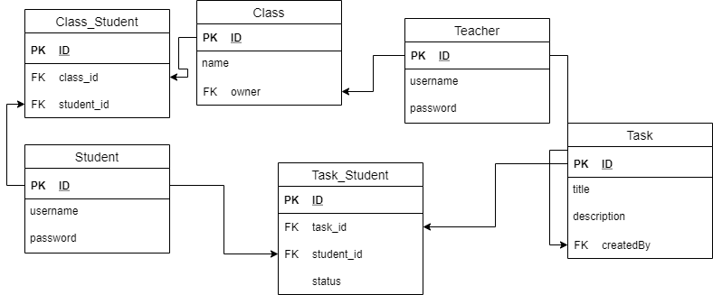

Pic.4.1. Database scheme

## Security Requirements (PR.SE)

Server side is using Spring Security with basic authorization type.

1. Attachment Title

[It is an example of placing the document's attachments]