Root Mean Squared Error

Call Option

Periods | RMSE_CRR | RMSE_KR
25 | 0.00538118 | 0.00259571
50 | 0.00279988 | 0.00125349
100 | 0.00135929 | 0.00062712
200 | 0.00067847 | 0.00031582
400 | 0.00034726 | 0.00015417
800 | 0.00017238 | 7.7788E-05

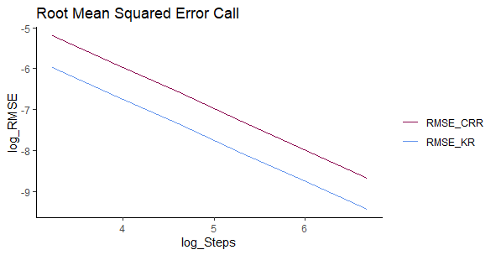

European Put Option

Periods | RMSE_CRR | RMSE_KR
25 | 0.00857285 | 0.00420883
50 | 0.00447961 | 0.0020307
100 | 0.00219377 | 0.00099707
200 | 0.00108539 | 0.00050673
400 | 0.00054333 | 0.00024843
800 | 0.00027624 | 0.00012417

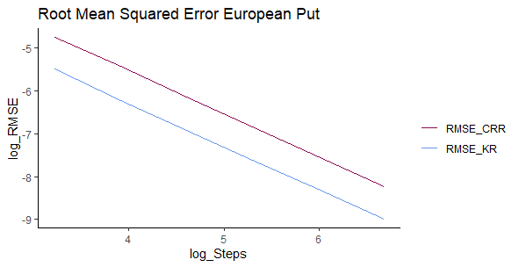

American Put Option

Periods | RMSE_CRR | RMSE_KR
25 | 0.00676932 | 0.00346367
50 | 0.0035222 | 0.00168825
100 | 0.00171842 | 0.00080981
200 | 0.00083118 | 0.00038716
400 | 0.00039918 | 0.00017222
800 | 0.00019095 | 8.1961E-05

