**Driver Version Comparison tool**

**Goal**

There are many tools which give driver version including msinfo32 and systole etc. The goal of this tool is to focus primarily on drivers which are different per processor, Hardware drivers from IHV’s. Then compare their versions to see the differences between 2 different devices in terms of drivers. This is useful in many scenarios such as making sure all the driver updates have been applied, understanding difference of behaviors – power consumption, performance or other issues…

**How to run the tool?**

Unzip the file driververversion_<version>.zip

Open cmd prompt with admin privileges

Launch get_driver_version.cmd

And send us the driver_version_<machinename>.txt file

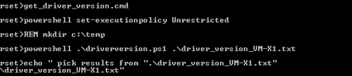

**How to do the “diff”?**

We compare the baseline with the other system

