Statistician case study

Solomon Nganga

2020-04-24 10:46:48

## Greenlight Planet Pilot Presentation.

Greenlight Planet sells lamps and TVs that are repaid over time by its customers.

## Background

### Trends in the disabled rates

We are going to do some exploration of the pilot study and have a look at the the evolution over time of the disabled rates for Country 1 with/without treatment and Country 2

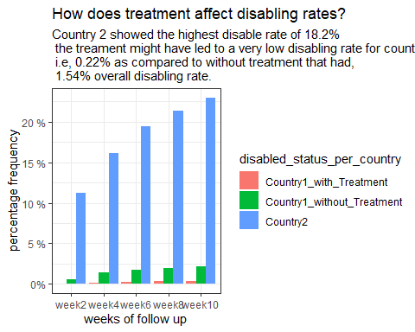

Table showing overall percentage of disable rates per country

|  |  |
| --- | --- |
| Disabled Status of country | perc disable rate |
| Country2 | 18.2% |
| Country1_without_Treatment | 1.5% |
| Country1_with_Treatment | 0.2% |

### Trend in the disabled FRR

The evolution over time of the FRR for Country 1 with/without treatment

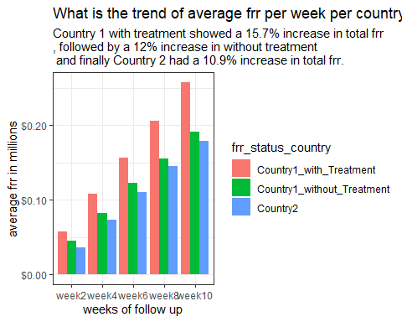

table showing the overall average in frr i millions across each country in the pilot survey

|  |  |
| --- | --- |
| names | Average frr value |
| Country1_with_Treatment | $157,484 |
| Country1_without_Treatment | $119,739 |
| Country2 | $108,962 |

### Comparison test

We going to run analysis of variance test on the means of the metrics. We initially assume that the metrics per country are the same, but we are going to try to prove this!!!

We are going to do this using individual t_test within groups. This is very important because we need to see which

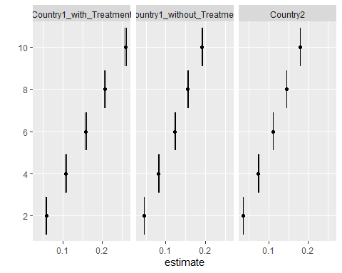

## # A tibble: 15 x 6  
## # Groups: frr_status_country [3]  
## frr_status_country frr_track_wk estimate conf.low conf.high method   
## <chr> <chr> <dbl> <dbl> <dbl> <chr>   
## 1 Country1_with_Treatment 10 0.258 0.256 0.260 One Sample ~  
## 2 Country1_with_Treatment 2 0.0581 0.0567 0.0595 One Sample ~  
## 3 Country1_with_Treatment 4 0.108 0.106 0.110 One Sample ~  
## 4 Country1_with_Treatment 6 0.157 0.156 0.159 One Sample ~  
## 5 Country1_with_Treatment 8 0.206 0.204 0.208 One Sample ~  
## 6 Country1_without_Treat~ 10 0.192 0.191 0.193 One Sample ~  
## 7 Country1_without_Treat~ 2 0.0455 0.0448 0.0463 One Sample ~  
## 8 Country1_without_Treat~ 4 0.0820 0.0812 0.0828 One Sample ~  
## 9 Country1_without_Treat~ 6 0.123 0.122 0.124 One Sample ~  
## 10 Country1_without_Treat~ 8 0.155 0.154 0.157 One Sample ~  
## 11 Country2 10 0.179 0.179 0.179 One Sample ~  
## 12 Country2 2 0.0362 0.0360 0.0364 One Sample ~  
## 13 Country2 4 0.0741 0.0739 0.0743 One Sample ~  
## 14 Country2 6 0.110 0.110 0.111 One Sample ~  
## 15 Country2 8 0.145 0.145 0.145 One Sample ~