Introductory Econometrics II - Assignment

Kenny

August 10, 2019

## Abstract

This document to shed some light on monthly income, household size, Age of respondent, vulnerability index and marital Status as variables from the Kenya FinAccess Survey (FinAccess), 2018 to answer the following questions. The 47 counties except Turkana County and only five variables are needed. The table below shows the first four observations.

## Renaming the variables and viewind the first four entries

|  |  |  |  |  |
| --- | --- | --- | --- | --- |
| Household Size | Age of Respondents | Marital Status | Monthly Income | Vulnerability Index |
| 3 | 69 | 2 | 2000 | 1 |
| 1 | 21 | 2 | 500 | 3 |
| 1 | 38 | 2 | 5000 | 3 |
| 2 | 20 | 4 | 1000 | 3 |

## Correlation

The main aim of this correlation is to estimate the strength of relationship between Monthly income, Household Size, Respondents Age and Vulnerability Index .

|  |  |  |  |  |  |
| --- | --- | --- | --- | --- | --- |
|  | Household Size | Age of Respondents | Marital Status | Monthly Income | Vulnerability Index |
| Household Size | 1.000(0.00) | -0.153(0.00) | 0.037(0.00) | -0.08(0.00) | -0.116(0.00) |
| Age of Respondents | -0.153(0.00) | 1.00(0.00) | 0.132(0.00) | 0.037(0.00) | -0.098(0.00) |
| Marital Status | 0.037(0.00) | 0.132(0.00) | 1.00(0.00) | 0.036(0.00) | 0.004(0.66) |
| Monthly Income | -0.08(0.00) | 0.037(0.00) | 0.03(0.00) | 1.00(0.00) | 0.164(0.00) |
| Vulnerability Index | -0.12(0.00) | -0.09(0.00) | 0.004(0.66) | 0.164(0.00) | 1.00(0.00) |

The table above shows the correlation between the variables. From the table we realize that all of the variables have significantly weak relationship between each other, except the relationship between marital status and vulnerability index which has a p-value of 0.66, that is greater than 0.05.

## Graph showing monthly income across age groups

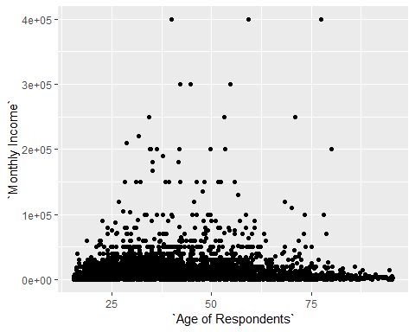

From the scatter plot above, we can see that across the ages, the average monthly salary of most of the respondents is mainly below Ksh. 40,000. This is clearly shown in the table below, where more than 70% of the respondents earned below 40,000.

|  |  |  |  |  |  |  |
| --- | --- | --- | --- | --- | --- | --- |
|  | Below 2,000 | 2,000-5,000 | 5,001-10,000 | 10,001-40,000 | 40,001-100,000 | Above 100,000 |
| Below 20 | 510 | 186 | 105 | 48 | 1 | 0 |
| 20-25 | 199 | 303 | 263 | 198 | 13 | 0 |
| 26-30 | 197 | 340 | 325 | 299 | 21 | 5 |
| 31-35 | 140 | 251 | 282 | 251 | 24 | 8 |
| 36-40 | 128 | 237 | 225 | 222 | 29 | 5 |
| Above 40 | 687 | 984 | 650 | 519 | 99 | 24 |

## Marital Status change

Otieno changed marital status to a dummy variable where 1 was Married and 0 otherwise. Using the new variable, establish whether monthly income is the same regardless of your marital status.

|  |  |  |
| --- | --- | --- |
| Marrital Status | Number of people | Percentage |
| Married | 5050 | 69.84 |
| Otherwise | 2180 | 30.16 |

The analysis showed that 69.84 percent of the respondents were married while 2180 respondents’ marital status was otherwise. To establish whether monthly income changes with the marriage status we run a linear model.

**Coefficients Estimate p-value**(Intercept) 7719.0 0.0001  
factor(new_status)1 3900.0 0.0001

$Monthly Income= 7719+ 3900married+e$,

The regression model shows that at 0.05, the relationship between monthly income and marriage status is significant. Further, it is shown that married people earn Ksh. 3,900 more than those not married holding other factors constant.

**Regression analysis**

Joy postulates that household size, respondents age and vulnerability index are covariates of monthly income. This would best be answered using regression where we seek to estimate the how Monthly income as the dependent variable is likely to be influenced by Household Size, Respondents Age and Vulnerability Index (as the independent variables).

Our null hypotheses would be;

1. There is no significant relationship between monthly income and household size.
2. There is no significant relationship between monthly income and respondents age.
3. There is no significant relationship between monthly income and vulnerability index.

The linear model is as follows;-

Estimate P-value   
 (Intercept) -2236.60 0.05374   
Household Size -491.02 0.0001  
Age of Respondents 47.81 0.0001  
Vulnerability Index 4717.40 0.0001

$$Monthly Income= -2236.60- 491.02 Household size+47.81Age+4717.40 Vulnerability index+e$$

From the analysis joy, would have been right in stipulating that there was a significant relationship between all the variables because there p-value are below 0.05. The analysis further shows that, as household size increases by on person their monthly income reduces by Ksh. 491 holding other factors constant. On the other hand, as age increases by 1 year, the monthly income is likely to increase by Ksh. 47.81 holding other factors constant. Finally, as vulnerability index increase by one unit monthly income of the individual increases by Ksh. 4717 holding other factors constant.