*CHAPTER 1*

**INTRODUCTION TO THE PROJECT**

**1.1 Overview**

In today's digital era, the e-commerce industry has witnessed significant growth, making it easier for customers to buy a variety of products from the comfort of their homes. Among the many sectors adopting digital transformation, the food and grocery industry, including dry fruits, is rapidly moving online to cater to a tech-savvy and convenience-seeking customer base.

This project, titled **“Online Dry Fruit Shop Website – Krishna Naturals,”** is developed as a fully functional e-commerce platform that allows users to explore and purchase premium dry fruits online. The website serves as a bridge between local dry fruit sellers and nationwide consumers by offering a convenient, organized, and reliable online shopping experience.

**1.2 Purpose of the Project**

The purpose of this project is to:

* Provide a digital platform for selling dry fruits online.
* Make high-quality dry fruits easily accessible to customers across India.
* Support bulk order enquiries for institutions, resellers, and corporate buyers.
* Help small businesses grow by expanding their presence in the digital marketplace.

**1.3 Why Dry Fruits?**

Dry fruits are a staple in many Indian households due to their health benefits and traditional value. They are widely used for daily consumption, gifting, and festive occasions. However, buying dry fruits online is still a growing market, and many consumers face difficulty finding reliable sources with fair pricing, variety, and quality assurance.

By launching **Krishna Naturals** as an online store, this project addresses the need for:

* Trusted sources of fresh and pure dry fruits.
* A transparent, user-friendly platform with clear product information and secure ordering.
* Availability of both retail and wholesale options.

**1.4 Problem Statement**

Despite the rising popularity of online shopping, many local dry fruit businesses are limited to physical stores and unable to reach customers beyond their local area. Moreover, existing platforms may not offer competitive pricing or direct wholesale options for buyers.

The challenge is to:

* Build a responsive and scalable online platform.
* Provide users with a smooth shopping experience.
* Enable bulk order handling through enquiry forms.
* Make dry fruits accessible across India with proper information and assurance.

**1.5 Project Objectives**

* Develop a clean and mobile-friendly website for dry fruit shopping.
* Allow users to view products, add them to the cart, and place orders.
* Provide a dedicated module for bulk order enquiries.
* Enable admin functionalities for managing products and viewing leads.

*CHAPTER 2*

**SYSTEM REQUIREMENTS AND TECHNOLOGIES USED**

**2.1 Overview**

This CHAPTER outlines the system environment required to develop, deploy, and run the **Online Dry Fruit Shop Website** successfully. It also details the software tools, programming languages, and frameworks used throughout the development process.

**2.2 Hardware Requirements**

| **Component** | **Specification** |
| --- | --- |
| Processor | Intel Core i3 or higher |
| RAM | Minimum 4 GB |
| Storage | At least 10 GB free space |
| Display | 1366×768 resolution or higher |
| Internet Connection | Required for deployment and hosting |

**2.3 Software Requirements**

| **Software** | **Purpose** |
| --- | --- |
| Operating System | Windows 10 / macOS / Linux |
| Web Browser | Google Chrome / Mozilla Firefox |
| Code Editor | Visual Studio Code |
| Version Control | Git & GitHub |
| Design Tools (optional) | Figma / Canva (for UI prototyping) |
| Package Manager | npm (Node Package Manager) |
| Hosting Platform | Vercel (for frontend deployment) |
| Database Hosting (if used) | Firebase / MongoDB Atlas |

**2.4 Technologies Used**

**Frontend Development**

| **Technology** | **Description** |
| --- | --- |
| **HTML5** | For structuring content and web pages |
| **CSS3** | For styling and designing responsive layouts |
| **JavaScript** | To make the web pages dynamic and interactive |
| **React.js** | JavaScript library for building fast and modular user interfaces |
| **Bootstrap / Tailwind CSS** (if used) | For pre-built responsive design components |

**Backend Development**

| **Technology** | **Description** |
| --- | --- |
| **Node.js** | JavaScript runtime used to build the backend server |
| **Express.js** | Lightweight web application framework for creating RESTful APIs |
| **MongoDB** | NoSQL database used to store product details, user data, cart items, etc. |
| **Mongoose** | ODM (Object Data Modeling) library used to interact with MongoDB easily |

*CHAPTER 3*

**WEBSITE FUNCTIONALITIES AND FEATURES**

**3.1 Overview**

The Krishna Naturals website is designed as a user-friendly and responsive e-commerce platform offering a variety of dry fruits, nuts, seeds, and spices. This CHAPTER explains each of the core features, their purpose, and the benefits they provide to users and admins.

**3.2 Key Functional Features**

**1. Home Page**

* Eye-catching banner with promotional headings.
* Clear call-to-action buttons: “Shop Now” and “Learn More.”
* Highlight on offers and product categories.
* Sets a welcoming tone and professional look for first-time visitors.

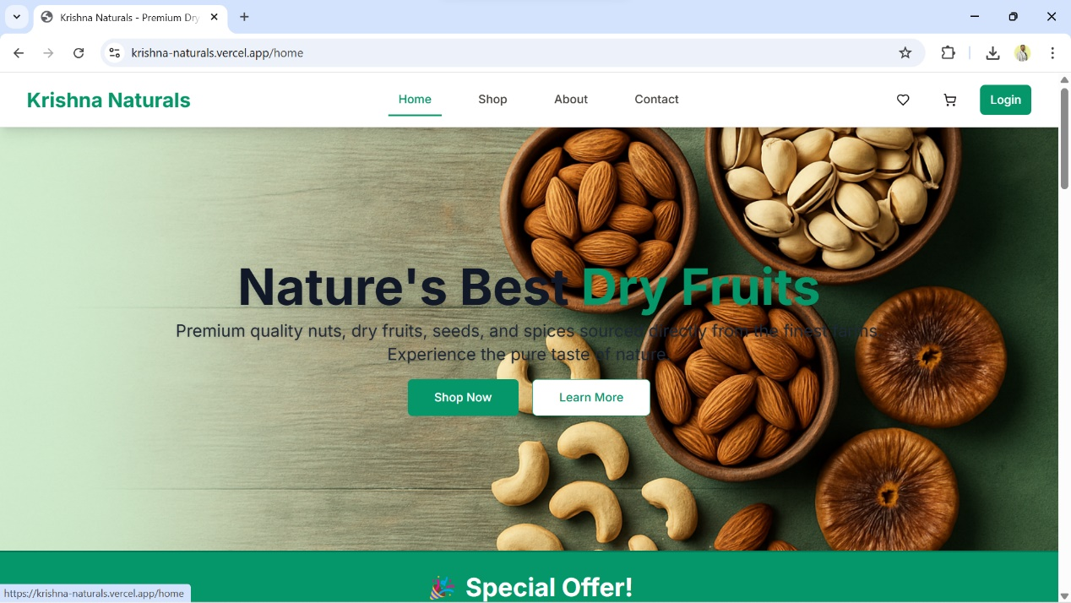 **Fig 3.2.1 Home Page**

**2. Shop All Products Page**

* **Category Filter:** Users can filter products by categories like Nuts, Dry Fruits, Seeds, and Spices.
* **Weight Filter:** Filter by packaging size – 100g, 250g, 500g, and 1kg.
* **Price Slider:** Dynamically updates the visible product range based on price selection (₹0–₹2000).
* **Search Box:** Users can search products by name or tag.
* **Sorting Options:** Sort by Name A-Z or other available criteria.
* **Stock Status & Tagging:** Shows if a product is in stock or low stock and categorizes items visually.

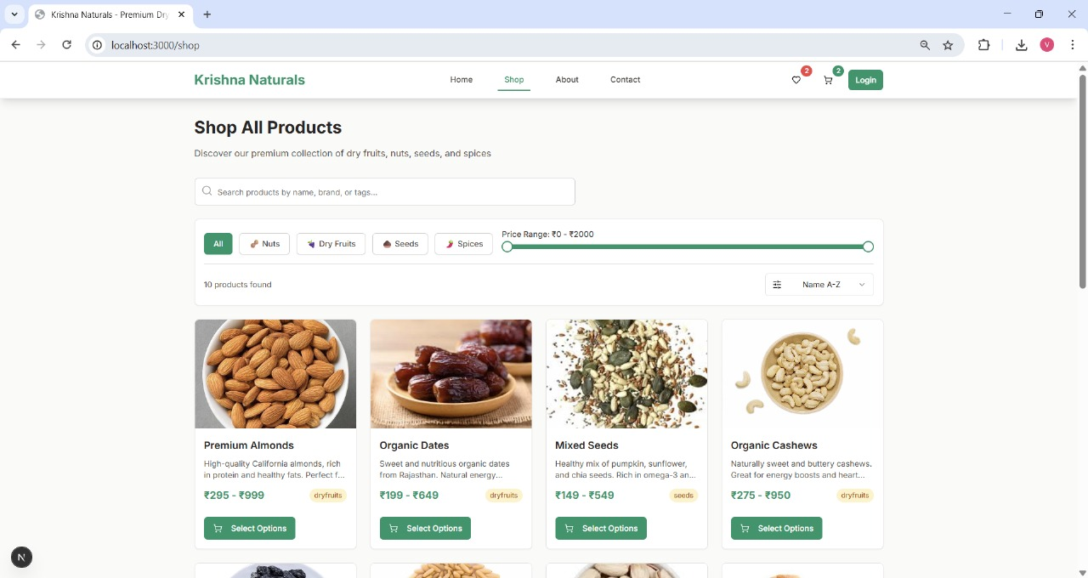**Advantage:** Offers a convenient shopping experience with interactive filters and visual cues.

**Fig 3.2.2 Shop Page**

**3. Product Cards**

* Each product card displays:
  + Product image
  + Name and short description
  + Price range
  + Category tag (e.g., dryfruits, seeds)
  + Stock availability
  + “Select Options” button for further actions
* Products like **Premium Almonds**, **Organic Dates**, and **Mixed Seeds** are listed.

**Advantage:** Easy browsing and purchasing without clutter; clear product info improves trust.

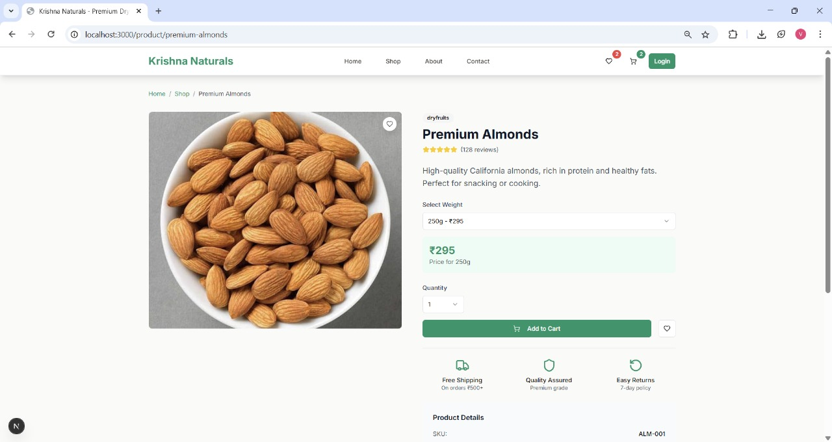

**Fig 3.2.3 Product Page**

**4. Cart & Checkout (Coming Soon or Under Development)**

* Add-to-cart and checkout buttons are available for each product.
* Product selection options such as quantity or weight can be included.
* Cart saves user choices temporarily or via backend (if implemented).

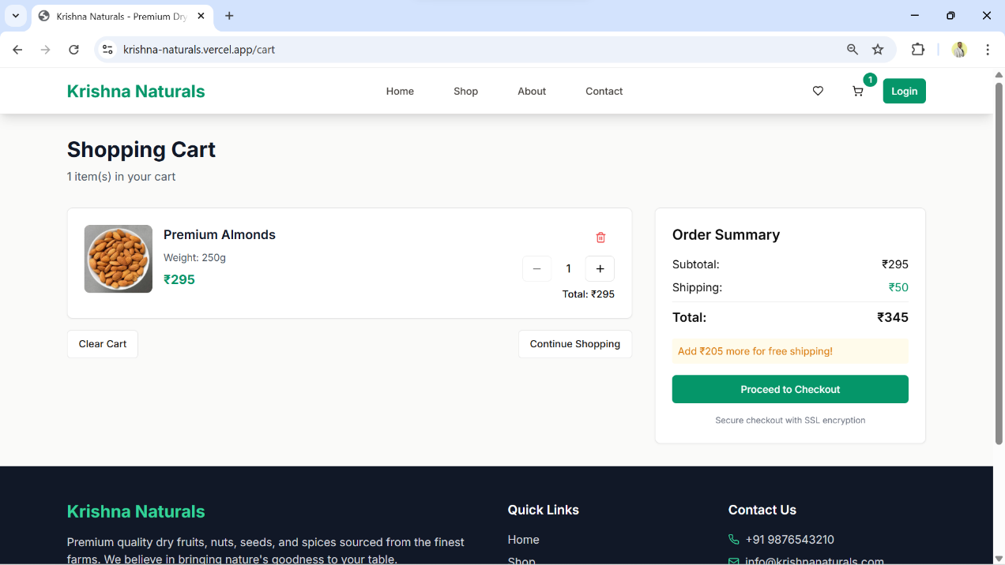

**Fig 3.2.4 Cart Page**

**5. Contact Page**

**Contact Form:**

* Fields: Name, Email, and Message
* Use: Allows users to send inquiries directly to the site admin

**Contact Information Cards:**

* Phone Number
* Email Address
* Physical Store Address
* Store Hours

**Advantage:** Builds trust and allows customers to reach out with questions or complaints easily.

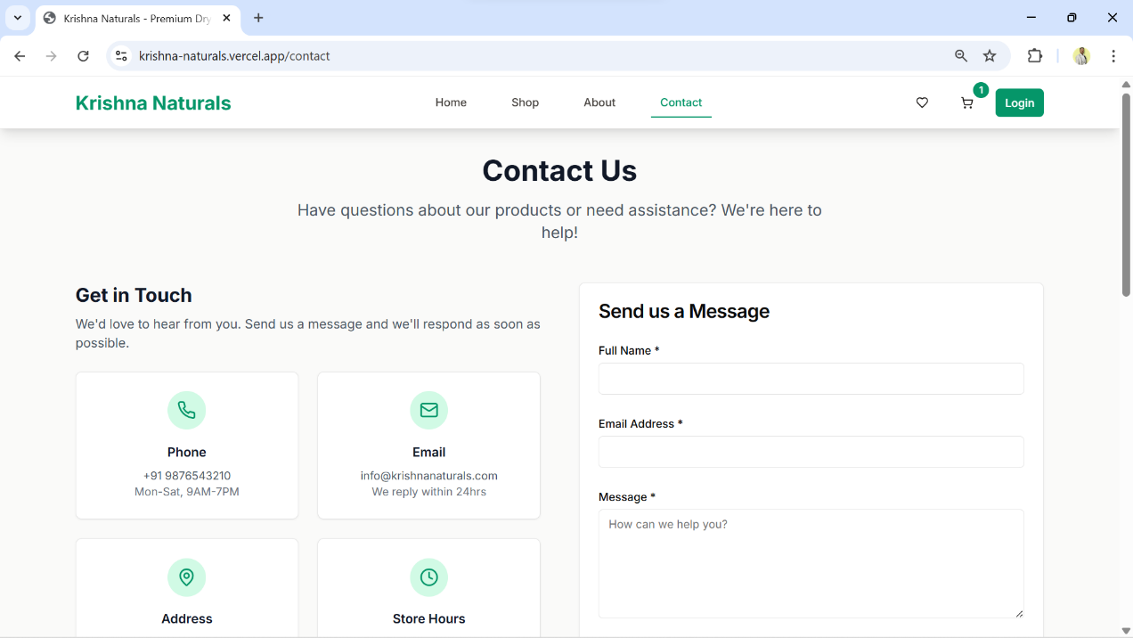

**Fig 3.2.5 Contact Us**

**3.3 User and Admin Authentication**

The website includes secure authentication mechanisms to differentiate between customers (users) and administrators (admin users). These login pages are essential to ensure role-based access to the platform.

1. **User Login Page:**

* Customers use the Login button on the main navigation bar to sign in.
* After successful login:
  + They can browse products, add to cart, place bulk orders, and send inquiries.
  + Their preferences and cart items are preserved.
  + Ensures a personalized shopping experience.

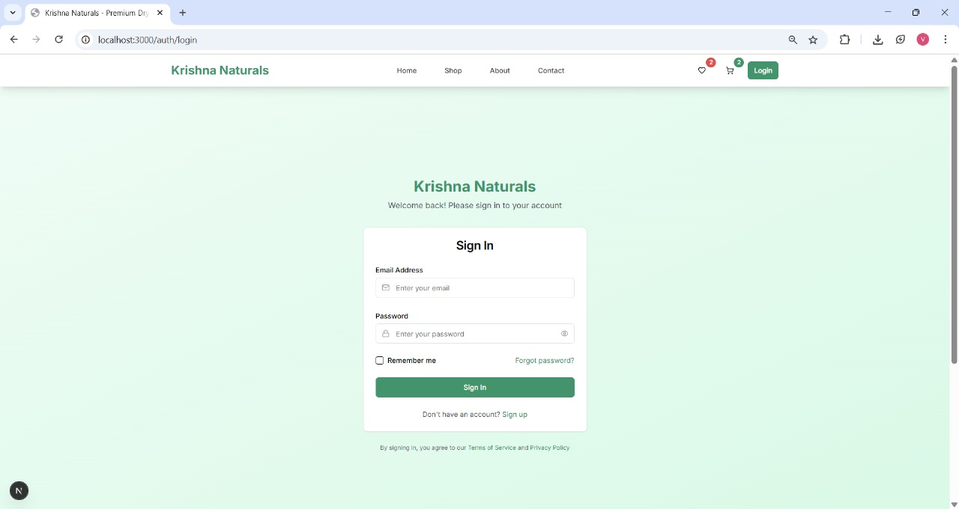

**Fig 3.3.1 User Sign In**

1. **Admin Dashboard Page:**

* Admins access a dedicated admin login (usually via a protected route like /admin/login).
* Once authenticated:
  + They are redirected to the Admin Dashboard.
  + Access to manage products, orders, users, and review system stats is granted.
* Ensures only authorized users can make critical changes to the backend.

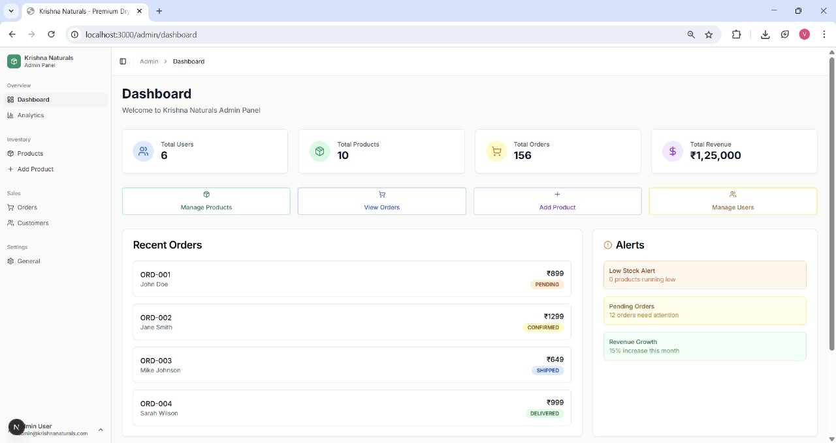

**Fig 3.3.2 Admin Dashboard**

**Key Features of Admin Dashboard**

* User Management: View and manage registered users.
* Product Control: Add, edit, or delete products.
* Order Monitoring: Track recent and past orders with status updates.
* Revenue Overview: Display of total income and monthly growth.
* Stock Alerts: Notify admin about low stock items.
* Quick Actions: Buttons for managing users, orders, and products efficiently.
* Dashboard Stats: Summary cards for total users, products, orders, and revenue.

3.4 **About Us Section**

The "About Us" section of **Krishna Naturals** provides users with insight into the brand's vision, mission, and core values. It highlights the commitment to offering premium quality dry fruits, nuts, seeds, and spices sourced directly from trusted farms. This section helps build customer trust by emphasizing freshness, purity, and ethical sourcing. It also aims to create a strong brand identity by showcasing the journey and goals of the business.

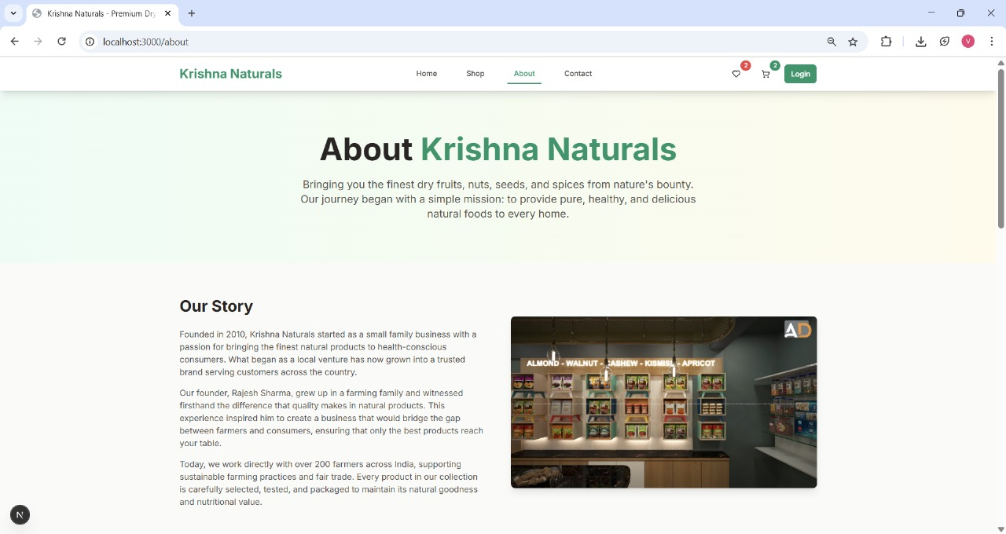

**Fig 3.4 About Us Page**

*CHAPTER 4*

**BACKEND ARCHITECTURE AND DATABASE DESIGN**

**4.1 Backend Architecture**

The backend is built using **Node.js** and **Express.js**, which form a lightweight, efficient, and scalable server environment for modern web applications. It follows a **RESTful API** architecture, enabling smooth communication between the frontend and backend.

**🛠️ Key Components:**

* **Node.js** – JavaScript runtime environment for backend development.
* **Express.js** – Framework for building fast, modular, and maintainable REST APIs.
* **MongoDB** – Cloud-hosted NoSQL database (via MongoDB Atlas).
* **Mongoose** – Object Data Modeling (ODM) tool to simplify database interaction.
* 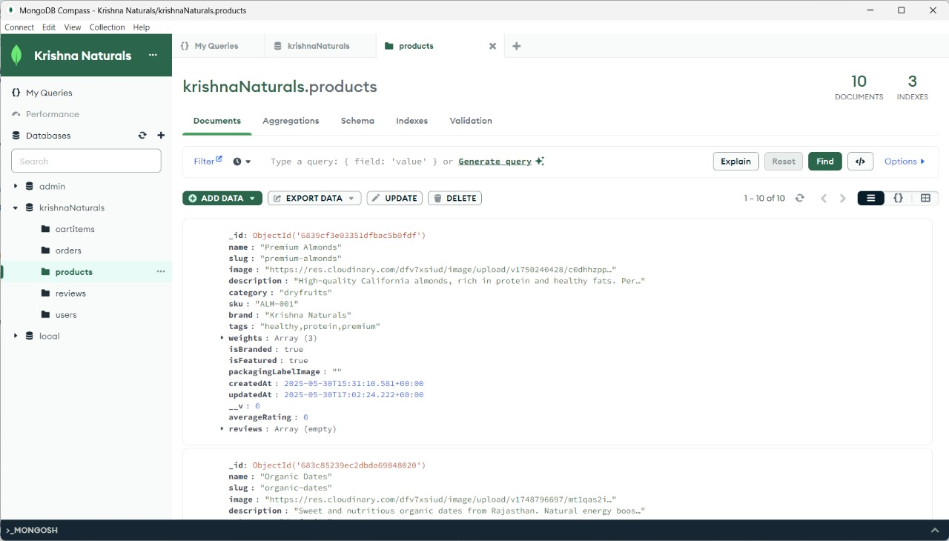**dotenv** – Manages configuration and environment variables securely.

**Fig 4.1 Mongodb Database**

**4.2 API Functionality**

The backend is designed to serve multiple API routes that handle various operations:

| **API Route** | **Description** |
| --- | --- |
| GET /api/products | Fetch all available products |
| POST /api/cartitems | Add items to the user cart |
| POST /api/enquiry | Accept bulk order form submissions |
| GET /api/users | Retrieve user details (for admin or auth system) |
| POST /api/orders | Store placed order data (future enhancement) |

Each endpoint communicates securely with the MongoDB database and returns structured JSON responses to the frontend.

**4.3 MongoDB Database Design**

The database krishnaNaturals is hosted on **MongoDB Atlas** and contains five main collections, each serving a specific purpose:

**1. products**

Stores all available dry fruits, seeds, nuts, and spices for sale.

**Sample Fields:**

* name
* category (e.g., dryfruits, seeds)
* description
* priceRange
* stock
* availableWeights
* imageUrl

**2. cartitems**

Tracks the items added to cart by users.

**Fields:**

* productId
* selectedWeight
* quantity
* userSessionId or userId

**3. users**

Contains details of registered users.

**Fields:**

* name
* email
* passwordHash
* address
* role (e.g., customer, admin)

**4. orders**

Pre-configured to store complete order data. Will be used when the full order placement and checkout system is implemented.

**Fields:**

* userId
* items[]
* totalAmount
* paymentStatus
* orderStatus

**5. reviews**

Structured to allow customers to post feedback on purchased products.

**Fields:**

* productId
* userId
* rating
* comment

**4.4 MongoDB Compass View**

A snapshot of the live database shows the collections along with their document count:

| **Collection** | **Documents** | **Usage** |
| --- | --- | --- |
| products | 3 | Store all products for the shop |
| cartitems | 1 | Tracks cart items temporarily |
| orders | 0 | Future order records |
| reviews | 0 | Customer feedback (planned) |
| users | 6 | Registered user accounts |

**4.5 Security & Best Practices**

* Passwords are stored in **hashed** form (using bcrypt or similar methods).
* API endpoints are protected from unauthorized access (via middleware, future JWT support).
* Sensitive credentials are stored in .env and are **never hard-coded**.
* Mongoose validation is used to maintain consistency in database entries.
* Data is sanitized before being stored to prevent injection attacks.

**4.6 Scalability & Future Enhancements**

* **Payment Integration:** Razorpay/Stripe for secure online transactions.
* **Admin Dashboard:** For managing products and viewing orders.
* **Search Optimization:** ElasticSearch or MongoDB text indexing.
* **Analytics:** Product views, sales tracking, and customer activity logs.

**REFERENCE**

Web Development & Frameworks

1. ReactJS – Official Documentation  
   https://reactjs.org/docs/getting-started.html
2. Node.js – Official Documentation  
   https://nodejs.org/en/docs
3. Express.js – API Reference  
   https://expressjs.com/en/api.html
4. MongoDB – Atlas & Mongoose Documentation  
   <https://www.mongodb.com/docs/atlas/>  
   https://mongoosejs.com/docs/guide.html

Tools and Deployment

1. Visual Studio Code – Code Editor  
   <https://code.visualstudio.com>
2. Vercel – Frontend Hosting Platform  
   <https://vercel.com>
3. MongoDB Compass – GUI for Database Management  
   <https://www.mongodb.com/products/compass>
4. Postman – API Testing Tool  
   <https://www.postman.com>

**🔗** Project Link

* Live Project URL:  
  <https://krishna-naturals.vercel.app>

GitHub Repository

Project Source Code (GitHub):

<https://github.com/vmandhani09/Krishna-Naturals>

**CONCLUSION**

The Krishna Naturals – Online Dry Fruit Shop project marks a significant step towards digitizing traditional dry fruit and grocery retailing. The goal of this project was to develop a fully functional, responsive, and user-friendly e-commerce platform where customers can browse, filter, and order premium quality dry fruits, seeds, nuts, and spices from the comfort of their homes.

The project involved both frontend development using ReactJS and backend development using Node.js, Express.js, and MongoDB. The product filtering features, cart system (under development), bulk enquiry form, and contact page collectively contribute to a seamless user experience. The integration of a NoSQL database (MongoDB) allows for efficient data storage and retrieval, making the system highly scalable and adaptable to future needs.

Throughout the development journey, multiple technical concepts were applied and understood in-depth—ranging from RESTful API creation, component-based architecture, state management, to data modeling and secure form handling. The website is fully deployed on Vercel, and the backend APIs (where applicable) can be scaled or migrated for future integrations like payment gateways, user login systems, and admin dashboards.

In conclusion, the project not only meets the core objectives of offering an online platform for dry fruit shopping but also lays the foundation for a full-fledged business expansion in the digital domain. It has enhanced the developer’s understanding of full-stack web development and opened up new possibilities for implementing real-world applications using modern web technologies.