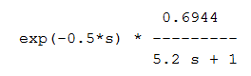= G

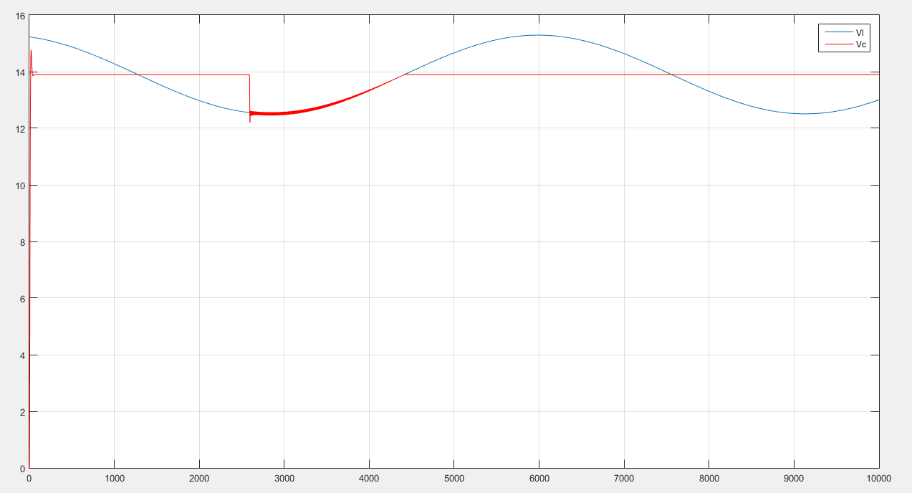

Controlando com um PI:

Tau novo = 1,01 tau

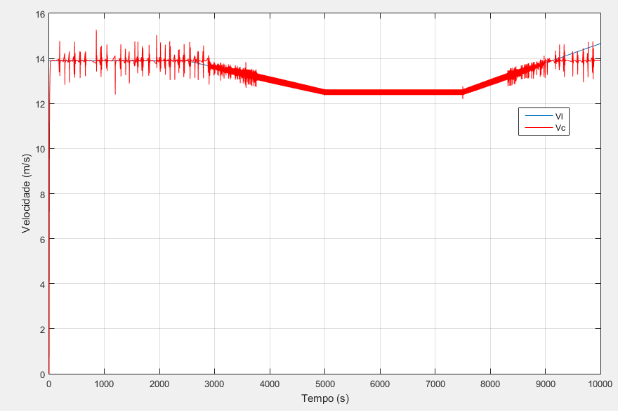

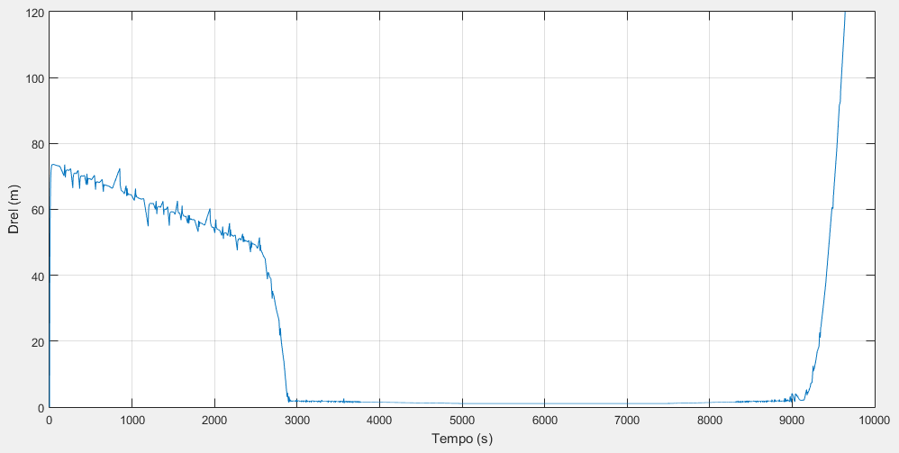

Tau novo = 1,05 tau

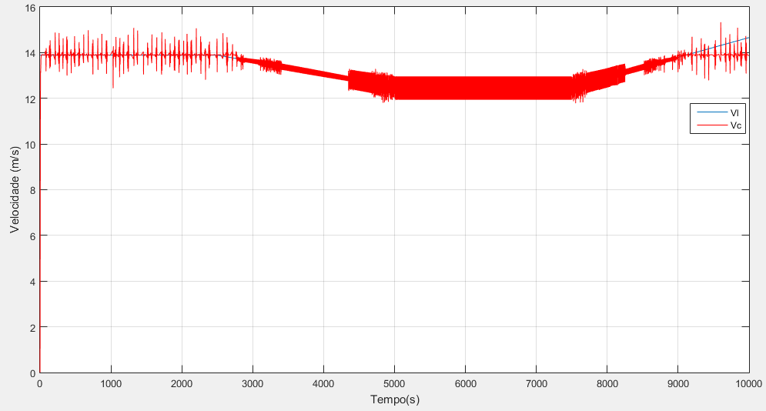

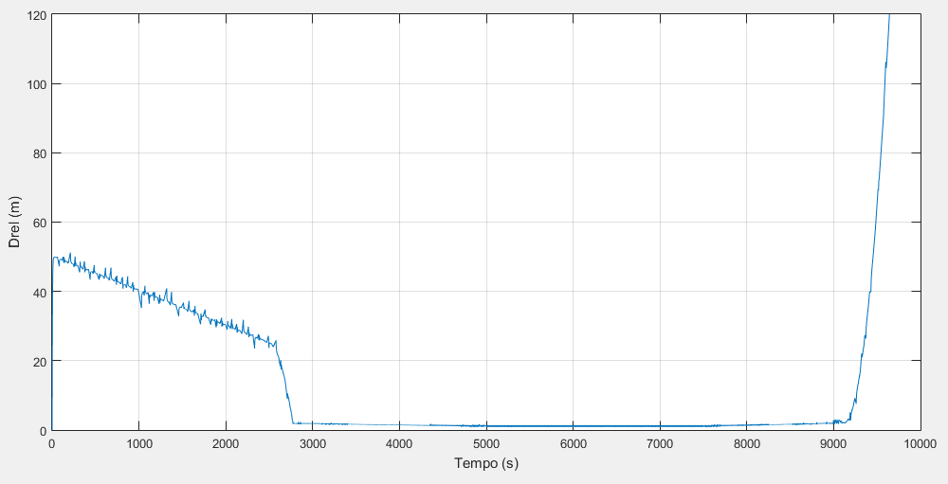

Tau novo = 2 tau

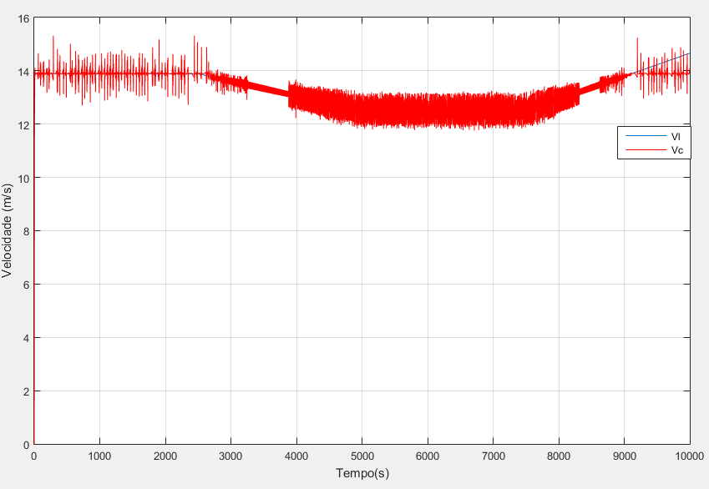

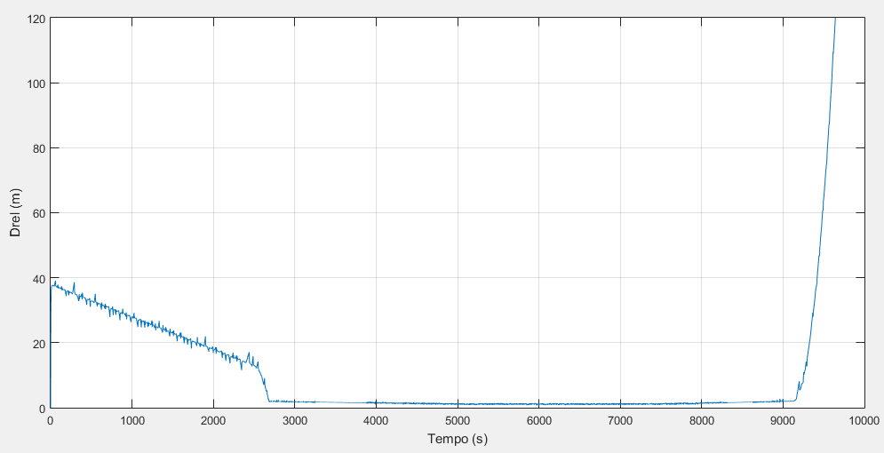

Simulink

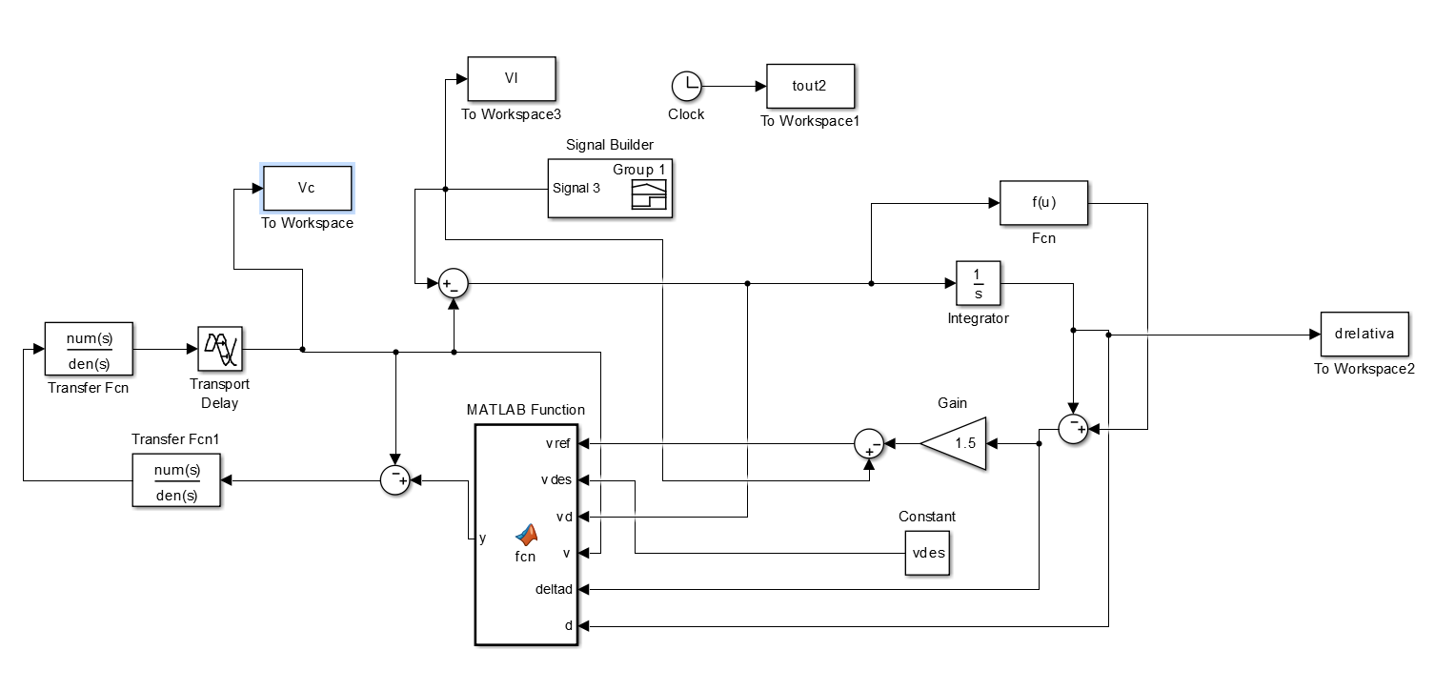

LGR Planta

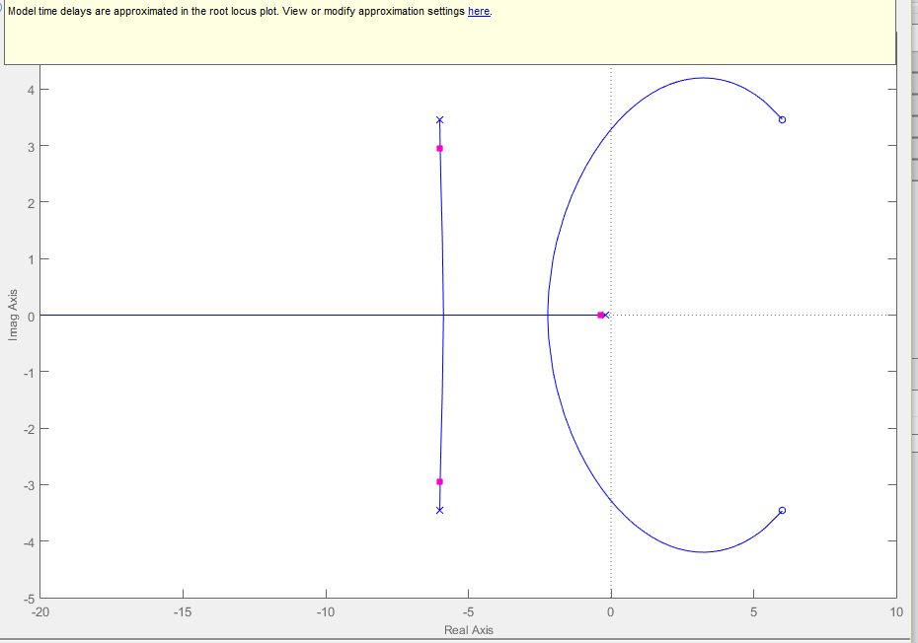

LGR com controlador

Com zoom:

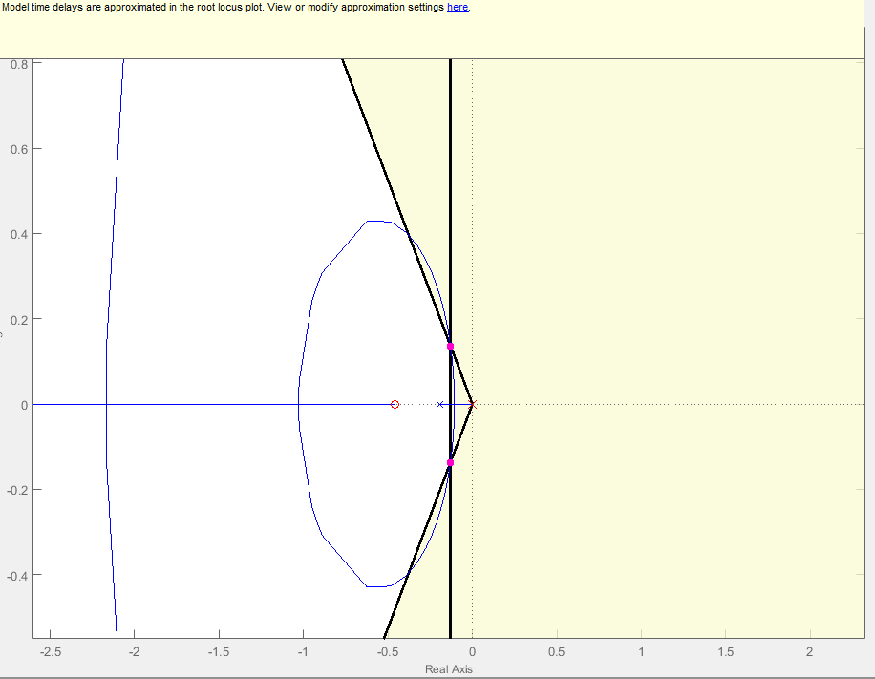

Sem zoom:

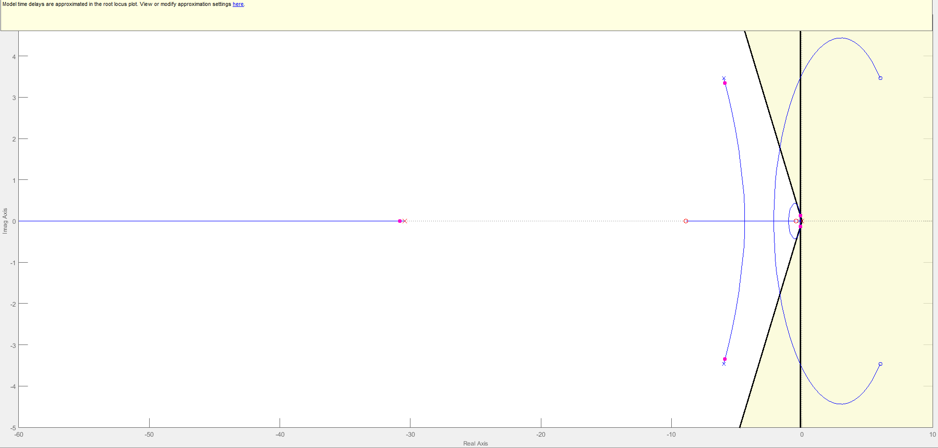

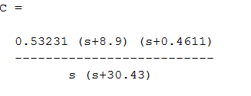

Q tbm pode ser representado assim:

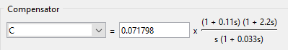

Comparação modelo e curva experimental

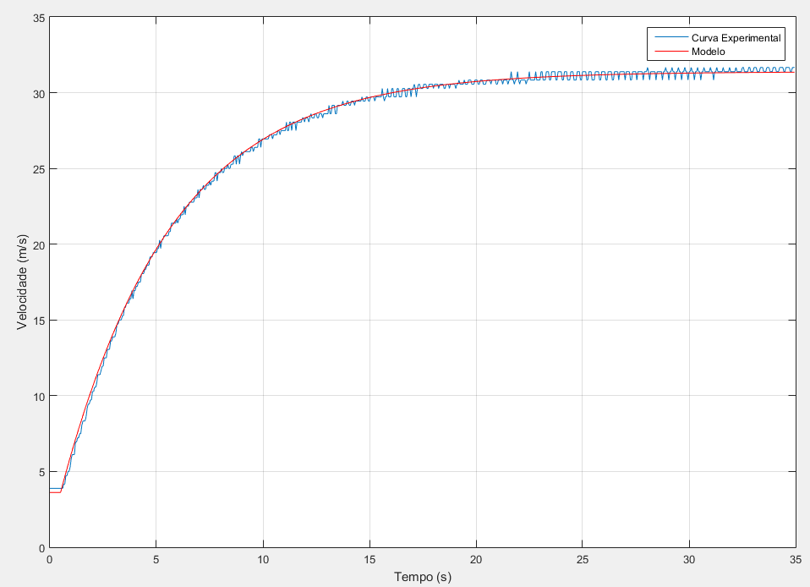

Saidas com PID

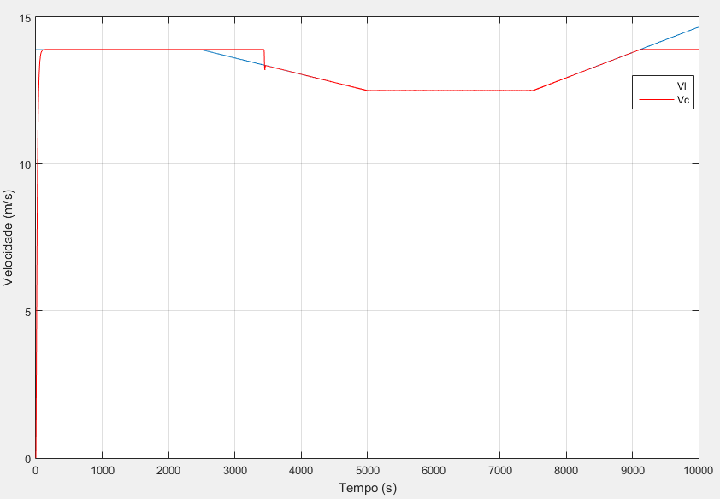

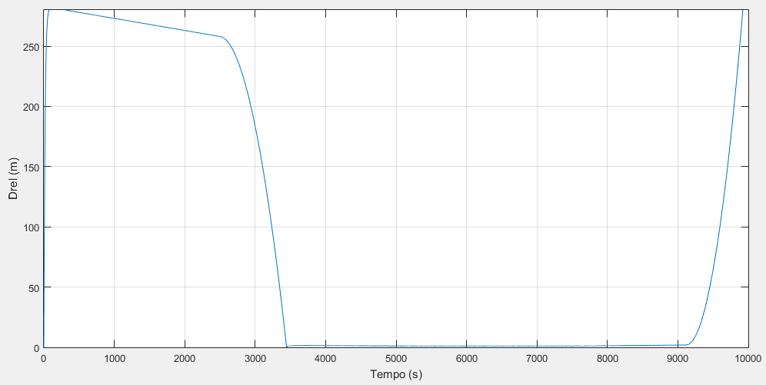

Codigo Principal : (Tem q tirar os comentários)

close all;

clear all;

clc;

Ta = 1/100;

Tsim = 10000;

t = 0:Ta:Tsim;

%vdes = zeros(1,length(t));

%vdes(t>0) = 50;

vdes=13.9;

% vl = zeros(1,length(t));

% dref = zeros(1, length(t));

% m = 1067;

% b = 50;

ident;

%calcula vl

% vl(t>2) = 50/3.6;

% for k = 400:1000

% vl(k) = vl(k-1) - .005;

% end

%

% for k = 1000:100000

% vl(k) = vl(k-1);

% end

% for k = 3000:4000

% vl(k) = vl(k-1) + .01;

% end

% for k = 4000:6000

% vl(k) = vl(k-1);

% end

% for k = 6000:7000

% vl(k) = vl(k-1) + .02;

% end

% for k = 7000:9000

% vl(k) = vl(k-1) - .02;

% end

% for k = 9000:10000

% vl(k) = vl(k-1);

% end

% plot(vl)

% taux=t';

% Vl.time = taux;

% Vl.signals.values = vl';

% Vl.signals.dimensions = 1;

s=tf('s');

% Ti = 5.2;

% Kp = 2/0.6944;

% Cpi = (Kp/(Ti*s))*(Ti*s + 1);

sim('Curva_vl');

figure (99);

plot(tout2,vl,tout2,vc, 'r');

grid

figure (101);

plot(tout2, drelativa);

grid

%figure (102);

%plot(tout2,dist, tout2, ent, 'r');

%grid

Codigo do bloco no simulink:

function y = fcn(vref, vdes, vd, v, deltad,d)

if(deltad<0)

y=vdes;

else

if(v<vref)

y=min(vdes, vref);

else

if(vd < 0)

y=min(vdes, vref);

else

y = vdes;

end

end

end

Codigo q calculou o modelo:

tempo = 1e-3*[33

83

133

183

233

283

333

383

433

483

533

583

633

683

733

783

833

883

933

984

1033

1083

1133

1183

1233

1283

1333

1383

1433

1483

1533

1583

1633

1683

1733

1783

1833

1883

1933

1983

2033

2083

2133

2183

2233

2283

2333

2383

2433

2483

2533

2583

2633

2683

2733

2783

2833

2883

2933

2983

3033

3083

3133

3184

3233

3283

3333

3383

3433

3483

3533

3583

3633

3683

3733

3783

3833

3883

3933

3983

4033

4083

4133

4183

4233

4283

4333

4383

4433

4483

4533

4583

4633

4683

4733

4783

4833

4883

4933

4983

5033

5083

5133

5183

5233

5283

5333

5383

5433

5483

5533

5583

5633

5683

5733

5783

5833

5883

5933

5983

6033

6083

6133

6183

6233

6283

6333

6383

6433

6483

6533

6583

6633

6683

6733

6783

6834

6883

6933

6983

7033

7083

7133

7183

7233

7283

7333

7384

7433

7483

7533

7583

7633

7683

7733

7783

7833

7883

7933

7983

8033

8083

8133

8183

8233

8284

8333

8383

8433

8483

8533

8583

8633

8683

8733

8783

8833

8883

8933

8983

9034

9083

9133

9183

9233

9283

9333

9383

9433

9483

9533

9583

9633

9683

9733

9783

9833

9884

9933

9983

10034

10084

10133

10183

10233

10284

10334

10384

10434

10485

10534

10584

10634

10684

10734

10784

10834

10884

10934

10984

11034

11084

11134

11184

11233

11284

11334

11384

11434

11484

11534

11584

11634

11684

11734

11784

11834

11884

11934

11984

12034

12084

12134

12184

12234

12284

12334

12384

12433

12483

12533

12583

12633

12683

12733

12783

12833

12883

12933

12983

13033

13083

13133

13183

13233

13283

13333

13383

13433

13483

13533

13583

13633

13683

13733

13783

13833

13883

13933

13983

14033

14083

14133

14183

14233

14283

14333

14383

14433

14483

14533

14583

14633

14683

14733

14783

14833

14883

14933

14983

15033

15083

15133

15183

15233

15283

15333

15383

15433

15483

15533

15583

15633

15683

15733

15783

15833

15883

15933

15983

16033

16083

16133

16183

16233

16283

16333

16383

16433

16483

16533

16583

16633

16683

16733

16783

16833

16883

16933

16983

17033

17083

17133

17183

17233

17283

17333

17383

17433

17483

17533

17583

17633

17683

17733

17783

17833

17883

17933

17983

18033

18083

18133

18183

18233

18283

18333

18383

18433

18483

18533

18583

18633

18683

18733

18783

18833

18883

18933

18983

19033

19083

19133

19183

19233

19283

19333

19383

19433

19483

19533

19583

19633

19683

19733

19783

19833

19883

19933

19983

20033

20083

20133

20183

20233

20283

20333

20383

20433

20483

20533

20583

20633

20683

20733

20783

20833

20883

20933

20983

21034

21083

21133

21183

21233

21283

21333

21383

21433

21483

21533

21583

21633

21683

21733

21783

21833

21883

21933

21983

22033

22083

22133

22183

22233

22283

22333

22383

22433

22483

22533

22583

22633

22683

22733

22783

22833

22883

22933

22988

23033

23083

23133

23183

23233

23283

23333

23383

23433

23483

23533

23583

23633

23683

23733

23783

23833

23883

23933

23983

24033

24083

24133

24183

24233

24283

24333

24384

24433

24483

24533

24583

24633

24683

24733

24783

24833

24883

24933

24983

25033

25083

25134

25183

25233

25283

25333

25383

25433

25483

25533

25583

25633

25683

25733

25783

25833

25883

25933

25983

26033

26083

26133

26183

26233

26283

26333

26383

26433

26483

26533

26584

26633

26683

26733

26783

26833

26883

26933

26983

27033

27083

27133

27183

27233

27283

27333

27383

27433

27483

27533

27583

27633

27683

27733

27783

27833

27883

27933

27983

28033

28083

28133

28183

28233

28283

28333

28383

28433

28483

28533

28583

28633

28683

28733

28783

28833

28883

28933

28983

29033

29083

29133

29183

29233

29283

29333

29383

29433

29483

29533

29583

29633

29683

29733

29783

29833

29883

29932

29982

30032

30082

30133

30182

30232

30282

30332

30382

30432

30482

30532

30582

30632

30682

30732

30782

30832

30882

30932

30983

31032

31082

31132

31182

31232

31282

31332

31382

31432

31482

31532

31582

31632

31682

31733

31782

31832

31882

31932

31982

32032

32082

32132

32182

32232

32282

32332

32382

32432

32482

32532

32582

32632

32682

32732

32782

32832

32882

32932

32982

33033

33083

33132

33182

33233

33282

33332

33382

33432

33482

33532

33582

33632

33682

33732

33782

33832

33882

33932

33982

34032

34082

34132

34182

34232

34282

34332

34382

34433

34482

34532

34582

34633

34682

34732

34782

34832

34882

34932

34982

35032

35082

35133

35182

35232

35282

35332

35382

35432

35483

35532

35583

35633

35682

35733

35783

35833

35883

35933

35983

36033

36083

36133

36183

36233

36283

36332

36383

36433

36483

36533

36583

36632

36683

36733

36783

36833

36883

36933

36983

37033

37083

37133

37183

37233

37283

37333

37383

37433

37483

37533

37583

37633

37683

37733

37783

37833

37883

37933

37983

38033

38083

38133

38183

38233

38283

38333

38383

38433

38483

38533

38583

38633

38683

38733

38783

38833

38883

38933

38983

39033

39083

39133

39183

39233

39283

39333

39383

39433

39483

39533

39583

39633

39683

39734

39783

39833

39883

39933

39983];

vel = (1/3.6)*[13

13

14

14

14

13

13

13

13

13

13

13

14

14

14

13

13

13

13

13

13

14

14

14

13

13

13

13

13

13

13

14

14

13

13

13

14

14

13

14

14

14

14

14

14

14

14

14

14

14

14

14

14

14

14

14

14

14

14

14

14

14

14

14

14

14

14

14

14

14

14

14

14

14

14

14

14

14

14

14

14

14

14

14

14

14

14

14

14

14

14

14

14

14

14

14

14

14

14

14

14

14

14

14

14

14

14

14

14

14

14

14

14

15

15

17

17

18

18

19

21

22

22

22

25

25

26

26

27

27

29

30

30

30

31

33

34

34

35

35

37

37

38

38

39

41

41

41

42

43

43

45

45

45

47

47

47

49

49

50

50

50

51

53

53

54

54

54

55

55

57

57

58

58

58

59

59

61

59

61

61

62

62

63

63

63

65

65

65

66

66

67

67

67

69

69

69

70

70

70

70

71

71

73

71

73

73

74

74

74

74

74

75

75

77

77

77

77

77

78

77

78

78

79

79

79

81

79

81

81

81

82

82

82

82

82

83

83

83

85

83

85

85

85

86

85

85

86

86

86

87

86

87

87

87

89

89

87

89

89

89

90

89

89

90

90

90

91

90

90

91

91

91

93

93

91

93

93

91

93

94

93

94

94

94

94

94

94

94

95

95

94

95

95

95

95

97

97

95

97

97

97

97

97

97

97

98

98

98

97

98

98

98

98

99

99

98

99

99

99

99

99

101

99

99

101

101

99

101

101

101

99

101

101

101

101

101

102

102

101

102

102

102

101

102

103

102

102

102

103

103

102

102

103

103

103

102

103

103

103

103

103

105

103

103

105

105

105

103

103

105

105

105

105

105

106

105

105

105

106

106

105

105

106

106

106

105

106

106

106

106

106

106

107

106

106

106

107

107

106

106

107

107

107

107

106

107

107

107

107

107

107

109

107

106

107

107

109

107

107

107

109

109

107

107

107

109

109

107

107

107

109

109

109

107

107

109

109

109

107

109

109

110

109

107

109

110

110

109

109

109

110

110

110

109

109

110

110

110

110

109

110

110

110

110

109

110

110

110

110

109

109

110

110

110

109

110

110

110

110

110

109

110

110

111

110

110

110

110

111

110

110

110

111

111

111

110

110

110

111

111

111

110

110

111

111

111

110

110

110

111

111

111

111

110

111

111

111

111

110

110

111

111

111

111

110

111

111

111

111

110

111

111

113

111

111

110

111

111

113

111

110

111

111

111

111

111

110

111

111

113

111

111

111

111

111

113

111

111

111

111

113

113

111

111

111

113

113

113

111

111

113

113

113

113

111

111

113

113

113

113

111

111

113

113

113

111

111

111

113

113

113

111

111

111

113

113

113

111

111

113

113

113

113

111

111

113

113

113

111

111

111

113

113

113

113

111

111

113

113

113

113

111

111

113

113

113

113

111

111

113

113

113

113

111

113

113

113

113

113

111

113

113

113

113

111

111

113

113

113

113

111

113

113

113

113

113

111

113

113

113

114

113

111

113

113

113

113

113

111

113

113

113

113

113

111

113

113

114

113

113

111

113

113

114

113

113

111

113

113

114

113

113

111

113

113

114

113

113

111

113

113

114

113

113

111

113

113

114

113

113

111

113

113

114

113

113

113

113

113

114

113

113

111

113

113

114

113

113

113

113

113

114

113

113

113

113

113

114

113

113

113

113

113

114

113

113

113

113

113

114

114

113

113

113

113

114

114

113

113

113

114

114

114

113

113

113

114

114

114

113

113

113

114

114

114

113

113

113

114

114

114

113

113

113

114

114

114

114

113

113

114

114

114

114

113

113

114

114

114

];

u = [0

0

0

0

0

0

0

0

0

0

0

0

0

0

0

0

0

0

0

0

0

0

0

0

0

0

0

0

0

0

0

0

0

0

0

0

0

0

0

0

0

0

0

0

0

0

0

0

0

0

0

0

0

0

0

0

0

0

0

0

0

0

0

0

0

0

0

0

0

0

0

0

0

0

0

0

0

0

0

0

0

0

0

0

0

0

0

0

0

0

0

0

0

0

0

0

0

0

0

0

40

40

40

40

40

40

40

40

40

40

40

40

40

40

40

40

40

40

40

40

40

40

40

40

40

40

40

40

40

40

40

40

40

40

40

40

40

40

40

40

40

40

40

40

40

40

40

40

40

40

40

40

40

40

40

40

40

40

40

40

40

40

40

40

40

40

40

40

40

40

40

40

40

40

40

40

40

40

40

40

40

40

40

40

40

40

40

40

40

40

40

40

40

40

40

40

40

40

40

40

40

40

40

40

40

40

40

40

40

40

40

40

40

40

40

40

40

40

40

40

40

40

40

40

40

40

40

40

40

40

40

40

40

40

40

40

40

40

40

40

40

40

40

40

40

40

40

40

40

40

40

40

40

40

40

40

40

40

40

40

40

40

40

40

40

40

40

40

40

40

40

40

40

40

40

40

40

40

40

40

40

40

40

40

40

40

40

40

40

40

40

40

40

40

40

40

40

40

40

40

40

40

40

40

40

40

40

40

40

40

40

40

40

40

40

40

40

40

40

40

40

40

40

40

40

40

40

40

40

40

40

40

40

40

40

40

40

40

40

40

40

40

40

40

40

40

40

40

40

40

40

40

40

40

40

40

40

40

40

40

40

40

40

40

40

40

40

40

40

40

40

40

40

40

40

40

40

40

40

40

40

40

40

40

40

40

40

40

40

40

40

40

40

40

40

40

40

40

40

40

40

40

40

40

40

40

40

40

40

40

40

40

40

40

40

40

40

40

40

40

40

40

40

40

40

40

40

40

40

40

40

40

40

40

40

40

40

40

40

40

40

40

40

40

40

40

40

40

40

40

40

40

40

40

40

40

40

40

40

40

40

40

40

40

40

40

40

40

40

40

40

40

40

40

40

40

40

40

40

40

40

40

40

40

40

40

40

40

40

40

40

40

40

40

40

40

40

40

40

40

40

40

40

40

40

40

40

40

40

40

40

40

40

40

40

40

40

40

40

40

40

40

40

40

40

40

40

40

40

40

40

40

40

40

40

40

40

40

40

40

40

40

40

40

40

40

40

40

40

40

40

40

40

40

40

40

40

40

40

40

40

40

40

40

40

40

40

40

40

40

40

40

40

40

40

40

40

40

40

40

40

40

40

40

40

40

40

40

40

40

40

40

40

40

40

40

40

40

40

40

40

40

40

40

40

40

40

40

40

40

40

40

40

40

40

40

40

40

40

40

40

40

40

40

40

40

40

40

40

40

40

40

40

40

40

40

40

40

40

40

40

40

40

40

40

40

40

40

40

40

40

40

40

40

40

40

40

40

40

40

40

40

40

40

40

40

40

40

40

40

40

40

40

40

40

40

40

40

40

40

40

40

40

40

40

40

40

40

40

40

40

40

40

40

40

40

40

40

40

40

40

40

40

40

40

40

40

40

40

40

40

40

40

40

40

40

40

40

40

40

40

40

40

40

40

40

40

40

40

40

40

40

40

40

40

40

40

40

40

40

40

40

40

40

40

40

40

40

40

40

40

40

40

40

40

40

40

40

40

40

40

40

40

40

40

40

40

40

40

40

40

40

40

40

40

40

40

40

40

40

40

40

40

40

40

40

40

40

40

40

40

40

40

40

40

40

40

40

40

40

];

u_ = u(101:end);

vel_ = vel(101:end);

tempo_ = tempo(101:end) - tempo(101);

s = tf('s');

t_ = (0:length(u_)-1)*0.05;

G = (1/3.6)*2.5/(5.2*s +1);

G.InputDelay = 0.5;

y = (1/3.6)*13+lsim(G,u_,t_);

figure(100);

plot(tempo_,vel_,t_,y,'r')