Cum importi view:

Rulare;:

http://127.0.0.1:8000/accounts/login/.

http://127.0.0.1:8000/admin/

D:\An3\IS\P1>python -m pipenv shell

(P1-qv8LNru9) D:\An3\IS\P1>pip shell

(P1-qv8LNru9) D:\An3\IS\P1>python manage.py runserver

<http://127.0.0.1:8000/>

<http://127.0.0.1:8000/accounts/signup/>

<http://127.0.0.1:8000/accounts/login/>

<http://127.0.0.1:8000/>

Imbunatatire:

IS:

-am pus logo

--am facut frontend pagina log-out +log in

- e responsive- hamburger!!

-hover pe butoane

-pagini pt fiecare actiune

-carusel 😊

0La butoane (Lojin) are mesaje😊

Modificari:

D:\An3\IS\P1\templates\account\login.html

D:\An3\IS\P1\templates\home.html

Create a new view:

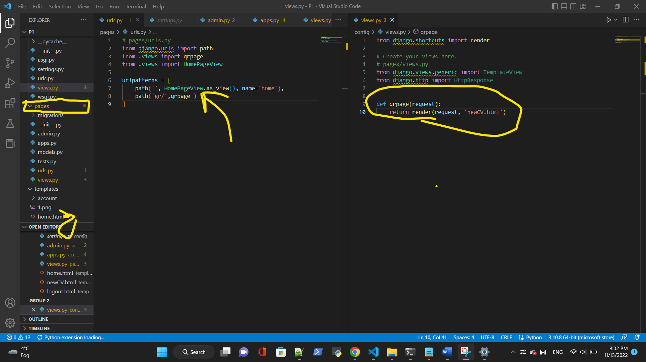

Modificari pt pagin home, deschid pagina cand apas pe un buton…

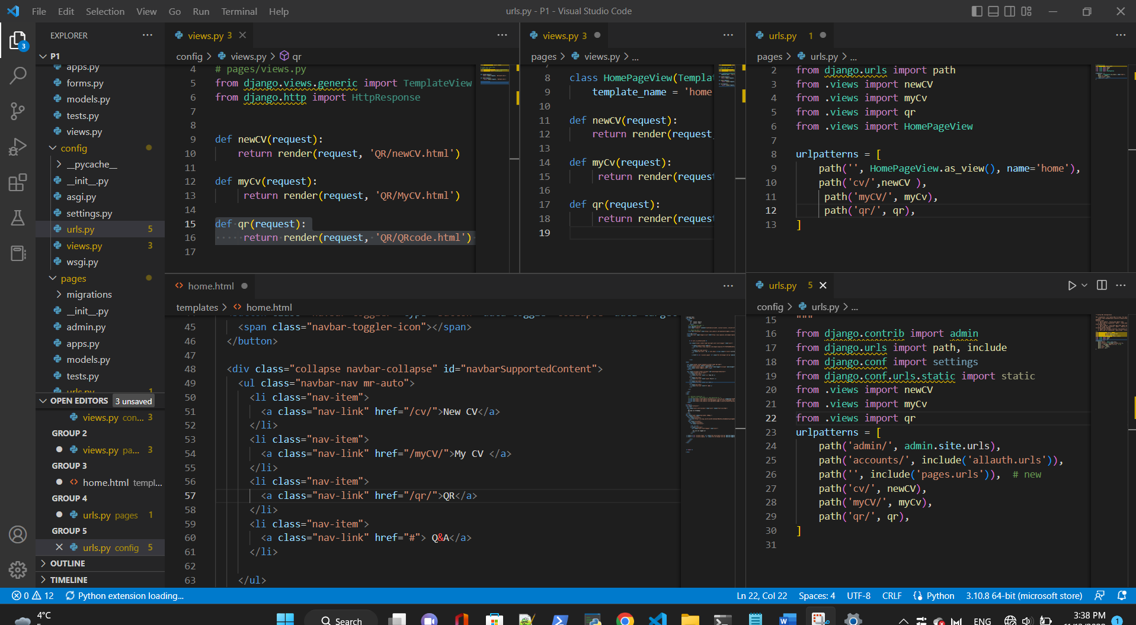

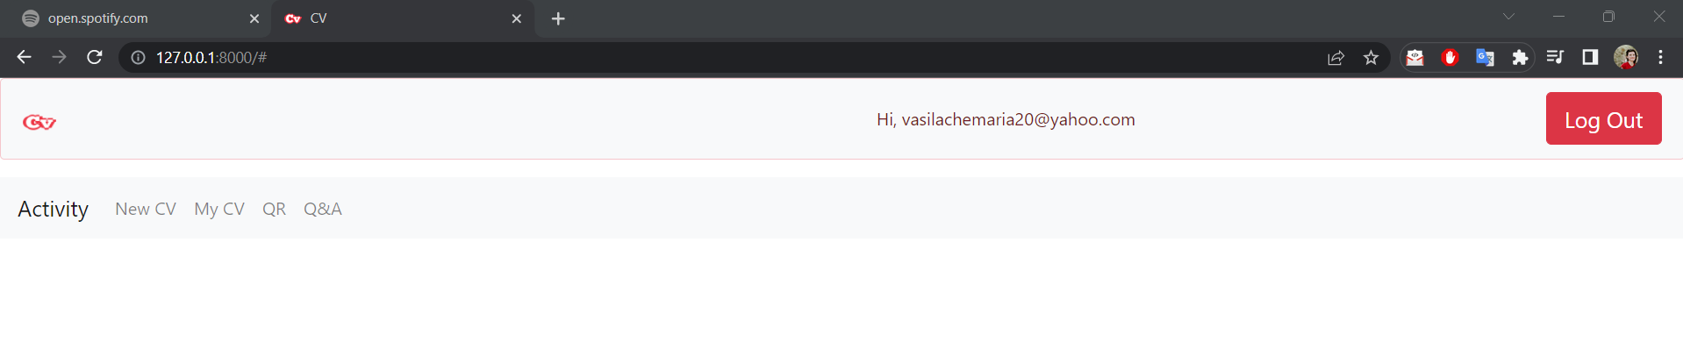

DE facut- pagina de inceput: ce este si la ce se utilizeaza 😊

Pt parola- sa respecte un format

Send email

Create CV-ul propriu-zis 😊