VINEETH REDDY MARYADA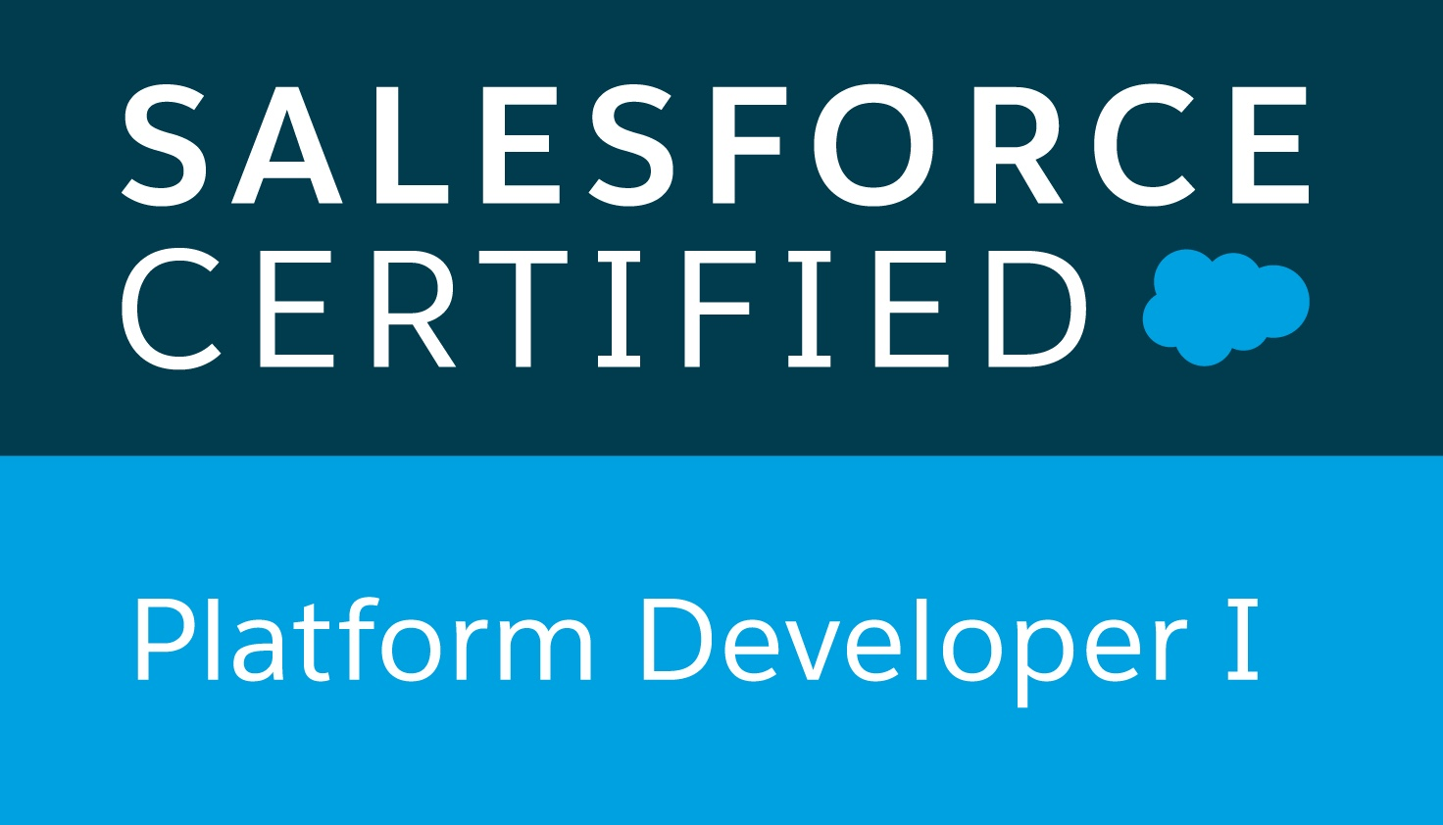

**Phone No.** +1 (402) 305-1244, **Email:** [vmaryada@unomaha.edu](mailto:vmaryada@unomaha.edu)

**Linkedin**: [linkedin.com/in/vmaryada/](https://www.linkedin.com/in/vmaryada/) **Github**: [github.com/vmaryada](http://github.com/vmaryada)

SUMMARY

* 4+ years of experience working extensively in application design, development and testing across different software programming platforms (Salesforce, Amazon S3, React Native, React JS and Wordpress).
* I am an efficient leader, fast and forever learner, and possess the ability to switch gears when needed.
* Took the initiative to learn React Native to single-handedly develop a iOS app to unify all the applications into one.
* As a full stack developer i had opportunity to work in frontend, backend and deployment.
* Developed a Full Stack web application using React JS, Redux, Express JS, Material UI and Firebase in the backend.

• Mentoring and collaborating with Jr. Developer in various web development projects.

• Ability to quickly adapt to new technologies, methodologies and frameworks.

TECHNOLOGY STACK

* Programming Languages - Typescript, Javascript, PHP, Apex.
* Web Development – HTML5, CSS, Node JS, Visual Force, AWS S3.
* Mobile App Development - React Native.
* Frameworks – React JS, Angular Js, jQuery.
* Unit Testing – Jest, Enzyme.

• Database – Firebase, MySQL, SOQL (Salesforce), Amazon RDS (PostgreSQL).

• Robotic Process Automation – UiPath.

* UI Frameworks - Material UI, React Native Paper and Bootstrap.
* State Management - Redux, React Context.
* Tools - Docker, Visual Studio Code, Postman, MavensMate (Salesforce), Adobe Dreamweaver.
* SDLC Methodologies - Agile, Waterfall.

CERTIFICATIONS

* **Salesforce Platform Developer I.**
* System Analysis and Design, Graduate Certificate at University of Nebraska at Omaha.
* RPA Developer Foundation Diploma from UiPath.

PROFESSIONAL EXPERIENCE

**Full Stack Application Developer** at **Milan Laser Corporate**, Omaha, Nebraska. From May 2017

* Design, develop and deployment of a one stop shop iOS app for store managers using React Native, React, Express JS, Redux and Firebase.
* Developed a type-script, React JS single page application to gather user information and created an api using Express JS and firebase cloud functions to send data to Firebase Cloudstore. Tested the application using react-testing-library and Jest. This project eliminated paper entries and allowed store managers to have more analytics on the promotion.
* Developed a React JS based single page application to populate Google reviews for all our stores by using Google Places Api. Used the browser’s local storage to efficiently make api calls. This minimized the api usage and in turn saving company money.
* Developed a React Native component to display an interactive sales presentation to replace third party company’s presentation saving well over $10,000 a year and at least 4 hours of time for graphic designers for every update.
* Developed a Quote Calculator application using Angular JS, MySQL, PHP. This project eliminated human calculation and made it easy for managers to sell the product more professionally. Company saw a dramatic increase in sales after this project.
* Developed various Salesforce web services in apex so that we can send data to Salesforce using web hooks from different software applications.
* Developed an Angular JS, PHP, Firebase based application to pre-qualify clients by consuming and sending data to external financial institution’s api.
* Developed a directory website for laser hair removal called [laserhairremovalnearme.com](http://laserhairremovalnearme.com) in Wordpress and have done lot of custom coding in themes and plugins as per the leadership’s requirement.

Other Duties

* Mentoring and guiding a Jr. Developer in various software development projects and about the best practices in software development.
* Collaborating with graphic designers, project managers and SEO Analysts to improve legacy application’s performance and usability.

**Web Developer Intern** at **Water for Food Institute**, University of Nebraska, Lincoln. July 2016-Sept 2016

• Creating a custom websites on WordPress platform for WFI research projects.

• Updating the existing HTML pages to match the look and feel of the new Nebraska Water Center website.

• Building a Database driven website to showcase research projects related to Water for Food Institute and

Nebraska Water Center.

ACADEMIC PROJECTS

**Omaha Fire Department Wellness Application Capstone Project**

University of Nebraska at Omaha

* Web Application using Laravel 5.3 PHP Framework to develop a MVC architecture which is platform independent to eliminate paper based process for firefighters’ wellness.
* Environment: HTML5, Angular JS, Bootstrap, Node JS, Heroku, GitHub.

**Financial Services Online Portal ISQA 8210**

University of Nebraska at Omaha

* Developed a web application for online portal for fictional financial institution.
* Environment: HTML5, PHPmyAdmin, CakePHP, Ajax, jQuery, GitHub.

PERSONAL PROJECTS:

**Social Media Application**

* A Twitter like React JS Application that uses Firebase in the backend.
* App is hosted on Github pages and can be visited at this link - <https://vmaryada.github.io/rooster/>

**React Native before after slider**

* Developed a npm package for before after image comparison slider.
* <https://www.npmjs.com/package/react-native-before-after-slider-v2>

EDUCATION

• **University of Nebraska at Omaha**. May 2017 GPA: 3.58

Master of Sciences in MANAGEMENT INFORMATION SYSTEMS.

• **Jawaharlal Nehru Technological University**, India. May 2015 GPA: 3.60

Bachelor of Technology in COMPUTER SCIENCE.