Table “dbo.Provider” contains all providers registered in system. Exist next columns to describe import process:

* “Folder” column – path to raw files
* “SchemaFilePath” column – path to xml file which describe mapping settings from raw file to some table in database
* “TableName” column – table name in database where we can find imported data from raw file
* “FirstRow” column – number of first row with data in raw file

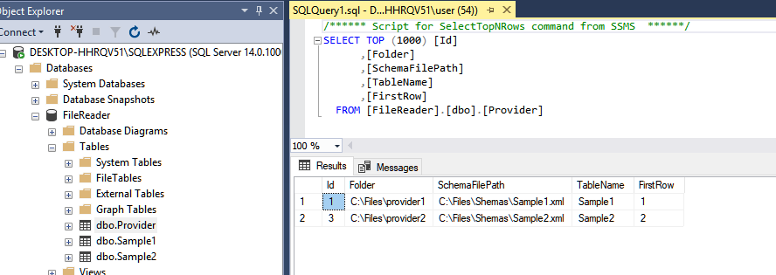

Stored procedure [dbo].[spReadFiles] have one input parameter “@folder” for what folder we need to process all files, for example “C:\Files\provider2”. Stored procedure will determine what provider need to use and will process all files.

Sample of Shema xml file for provider with Id=1 (linked table Sample1 in database)

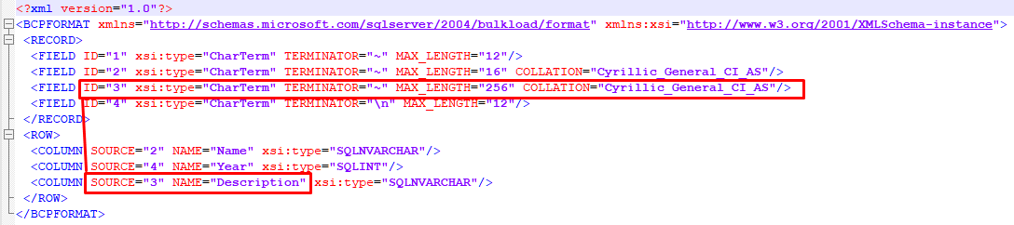

In section <Record> we describe structure of column/data in file

In section <Row> we describe how to map each column to linked table columns

Here you can see Field with ID=3 will map to Column Description in table Sample1

Here is sample of data for provider1:

