Assignment 1

Table of Contents:

Home……...………………………………………………………………………………………………………………………………………………3

Products………………………………………………………………………………………………………………………………………………….4

Sign Up…………………………………………………………………………………………………………………………………………………….5

Login………………………………………………………………………………………………………………………………………………………..6

Home : 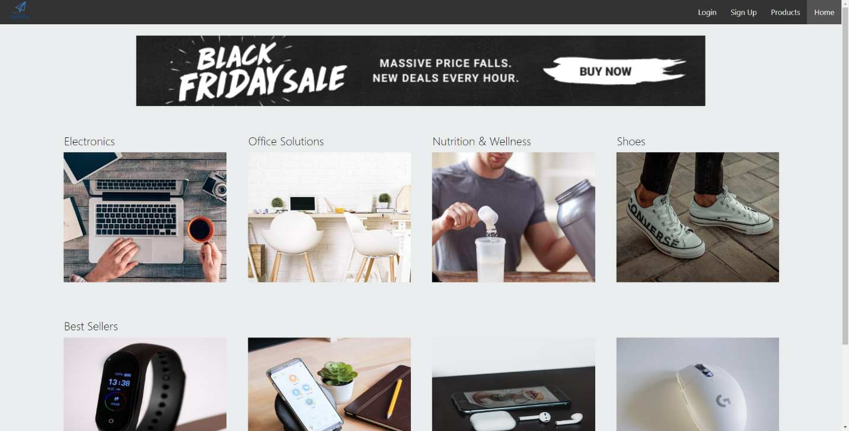

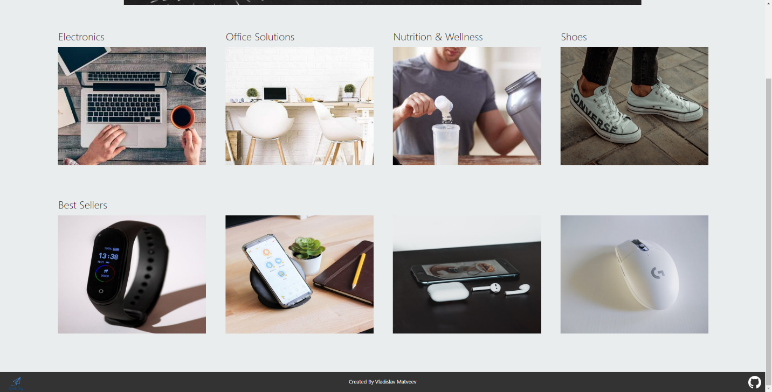

I created 3 different models for the Categories, Best Sellers and the Products page. I have successfully pulled these images from the “fake database” but I could not figure out how to implement the boolean attribute indicating if it is a best seller or not.

Products :

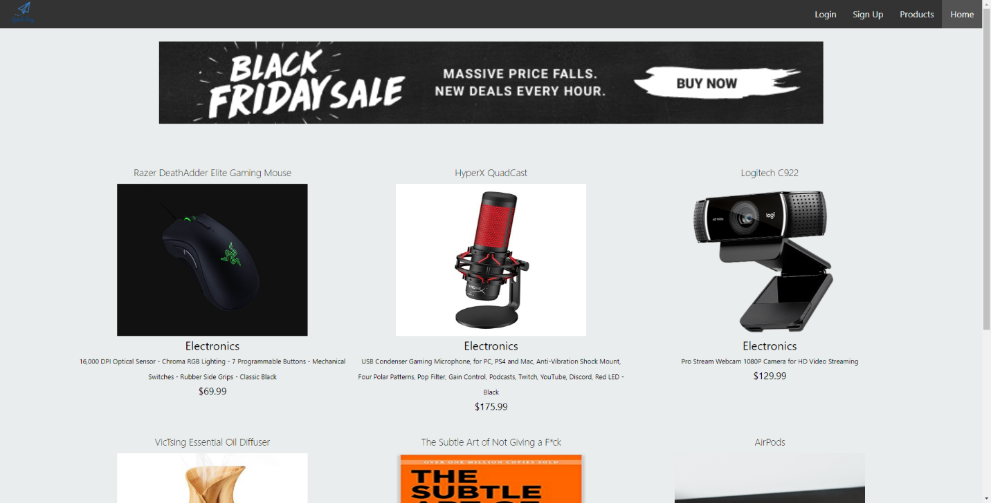

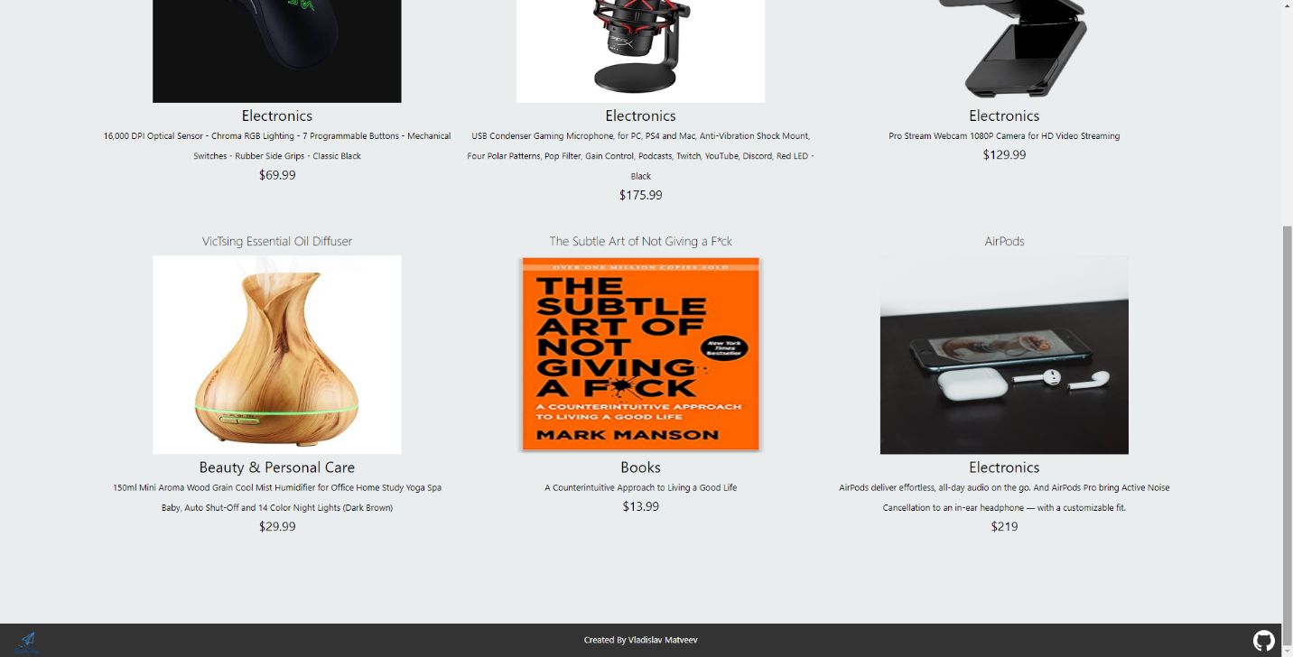

Mostly all the functionalities were met except the boolean attribute indicating if it is a best seller or not. I was not sure how to implement this functionality, otherwise everything went well.

Sign Up Form :

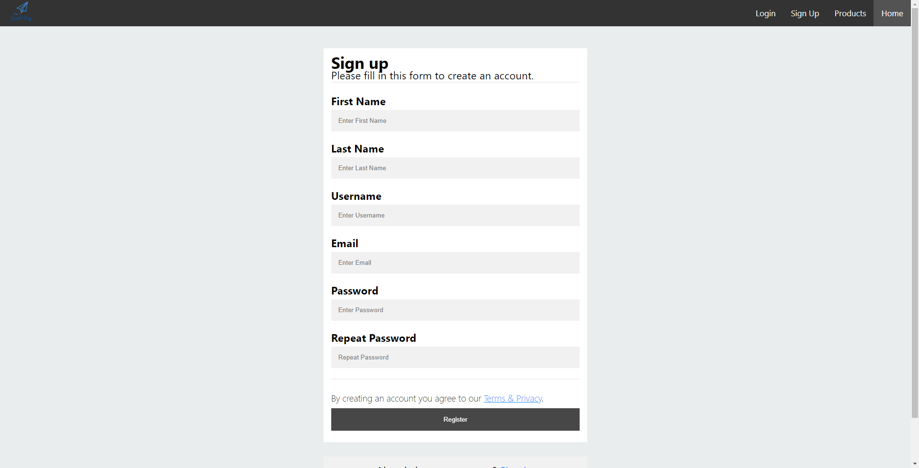



I basically took the Signup and Login form from W3Schools but changed the CSS to my liking. There is no functionality for this page and Login page. Doing CSS on this was a headache but DEV Tools was a big friend.

Login :

