The Mantra
Red Green Refactor
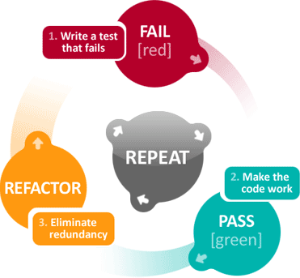

The Rules
1. You are not allowed to write any production code until you have first written a failing unit test.
2. You are not allowed to write more of a unit test than is sufficient to fail – and not compiling is failing.
3. You are not allowed to write more production code that is sufficient to pass the currently failing unit test.
Why write tests first?
1. To simplify design, and therefore code. Small simple increments.
2. To force me to think about design - ideally what are the methods I would like to call?
3. To maximize test coverage - If I break existing code, I find out immediately.

