BVAL 7Y

* Statespace representation was done since OLS cannot fit when there’s no estimation performed.
* Variables were lagged from 1 to 2 data points.
* Forward selection criterion was performed to initially get optimal variables, n_vars was set to 15.
* Reduction was done to meet VIF < 10 and p-value < 0.10.
* Robust check was performed to check if the linear model passed the assumptions.
* Serial correlation was present.

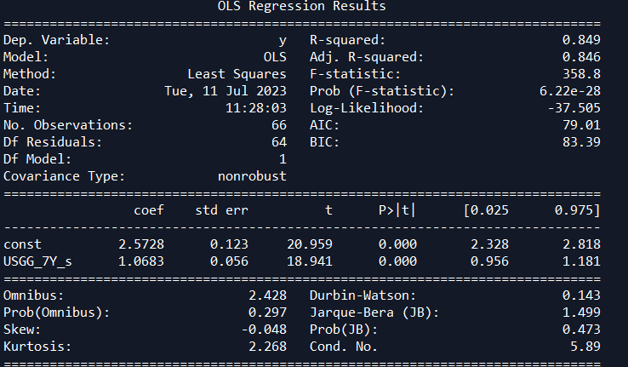

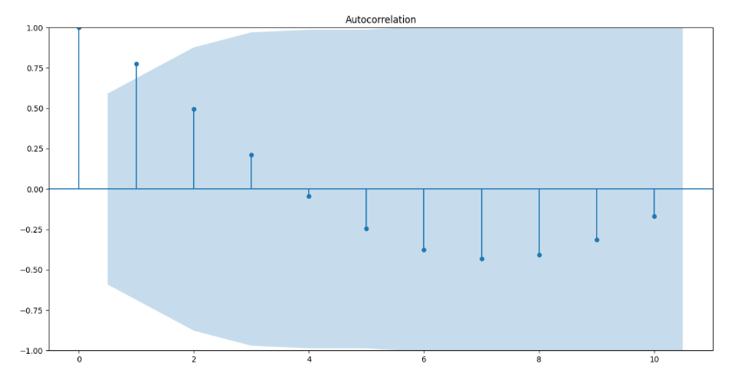

* Cochrane Orcutt procedure was implemented to derive the **FINAL Model**.

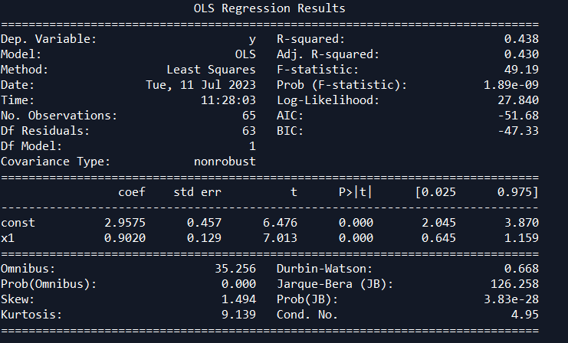

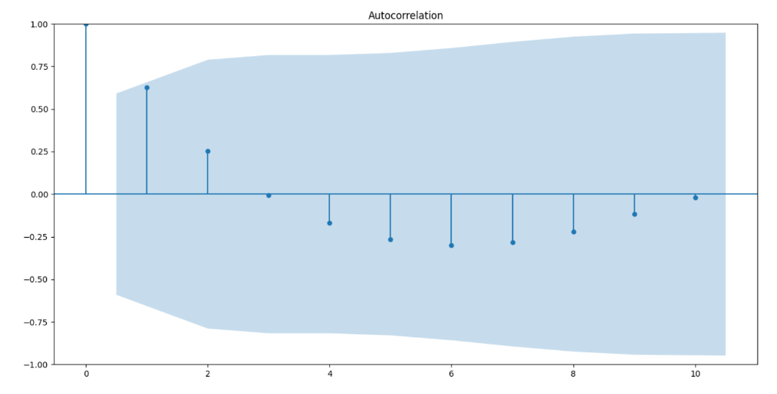

* Mean absolute percentage error (test size: 5 data points).

|  |  |  |
| --- | --- | --- |
|  | In-sample | Out-sample |
| MAPE | 11.05% | 5.69% |

BVAL 10Y

* + Statespace representation was done since OLS cannot fit when there’s no estimation performed.
  + Variables were lagged from 1 to 2 data points.
  + Forward selection criterion was performed to initially get optimal variables, n_vars was set to 15.
  + Reduction was done to meet VIF < 10 and p-value < 0.10.
  + Robust check was performed to check if the linear model passed the assumptions.
  + Serial correlation was present.

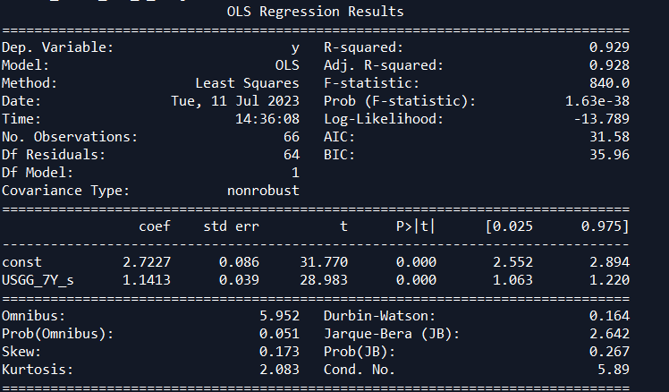

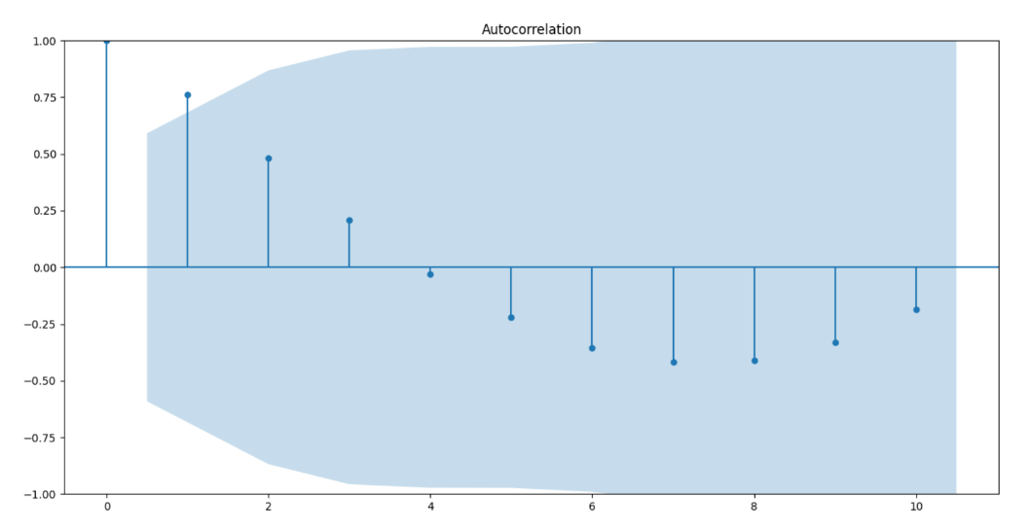

* + Cochrane Orcutt procedure was implemented to derive the **FINAL Model**.

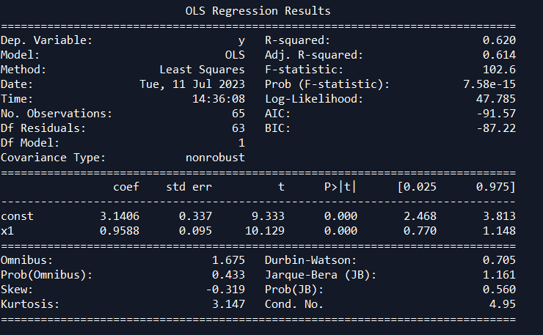

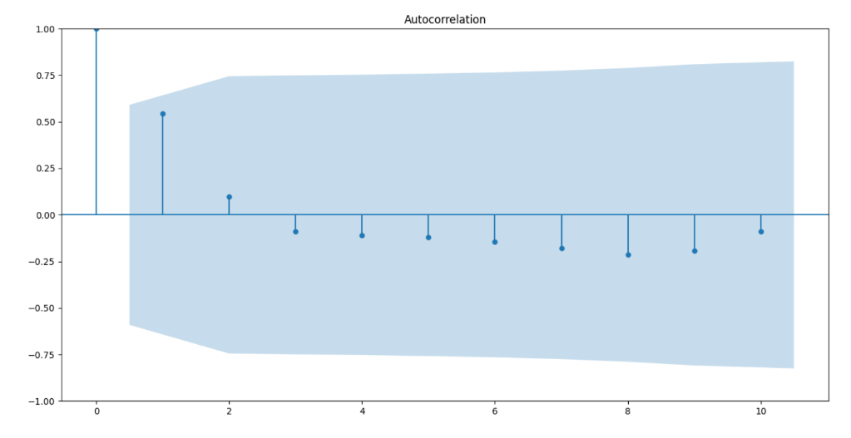

* Mean absolute percentage error (test size: 5 data points).

|  |  |  |
| --- | --- | --- |
|  | In-sample | Out-sample |
| MAPE | 8.43% | 10.15% |