Wireless Sonar System In The Tank Level Measurement
Lam-Pham-Nhu¹, Tu-Tran-Thanh², Hieu-Vo-Manh³, Binh-Nguyen-Thanh⁴ and Tin- Dang-Thanh⁵
¹²³⁴⁵University of Technology-Vietnam National University Ho Chi Minh City
dttin@hcmut.edu.vn
Abstract. Storage of water is common to all human for domestic and industrial utilization. Nowadays, water tank are conventional and major in water storage systems as they have the capacity to hold a large volume of water over a long period of time. They come in different shapes and sizes. However inadequate monitoring of water level in this storage facility may lead to either shortage of water supply when needed or its wastage during lifting process. Hence, there is a need for proper monitoring of water level in the storage facility. We need motivate this work, which is the development of wireless water level monitoring system that based on sonar technology. Materials employed in the development include ultrasonic sensor module, Adruino Uno and Arduino Nano, Bluetooth device HC-05. The developed system which helps us to measure the tank level at anytime has potential of mitigating the attendant problems that usually arise from wastage or shortage of water supply with respect to water storage facility.
Keywords: Sonar, Wireless, Bluetooth, Tank level measuring.
- Introduction
SONAR (Sound Navigation and Ranging) refers to the technique of using sound wave propagation for navigation, detecting and communicating between two entities that are SONAR based devices. SONAR technology relies principally on reflection property of sound, as a form of wave, when it encounters an obstruction in its path of travel. The former only observes the remotely generated sound without transmitting while the latter has the capability of emitting and receiving pulses of sound signals. The pulse signals involved in SONAR could either be infrasonic (low frequency signals usually below the threshold of human perception, typically 20 Hz) and ultrasonic waves, which consist of highfrequency sound waves that are inaudible to humans (typically above 20 kHz). SONAR based on ultrasonic finds application in range estimation. The use of tubes as non-mechanical underwater listening devices, for detection and transmission of sound waves in water is ancient. The art of underwater communication via sound wave actually began in 1490, when Leonardo Da Vinci proposed a method of detecting a remote ship at a distance from a stationary onboard ship by placing one head of a long tube inside water and the other outer one to ear (Urick, 1983). Towards the end of 18th century, increased efforts are geared toward exploring physical properties associated with sound transmission in water. Notable achievements in this regard include articulation of the principle of sound transmission, discovery of piezoelectric effect for pulse generation, and invention of the hydrophone, which is designed to utilize acoustic sound waves and echoes in underwater detection system (Smith, 2016). Threat of submarine warfare during WW I fast-tracked the development of SONAR technology. However not all of the advances were restricted to military applications. Corresponding Author Among typical civilian applications is a SONAR-based device installed on large ocean-liners for detecting, visualizing and quantifying schools of fish in water in order to enhance fish hunting efficiency (Persons et al., 2014). Also, underwater human-robot interaction where detection and tracking of a diver by an underwater robotic assistant is realized through a high-frequency forward-looking SONAR system has been reported (DeMarco et al, 2013). SONAR equally finds applications in acoustics as well as oceanic engineering for range estimation and terrain modeling (Dombestein and Wegger, 2014; Hjelmervik, 2010; Hodges, 2011). Besides the underwater applications of SONAR, air-borne SONAR has been widely deployed in robots and car navigation (Ullah et al., 2013; Sarabia et al., 2013), driverless cars for people detection and navigation of autonomous [1].
To design the tank level measurement device, in this paper we will introduce the Related Work in Section 2. Section 3 will introduce how sonar technology works. Then, we describe the measurement principle in Section 4. In Section 5, the base system is showed. Our experiment results are illustrated in section 6. Finally, some conclusions are drawn in Section 7.
- Related Work
From the olden days, water is an extremely precious resource that nature has bestowed on us. It represents the survival of the existence of all living things on earth in general and humans in particular. In the olden times, empires were strong to develop, based on the terrain of the rivers. When people knew different ways to store water, then the empire could expand and expand. Therefore, the reservation and management of water resources were a vital issue of the empire. army,... Since ancient times, people have known how to engrave and contemplate water reserves, and then with the development of science and technology, people have been creating many different ways to manage. The height of the water source is being stored. We can mention that the method is to use that pressure method to get the liquid level. In this method, it is based on the basic formula P = P₀ + ρgh where P₀ is the pressure [2]. The rate of fluid surface clearance, g is the gravitational acceleration and ρ is the specific gravity of the liquid. We can see that the biggest drawback of this method is that the height we calculate will depend ρ, which is the nature of the fluid because each of the different liquids ρ will be different, not only that ρ is dependent. In many environments, such as temperature, flow rate, another method can be used to convert float to ink [3]. This method uses a stainless steel float device that floats on the surface of the water, which is mounted with a rheostat. When the water rises or falls, the buoy also changes position, which leads to a change in the position of the slider on the boundary, where the value of the variable resistor plays an important role. The disadvantage of this method is that the use of rheostat, long-term use will wear out the scanners which are easy to damage, not only the float in the tank can jam, cause false signals. Finally, the sonar method, using ultrasonic broadcasting technology to measure the height of the container. The method is to use a device to shoot ultrasound, at which time the timer will work, when the ultrasonic waves meet the liquid surface. Immediately reflect back, there will be equipment to recognize that the ultrasonic wave was fired to notify the timer stop, after the time value, we will value the time the super warm wave calculates the ink distance The liquid with the equipment and when the average height we can calculate to obtain the average height value. The main thing is to calculate the distance to the times. However, the alternative is that it can be applied to many types of liquids, without having to contact the liquid directly, avoiding the effects on the equipment, internal power of the appliance and easy to maintain when the appliance is on the lid. It is these advantages that most people use the third option widely nowadays [4].
- Fundamental theory
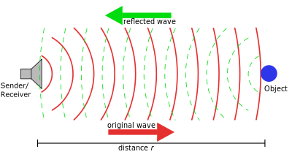
Active sonar creates a pulse of sound, often called a "ping", and then listens for reflections (echo) of the pulse. This pulse of sound is generally created electronically using a sonar projector consisting of a signal generator, power amplifier and electro-acoustic transducer/array. A transducer is a device that can transmit and receive acoustic signals ("pings") [5]. A beamformer is usually employed to concentrate the acoustic power into a beam, which may be swept to cover the required search angles. Generally, the electro-acoustic transducers are of the Tonpilz type and their design may be optimised to achieve maximum efficiency over the widest bandwidth, in order to optimise performance of the overall system. Occasionally, the acoustic pulse may be created by other means, e.g. chemically using explosives, airguns or plasma sound sources [6].
Fig. 1. Principle of an active sonar.
- The Measurement Principle
An ultrasonic sensor is used to sense the amount of liquid inside the tank. These sensors send out high frequency waves which are reflected back when it strikes an object or liquid surface. The time span between the transmitting and reflecting waves is measured by the microcontroller. This time of flight is used to determine the distance travelled by the waves, and extrapolate the depth of the liquid in the tank from the point where sensor is placed. The microcontroller sends a pulse through the software code, to the ultrasonic sensors which in turn transmits a wave form [7]. Simultaneously, a timer in the software code is activated and runs until the waveform is received back. Once the waveform is received, the sensor sends a signal to the microcontroller and the timer value is counted and the distance is determined. The microcontroller has various timers and timer 3 (TIM3) is used because it consumes relatively less current (0.46mA) when compared to all the other timers present in the microcontroller [8]. The software code used here takes three different ranges into consideration to find the distances. The ranges are Short Range, Medium Range and Long Range. The depth of the liquid is calculated accordingly and stored in the flash memory available for transmission to the server via the GSM Module [9].
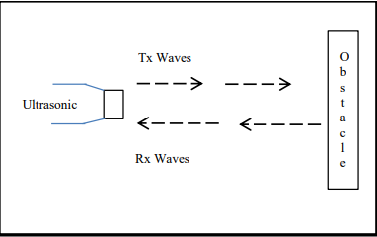
Fig. 2. Operation of Ultrasonic sensor.
- System Structure
The article is based on the basic sonar principles, that is, emitting electromagnetic or sound waves and detecting the interface between water and air is reflected, the sonar signal is generated by the transmitter, it set the signal so that the signal emits in a direction perpendicular to the interface between water and air, and the signal reflects the device's receiver. After the signal is received, the device will process the calculated time interval from at the time the transmitter detects the moment it receives a reflected signal to calculate the distance, and the depth of the current water level. In fact, the water tank with a very large size, bringing the device to the top and measuring it will be very difficult, so we will put our system into two main parts including a sonar device. The measurement is fixed at the top (we call the slave part), a handheld device is used to display the measured values, as well as the activation of the measuring device (we are the master). is the progress of our system.
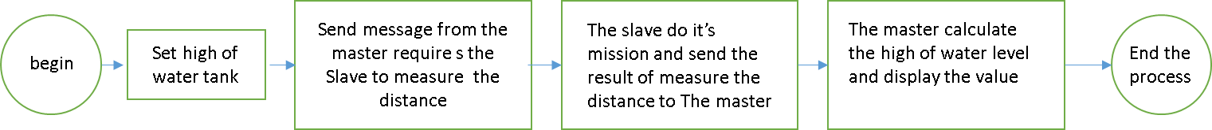
Fig. 3. Operation of the devices.
  - Base System building
Our device consists of two main parts: a device used to catch a tank, a measure of the distance of the water (we call it Slave) and a handheld device to send to work with the Slave, handle the measurement process and export the value of the altitude (we call it Master). To do this we use two main processors for each part to control and program the operation. The following is the model of master and slave:
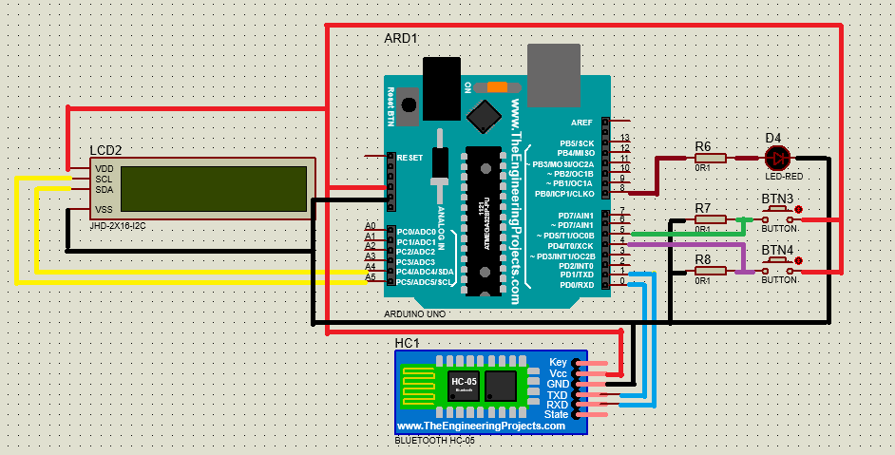
Fig. 4. Model of Master device.
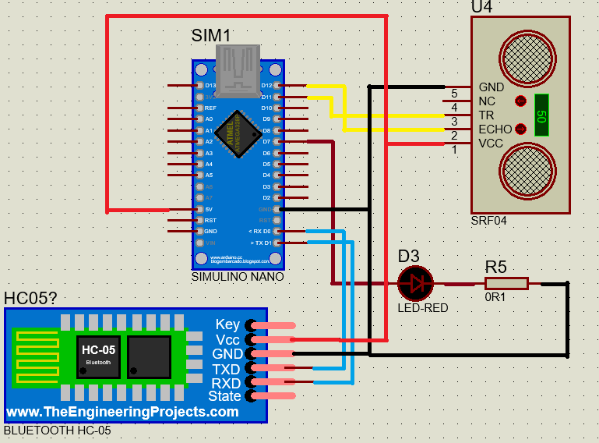
Fig. 5. Model of Slave device.
Having said the above, our master will have three tasks: send requests to the slave device to perform its tasks, receive information from the displayed slave to the result and calculate the ink level. To do this, you first need the LCD with the serial I2C backpack. LCD displays 16 characters on 2 lines enough to be able to display both the value of the water level and the height of the water level. Then solving the second task, exchanging information between the two master and slave devices, we use the previously connected Bluetooth HC-05 module, how to connect the two Bluetooth HC-05 modules we will present. The module HC-05 is used to transmit and receive messages in digital form, the message is a tool for the master to communicate and send requests to the Slave. The LED will illuminate the LED on the side of the Slave circuit. Then, the circuit will perform its measurement task, which is done by the ultrasonic sensor HC-SR04. The principle of HC-SR04 is very simple, including 1 module that emits ultrasonic waves at 40 kHz and 1 module that receives reflected ultrasound. If obstacles are encountered along the way, the ultrasonic waves will reflect and effects on the receiver module. By measuring the time from transmitter to receiver we will calculate the distance from sensor to obstacle with the formula. However, after testing we realise that the formula need edited, because of angle broadcasting.
Distance = (time*sound velocity)/(2*cos(15)) (1)
After measuring the distance, we have to return this value to the same Master by Bluetooth protocol as you above. When the master receives the distance value now to determine the height of the liquid, we will subtract the distance from the top of the bottle to the water surface. Then export the measurement results to the display. Finally, the height of the water will be calculated through this formula:
Height of the water = (Height of the tank-Distance) (2)
Then export the calculation results to the display. However, each tank has a size, so we use the extra button to set the height of the tank so the device can fit different types of tank.
  - Configure and pair two module bluetooth HC-05
Our device will have to communicate via bluetooth, so it's essential to determine the extent to which the two part of our device can communicate with each other in many distances. In this experiment we will perform measurements at many different distance to find the max range of the device. In order for both Master - Slave to communicate with each other and transmit data to each other by bluetooth module HC-05, we first need to configure and pair two bluetooth modules. To do that we need to switch to AT Command Mode. Then you have to do the settings so that the module can be either frequency or working mode. The working frequency of Bluetooth module HC-05 is stable at 38400 bps. Principle of operation according to the method (Master-Slave) and a Master can connect up to 7 devices at the same time into a mini network system. So determining the roles of Master and Slave of each device is necessary. The device on the side of the output value section will perform the role of operating request from the task on the measuring side, so the device will operate in Master mode, while the measurement device on the wall will do. in Slave state. Then you set the operating status of the device, there are two basic states: open and close, the open state, the device can connect more devices, the closed state is only connected. To avoid interference from other devices, we should set it to close, meaning that only two of our devices are connected and transmitting data to each other. Finally, we just need to enter the Slave address into the Master to finish connecting the two modules.
  - Set up the high of tank
As mentioned above, in order to determine the height, we need to create height values ​​into cylinders and there are many types of flasks with different sizes, so setting only a fixed value to calculate the degree. If your device is tall, our device will only fit one size of the bottle, so we used an extra button to initialize that value. There are a lot of options you can use to set the number of buttons in the number you want to install, but this will take a lot of space for the buttons. Here, we propose an option that can reduce the number of nodes. For example, the height of the average container range of 100cm, 180cm, 260cm. You can use 3 buttons to set up the high of tank corresponding to each button with a row of hundreds, tens, units. Then we will show It is necessary to use a button to enter. To do this we need to determine the minimum height, and the high altitude, then we will divide the distance so that the result will contain all height values. In the example above, the smallest height is 100 cm, the highest height is 260, you can divide about 80 cm, or 40 cm, 20cm, 10cm,... If you divide it as 80cm then you will there are three about 100,180,260 cm. If the division is 40 cm then you will have 5 about 100, 140, 180, 220,260 cm,... So what if the average height were not about five ranges we provided from the beginning? For example, if you have a size of 250 while you only have about 220, 240, 260 cm. At that time, you will have to reach your sensor in the position provided by 220, 240, 260 because of the formula, the distance we measured will be the distance from the water surface to the sensor, so set up the height of the tank can be understood as if we have set the initial sensor so it is precisely because the height cannot be set correctly of sensor so error will be inevitable.
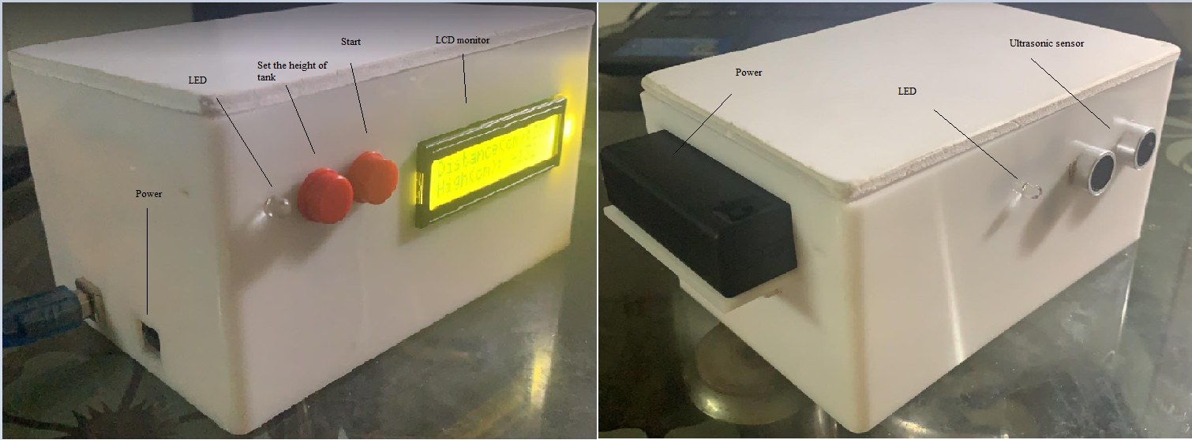
Fig. 6. Final prototype.
- Experimental results
In this section, we will check the accuracy of the device and the maximum range of Bluetooth connection and leave some comments about the results.
  - Check the accuracy of the device
We use the device to measure the water level with the height of tank 2.6m, which is the pool. Hence, our Slave device, which contains sensor is placed at the top of the pool and we set value 260cm with the Master device.
Table 1. The height of water level in real-time measurement and error.
Time | The height of water(cm) | Our system(cm) | Error(%)
1 | 10.7 | 11 | 2.804
2 | 14.8 | 15 | 1.351
3 | 24.1 | 24 | 0.415
4 | 34.2 | 34 | 0.585
5 | 58.6 | 58 | 1.024
6 | 79.1 | 79 | 0.126
7 | 132.1 | 132 | 0.076
8 | 159.9 | 160 | 0.063
9 | 187.6 | 188 | 0.213
10 | 210 | 210 | 0
We tested in 10 times with different heights of water from over 10cm to 210cm which is very high to measure. From the low level of the height to the high level of the height, our system still have a low error, even 0% at the highest, 210cm. Finally, average error is 0.667%, our device has a very high accuracy. However, because the jump is 20cm, it probably won’t be suitable for some customers. We will try to improve as soon as possible. On the other side, our prototype has a verry low error, that is what we aim for at the beginning. In conclusion, we believe our prototype can be widely used in practice.
  - Check the maximum range of connection
Our devices are communicated with Bluetooth. Hence, we need to check the maximum range of connection between them. In this experiment, we perform measurements with different ranges at the same height of water. We do it in 4 times with different water levels.
Table 2. The range of connection between Master device and Slave device.
Time\distance | 15m | 25m | 25m | 29m | 31m
1 | 17 | 17 | 17 | 17 | x
2 | 30 | 30 | 30 | 30 | x
3 | 100 | 100 | 100 | 100 | x
4 | 210 | 210 | 210 | 210 | x
The results show us that the maximum range of connection between pairs of the devices is 30m, which is very long and it’s very effective in practive. Users can check the height of water in the pool with a long distance and don’t worry about the sensor breaking down due to non-touching water measurements. Furthermore, the connection is still good at any range under 30m, there is no error on the distance since pairs of the devices are still under 30m on the distance. Finally, about the connection, our prototype does very well and can be used in practice.
- Conclusion
After more than 4 months of research and implementation, our team has completed our initial goal of completing the Tank Level Measurement device to support better management of industrial resources, especially the water level in the tank The equipment has been successfully tested in various conditions. The device has the advantages: fast, accurate processing with wireless signal transmission; long range (25-30m), stable use in different environments such as obstruction or next to other Bluetooth devices; compact device size, easy to hold, can measure many different types of liquids. It can be seen that the device will assist technicians in controlling the amount of water in the tanks, thereby calculating the optimal plans to use the amount of water in the bottle. In practice, our device can be used to measure indoor water tanks, helping to monitor the water level to stabilize when weather changes or something goes wrong. Our equipment can be used widely in high-rise building water tanks, where it is difficult to climb and measure regularly. Moreover, our device can be combined with automatic water pump systems and ensures that water levels in tanks or swimming pools are always guaranteed and monitored from a distance. However, our prototype will still cause difficulties for customers to install due to the initial jump of 20cm. In the future, when we finish the product, we will add a tweak button, which can help adjust the correct initial position to the standard centimeters. Thus, our product will no longer have any weakness and completely convenient for practice.

References
- Wikipedia Homepage, https://en.wikipedia.org/wiki/Sonar, last accessed 2021/1/7.
- Sarka, N., Tomás, B., Galdi, T., Giovanni, P.: Fluid Under Pressure.
- Fredy, S., Kevin, R.V., Cristian, M.S., Marco, M.A., Danny, C.P., Witman, A.D., Brian, M.C., Avid, R.G.: Implementation of a basic Sonar of Echolocation for Education in Telecommunications, Image Processing Research Laboratory (INTI-Lab). Universidad de Ciencias y Humanidadesima, Peru (2016).
- Hansen, R.S.: Introduction to sonar Course materiel to INF-GEO4310, University of Oslo (2012).
- Lurton, X.: An Introduction to Underwater Acoustic, Principles and Applications. Springer Praxis, Publishing (2002).
- Wang, Y., Zhao, Y., Bortoff, S. A., Ueda, K.: A real-time energy-optimal trajectory generation method for a servomotor system. IEEE Transactions on Industrial Electronics, 62(2), 1175-1188 (2015).
- Kleeman, L., Kuc, R.: Sonar sensing, Springer Handbook of Robotics. In: Siciliano, B., Khatib, O. (eds.). Springer, Berlin (2008).
- Viswanath, S., Belcastro, M., Barton, J., O’Flynn, B., Holmes, N., Dixon, P.: Low-Power Wireless Liquid Monitoring System Using Ultrasonic Sensors (2015).
- Venkatesh, B.: Arduino Using Make Phonecall From GSM Module (2016).

