Adjacent vertex exchange
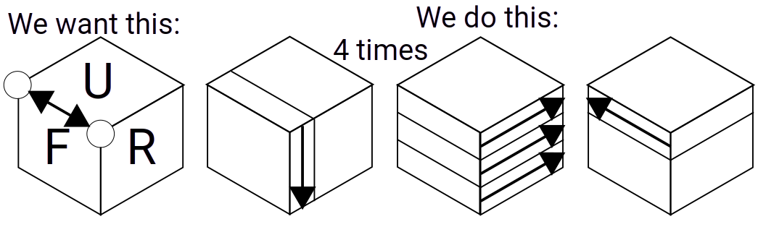

Triple vertex exchange forward
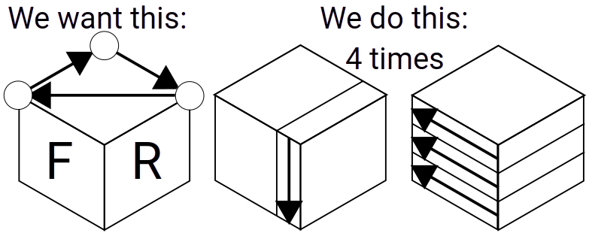

Triple vertex exchange backward
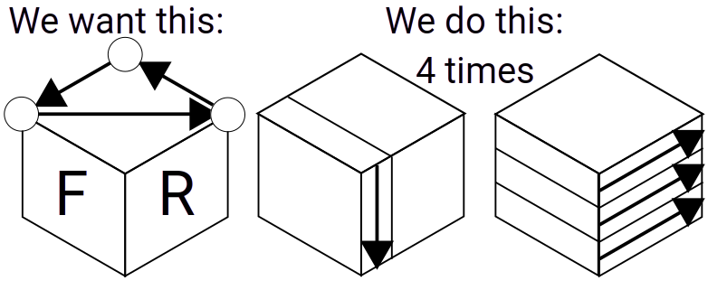

Triple corner rotate forward
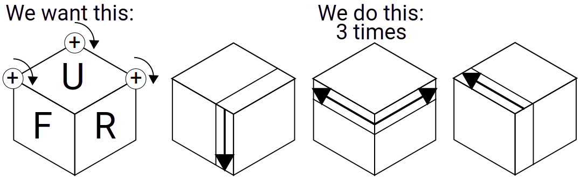

Triple corner rotate backward
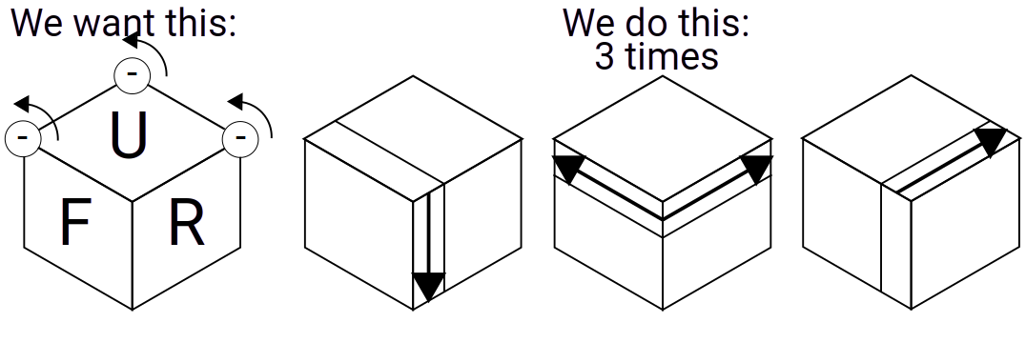

Double corner rotate
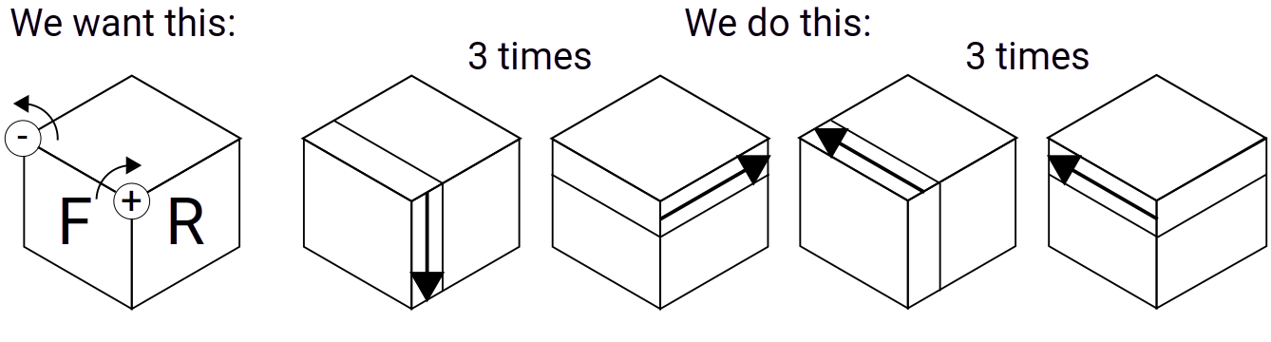

Edge change forward
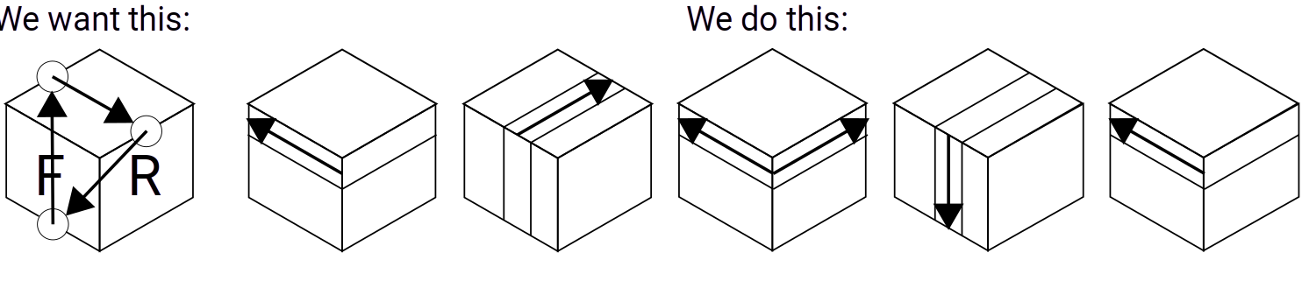

Edge change backward
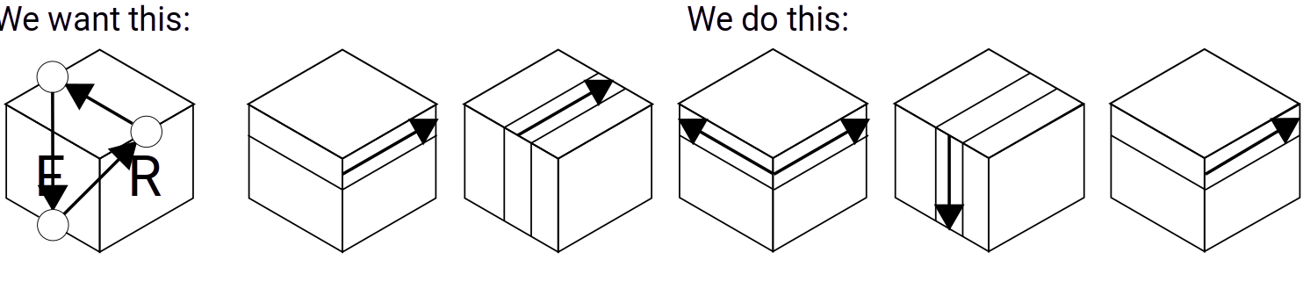

Edge change horizontal
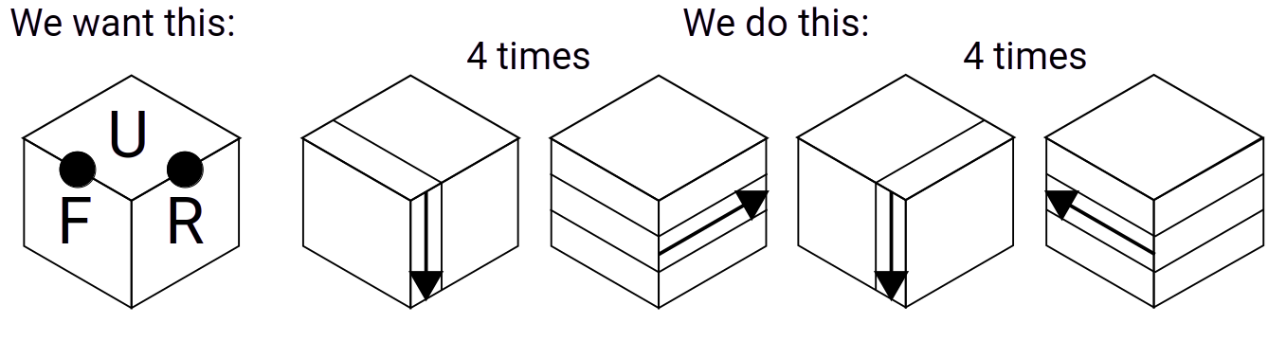

Edge change vertical
