Adjacent vertex exchange
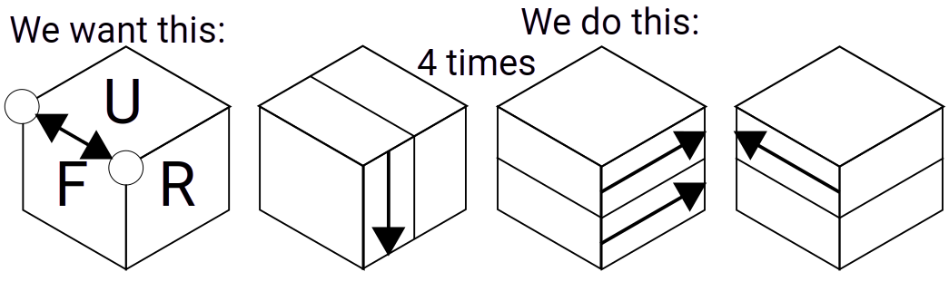

Triple vertex exchange forward
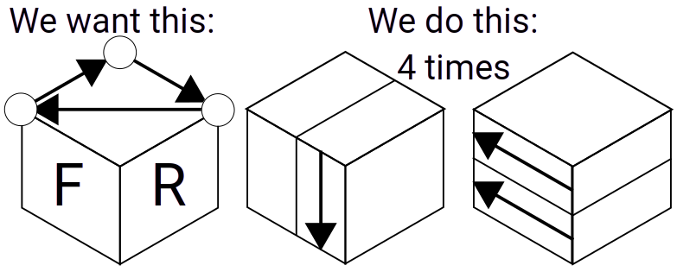

Triple vertex exchange backward
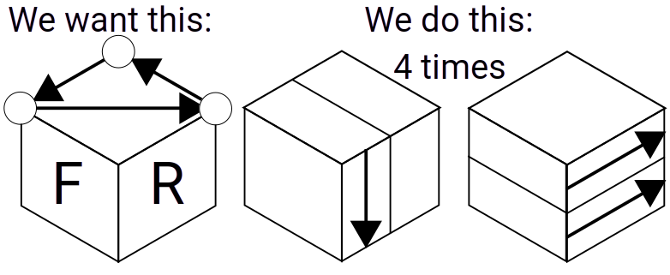

Triple corner rotate forward
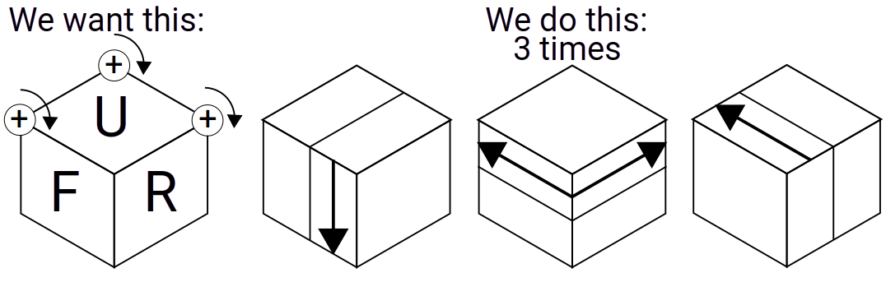

Triple corner rotate backward
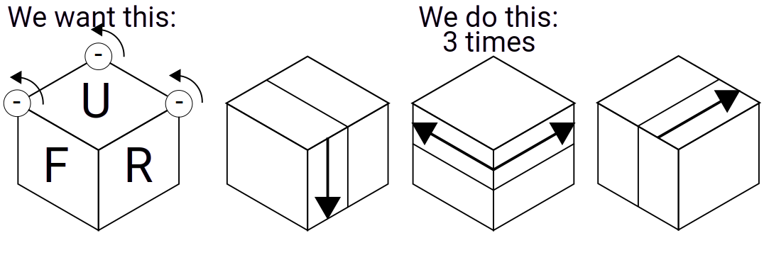

Double corner rotate
