GEDA pipeline  
need for updates and further investigations

Problems encountered must be documented and a directory link must be attached.

## Herd, period and AMS + errors description

|  |  |
| --- | --- |
| Farm 31563, Period 2021_10, AMS 2 | It was obvious to see from the log file that GEDA was not done with processing the data and removing unreliable signals, but it did anyway. Manual removing of unreliable signals was required |
| Herd 26089, Period 23/11/2021, AMS 1 | How do we deal/filter with repeated datetime periods. In this example (See (A) below). This specific example is a human-causes error by Martin. When he extracted data, he got 3 rows from another sniffer. See Sniffer ID! But when running GEDA this part was kept and no alarm/error etc occurred. The exact same datetime appeared later in the same inlet file. Should the pipeline send an error message when we encounter overlapping datetime? |
| Herd 34165, period 25/01/2024, AMS 2 | How do we deal with repeated imputation (See (B) below). In this case both CO2 and CH4 was repeated for 24 rows. Though this “only” accounts for half a minute, this has been encountered more then ones using GEDA. |
|  |  |
|  |  |

1. Raw sniffer file. Inlet file for GEDA

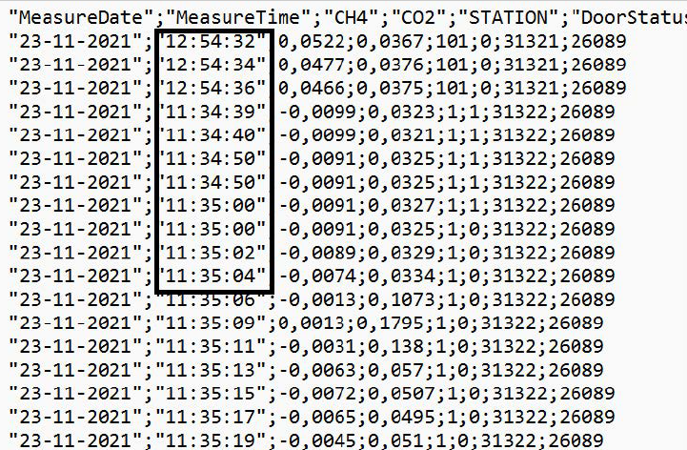

(B)

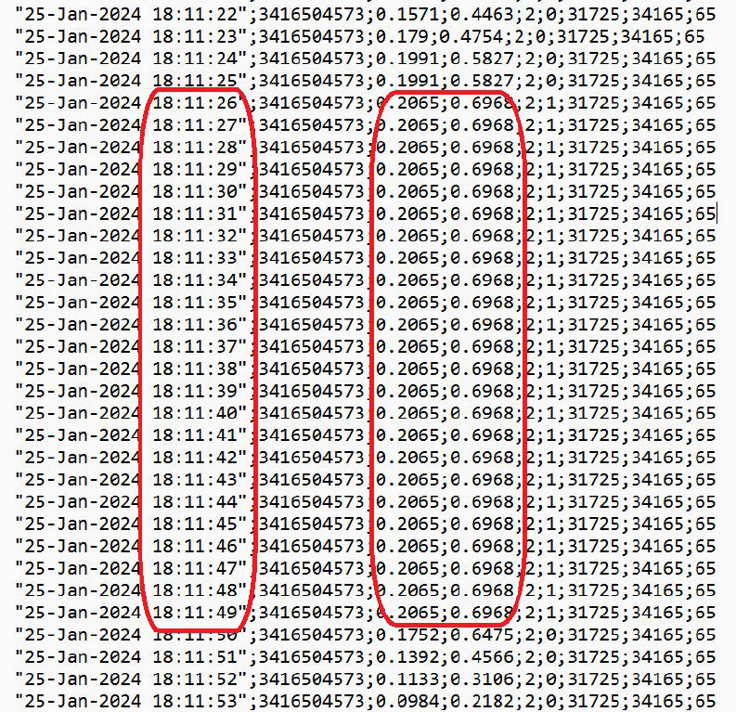

**

Why are last 2-3 signal numbers more or less always true?

**

Some programs do not give all expected outputs in the log file see e.g. the log file

/usr/home/ironbank/researchdata/gasemission/56614/2024_August_200_10/2024_4/ log_device_3.txt

This ends with the line: *Correcting (re-adjusting) the unreliable data*. But it doesn’t readjust.

On AMS 1 and 2 it works fine. I have tried to resubmit the submit_me file but with same result.

****

Daylight saving -move ½ hour

****

No reliable file if all data are good