Vivian Miller

CIT 212

Final Project

December 14, 2025

Documentation
about.html
CSS Code | Explanation of the Rule
p { margin: 5px; padding: 10px; } | This Internal Style targets all <p> (paragraph) elements on the page. It applies 5 pixels of external space (margin) around the paragraph and 10 pixels of internal space (padding) inside the paragraph border.
style="border: 4px dashed white; background-color: lightgray;" | This Inline Style is applied specifically to the Bob character card (<div class="card">). It sets a 4-pixel thick, dashed, white border and a light gray background color.
style="border: 4px dashed red; background-color: lightcoral;" | This Inline Style is applied specifically to the Linda character card. It sets a 4-pixel thick, dashed, red border and a light coral background color.
style="border: 4px dashed blue; background-color: lightblue;" | This Inline Style is applied specifically to the Tina character card. It sets a 4-pixel thick, dashed, blue border and a light blue background color.
style="border: 4px dashed gold; background-color: lightyellow;" | This Inline Style is applied specifically to the Gene character card. It sets a 4-pixel thick, dashed, gold border and a light yellow background color.
style="border: 4px dashed green; background-color: lightgreen;" | This Inline Style is applied specifically to the Louise character card. It sets a 4-pixel thick, dashed, green border and a light green background color.

Documentation continued
style.css
CSS Code | Explanation of the Rule
* { margin: 0; padding: 0; } | This is the Universal Selector. It targets every element on the page, removing all default browser margin (external space) and padding (internal space) to ensure a consistent starting point.
header { height: 5em; background: goldenrod; border: 10px solid darkred; } | This Type Selector styles the header. It sets a height relative to the font size (5em), colors the background goldenrod, and applies a noticeable 10-pixel thick, solid, darkred border.
.siteTitle { color: darkred; text-align: center; font-size: 70px; } | This Class Selector styles the main site title. It sets the text color to darkred, horizontally centers the text, and sets the font size to 70px.
ul { list-style-type: none; margin: 0; padding: 0; overflow: hidden; background-color: #333333; } | This targets the Navigation List. It removes the bullet points (list-style-type: none), removes space around the list, and sets a dark background color. overflow: hidden is used to contain the floated list items.
ul li { float: left; } | This Descendant Selector targets list items in the nav bar. It uses float: left to make the links display horizontally (side-by-side) instead of stacking vertically.
ul li a { display: block; color: white; text-align: center; padding: 14px 16px; text-decoration: none; } | This targets the Navigation Links. It makes the entire link area clickable (display: block), sets white text, centers the text, adds padding for a click target, and removes the default underline.
ul li a:hover { background-color: #111111; } | This is a Pseudo-Class that applies a style when the mouse hovers over a navigation link, changing the background to a slightly darker shade of gray.
.main { display: flex; } | This Class Selector targets the main content wrapper. display: flex enables the Flexbox layout, which is the modern method to make the children (article and aside) align side-by-side on larger screens.
aside { background-color: grey; } | This Type Selector sets the background color of the sidebar element to grey.
aside img { width: 300px; height: 350px; padding: 25px; object-fit: contain; } | This Descendant Selector styles the image inside the aside. It sets a fixed size, adds internal space (padding), and uses object-fit: contain to ensure the entire image is visible within the box without cropping.
footer { display: grid; position: relative; bottom: 0; background-color: lightblue; text-align: center; font-size: 1em; } | This Type Selector styles the page footer. It sets a lightblue background and centers the text. display: grid and position properties are included but primarily rely on the Flexbox flow to keep the footer below the main content.
@media screen and (max-width: 750px) { ... } | This is the Media Query. It tells the browser to apply the nested styles only when the viewport width is 750 pixels or less (used for mobile responsiveness).
header { height: 4em; } (inside the Media Query) | Mobile Optimization: Decreases the height of the header from 5em to 4em on smaller screens to save vertical space.
.siteTitle { font-size: 55px; } (inside the Media Query) | Mobile Optimization: Decreases the font size of the site title from 70px to 55px on smaller screens to prevent overflow.
.main { display: block; } (inside the Media Query) | Mobile Optimization: This crucial rule overrides display: flex and forces the article and aside to stack vertically (one on top of the other) on mobile devices, which is the standard, readable layout for small screens.

Wireframes
Desktop
Home Page
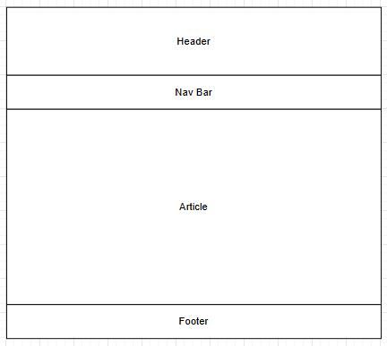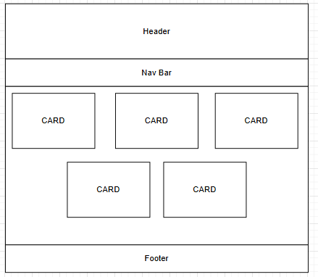

About Page
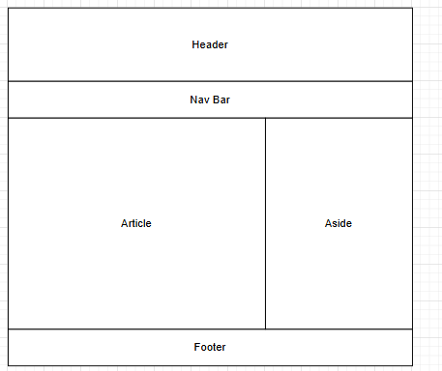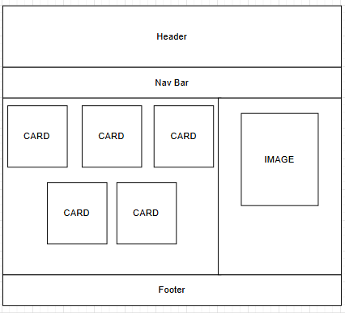

Wireframes continued
Contact Page

Mobile
Home Page
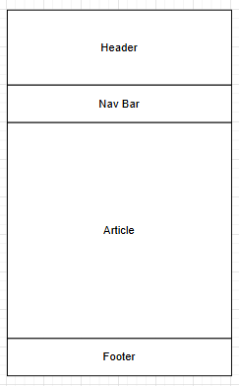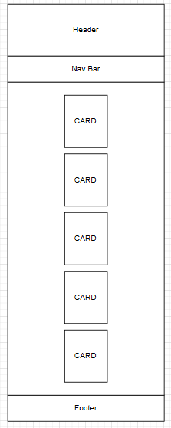

Mobile continued
About Page
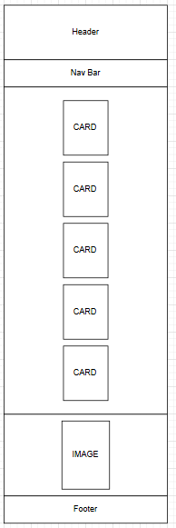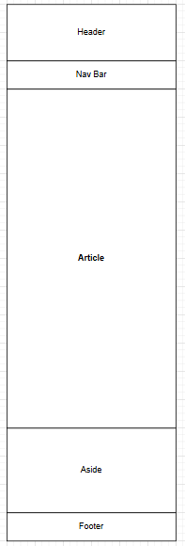

Wireframes continued
Contact Page

