# EMPATHY MAP

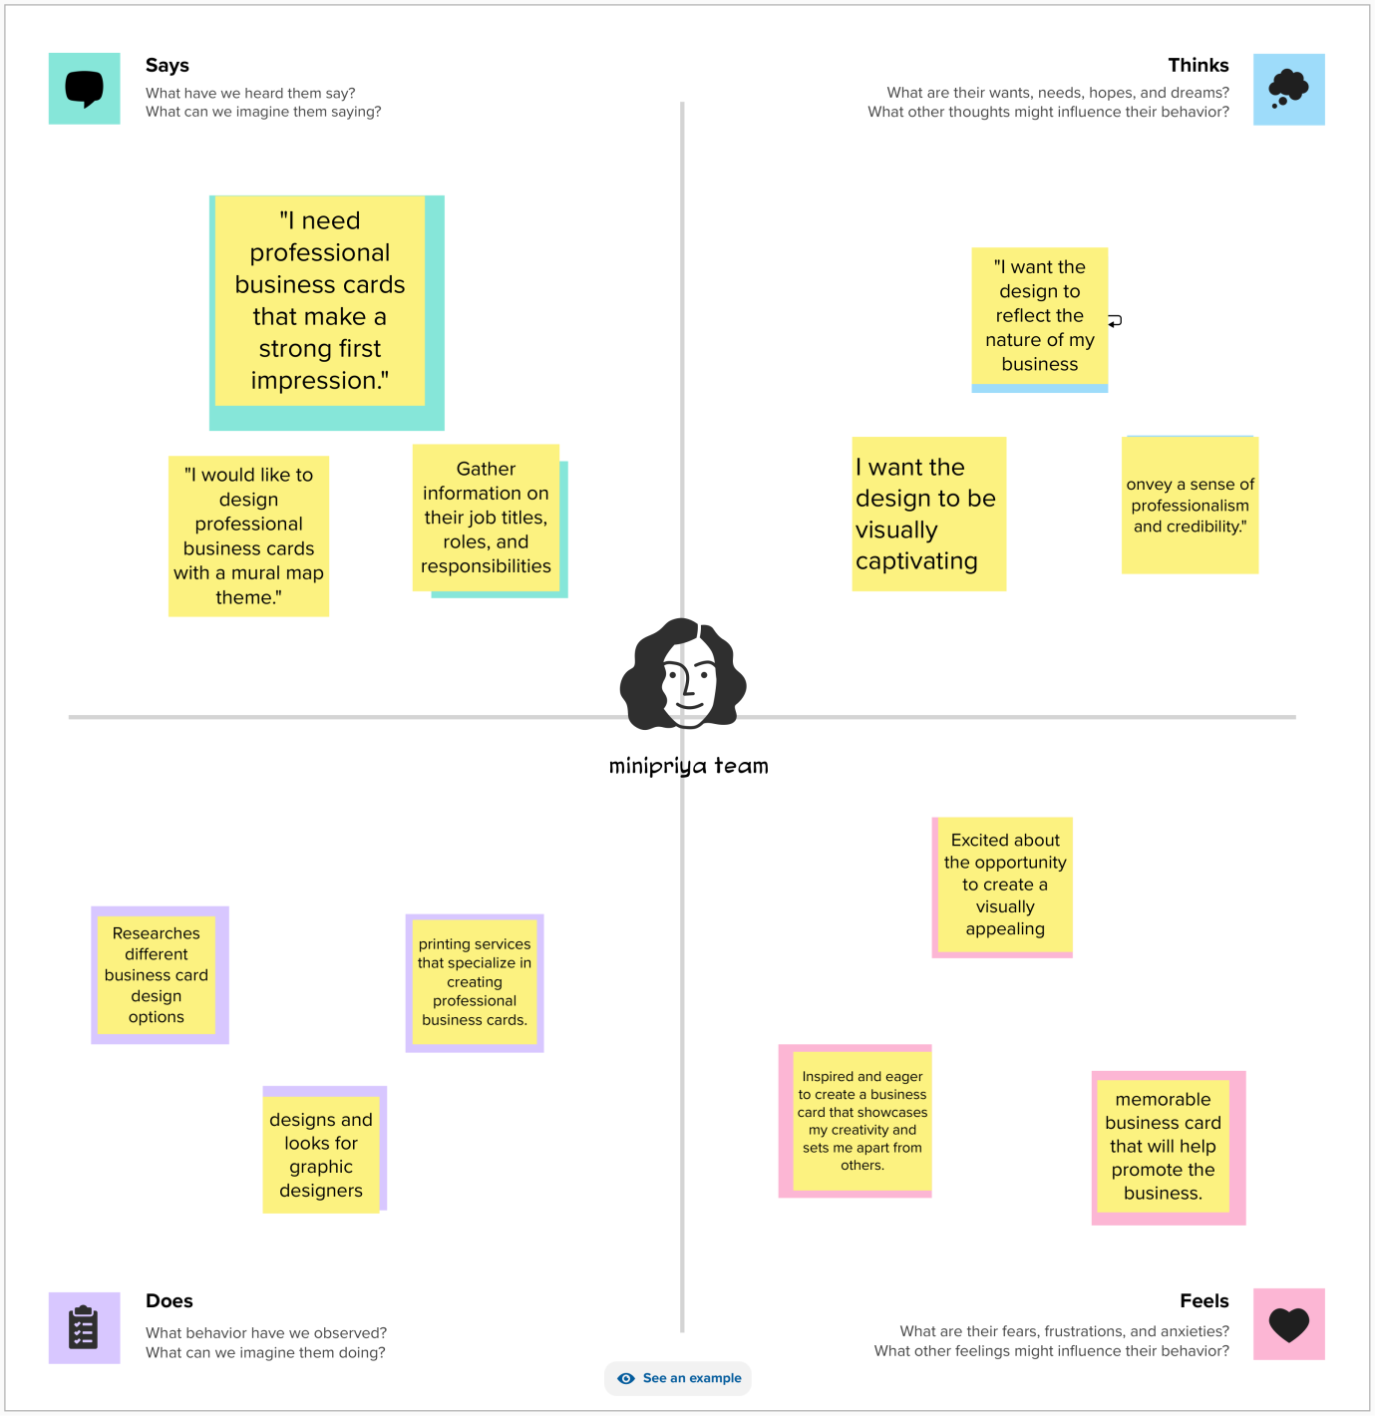

# BRAINSTORMING

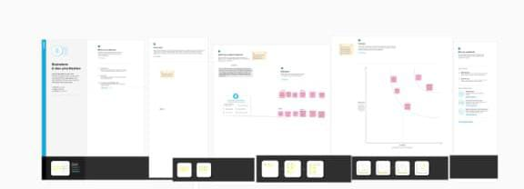

1. **Introduction:**
   * Introduce yourself and your profession.
   * Mention your expertise or specialty.
2. **Problem Definition:**
   * Highlight a common problem or challenge in your field.
   * Emphasize the need for creative solutions.
3. **Design Thinking:**
   * Explain the concept of design thinking.
   * Describe how it can be applied to address the problem mentioned.
4. **Results:**
   * Share some successful outcomes or projects that used design thinking.
   * Provide tangible examples of your work.
5. **Advantages:**
   * List the advantages of using design thinking in your profession.
   * Mention how it sets you apart from others.
6. **Disadvantages:**
   * Acknowledge any potential limitations or challenges.
   * Show your awareness of the nuances in your profession.
7. **Application:**
   * Explain how your profession benefits from design thinking.
   * Discuss the practical applications and real-world impact.
8. **Conclusion:**
   * Summarize the key points made in the previous sections.
   * Reiterate your unique selling proposition.
9. **Future Scope:**
   * Discuss the evolving trends and opportunities in your profession.
   * Highlight your commitment to staying at the forefront.
10. **Appendix:**
    * Include any additional information, such as case studies, references, or contact details.

