Milestone 1:

1)

select avg(nav),avg(repurchase_price),avg(sale_price) from navhistory;

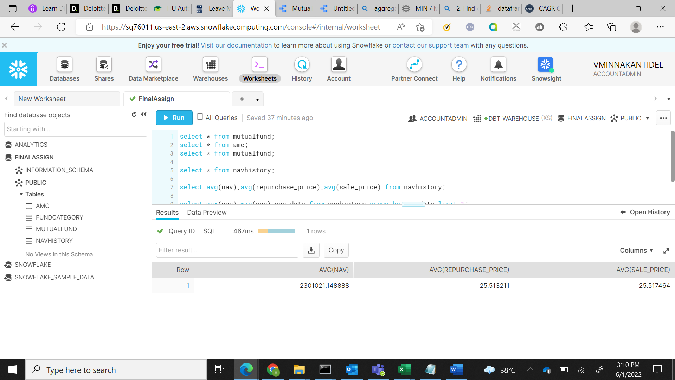

2)

select max(nav),min(nav),nav_date from navhistory group by nav_date limit 1;

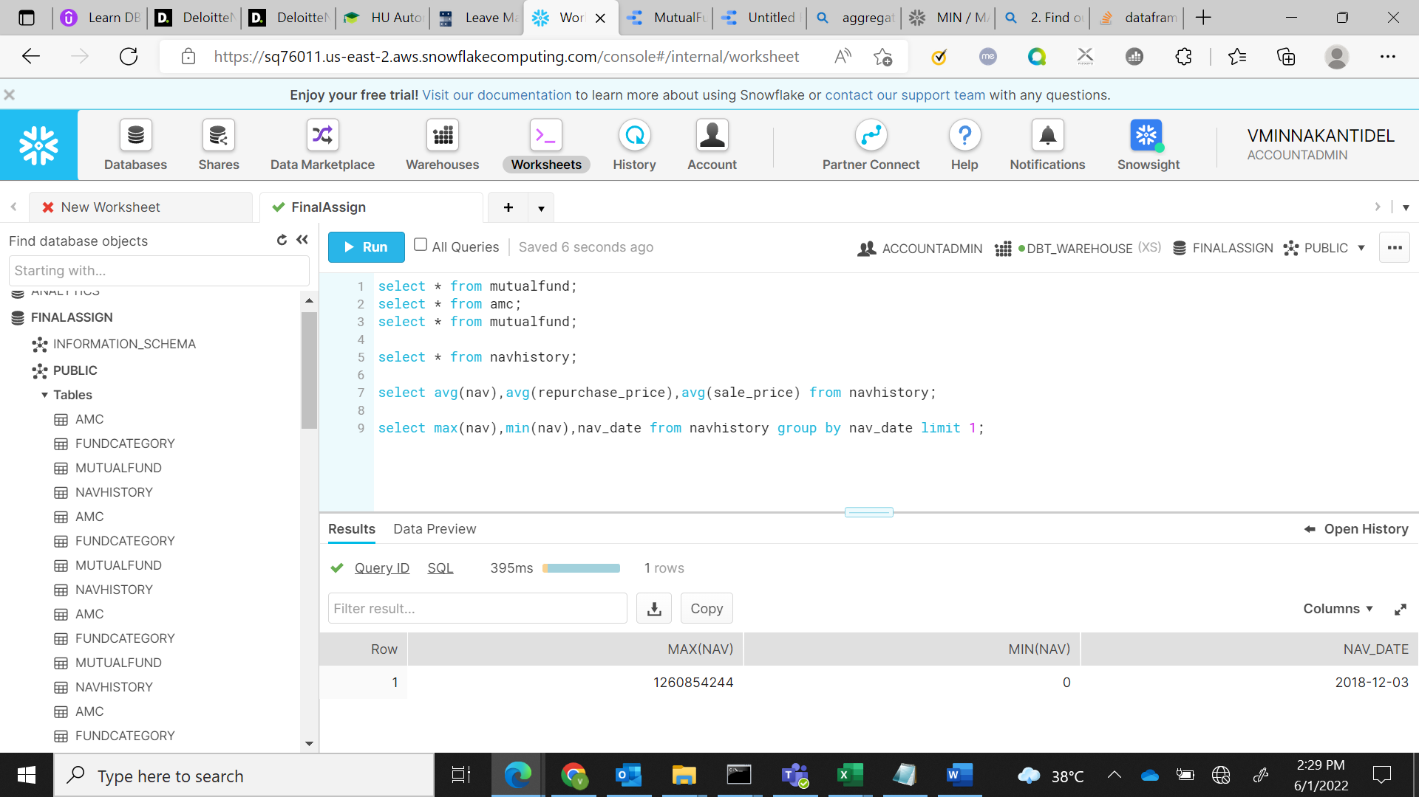

Milestone 2:

3)

select m.code,m.name from mutualfund as m inner join navhistory as n on m.code=n.code order by nav_date is null;

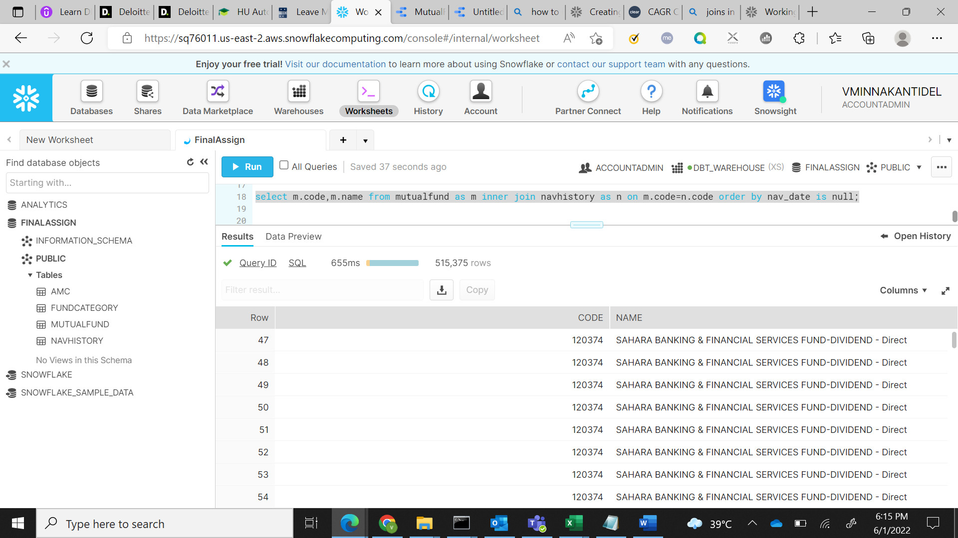

2) select m.code,m.name,n.repurchase_price,n.sale_price from mutualfund as m join navhistory as n on m.code=n.code where n.nav_date>'12/7/2018' and n.nav_date<='12/10/2018' limit 3;

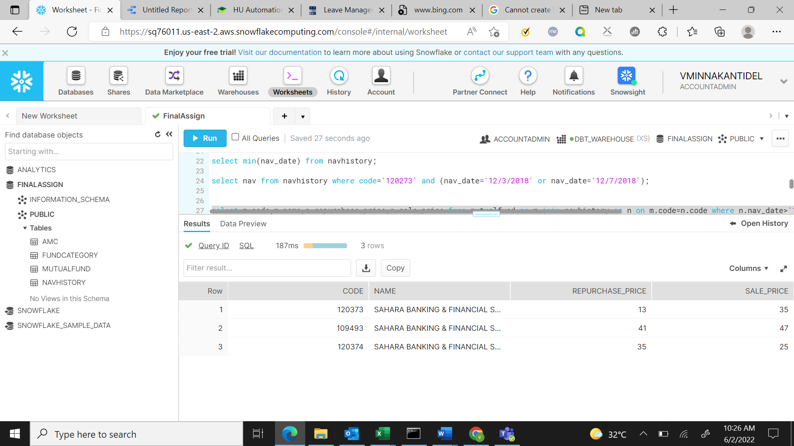

5)

select m.code,m.name from mutualfund as m join navhistory as n on m.code=n.code where (n.nav_date>'12/3/2018' and n.nav_date<'12/12/2018') and n.sale_price>n.repurchase_price order by n.sale_price

asc limit 1;

