Badges

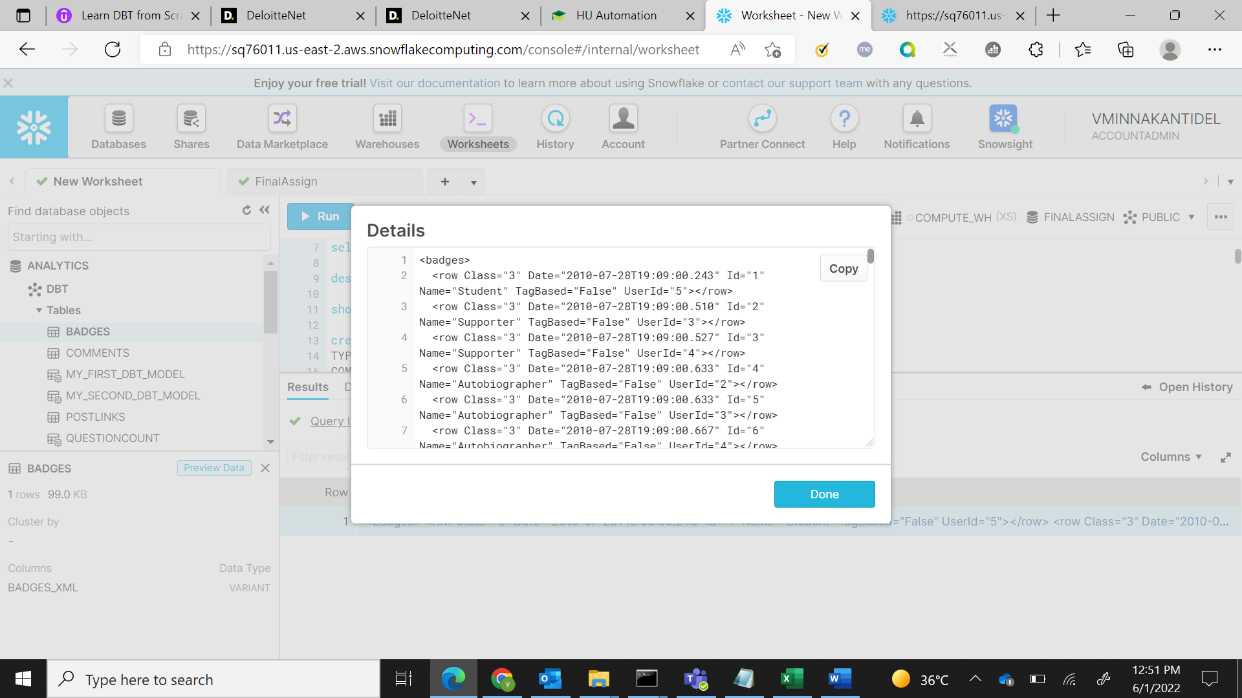

Users

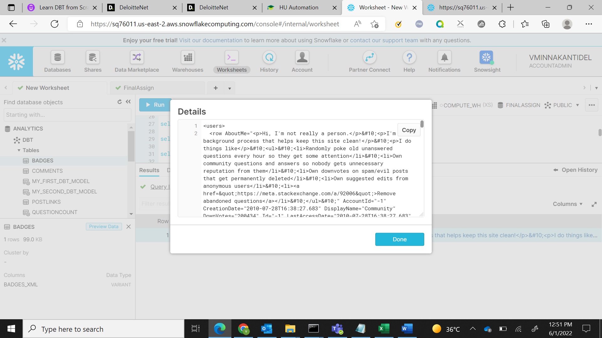

#reputation

SELECT XMLGET(value,'Id'):"$" as "Id",

XMLGET(value,'DisplayName'):"$" as "DisplayName",

XMLGET(value,'Reputation'):"$" as "Reputation"

FROM "ANALYTICS"."DBT"."USERS",

LATERAL FLATTEN(to_array(USERS.users_xml:"$" )) order by 'Reputation' desc limit 10;

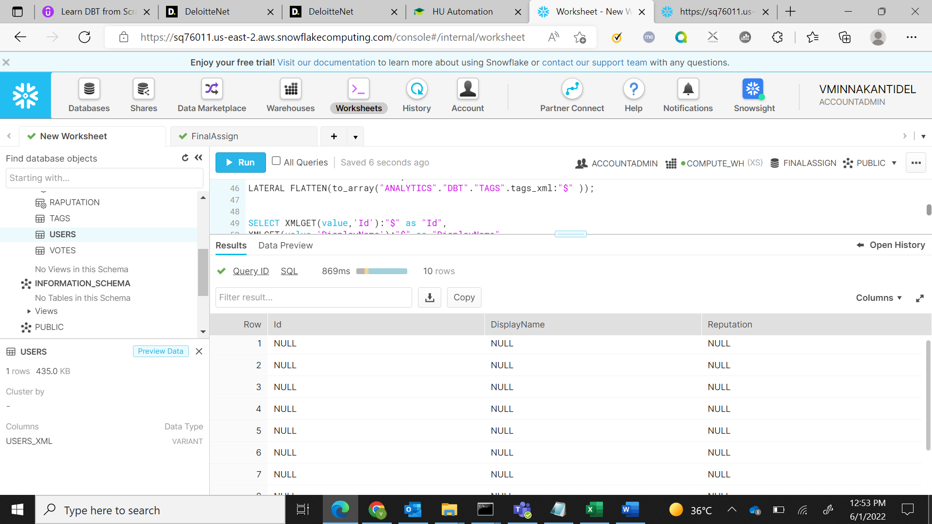

Most popular badges

SELECT XMLGET(value,'Class'):"$"::integer as "Class_Name",

XMLGET(value,'Date'):"$"::string as "Date",

XMLGET(value,'Id'):"$"::integer as "Id",

XMLGET(value,'Name'):"$"::string as "Name",

XMLGET(value,'TagBased'):"$"::string as TagBased

From "ANALYTICS"."DBT"."BADGES",

LATERAL FLATTEN(to_array("ANALYTICS"."DBT"."BADGES".badges_xml:"$" )) order by TagBased desc limit 10;

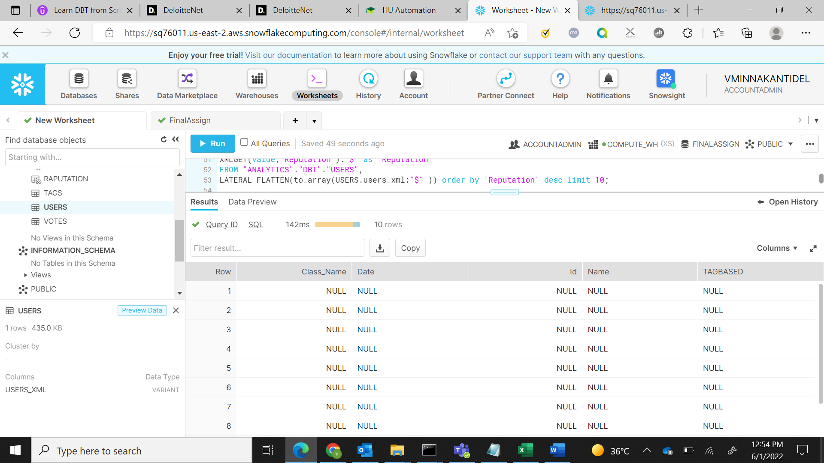

Question count

SELECT XMLGET(value,'Id'):"$" as "Id",

XMLGET(value,'DisplayName'):"$" as "DisplayName",

XMLGET(value,'Reputation'):"$" as "Reputation"

FROM USERS ,

LATERAL FLATTEN(to_array(USERS.users_xml:"$" )) having "Reputation" > 75000;

**Question like**

SELECT XMLGET(value,'AboutMe'):"$" as "Questions"

FROM "ANALYTICS"."DBT"."USERS",

LATERAL FLATTEN(to_array(USERS.users_xml:"$" )) where GET('DisplayName'.value,'@')='%nau%';