# Design Report

Contents

Design Report i

Introduction 1

Critical Reflection on UX Design 2

1. Laws of Visual Perception 2

2. Designing for human memory Limitation. 5

3. Color scheme 5

Reflection on Mobile App Development 6

Conclusion. 7

Appendix 7

References 10

# Introduction

Design of a website or a mobile app is the main Feature that enhances user experience. User experience generally entails the ease of end-user to interact with a company or organizations, its services, and its products. The main tool that enhances user experience especially in the technology realm is the Graphical user Interface (GUI). The Graphical user interface is the tool that allows user to interact with a computer visually and allow users to manipulate elements in a screen using mouse, finger for touch apps, or even stylus. So a good Design of the graphical user interface gives the end user a tremendous user experience on interacting with your website or apps.

Websites offer or rather acts as informational tools for potential clients who want or are seeking for an online solution. With the current trend of mobile phones being able to access the internet, people can easily search for online solutions with a click of a button. So it is always a good idea for a business or a company to have an online presence. Therefore, websites are an essential tool for a business or a company or even organizations to have a them. It gives you the online presence that you so really need at this current age.

A good website also has a good design. There are billions of websites in the internet, some of which are of our fellow competitors. There are many things you need to do in order for you to have an edge in the competition. Some of the things that you need to do is the search Engine optimization that makes your site rank above your competitor’s websites. This is accomplished using keyword’s that are most searched in the internet in regards to you niche or areas of expertise. Another important thing you need to have is a good Design. A good design will ensure you clients have a good user experience when interacting with the site’s user interface.

# Critical Reflection on UX Design

From the brief introduction we got to understand the user experience, the importance of websites and also the importance of having a good Design. In this segment we are going to critically look on the Design and the user interface and how it plays an important role to enhance the user experience. Our case study is going to be the Northampton Taxis website that I have created. Northampton Taxis is a family run business based in Northampton, England. The business was established in 1998. The nature of business of this company is that it is a booking company that runs booking system where the customers either call, email or fax the office in order to book and the company sends information to a nearby driver to pick up the customers. The company was seeking of an online presence and wanted a website where they will be able to increase their brand visibility and also connect with customers. The website features an online booking form for online customers to book cars.

From word go, you will understand that there are many taxis companies on the rise, all looking up for the same customers. So in order for Northampton company to soar or have an edge in the competition, they need a good web site with a good design. So in this segment we are going to reflect on the three laws of good designs as used in this site as listed below:

* + Laws of visual perception
  + Designing for human memory limitation
  + Color schemes

## Laws of Visual Perception

Visual perception in user experience is an important factor that needs to be considered when building a site. In design of Good User experience, it is important to understand how human beings assimilate information surrounding the experience. Traditionally human being’s method of perception is the five common sense of the human being, that is touch, taste, sight, sound and smell. In this case we need to leverage the sight method of perception in order to make a good Design.

We use our sight which is one of the traditional methods of perception in order to perceive information given to us visually in this case using the screens. The graphical user interface provides the information we are to interact with on the screens. From trying to read text in the site, we generally try to pick up information from the visual representation of the graphical user interface by quick or simultaneous movement of the eyes between two or more phases of fixation in the same direction in a process known as saccades. Saccades is the process of jumping our eyes in order to pick up different parts of the visual representation.

From this understanding, the design of our GUI should be able to leverage of the laws of perception and understand which Design is most effective in communicating the message to the potential clients. From the concept of human trying to make meaning from visual representation one can understand that just because you have something on screen does not guarantee that the user will look at it. This therefore leads us to identify the patterns of reading from the screens. According to Jacob Nielson’s series of research, people can scheme through and search through web pages in an F-Shaped pattern (Nielsen, J, 2007). In addition to that, a lot of people look at the top left region, because this is a place where the first search result shows up and most people expect there to be high-value information.

In our site we have tried to leverage this by including the Menus in the top starting with about us menu button, which is among the important menu links of the site since it directs user to the about us page. About us page contains brief information about Northampton Taxis business, the year and when it was started, how and why choose it above all the others.

Following the F-shaped pattern, the menu being part of the top bar of the F-shape structure, the about us page link is followed by Services link which is the also another major page link to the site because it contains the link to our services page. Our services page is an important page in the site because explains to the potential client the services offered in Northampton Taxis Company, and describes to the client how it works, i.e. how the clients can place a booking order and receive the services of the company. It is a page that give assurance to the client the type of services they are about to sign up for.

The next important link on the menu which follows the F-shaped stricture of page scanning is the Booking link which directs to the booking page. The booking Page is the heart and soul of the website. From the first link which talks about the company and when it was founded to the second link of our services page. This pages play important roles in preparing and helping the potential clients to understand what the company is all about. This in business terms is referred to us a lead stage (Goward, C, 2012). Then having seen all that, the client is now at a point where he needs to commit to our services. This is the stage which is called a conversion stage in business terms (Goward, C, 2012). The booking page offers the place where a converted client is able to commit by placing a booking order. The booking page has a form that contains fields to fill such as the name of the client, the email, the phone number, the pickup address the and the booking address. It also contains radio buttons where and client can select which type of car to select and also to check if the car need wheelchair space or not before an order is placed.

Then next important link after the booking in the menu inside the F-shape structure, is the Prices page. This is also an important page as important page to the client. They client may be willing to find out the destination that Northampton taxis has and the type of pricing it has before he even commits himself or rather place and order. This page contains the table with the list of destinations, and pricing depending on the type of car selected. This also has an important role in the entire infrastructure of the web design.

The last link in the menu is the contacts page which contains information of Northampton’s office. The client may be willing to contact the client, either through mail, phone call, fax or even visit their offices physically. The contacts page provides this information. It contains the office address, for those who wish to send them a package, and a map for those wish to visit them physically. Telephone number, Fax number and email address is also provided for clients who are far or who want their services and can reach them via phone email or fax without necessarily travelling to their offices.

From this we can understand the power of visual perception and be able to harness, leverage and use it in our design to ensure that important information can be viewed and pass out the necessary information needed. This plays a big part in enhancing User Experience in our site. From this we can easily get a conversion from a visiting Client

## Designing for human memory Limitation.

Much information is generated more than before. According to research, it shows that in two days we generate or create as more information as we did from the dawn of man through to 2003. This poses and limitation to human memory capacity, since Information increases but then our brain capacity remains constant. Therefore, this leads to the need of designing for human limitations. This also plays out in the entire process of impacting our users experience.

Different clients or rather user search for different information, and so there is a lot of relevant information that must be found quickly. This makes things a little complicated for a designer. Therefore, the core job for a designer in this case is to enable a user to find out information with little effort. We have to make the site more intuitive that finding something is almost an instant process.

In improving the design, we reduce user time for finding something and also enhance his or her experience. In our site the way we have tried to improve the reduce the users time for searching for information, one of them is by the use of menu links items that connects the users to the page they are seeking information for. The content is presented in an interactive with images, tables and icons. I have also improved connection of contents by putting back linking links to pages where the user can go back to a previous page. I have also simplified tables for example in the price page, there is a table which gives short summary of destinations of Northampton Taxis with their respective car prices.

## Color scheme

The color scheme enhances our Visual capabilities, while scheming through the site. A beautifully colored site can make the site to be fancy and catchy. They are some sights that have identified themselves with their color. Color schemes are also an important part in design as they give your site the theme you can use for the site. there are many themes you can use that can make the site pages attractive. one of the themes, that I like using is either the dark theme or rather the light theme. This themes affect the entire landscape of the site.

The background color used for the site also is part of the color scheme that is used. In this site we use a white back ground which comes with a light theme. A light theme makes the context text to be in dark color, or different color than white in order to enhance their visibility so as not to be the same color with the white background. The inverse is true for dark theme. all this plays an important role in enhancing the User Experience in the Design of the site and the client can be convinced to commit.

# Reflection on Mobile App Development

Mobile App Development curve has taken a rise in the recent couple of years. Some have attributed to the fact that mobile technology is the future, as currently the mobile and tablets accounts to more than 60% of the internet traffic in this days. This is made possible by the increase of smartphones which are cheap as compared to desktop or laptop computers. This also makes pops an interesting niche for Designers.

Considering that the media width of phones and computers are not the same, this means that resolution and alignment on both devices will not be the same. There is therefore need to make the website more responsive, in that it uses media queries to get the width of the device and make the content to be responsive in regards to the device size

In this site we have tried to make the site user friendly and highly responsive, in regards to this the devices width. We have make the mobile app to have the link to the website meaning the user can be able to access the website through the phone and thus made it highly responsive for this reason.

## Conclusion.

From the above Discussion, we have observed the Design process involved in making site and the mobile app and the important parameters to consider while creating the design. We also have looked at how we have integrated the Design in or Northampton Taxis company website. Some of the key features that greatly impact User Experience as seen in the discussion above in the Visual perception, where we leverage the F-shape structure of scanning through a site to align our important information in line with this parameter in order of impact the user experience. We also looked on color schemes that determines the overall theme of the site. A theme is lively is able to impact the user Experience in a positive way. We have also looked at mobile app Development. Phones now generate more traffic in internet than traditional computers, and thus there is greater need to enhance user Experience by making the websites to be mobile responsive.

## Appendix

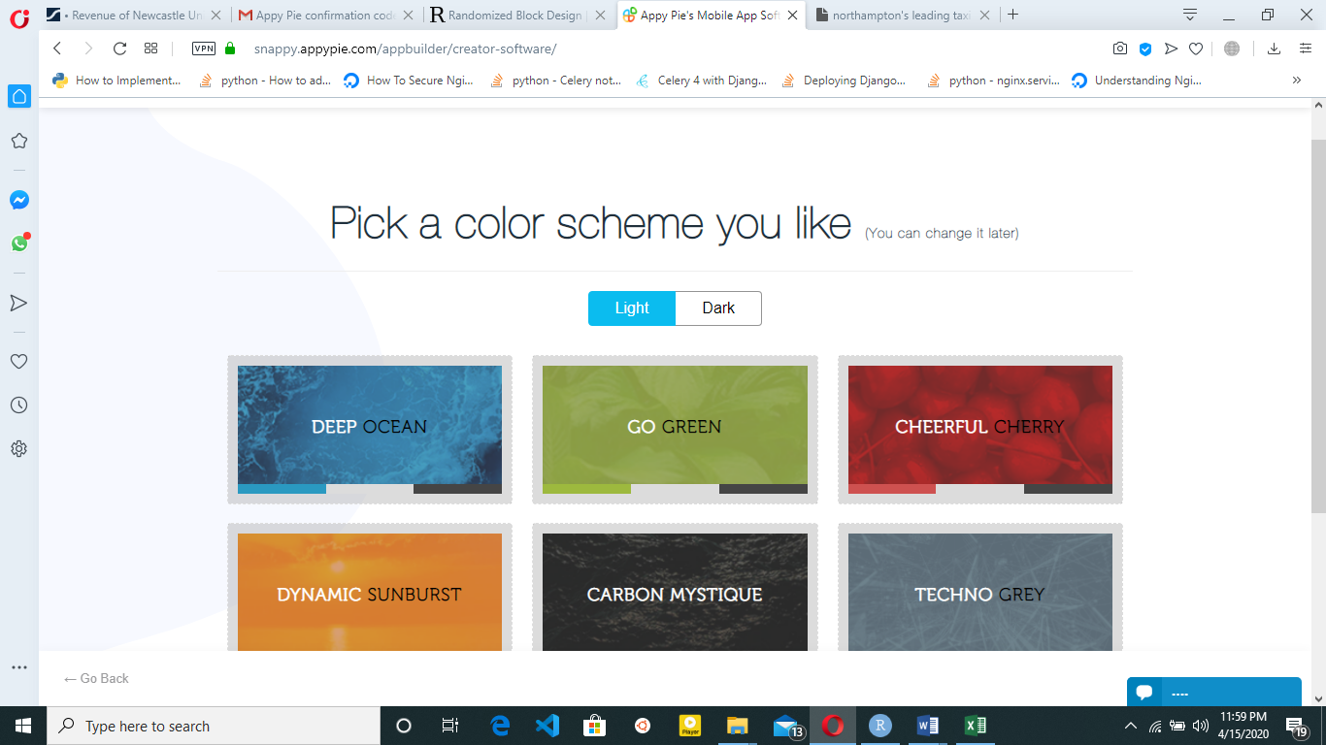

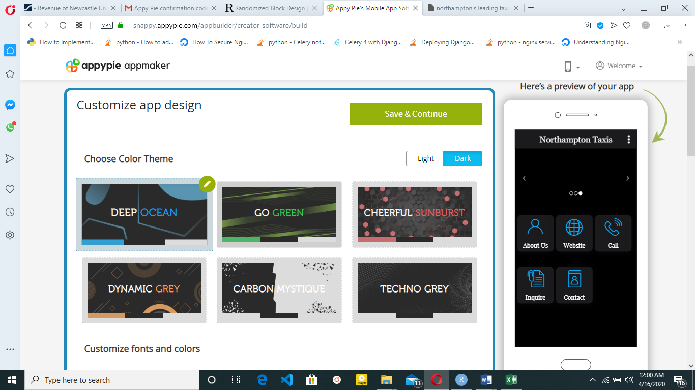

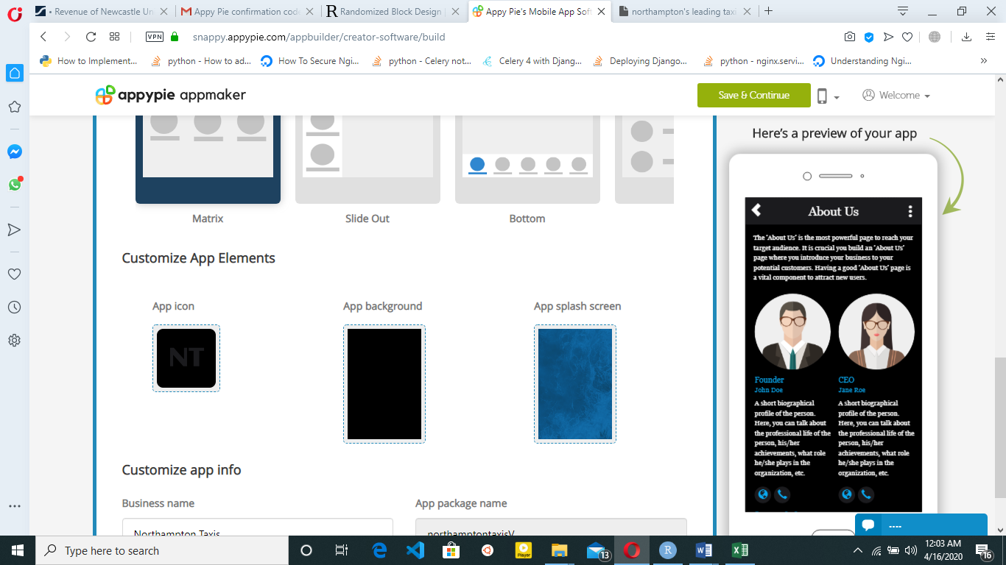

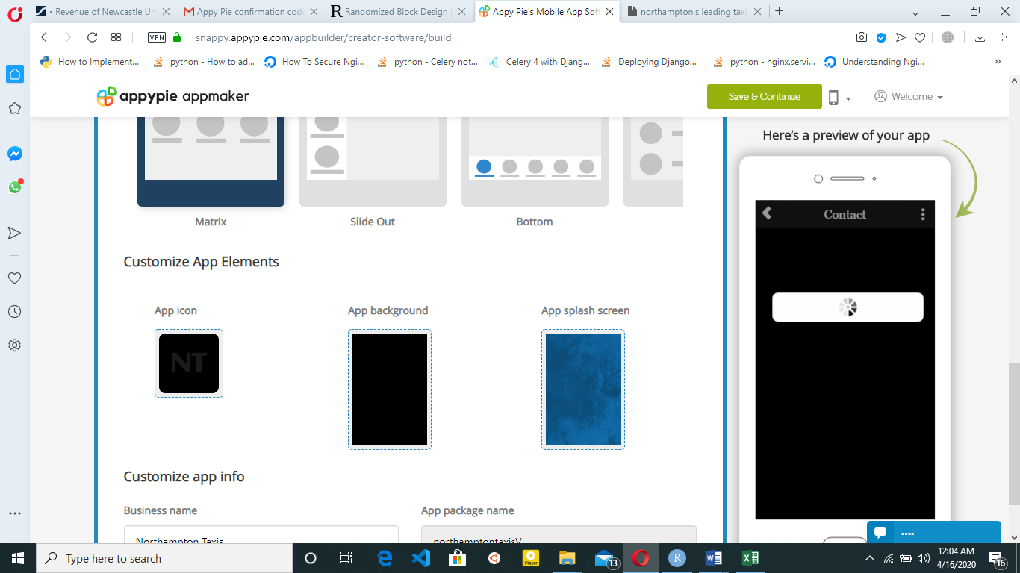

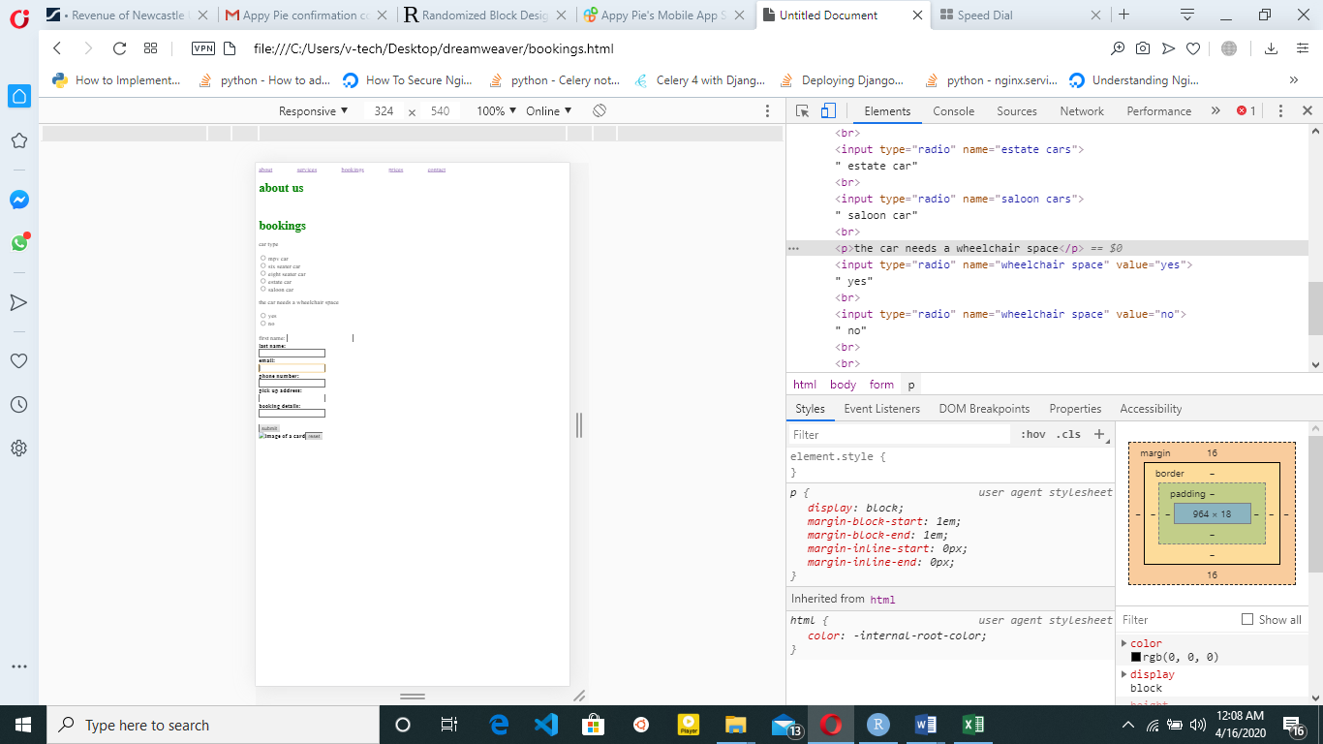

# References.

Nielsen, J. (2007). F-shaped pattern for reading web content. 2006. *Im Internet: www. nngroup. com/articles/f-shaped-pattern-reading-web-content*.

Sziklai, G. (1956). Some studies in the speed of visual perception. *IRE Transactions on Information Theory*, *2*(3), 125-128.

Park, J., DeLong, M., & Woods, E. (2012). Exploring product communication between the designer and the user through eye-tracking technology. *International Journal of Fashion Design, Technology and Education*, *5*(1), 67-78.

Goward, C. (2012). *You should test that: conversion optimization for more leads, sales and profit or the art and science of optimized marketing*. John Wiley & Sons.