KYANOS HOTELS & RESORTS
Unified Data & AI Platform on Microsoft Fabric
Solution documentation – architecture, data model, DAX, AI and build process
Item | Value
Document | Solution documentation · version 1.0
Date | 7 October 2026
Author | Vangelis Misirlis
Workspace | "Kyanos Hotels - Analytics & AI Demo" (tested on F4 and F8 capacities)
Purpose | Reference demo for hotel groups: real-time PMS integration, unified analytics, AI forecasting and data agents
Data | Fully synthetic. Kyanos Hotels & Resorts, its hotels, guests and partners are fictional.

Contents
1. Executive summary
2. Solution architecture
3. Data sources and synthetic data
4. Ingestion: PMS mirroring, shortcut and file landing
5. Lakehouse design and data lineage
6. Notebooks and transformation logic
7. Semantic model and table relationships
8. DAX measure catalog
9. DAX queries (validation and analysis)
10. Power BI report
11. AI demand forecast
12. Fabric data agent
13. Fabric IQ ontology
14. Live PMS simulator and demo operations
15. Build and deployment process
16. Issues encountered and resolutions
17. Important considerations
18. Appendices: item inventory, column dictionary, code excerpts, glossary

1. Executive summary
This document describes an end-to-end Microsoft Fabric solution built for a hotel group. It shows how a group that today runs an on-premises PMS and SQL Server data warehouse with a nightly batch (the 05:00–08:00 window) can move to one copy of the data in OneLake, near real-time reporting, AI forecasting and natural-language access, without re-platforming its operational systems.

1.1 What was built
- Operational source – KyanosPMS, a Fabric SQL database standing in for an on-premises PMS / SQL Server, holding 24 hotels, 117 room types, 255,848 guests and 483K reservations. It is replicated to OneLake automatically (Mirroring).
- Unified lakehouse – KyanosLakehouse (schema-enabled) combining the PMS (zero-copy shortcut), Salesforce (Privilege Club, service cases), SAP (monthly hotel costs) and airline seat capacity, refined into a gold star schema by PySpark notebooks.
- Governed semantic model – Kyanos Hotels Model: Direct Lake on OneLake, 11 tables, 15 relationships, 53 DAX measures (Occupancy, ADR, RevPAR, GOP, pace, forecast, live KPIs) and 2 row-level-security roles.
- Power BI report – 5 pages with a custom Aegean theme: Executive Overview, Hotel Scorecard, Channels & Guests, 2027 Demand Outlook (AI) and Live PMS Feed.
- AI demand forecast – a gradient-boosting booking-pace model (MLflow-tracked and registered) that forecasts 2027 occupancy per hotel-night from booking pace and published airline seat capacity.
- Fabric data agent – "Kyanos Revenue & Guest Assistant" answering Greek and English questions over the same governed model.
- Fabric IQ ontology – six business entities (Hotel, Airport, VIP guest, Upcoming stay, Open case, Tour operator) with five relationships.
- Live simulator – a Python process writing new bookings into the PMS; they appear in Power BI in about 13 seconds.

1.2 Headline results in the demo data
KPI (Jan–Sep closed months) | 2025 | 2026 | Change
Total revenue | €362,577,449 | €384,982,838 | 6.2%
Occupancy | 83.2% | 84.3% | +1.1 pts
ADR | €300.02 | €318.45 | 6.1%
RevPAR | €249.56 | €268.46 | 7.6%
GOP margin | 39.5% | 40.2% | +0.7 pts
Direct booking share | 34.5% | 38.3% | +3.8 pts

2027 outlook (AI forecast, Jan–Sep) | Value
Forecast occupancy 2027 | 86.0%
Actual occupancy 2026 (same weekdays) | 84.4%
Already on the books (snapshot 6 Oct 2026) | 7.1%
Forecast room revenue | €319,509,787 (5.4% vs 2026)
Model accuracy (holdout MAE) | 3.31 occupancy points vs 4.09 for "same as last year"

1.3 Key design decisions
- Mirror, don't extract. Operational SQL data lands in OneLake continuously; the nightly copy and the 05:00–08:00 window disappear.
- Zero-copy unification. The PMS is exposed in the lakehouse through a schema-level OneLake shortcut, so there is one physical copy.
- Direct Lake semantic model. Power BI reads Delta tables directly – no import refresh, and new commits are framed automatically.
- One set of KPI definitions. Report, Copilot and the data agent all use the same 53 measures, so numbers match everywhere.
- AI on the same platform. Forecasting runs in a notebook on the same capacity and writes back to gold; MLflow tracks and registers the model.

2. Solution architecture
The solution follows a five-layer flow: Sources → Ingestion → OneLake → Analytics & AI → Consumption, all inside one Fabric workspace on an F8 capacity. The workspace is organised into folders that mirror these layers.
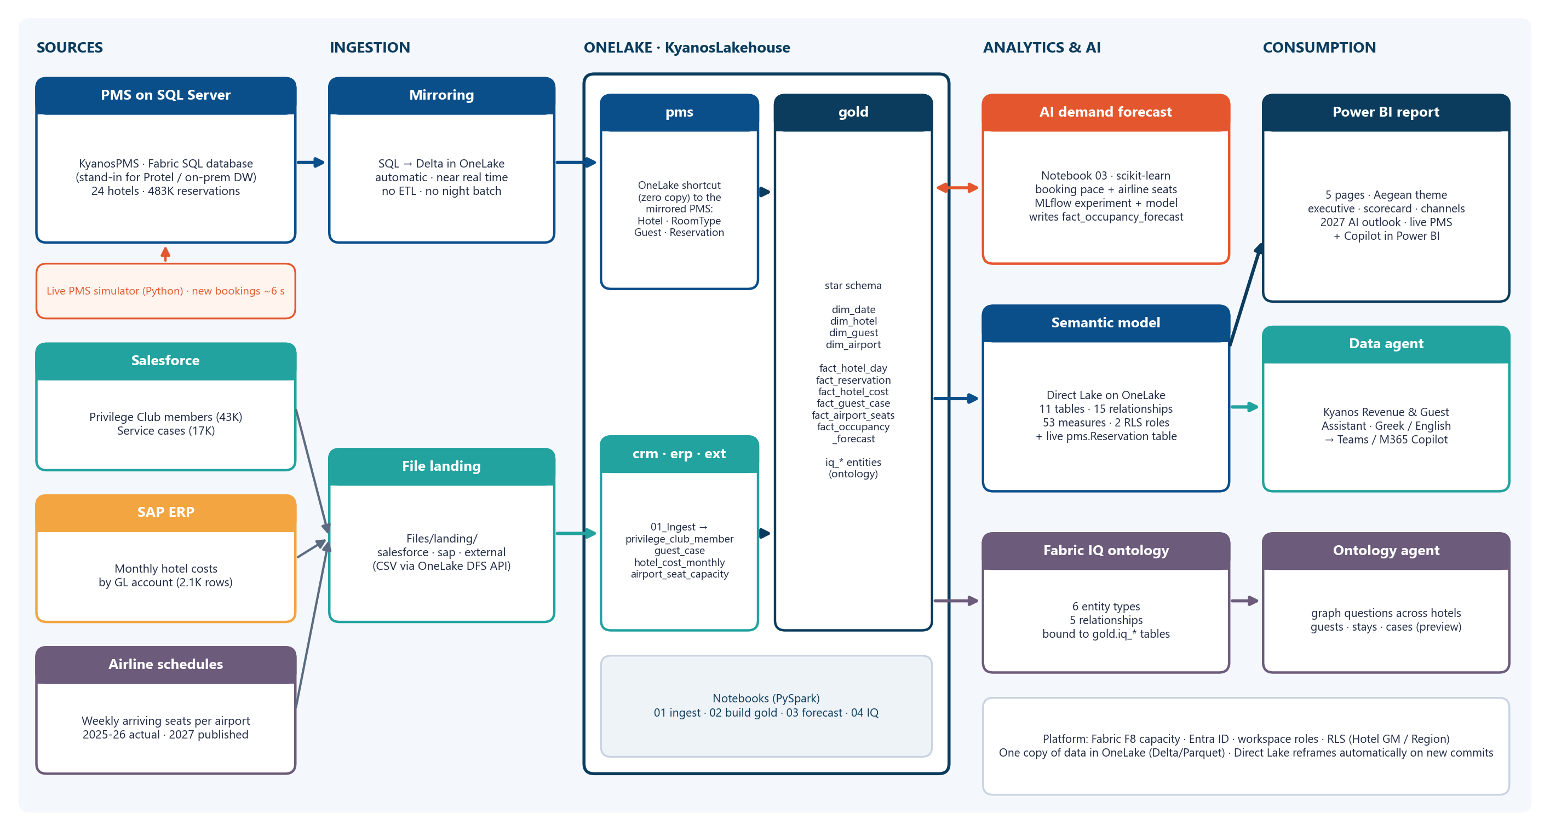
Figure 1 – Solution architecture

2.1 Layer-by-layer description
Layer | Fabric item(s) | Role | Key facts
Sources | KyanosPMS (SQL database); CSV extracts | Operational PMS; Salesforce, SAP and airline data | PMS is the system of record for stays and revenue; others arrive as files
Ingestion | Mirroring; OneLake shortcut; OneLake DFS API | Continuous replication of SQL tables; file landing | Mirrored Delta committed within seconds of each insert
OneLake | KyanosLakehouse (schemas pms, crm, erp, ext, gold) | Single copy of data; medallion refinement | 24 tables incl. 10 gold model tables and 6 iq_* entities
Transformation | Notebooks 01, 02, 04 (PySpark) | Typing, conformance, data quality, star schema | Run via the Fabric Jobs API; ~1–3 min each on F8
AI | Notebook 03; MLflow experiment + model | Occupancy forecast for Jan–Sep 2027 | HistGradientBoosting with monotonic constraints
Semantic layer | Kyanos Hotels Model (Direct Lake) | Governed KPIs, relationships, RLS | 11 tables, 15 relationships, 53 measures, 2 roles
Consumption | Power BI report; data agent; ontology | Dashboards, Copilot, natural-language Q&A, graph | Greek and English questions; Teams / M365 Copilot publishable

2.2 Design principles
- One copy of data: Delta/Parquet in OneLake is read by Spark, SQL, Power BI (Direct Lake), the data agent and the ontology.
- Near real time where it matters: the PMS is mirrored; the semantic model includes the live pms.Reservation table for the Live PMS page.
- Schema-enabled lakehouse: schemas separate sources (pms, crm, erp, ext) from serving tables (gold).
- Governed metrics: every KPI is a model measure with description and display folder; visuals and agents never recompute KPIs.
- Security by design: RLS anchored on dim_hotel (per-hotel GM and per-region roles); workspace roles control authoring.
- Everything as code: every item is deployed through Fabric REST APIs from Python, making the demo repeatable in any tenant.

2.3 Workspace organisation
Folder | Items
1 Sources PMS on SQL | KyanosPMS (SQL database + its SQL analytics endpoint)
2 OneLake unified data | KyanosLakehouse, 01_Ingest_Salesforce_SAP_Airports, 02_Build_Gold_Model
3 AI forecasting | 03_AI_Demand_Forecast_2027, MLflow experiment and registered model kyanos-occupancy-forecast
4 Power BI | Kyanos Hotels Model (semantic model), Kyanos Hotels - Commercial Performance (report)
5 Agents and Fabric IQ | Kyanos Revenue & Guest Assistant (data agent), KyanosHotelsOntology (+ its lakehouse and graph model), 04_Fabric_IQ_Ontology_Entities

3. Data sources and synthetic data
All data is generated by src/gen_data.py with a fixed random seed, so the dataset is reproducible. The snapshot date is 6 October 2026: stays before it are realised (checked-out or in-house), later stays are on-the-books (OTB) business.

3.1 Hotel portfolio
Code | Hotel | Region | Airport | Concept | Rooms | Season
KYN-ELO | Kyanos Elounda Palace | Crete | HER | Luxury Resort | 280 | 04-01 → 11-05
KYN-AGN | Kyanos Agios Nikolaos Bay | Crete | HER | Luxury Resort | 220 | 04-05 → 10-31
KYN-HER | Kyanos Heraklion City | Crete | HER | City Hotel | 160 | Year-round
KYN-RET | Kyanos Rethymno Mare | Crete | CHQ | Family Resort | 380 | 04-10 → 10-31
KYN-CHA | Kyanos Chania Kalyves | Crete | CHQ | Family Resort | 240 | 04-15 → 10-25
KYN-MAL | Kyanos Malia Riviera | Crete | HER | All-Inclusive Resort | 420 | 04-10 → 10-31
KYN-IXI | Kyanos Rhodes Ixia Grand | Rhodes | RHO | Luxury Resort | 360 | 04-01 → 11-01
KYN-LIN | Kyanos Lindos Blue | Rhodes | RHO | Adults-Only Resort | 180 | 04-10 → 10-31
KYN-FAL | Kyanos Faliraki Family | Rhodes | RHO | All-Inclusive Resort | 450 | 04-15 → 10-31
KYN-MAR | Kyanos Kos Marmari | Kos | KGS | All-Inclusive Resort | 400 | 04-20 → 10-25
KYN-PSA | Kyanos Kos Psalidi Suites | Kos | KGS | Luxury Resort | 200 | 04-20 → 10-31
KYN-DAS | Kyanos Corfu Dassia | Corfu | CFU | Luxury Resort | 320 | 04-25 → 10-25
KYN-KAV | Kyanos Kavos Lagoon | Corfu | CFU | All-Inclusive Resort | 260 | 05-01 → 10-15
KYN-PAL | Kyanos Paleokastritsa | Corfu | CFU | Family Resort | 150 | 04-25 → 10-25
KYN-ORN | Kyanos Mykonos Ornos | Cyclades | JMK | Luxury Resort | 120 | 04-25 → 10-31
KYN-CAL | Kyanos Santorini Caldera | Cyclades | JTR | Adults-Only Resort | 90 | 04-01 → 11-05
KYN-KAS | Kyanos Kassandra Palace | Halkidiki | SKG | Luxury Resort | 340 | 05-01 → 10-15
KYN-SIT | Kyanos Sithonia Beach | Halkidiki | SKG | Family Resort | 300 | 05-01 → 10-10
KYN-THE | Kyanos Thessaloniki Center | Macedonia | SKG | City Hotel | 180 | Year-round
KYN-OLY | Kyanos Olympia Riviera | Peloponnese | GPA | Family Resort | 380 | 04-01 → 10-31
KYN-MES | Kyanos Messinia Bay | Peloponnese | KLX | Luxury Resort | 260 | 04-01 → 11-01
KYN-ACR | Kyanos Athens Acropolis | Attica | ATH | City Hotel | 210 | Year-round
KYN-VOU | Kyanos Vouliagmeni Riviera | Attica | ATH | Luxury Resort | 150 | 03-15 → 11-30
KYN-ZAK | Kyanos Zakynthos Laganas | Zakynthos | ZTH | All-Inclusive Resort | 260 | 05-01 → 10-20

3.2 Data volumes
Dataset | System | Rows | Notes
pms.Hotel / pms.RoomType | PMS (SQL) | 24 / 117 | Resorts: 5 room types; city hotels: 4
pms.Guest | PMS (SQL) | 255,848 | Fictional names, emails at example.com, 20 source markets
pms.Reservation | PMS (SQL) | 484,782 | Arrivals 2025-01-01 → 2027; includes cancellations, no-shows, in-house, OTB; plus live simulator rows
privilege_club_members.csv | Salesforce | 43,250 | Tier Blue/Silver/Gold/Platinum by lifetime nights; 99 duplicate member IDs (deliberate data-quality issue)
guest_cases.csv | Salesforce | 17,379 | Complaints, requests, compliments with CSAT 1–5
hotel_costs_monthly.csv | SAP | 2,148 | 6 cost categories by GL account per hotel-month
airport_seat_capacity_weekly.csv | External | 1,884 | 12 airports; weekly arriving seats; 2027 = published schedules

3.3 Generation logic
- Inventory-consistent occupancy: for each hotel, room type and day a target occupancy is drawn (monthly seasonality × weekday × hotel performance × year factor × noise). Arrivals are created until the target is met, with length of stay truncated at full nights or hotel closure – occupancy can never exceed capacity.
- Seasonality: resorts peak in July–August (96–98%) and close between November and March/April; city hotels run all year with a weekday/weekend pattern.
- Channels and lead times: channel mix depends on concept (tour operators dominate all-inclusive resorts, OTAs and corporate dominate city hotels). Lead times are log-normal per channel (tour operators ≈190 days, OTAs ≈40 days).
- Prices: ADR = base rate × room-type multiplier × monthly season factor × channel factor × board factor × year factor (+6.5% in 2026) × noise.
- Cancellations and snapshot: cancellation rates per channel (Booking.com 24%, tour operators 7%). Only bookings made on or before the snapshot are kept; future cancellations stay as Confirmed.
- Extras revenue: F&B and other spend per adult-night depends on board type and hotel concept, realised only for stayed nights.
- SAP costs: payroll per room, F&B cost of sales (38%), energy (+12% in 2026), OTA/TO commissions, maintenance and marketing – producing a ~40% GOP margin.

3.4 Built-in business stories
Story | How it appears | Where to show it
Airlines cut seats to Kos and Zakynthos in 2026 | KGS −13%, ZTH −10% seats; RevPAR −6% to −8%; rates held flat | Executive Overview, Hotel Scorecard, data agent
Direct booking strategy is working | ≈12% of OTA demand shifts to direct web in 2026; direct share 34.5% → 38.3% | Channels & Guests
Air-conditioning issue at Kos Marmari | 35% of its 2026 cases are A/C complaints (151 vs 37 for the next category) | Hotel Scorecard (click the hotel)
Summer 2027 seat growth | Araxos +15%, Chania +12%, Kalamata +11% → forecast up; Kos still declining | 2027 Demand Outlook (AI)
Data-quality issue between CRM and PMS | 99 duplicate Privilege Club IDs | Notebook 02 (de-duplication)

4. Ingestion: PMS mirroring, shortcut and file landing

4.1 PMS database (KyanosPMS)
KyanosPMS is a Fabric SQL database (SQL Server engine). It plays the role of the customer's on-premises Protel/SQL Server. All tables have primary keys – a prerequisite for mirroring from SQL Server 2016–2022.

4.1.1 pms.Hotel
Column definition
HotelId INT NOT NULL PRIMARY KEY
HotelCode VARCHAR(10) NOT NULL
HotelName NVARCHAR(80) NOT NULL
Destination NVARCHAR(40)
Region NVARCHAR(40)
Airport CHAR(3)
Stars TINYINT
Concept NVARCHAR(40)
Rooms INT
Latitude DECIMAL(9,6)
Longitude DECIMAL(9,6)
OpenMMDD CHAR(5)
CloseMMDD CHAR(5)
IsSeasonal BIT
GeneralManager NVARCHAR(60)
GMEmail NVARCHAR(80)

4.1.2 pms.RoomType
Column definition
RoomTypeId INT NOT NULL PRIMARY KEY
HotelId INT NOT NULL
RoomTypeCode VARCHAR(6)
RoomTypeName NVARCHAR(60)
RoomCount INT
RateMultiplier DECIMAL(5,2)

4.1.3 pms.Guest
Column definition
GuestId INT NOT NULL PRIMARY KEY
FirstName NVARCHAR(40)
LastName NVARCHAR(40)
Email NVARCHAR(120)
Country CHAR(2)
CountryName NVARCHAR(40)
Language NVARCHAR(20)
LoyaltyNumber VARCHAR(12) NULL
CreatedAt DATETIME2(3)

4.1.4 pms.Reservation
Column definition
ReservationId BIGINT NOT NULL PRIMARY KEY
ConfirmationNo VARCHAR(12) NOT NULL
HotelId INT NOT NULL
RoomTypeId INT NOT NULL
GuestId INT NOT NULL
BookingDate DATE NOT NULL
ArrivalDate DATE NOT NULL
DepartureDate DATE NOT NULL
Nights INT NOT NULL
Adults TINYINT
Children TINYINT
Channel NVARCHAR(30)
MarketSegment NVARCHAR(30)
TourOperator NVARCHAR(40) NULL
BoardType NVARCHAR(20)
RateAmount DECIMAL(10,2)
RoomRevenue DECIMAL(12,2)
ExtrasRevenue DECIMAL(12,2)
Status NVARCHAR(15)
CancelDate DATE NULL
CreatedAt DATETIME2(3)
ModifiedAt DATETIME2(3)

4.2 Loading the PMS
- src/load_pms.py creates the pms schema and tables, then loads hotels, room types, 255,848 guests and 482,961 reservations.
- Connectivity uses mssql-python (bundled driver, no ODBC install) with an Entra access token from the Azure CLI passed as SQL_COPT_SS_ACCESS_TOKEN (attribute 1256).
- Throughput: ~2,000–6,700 rows/s with executemany (bulk copy opened a second connection without the token, so the loader falls back automatically). Total load time ≈ 5 min 40 s.
- An index IX_Res_Booking (BookingDate) INCLUDE (HotelId, Status) supports the simulator and booking-date queries.

4.3 Mirroring to OneLake
A Fabric SQL database replicates every table to OneLake as Delta automatically. Measured: a new Delta log version appeared within seconds of an insert, and the Direct Lake model showed 12 new bookings 13 seconds after they were written.
Customer equivalent (SQL Server 2022 on-premises)
Use the Mirrored database item for SQL Server through the on-premises data gateway already used for Power BI. Mirroring SQL Server 2016–2022 relies on CDC, needs a primary key on every mirrored table, runs from the primary replica of an availability group, and requires CDC to be re-enabled after DDL changes. See section 17.

4.4 Schema-level OneLake shortcut
The lakehouse exposes the PMS through one shortcut at `Tables/pms` pointing to the SQL database's Tables/pms folder. All four PMS tables (and any future table) appear in the lakehouse as pms.Hotel, pms.RoomType, pms.Guest, pms.Reservation – zero copy.
POST /v1/workspaces/{ws}/items/{lakehouseId}/shortcuts?shortcutConflictPolicy=CreateOrOverwrite
{
"path": "Tables",
"name": "pms",
"target": { "oneLake": { "workspaceId": "{ws}", "itemId": "{sqlDatabaseId}", "path": "Tables/pms" } }
}

4.5 File landing (Salesforce, SAP, airlines)
Source file | Landing path | Bronze/silver table
salesforce_privilege_club_members.csv | Files/landing/salesforce/privilege_club_members.csv | crm.privilege_club_member
salesforce_guest_cases.csv | Files/landing/salesforce/guest_cases.csv | crm.guest_case
sap_hotel_costs_monthly.csv | Files/landing/sap/hotel_costs_monthly.csv | erp.hotel_cost_monthly
airport_seat_capacity_weekly.csv | Files/landing/external/airport_seat_capacity_weekly.csv | ext.airport_seat_capacity
Files are uploaded with the OneLake DFS API (create → append → flush, x-ms-version: 2021-08-06, storage audience token). In production Salesforce would use the Data Factory Salesforce connector or Copy job instead of hand-coded API extracts.

5. Lakehouse design and data lineage
KyanosLakehouse is created with enableSchemas: true. Schemas separate source-aligned data from serving data:
Schema | Purpose | Written by
pms | Mirrored PMS tables (shortcut, read-only) | Mirroring
crm | Salesforce Privilege Club and cases | 01_Ingest
erp | SAP monthly costs | 01_Ingest
ext | Airline seat capacity | 01_Ingest
gold | Star schema for BI + forecast + ontology entities | 02, 03, 04

5.1 Table inventory
Schema | Table | Rows | Cols | Role
crm | guest_case | 17,379 | 11 | Bronze/silver (typed landing)
crm | privilege_club_member | 43,250 | 15 | Bronze/silver (typed landing)
erp | hotel_cost_monthly | 2,148 | 9 | Bronze/silver (typed landing)
ext | airport_seat_capacity | 1,884 | 8 | Bronze/silver (typed landing)
gold | dim_airport | 12 | 3 | Gold dimension
gold | dim_date | 1,095 | 13 | Gold dimension
gold | dim_guest | 255,848 | 12 | Gold dimension
gold | dim_hotel | 24 | 15 | Gold dimension
gold | fact_airport_seats | 1,872 | 6 | Gold fact
gold | fact_guest_case | 17,379 | 9 | Gold fact
gold | fact_hotel_cost | 2,148 | 5 | Gold fact
gold | fact_hotel_day | 26,280 | 9 | Gold fact
gold | fact_occupancy_forecast | 4,390 | 16 | Gold fact
gold | fact_reservation | 482,961 | 25 | Gold fact
gold | iq_airport | 12 | 5 | Ontology entity
gold | iq_hotel | 24 | 15 | Ontology entity
gold | iq_open_case | 124 | 9 | Ontology entity
gold | iq_tour_operator | 6 | 5 | Ontology entity
gold | iq_upcoming_stay | 3,600 | 11 | Ontology entity
gold | iq_vip_guest | 2,943 | 8 | Ontology entity
pms | Guest | 255,848 | 9 | Shortcut → mirrored PMS
pms | Hotel | 24 | 16 | Shortcut → mirrored PMS
pms | Reservation | 484,782 | 22 | Shortcut → mirrored PMS
pms | RoomType | 117 | 6 | Shortcut → mirrored PMS
Row counts were taken from the lakehouse SQL analytics endpoint on 7 Oct 2026 (pms.Reservation includes live simulator bookings).

5.2 Data lineage
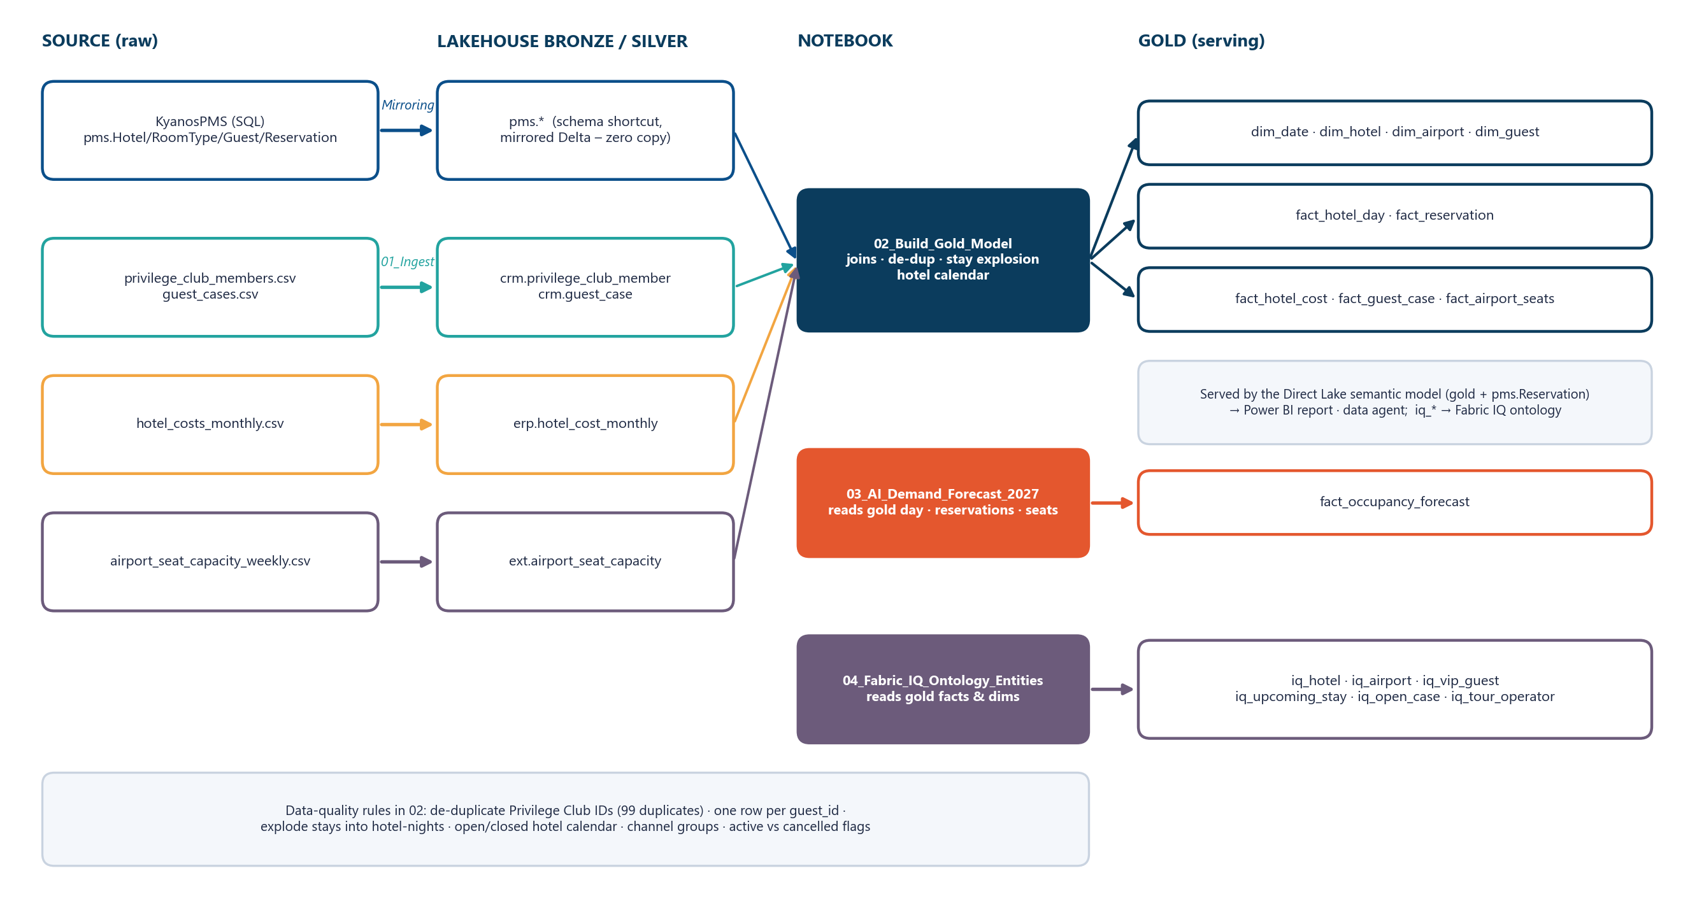
Figure 2 – Data lineage from source to gold

6. Notebooks and transformation logic
Four PySpark notebooks are deployed in Fabric git format (notebook-content.py) with the lakehouse attached as default, and executed with the Jobs API (jobType=RunNotebook). Typical duration on F8: 65–170 seconds.
Notebook | Inputs | Outputs | Key logic
01_Ingest_Salesforce_SAP_Airports | Files/landing/*.csv; pms.Reservation (check) | crm.*, erp.*, ext.* | CSV with schema inference + explicit casts; lineage columns _ingested_at, _source_file
02_Build_Gold_Model | pms.*, crm.*, erp.*, ext.* | gold.dim_* and gold.fact_* (10 tables) | Conformed dimensions, data-quality de-dup, stay explosion to hotel-nights, hotel calendar
03_AI_Demand_Forecast_2027 | gold.fact_reservation, fact_hotel_day, dim_hotel, fact_airport_seats | gold.fact_occupancy_forecast; MLflow run + registered model | Booking-pace model, see section 11
04_Fabric_IQ_Ontology_Entities | gold dims and facts | gold.iq_* (6 tables) | Business entities for the ontology (VIP guests, upcoming stays, open cases …)

6.1 Gold table derivations
Gold table | Grain | Derivation
dim_date | Day 2025-01-01 → 2027-12-31 | Generated sequence; year, quarter, month, week_start, weekday, season (Peak/High/Shoulder/Winter), is_actual (≤ snapshot), is_closed_ytd (month < October)
dim_hotel | Hotel | pms.Hotel renamed; short name; operating model; GM name and email (RLS)
dim_airport | Airport | 12 airports with name and region
dim_guest | Guest | pms.Guest LEFT JOIN de-duplicated crm.privilege_club_member on loyalty number; tier, opt-in, preference; dropDuplicates(guest_id)
fact_reservation | Reservation | pms.Reservation + room type; lead_time_days; channel_group (Direct / OTA / Tour Operator & Wholesale / Corporate & MICE); is_cancelled, is_active
fact_hotel_day | Hotel × day | Active stays exploded into nights (revenue spread evenly) + arrivals, cross-joined with the hotel open/closed calendar → rooms_available, rooms_sold, revenue
fact_hotel_cost | Hotel × month × cost line | SAP plant code mapped to hotel_id; amount in EUR
fact_guest_case | Case | Salesforce case with hotel_id via hotel code; category, sub_category, CSAT
fact_airport_seats | Airport × week | Weekly arriving seats and flights (2025+)
fact_occupancy_forecast | Hotel × day (Jan–Sep 2027) | Notebook 03 output: OTB, LY, forecast rooms and revenue, drivers, model_run_id

6.2 Data-quality rules
- Duplicate loyalty IDs: 99 Privilege Club IDs are duplicated across Salesforce accounts. Without handling, the join produced duplicate guest_id values and broke the many-to-one relationship in the model. Notebook 02 keeps one member record per ID and one row per guest.
- Stay explosion: each active reservation becomes one row per night, so occupancy and RevPAR are exact at day level.
- Hotel calendar: rooms_available is zero when a seasonal hotel is closed, so occupancy is never diluted by closed days.
- Status logic: only Checked-Out, In-House and Confirmed stays count as active; cancellations and no-shows are excluded from occupancy.

7. Semantic model and table relationships
Property | Value
Name | Kyanos Hotels Model
Storage mode | Direct Lake on OneLake (expression DL_Lakehouse → AzureStorage.DataLake on the lakehouse)
Compatibility level | 1702 · culture en-US · discourageImplicitMeasures
Definition format | TMDL, deployed with the Fabric items API (format TMDL)
Tables / relationships / measures | 11 / 15 / 53
Date table | dim_date (dataCategory Time, date column isKey)
Refresh | None scheduled. Direct Lake reframes automatically on new Delta commits; a full refresh (reframe) is requested after each deployment
Security | RLS roles: Crete Region Manager, Hotel General Manager

expression DL_Lakehouse =
let
Source = AzureStorage.DataLake("https://onelake.dfs.fabric.microsoft.com/<workspaceId>/<lakehouseId>", [HierarchicalNavigation=true])
in
Source

partition fact_hotel_day = entity
mode: directLake
source
entityName: fact_hotel_day
schemaName: gold
expressionSource: DL_Lakehouse

Table relationship diagram
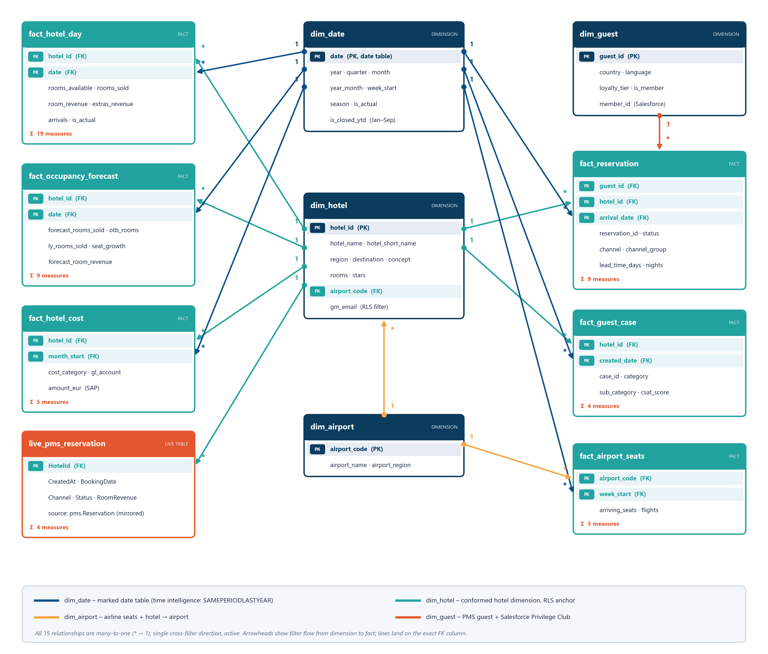
Figure 3 – Table relationship diagram of the semantic model (Direct Lake)

7.1 Relationships
From (many) | To (one) | Cardinality | Cross-filter | State
fact_hotel_day[hotel_id] | dim_hotel[hotel_id] | Many-to-one (*:1) | Single | Active
fact_hotel_day[date] | dim_date[date] | Many-to-one (*:1) | Single | Active
fact_reservation[hotel_id] | dim_hotel[hotel_id] | Many-to-one (*:1) | Single | Active
fact_reservation[arrival_date] | dim_date[date] | Many-to-one (*:1) | Single | Active
fact_reservation[guest_id] | dim_guest[guest_id] | Many-to-one (*:1) | Single | Active
fact_hotel_cost[hotel_id] | dim_hotel[hotel_id] | Many-to-one (*:1) | Single | Active
fact_hotel_cost[month_start] | dim_date[date] | Many-to-one (*:1) | Single | Active
fact_guest_case[hotel_id] | dim_hotel[hotel_id] | Many-to-one (*:1) | Single | Active
fact_guest_case[created_date] | dim_date[date] | Many-to-one (*:1) | Single | Active
fact_airport_seats[airport_code] | dim_airport[airport_code] | Many-to-one (*:1) | Single | Active
fact_airport_seats[week_start] | dim_date[date] | Many-to-one (*:1) | Single | Active
fact_occupancy_forecast[hotel_id] | dim_hotel[hotel_id] | Many-to-one (*:1) | Single | Active
fact_occupancy_forecast[date] | dim_date[date] | Many-to-one (*:1) | Single | Active
dim_hotel[airport_code] | dim_airport[airport_code] | Many-to-one (*:1) | Single | Active
live_pms_reservation[HotelId] | dim_hotel[hotel_id] | Many-to-one (*:1) | Single | Active

7.2 Relationship design notes
- Star schema with conformed dimensions. dim_hotel and dim_date are shared by all facts, so one slicer filters revenue, costs, cases, forecast and live data consistently.
- Different date roles per fact: stays by arrival_date, costs by month_start, cases by created_date, seats by week_start, hotel-day and forecast by date. Last-year measures therefore work for every fact.
- Snowflake to airports: dim_hotel[airport_code] → dim_airport. Because filters flow only from dim_airport to dim_hotel, airline-seat measures use TREATAS(VALUES(dim_hotel[airport_code]), dim_airport[airport_code]) to respond to hotel filters without a bidirectional relationship.
- Live table: live_pms_reservation maps directly to the mirrored pms.Reservation (schema pms) and joins only to dim_hotel – it powers the Live PMS Feed page without any refresh.
- All single-direction: no bidirectional or many-to-many relationships, so there are no ambiguous paths and RLS on dim_hotel propagates to every fact.

7.3 Row-level security
Role | Table filter | Use
Crete Region Manager | dim_hotel : [region] = "Crete" | Regional manager sees the 6 Crete hotels
Hotel General Manager | dim_hotel : [gm_email] = USERPRINCIPALNAME() | Each GM sees only their own hotel (gm_email = signed-in user)
Role members are assigned in the Power BI service. Test with Security → Test as role on the semantic model.

7.4 Column conventions
- Keys and raw numeric columns on facts are hidden; users work with measures and dimension attributes.
- dim_date[month] sorts by month_num, dim_date[weekday] by weekday_num; dim_hotel latitude/longitude carry geographic data categories.
- Numeric key columns use summarizeBy: none to avoid implicit aggregation; discourageImplicitMeasures is enabled.

8. DAX measure catalog
All 53 measures are defined in TMDL with a description and display folder. They are grouped below by host table. Formats use EUR, percentages with one decimal, and signed percentage points for changes.

8.1 fact_hotel_day (19 measures)
Measure | DAX expression | Format | Description
Rooms Available | SUM(fact_hotel_day[rooms_available]) | #,0 | Saleable room nights (hotel open days x rooms).
Rooms Sold | SUM(fact_hotel_day[rooms_sold]) | #,0 | Occupied room nights (on-the-books for future dates).
Occupancy % | DIVIDE([Rooms Sold], [Rooms Available]) | 0.0% | Rooms sold / rooms available.
Room Revenue | SUM(fact_hotel_day[room_revenue]) | €#,0 | Accommodation revenue in EUR.
F&B and Other Revenue | SUM(fact_hotel_day[extras_revenue]) | €#,0 | Food & beverage, spa and other outlet revenue in EUR.
Total Revenue | SUM(fact_hotel_day[total_revenue]) | €#,0 | Room + F&B and other revenue in EUR.
ADR | DIVIDE([Room Revenue], [Rooms Sold]) | €#,0.00 | Average daily rate = room revenue / rooms sold.
RevPAR | DIVIDE([Room Revenue], [Rooms Available]) | €#,0.00 | Revenue per available room = room revenue / rooms available.
TRevPAR | DIVIDE([Total Revenue], [Rooms Available]) | €#,0.00 | Total revenue per available room.
Guest Arrivals | SUM(fact_hotel_day[arrivals]) | #,0 | Number of arriving reservations.
Occupancy % LY | CALCULATE([Occupancy %], SAMEPERIODLASTYEAR(dim_date[date])) | 0.0% | Occupancy for the same period last year.
ADR LY | CALCULATE([ADR], SAMEPERIODLASTYEAR(dim_date[date])) | €#,0.00 | ADR for the same period last year.
RevPAR LY | CALCULATE([RevPAR], SAMEPERIODLASTYEAR(dim_date[date])) | €#,0.00 | RevPAR for the same period last year.
Room Revenue LY | CALCULATE([Room Revenue], SAMEPERIODLASTYEAR(dim_date[date])) | €#,0 | Room revenue same period last year.
Total Revenue LY | CALCULATE([Total Revenue], SAMEPERIODLASTYEAR(dim_date[date])) | €#,0 | Total revenue same period last year.
Occupancy vs LY (pts) | IF(NOT ISBLANK([Occupancy % LY]), [Occupancy %] - [Occupancy % LY]) | +0.0%;-0.0%;0.0% | Change in occupancy vs last year, in percentage points.
ADR vs LY % | DIVIDE([ADR] - [ADR LY], [ADR LY]) | +0.0%;-0.0%;0.0% | ADR growth vs last year.
RevPAR vs LY % | DIVIDE([RevPAR] - [RevPAR LY], [RevPAR LY]) | +0.0%;-0.0%;0.0% | RevPAR growth vs last year.
Total Revenue vs LY % | DIVIDE([Total Revenue] - [Total Revenue LY], [Total Revenue LY]) | +0.0%;-0.0%;0.0% | Total revenue growth vs last year.

8.2 fact_hotel_cost (5 measures)
Measure | DAX expression | Format | Description
Operating Costs | SUM(fact_hotel_cost[amount_eur]) | €#,0 | Operating costs from SAP in EUR.
GOP | [Total Revenue] - [Operating Costs] | €#,0 | Gross operating profit = total revenue - operating costs.
GOP Margin % | DIVIDE([GOP], [Total Revenue]) | 0.0% | GOP as a share of total revenue.
GOPPAR | DIVIDE([GOP], [Rooms Available]) | €#,0.00 | Gross operating profit per available room.
GOP Margin % LY | CALCULATE([GOP Margin %], SAMEPERIODLASTYEAR(dim_date[date])) | 0.0% | GOP margin same period last year.

8.3 fact_reservation (9 measures)
Measure | DAX expression | Format | Description
Bookings | CALCULATE(COUNTROWS(fact_reservation), fact_reservation[is_active]) | #,0 | Active reservations (not cancelled / no-show), by arrival date.
Cancellations | CALCULATE(COUNTROWS(fact_reservation), fact_reservation[is_cancelled]) | #,0 | Cancelled reservations.
Cancellation Rate % | DIVIDE([Cancellations], [Cancellations] + [Bookings]) | 0.0% | Cancelled / all reservations.
Avg Lead Time (days) | CALCULATE(AVERAGE(fact_reservation[lead_time_days]), fact_reservation[is_active]) | 0 | Average days between booking and arrival.
Avg Length of Stay | CALCULATE(AVERAGE(fact_reservation[nights]), fact_reservation[is_active]) | 0.0 | Average nights per stay.
Booked Room Revenue | CALCULATE(SUM(fact_reservation[room_revenue]), fact_reservation[is_active]) | €#,0 | Room revenue of active reservations.
Direct Share % | DIVIDE(CALCULATE([Booked Room Revenue], fact_reservation[channel_group] = "Direct"), [Booked Room Revenue]) | 0.0% | Share of room revenue booked direct (web + call centre).
Direct Share % LY | CALCULATE([Direct Share %], SAMEPERIODLASTYEAR(dim_date[date])) | 0.0% | Direct share same period last year.
Privilege Club Share % | DIVIDE(CALCULATE([Bookings], dim_guest[is_member] = TRUE()), [Bookings]) | 0.0% | Share of stays by Privilege Club members.

8.4 fact_guest_case (4 measures)
Measure | DAX expression | Format | Description
Guest Cases | COUNTROWS(fact_guest_case) | #,0 | Number of Salesforce guest cases.
Complaints | CALCULATE([Guest Cases], fact_guest_case[category] = "Complaint") | #,0 | Guest complaints.
Avg Case CSAT | AVERAGE(fact_guest_case[csat_score]) | 0.00 | Average case satisfaction score (1-5).
Complaints per 1,000 Room Nights | DIVIDE([Complaints], [Rooms Sold]) * 1000 | 0.00 | Complaints normalised by occupied room nights.

8.5 fact_airport_seats (3 measures)
Measure | DAX expression | Format | Description
Airline Seats | CALCULATE(SUM(fact_airport_seats[arriving_seats]), TREATAS(VALUES(dim_hotel[airport_code]), dim_airport[airport_code])) | #,0 | Scheduled arriving airline seats.
Airline Seats LY | CALCULATE([Airline Seats], SAMEPERIODLASTYEAR(dim_date[date])) | #,0 | Arriving seats same period last year.
Airline Seat Growth % | DIVIDE([Airline Seats] - [Airline Seats LY], [Airline Seats LY]) | +0.0%;-0.0%;0.0% | Change in scheduled arriving seats vs last year.

8.6 fact_occupancy_forecast (9 measures)
Measure | DAX expression | Format | Description
Forecast Occupancy % | DIVIDE(SUM(fact_occupancy_forecast[forecast_rooms_sold]), SUM(fact_occupancy_forecast[rooms_available])) | 0.0% | AI forecast occupancy for 2027.
Last Year Occupancy % | DIVIDE(SUM(fact_occupancy_forecast[ly_rooms_sold]), SUM(fact_occupancy_forecast[rooms_available])) | 0.0% | Actual occupancy of the same weekdays in 2026.
On-the-Books % | DIVIDE(SUM(fact_occupancy_forecast[otb_rooms]), SUM(fact_occupancy_forecast[rooms_available])) | 0.0% | Occupancy already booked for 2027 as of 6 Oct 2026.
On-the-Books LY % | DIVIDE(SUM(fact_occupancy_forecast[ly_otb_rooms]), SUM(fact_occupancy_forecast[rooms_available])) | 0.0% | Occupancy that was booked for 2026 at the same point last year.
Forecast vs LY (pts) | [Forecast Occupancy %] - [Last Year Occupancy %] | +0.0%;-0.0%;0.0% | Forecast occupancy change vs 2026, in points.
Booking Pace vs LY (pts) | [On-the-Books %] - [On-the-Books LY %] | +0.0%;-0.0%;0.0% | On-the-books ahead (+) or behind (-) last year's pace.
Forecast Room Revenue | SUM(fact_occupancy_forecast[forecast_room_revenue]) | €#,0 | Forecast 2027 room revenue (LY ADR +4%).
Forecast Room Revenue vs LY % | DIVIDE([Forecast Room Revenue] - SUM(fact_occupancy_forecast[ly_room_revenue]), SUM(fact_occupancy_forecast[ly_room_revenue])) | +0.0%;-0.0%;0.0% | Forecast room revenue growth vs 2026.
Seat Growth at Airport % | DIVIDE(SUMX(fact_occupancy_forecast, fact_occupancy_forecast[seat_growth] * fact_occupancy_forecast[rooms_available]), SUM(fact_occupancy_forecast[rooms_available])) | +0.0%;-0.0%;0.0% | Airline seat capacity change at the hotel's airport, Summer 2027 vs 2026.

8.7 live_pms_reservation (4 measures)
Measure | DAX expression | Format | Description
PMS Reservations (live) | COUNTROWS(live_pms_reservation) | #,0 | All reservations currently in the PMS.
Bookings Last 24h (live) | VAR cutoff = NOW() - 1 RETURN COALESCE(CALCULATE(COUNTROWS(live_pms_reservation), live_pms_reservation[CreatedAt] >= cutoff), 0) | #,0 | Reservations saved in the PMS in the last 24 hours (rolling).
Booked Revenue Last 24h (live) | VAR cutoff = NOW() - 1 RETURN COALESCE(CALCULATE(SUM(live_pms_reservation[RoomRevenue]), live_pms_reservation[CreatedAt] >= cutoff), 0) | €#,0 | Room revenue of reservations saved in the last 24 hours (rolling).
Last PMS Booking | FORMAT(MAX(live_pms_reservation[CreatedAt]), "dd mmm yyyy hh:nn:ss") | text | Timestamp of the latest reservation in the PMS.

8.8 DAX patterns used

8.8.1 Time intelligence on a marked date table
RevPAR LY = CALCULATE ( [RevPAR], SAMEPERIODLASTYEAR ( dim_date[date] ) )
Because every fact relates to dim_date, the same pattern works for occupancy, ADR, revenue, GOP, direct share and airline seats. Pages filter dim_date[is_closed_ytd] = TRUE so both years compare January–September.

8.8.2 Blank-safe comparisons
RevPAR vs LY % = DIVIDE ( [RevPAR] - [RevPAR LY], [RevPAR LY] )
Occupancy vs LY (pts) = IF ( NOT ISBLANK ( [Occupancy % LY] ), [Occupancy %] - [Occupancy % LY] )
The first version used DIVIDE([RevPAR], [RevPAR LY]) - 1, which returned −100% when last year was blank (e.g. 2025 has no prior year). The rewritten form returns blank instead.

8.8.3 Virtual relationship with TREATAS
Airline Seats =
CALCULATE (
SUM ( fact_airport_seats[arriving_seats] ),
TREATAS ( VALUES ( dim_hotel[airport_code] ), dim_airport[airport_code] )
)
Pushes the hotel selection onto the airport dimension so seat growth can be shown next to each hotel, keeping the physical relationship single-direction.

8.8.4 Rolling 24-hour live window
Bookings Last 24h (live) =
VAR cutoff = NOW () - 1
RETURN
COALESCE (
CALCULATE ( COUNTROWS ( live_pms_reservation ), live_pms_reservation[CreatedAt] >= cutoff ),
0
)
Replaced an earlier BookingDate = TODAY() filter that left the Live page empty at the start of a new day. NOW() is evaluated in UTC in the service; CreatedAt is stored in UTC by the simulator.

8.8.5 Weighted ratios instead of averages
Forecast Occupancy % =
DIVIDE ( SUM ( fact_occupancy_forecast[forecast_rooms_sold] ), SUM ( fact_occupancy_forecast[rooms_available] ) )

Seat Growth at Airport % =
DIVIDE (
SUMX ( fact_occupancy_forecast, fact_occupancy_forecast[seat_growth] * fact_occupancy_forecast[rooms_available] ),
SUM ( fact_occupancy_forecast[rooms_available] )
)
Ratios are always re-computed from additive components (rooms sold ÷ rooms available), never averaged, so totals are correct at any grain. Seat growth is weighted by room capacity.

9. DAX queries (validation and analysis)
The queries below were executed against the deployed model through the Power BI REST API (POST /groups/{ws}/datasets/{id}/executeQueries) to validate measures and relationships. Results are the actual values returned on 7 October 2026.

9.1 Season-to-date KPIs, 2026 vs 2025
Headline KPIs for closed months (Jan–Sep) per year; validates time intelligence and the GOP join to SAP costs.
EVALUATE
SUMMARIZECOLUMNS (
dim_date[year],
TREATAS ( { TRUE () }, dim_date[is_closed_ytd] ),
TREATAS ( { 2025, 2026 }, dim_date[year] ),
"Occupancy", [Occupancy %],
"ADR", [ADR],
"RevPAR", [RevPAR],
"RevPAR vs LY", [RevPAR vs LY %],
"Total Revenue", [Total Revenue],
"GOP Margin", [GOP Margin %],
"Direct Share", [Direct Share %]
)
ORDER BY dim_date[year]

year | Occupancy | ADR | RevPAR | RevPAR vs LY | Total Revenue | GOP Margin | Direct Share
2025 | 83.2% | €300.02 | €249.56 | (blank) | €362,577,449 | 39.5% | 34.5%
2026 | 84.3% | €318.45 | €268.46 | 7.6% | €384,982,838 | 40.2% | 38.3%

9.2 Weakest hotels vs last year and airline seats
Bottom three hotels by RevPAR growth with the seat change at their airport (TREATAS bridge dim_hotel → dim_airport).
EVALUATE
TOPN (
3,
SUMMARIZECOLUMNS (
dim_hotel[hotel_name],
dim_hotel[airport_code],
TREATAS ( { 2026 }, dim_date[year] ),
TREATAS ( { TRUE () }, dim_date[is_closed_ytd] ),
"RevPAR vs LY", [RevPAR vs LY %],
"Occupancy vs LY (pts)", [Occupancy vs LY (pts)],
"Airline Seat Growth", [Airline Seat Growth %]
),
[RevPAR vs LY], ASC
)
ORDER BY [RevPAR vs LY] ASC

hotel_name | airport_code | RevPAR vs LY | Occupancy vs LY (pts) | Airline Seat Growth
Kyanos Kos Psalidi Suites | KGS | -8.1% | -6.8 pts | -12.9%
Kyanos Kos Marmari | KGS | -6.8% | -4.9 pts | -12.9%
Kyanos Zakynthos Laganas | ZTH | -6.2% | -4.1 pts | -10.2%

9.3 Guest cases at Kyanos Kos Marmari (2026)
Salesforce case mix for one hotel; surfaces the air-conditioning complaint cluster.
EVALUATE
TOPN (
4,
SUMMARIZECOLUMNS (
fact_guest_case[sub_category],
TREATAS ( { "Kyanos Kos Marmari" }, dim_hotel[hotel_name] ),
TREATAS ( { 2026 }, dim_date[year] ),
"Cases", [Guest Cases],
"Avg CSAT", [Avg Case CSAT]
),
[Cases], DESC
)
ORDER BY [Cases] DESC

sub_category | Cases | Avg CSAT
Air conditioning | 157 | 2.46
Compliment - staff | 39 | 4.74
Special request | 38 | 4.13
Food & beverage | 35 | 2.63

9.4 Summer 2027 AI forecast – top movers
Hotels with the largest forecast occupancy change vs 2026 and their drivers.
EVALUATE
TOPN (
5,
SUMMARIZECOLUMNS (
dim_hotel[hotel_name],
"Forecast Occ", [Forecast Occupancy %],
"2026 Occ", [Last Year Occupancy %],
"Change (pts)", [Forecast vs LY (pts)],
"Seat Growth", [Seat Growth at Airport %],
"Pace vs LY", [Booking Pace vs LY (pts)]
),
[Change (pts)], DESC
)
ORDER BY [Change (pts)] DESC

hotel_name | Forecast Occ | 2026 Occ | Change (pts) | Seat Growth | Pace vs LY
Kyanos Olympia Riviera | 86.8% | 82.4% | +4.4 pts | 15.4% | +1.3 pts
Kyanos Chania Kalyves | 88.9% | 85.1% | +3.8 pts | 12.1% | +1.0 pts
Kyanos Thessaloniki Center | 81.2% | 77.8% | +3.4 pts | 8.9% | +0.1 pts
Kyanos Heraklion City | 80.8% | 77.8% | +3.0 pts | 8.0% | -0.0 pts
Kyanos Rethymno Mare | 89.3% | 86.6% | +2.8 pts | 12.2% | +1.2 pts

9.5 Group-level 2027 outlook
Single-row summary of the forecast page cards.
EVALUATE
ROW (
"Forecast Occ 2027", [Forecast Occupancy %],
"Actual Occ 2026", [Last Year Occupancy %],
"On the books", [On-the-Books %],
"Forecast Room Revenue", [Forecast Room Revenue],
"vs 2026", [Forecast Room Revenue vs LY %]
)

Forecast Occ 2027 | Actual Occ 2026 | On the books | Forecast Room Revenue | vs 2026
86.0% | 84.4% | 7.1% | €319,509,787 | 5.4%

9.6 Privilege Club tier mix (2026)
Stays by Salesforce loyalty tier through dim_guest.
EVALUATE
SUMMARIZECOLUMNS (
dim_guest[loyalty_tier],
TREATAS ( { 2026 }, dim_date[year] ),
TREATAS ( { TRUE () }, dim_date[is_closed_ytd] ),
"Stays", [Bookings]
)
ORDER BY [Stays] DESC

loyalty_tier | Stays
Non-member | 126,041
Silver | 20,501
Gold | 15,463
Blue | 9,649
Platinum | 5,797

9.7 GOP margin by hotel concept (2026 vs 2025)
Profitability by concept combining PMS revenue and SAP costs.
EVALUATE
SUMMARIZECOLUMNS (
dim_hotel[concept],
TREATAS ( { 2026 }, dim_date[year] ),
TREATAS ( { TRUE () }, dim_date[is_closed_ytd] ),
"GOP Margin", [GOP Margin %],
"GOP Margin LY", [GOP Margin % LY],
"GOPPAR", [GOPPAR]
)
ORDER BY [GOP Margin] DESC

concept | GOP Margin | GOP Margin LY | GOPPAR
Adults-Only Resort | 56.8% | 55.8% | €346.70
Luxury Resort | 48.8% | 48.0% | €224.00
Family Resort | 35.1% | 33.8% | €107.53
All-Inclusive Resort | 24.5% | 25.4% | €59.33
City Hotel | 23.3% | 22.6% | €47.90

9.8 Live PMS – last 24 hours by hotel
Rolling 24-hour window over the mirrored PMS table (Direct Lake, no refresh needed).
EVALUATE
TOPN (
5,
SUMMARIZECOLUMNS (
dim_hotel[hotel_short_name],
"Bookings 24h", [Bookings Last 24h (live)],
"Revenue 24h", [Booked Revenue Last 24h (live)]
),
[Bookings 24h], DESC
)
ORDER BY [Bookings 24h] DESC

hotel_short_name | Bookings 24h | Revenue 24h
Athens Acropolis | 94 | €52,671
Heraklion City | 64 | €19,719
Thessaloniki Center | 54 | €14,224
Malia Riviera | 31 | €52,346
Olympia Riviera | 21 | €68,619
Faliraki Family | 21 | €35,156

10. Power BI report
Kyanos Hotels - Commercial Performance is deployed in PBIR format (definition.pbir, report.json, pages/, visuals/) bound to the semantic model by ID, with a custom theme registered as a static resource.

10.1 Design system
Element | Specification
Canvas | 1280 × 720, FitToPage, page background #EEF3F8
Theme | Custom "Kyanos Aegean" – data colours #0B4F8A, #22A39F, #F2A541, #E4572E, #7A9E7E; Segoe UI; navy #0B3C5D callouts
Header band | Full-width navy textbox: brand line, page title (18pt), context subtitle (sources, period)
KPI tiles | White rounded container (textbox) + transparent card for the value + transparent card for the comparison (vs LY)
Visual containers | White background, 10px radius, light border, 11pt bold titles, optional subtitles carrying the insight
Filters | Page-level filters on dim_date (year, is_closed_ytd) so every visual compares the same months

10.2 Pages

10.2.1 Executive Overview
Page filters: dim_date[year] = 2026L, dim_date[is_closed_ytd] = true
Visual | Title | Fields / measures
card ×6 | KPI tiles | Total revenue (vs last year); Occupancy (pts vs last year); ADR (vs last year); RevPAR (vs last year); GOP margin (last year); Direct booking share (last year)
lineChart | Total revenue by month — 2026 vs 2025 | month, 2026, 2025
treemap | Revenue mix by destination | Destination, Total Revenue
clusteredColumnChart | GOP margin by hotel concept (SAP) | concept, GOP Margin %, GOP Margin % LY
barChart | RevPAR growth vs last year, by hotel | Hotel, RevPAR vs LY

10.2.2 Hotel Scorecard
Page filters: dim_date[year] = 2026L, dim_date[is_closed_ytd] = true
Visual | Title | Fields / measures
tableEx | Hotel KPIs vs last year | Hotel, Region, Concept, Occupancy, Occ vs LY, ADR, ADR vs LY, RevPAR, RevPAR vs LY, GOP %, GOPPAR, Case CSAT, Complaints /1k RN
scatterChart | Rate vs volume — ADR by occupancy (bubble = revenue) | Hotel, Occupancy %, ADR, Total Revenue, concept
barChart | Salesforce guest cases by type | Case type, Guest Cases, category

10.2.3 Channels & Guests
Page filters: dim_date[year] = 2026L, dim_date[is_closed_ytd] = true
Visual | Title | Fields / measures
card ×6 | KPI tiles | Direct booking share (last year); Privilege Club stays; Avg lead time (days); Avg length of stay; Cancellation rate; Stays
lineChart | Direct booking share by month — the direct strategy is working | month, 2026, 2025
barChart | Room revenue by booking channel | Channel, Room revenue
donutChart | Stays by Privilege Club tier (Salesforce) | Tier, Stays
clusteredColumnChart | Average booking lead time (days) | Channel group, Lead time
barChart | Source markets | Country, Stays

10.2.4 2027 Demand Outlook (AI)
Page filters: dim_date[year] = 2027L, dim_date[is_closed_ytd] = true
Visual | Title | Fields / measures
card ×5 | KPI tiles | Forecast occupancy 2027 (pts vs 2026); 2026 actual occupancy; Already on the books (pace vs LY (pts)); Forecast room revenue (vs 2026); Airline seats vs 2026
lineChart | Occupancy by month — forecast vs 2026 actual vs booked so far | month, Forecast 2027, Actual 2026, On the books today
clusteredColumnChart | Published airline seat capacity, Summer 2027 vs 2026 | Airport, Seat growth
barChart | Forecast occupancy change vs 2026, by hotel | Hotel, Forecast vs 2026 (pts)
tableEx | Drivers per hotel | Hotel, Airport, Seats, Pace, 2026, 2027 fcst, Fcst room rev

10.2.5 Live PMS Feed
Visual | Title | Fields / measures
card ×4 | KPI tiles | Bookings in the last 24 hours; Room revenue booked, last 24 hours; Reservations in the PMS; Latest booking saved at (UTC)
tableEx | Latest reservations in the PMS | Saved at (UTC), Confirmation, Hotel, Channel, Arrival, Nights, Board, Status
barChart | Bookings in the last 24 hours, by hotel | Hotel, Bookings, last 24h
donutChart | Last 24 hours bookings by channel | Channel, Bookings, last 24h

10.3 Screenshots
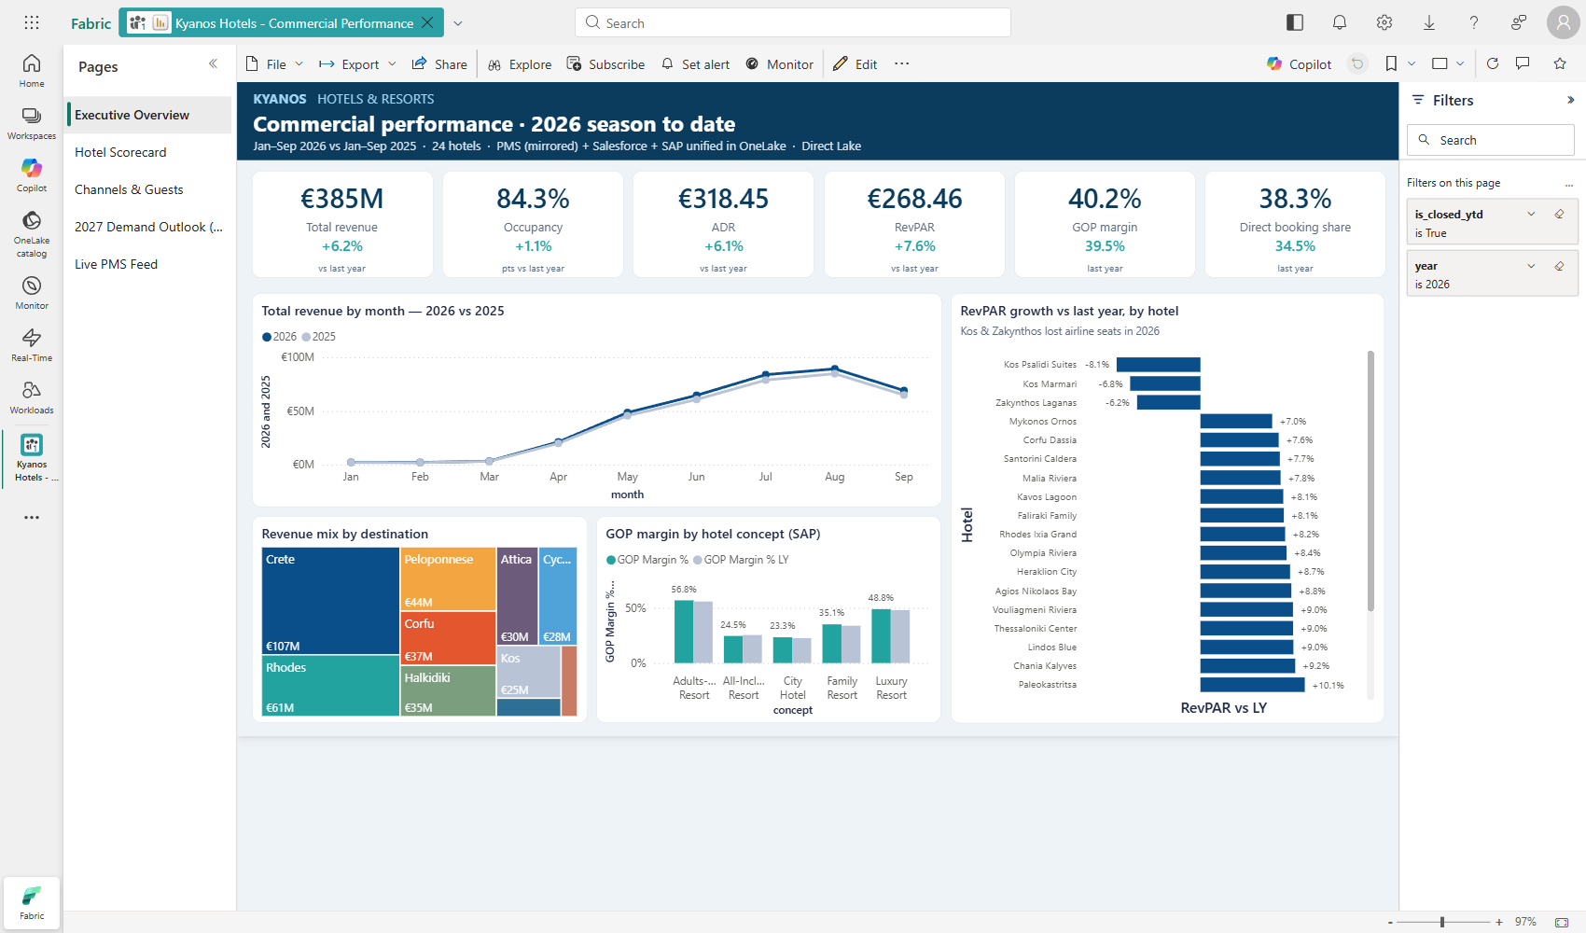
Figure 4 – Executive Overview
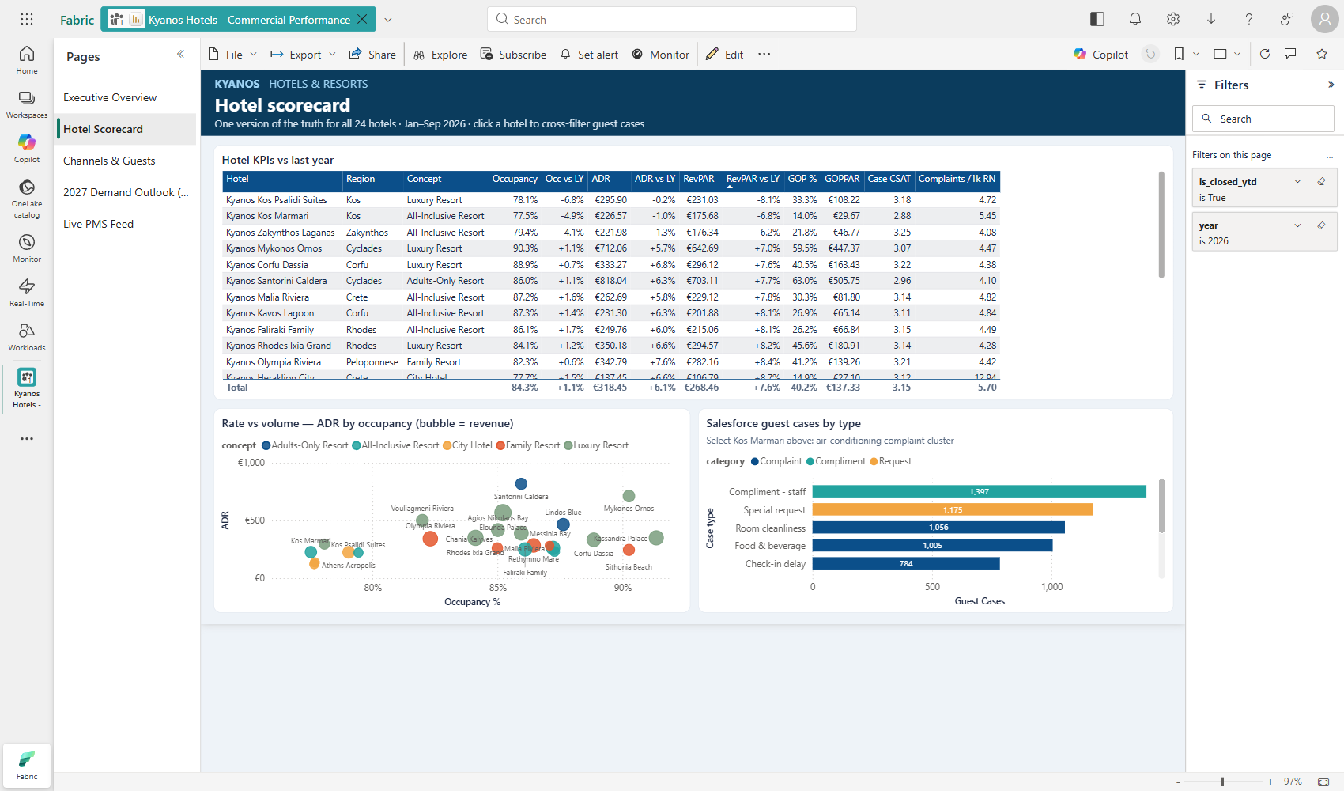
Figure 5 – Hotel Scorecard
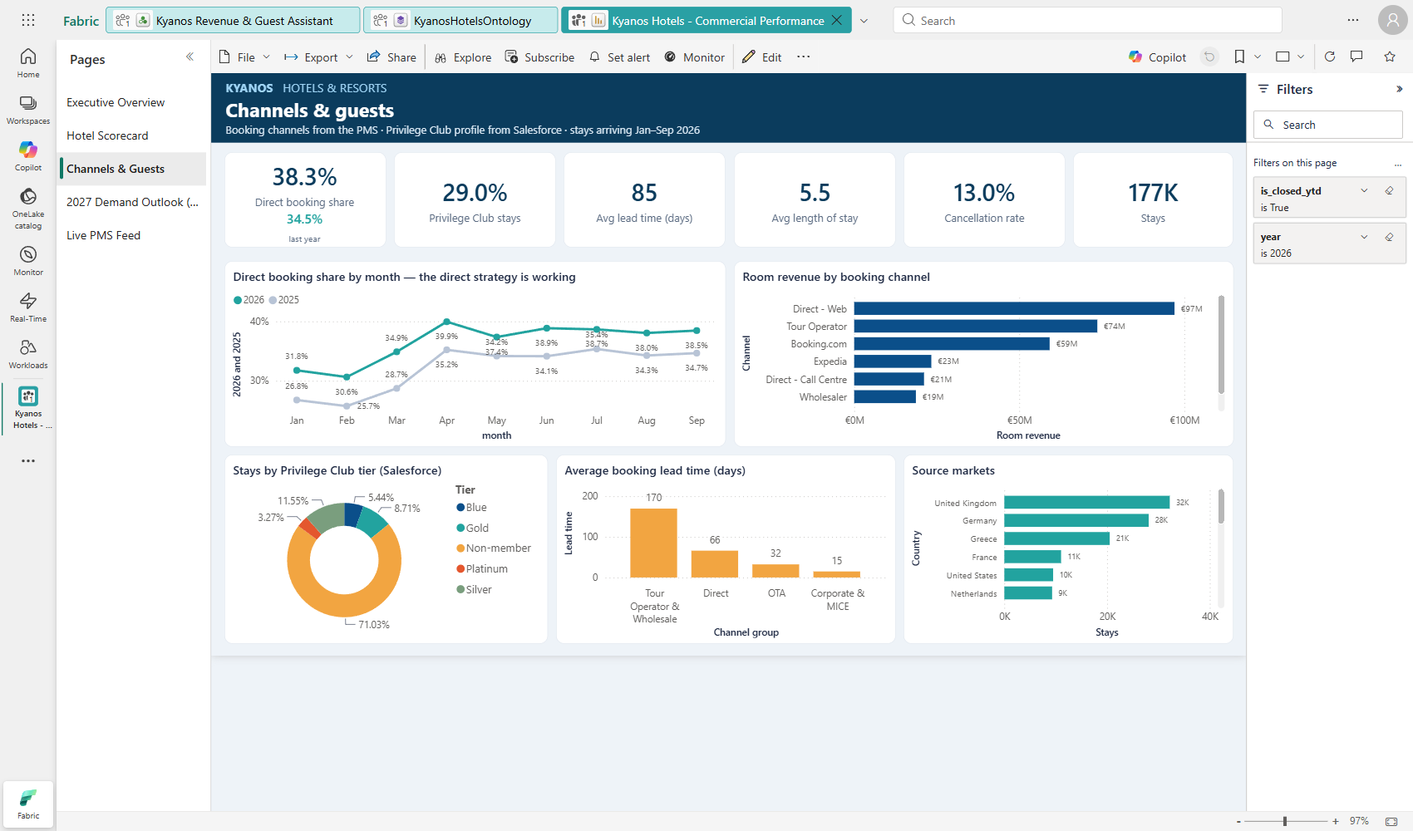
Figure 6 – Channels & Guests
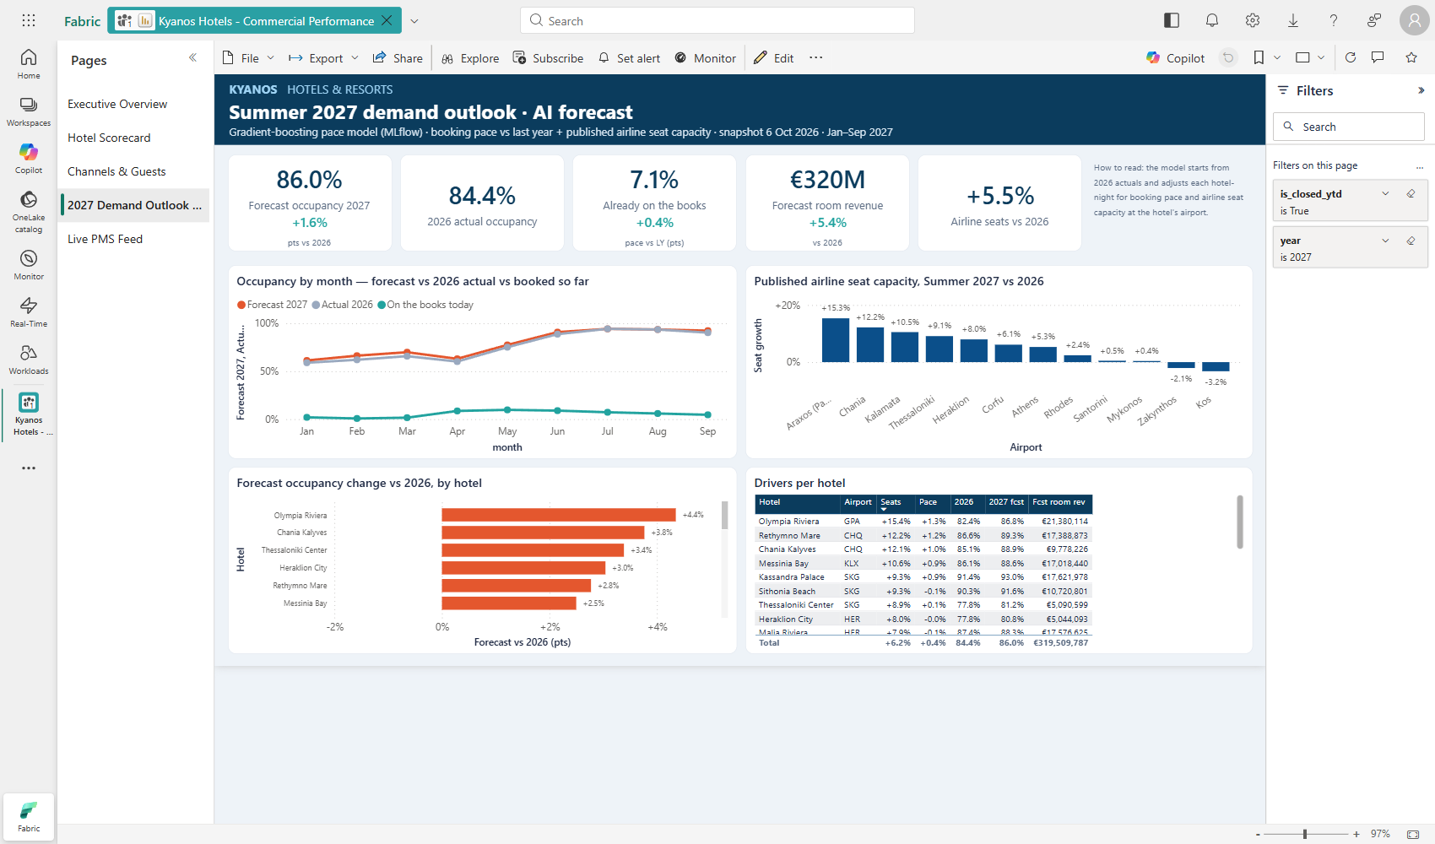
Figure 7 – 2027 Demand Outlook (AI)
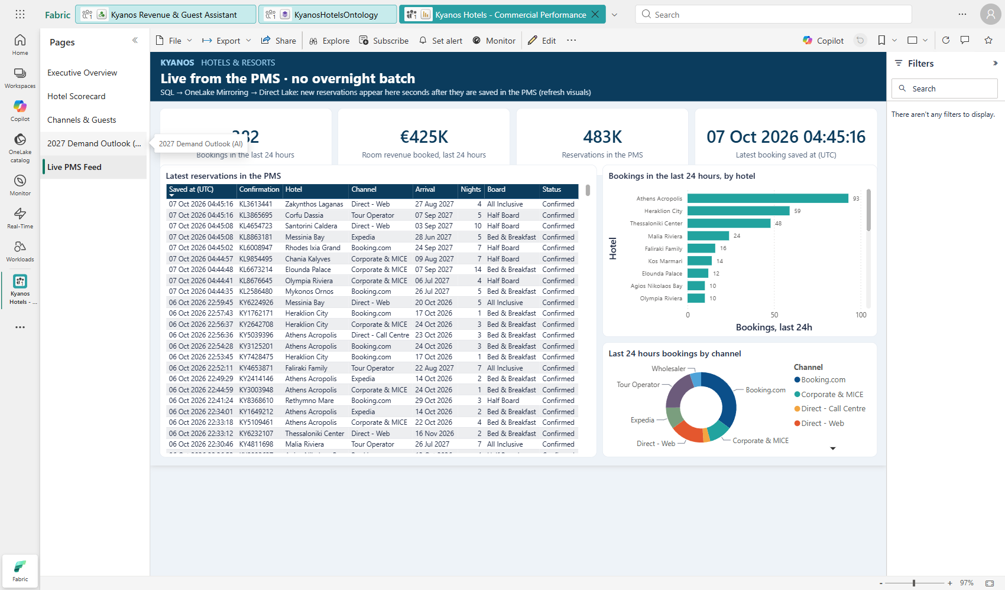
Figure 8 – Live PMS Feed

11. AI demand forecast

11.1 Business question
“How full will each hotel be next season, given what is already on the books and what the airlines have scheduled?” Revenue managers answer this every October when contracting tour operators and setting rates for the next summer.

11.2 Approach
- Target: change in daily occupancy versus the same weekday last year (delta_vs_ly = occ − ly_occ). Predicting the change, not the level, stops the model from simply memorising each hotel.
- Training data: every open hotel-day of 2026 up to the snapshot (4,534 rows) with its final occupancy, last year's occupancy and the drivers as they stood on 6 Oct 2025.
- Scoring data: every open hotel-day of Jan–Sep 2027 (4,390 rows) with drivers as of the 6 Oct 2026 snapshot.
Feature | Definition | Constraint
seat_growth_28d | Scheduled arriving seats at the hotel's airport vs the same week last year, 28-day centred rolling mean | Monotonic increasing
pace_vs_ly_28d | (rooms on the books − rooms on the books at the same point last year) ÷ rooms available, 28-day rolling mean | Monotonic increasing
headroom | 1 − last-year occupancy (how much room there is to grow) | None
- Model: scikit-learn HistGradientBoostingRegressor (max_iter 300, learning_rate 0.04, max_leaf_nodes 15, min_samples_leaf 60, l2 1) with monotonic constraints so that more seats or a stronger pace can only raise the forecast.
- Forecast: forecast_occ = clip(ly_occ + predicted change, otb_occ, 99.5%) – never below what is already booked. Forecast room revenue = forecast rooms × last-year ADR × 1.04.

11.3 Accuracy and tracking
Metric | Value
Holdout MAE (20% random hotel-days) | 3.31 occupancy points
Baseline: 'same as last year' | 4.09 occupancy points
Improvement | 19% lower error than the baseline
MLflow experiment | kyanos-occupancy-forecast (run pace-model-summer-2027; params, metrics, model, input example)
Registered model | kyanos-occupancy-forecast (Fabric ML model item, versioned)

11.4 Results by hotel (Jan–Sep 2027)
Hotel | Airport | 2026 occ. | 2027 fcst | Change (pts) | Seat growth | Pace vs LY (pts)
Kyanos Olympia Riviera | GPA | 82.4% | 86.8% | +4.4 | +15.4% | +1.3
Kyanos Chania Kalyves | CHQ | 85.1% | 88.9% | +3.8 | +12.1% | +1.0
Kyanos Thessaloniki Center | SKG | 77.8% | 81.2% | +3.4 | +8.9% | +0.1
Kyanos Heraklion City | HER | 77.8% | 80.9% | +3.1 | +8.0% | +0.0
Kyanos Rethymno Mare | CHQ | 86.6% | 89.3% | +2.7 | +12.2% | +1.2
Kyanos Messinia Bay | KLX | 86.1% | 88.6% | +2.5 | +10.6% | +0.9
Kyanos Athens Acropolis | ATH | 79.2% | 81.6% | +2.4 | +5.3% | +0.0
Kyanos Kavos Lagoon | CFU | 87.3% | 89.2% | +1.9 | +6.4% | -0.1
Kyanos Paleokastritsa | CFU | 87.2% | 89.1% | +1.9 | +6.3% | +0.9
Kyanos Agios Nikolaos Bay | HER | 85.1% | 87.0% | +1.9 | +7.7% | +1.3
Kyanos Kassandra Palace | SKG | 91.4% | 93.0% | +1.6 | +9.3% | +0.9
Kyanos Elounda Palace | HER | 85.4% | 86.8% | +1.4 | +7.8% | +0.6
Kyanos Sithonia Beach | SKG | 90.3% | 91.6% | +1.3 | +9.3% | -0.1
Kyanos Corfu Dassia | CFU | 89.0% | 90.0% | +1.0 | +6.3% | +0.3
Kyanos Malia Riviera | HER | 87.4% | 88.3% | +0.9 | +7.9% | -0.1
Kyanos Vouliagmeni Riviera | ATH | 82.2% | 82.9% | +0.7 | +5.3% | +1.2
Kyanos Kos Marmari | KGS | 77.6% | 77.9% | +0.3 | -3.0% | -0.6
Kyanos Kos Psalidi Suites | KGS | 78.2% | 78.5% | +0.3 | -3.0% | -0.4
Kyanos Faliraki Family | RHO | 86.3% | 86.6% | +0.3 | +2.0% | +-0.0
Kyanos Zakynthos Laganas | ZTH | 79.5% | 79.8% | +0.3 | -2.2% | +0.0
Kyanos Rhodes Ixia Grand | RHO | 84.2% | 84.2% | +0.0 | +2.2% | +0.0
Kyanos Lindos Blue | RHO | 87.8% | 87.7% | -0.1 | +2.0% | +1.0
Kyanos Santorini Caldera | JTR | 86.1% | 85.4% | -0.7 | +0.3% | +1.1
Kyanos Mykonos Ornos | JMK | 90.4% | 88.9% | -1.5 | +0.1% | +1.5
Reading: Olympia Riviera (Araxos +15% seats) and Chania (+12%) lead; Kos and Zakynthos stay flat because airlines are still reducing capacity. City hotels gain on Athens/Heraklion/Thessaloniki capacity growth.

11.5 First attempt and lesson learned
The first model predicted occupancy directly from on-the-books, last-year occupancy, seats, hotel attributes and calendar. It reproduced last year almost exactly and even forecast growth for Kos despite seat cuts – it had learned hotel identity. Re-framing the target as the change versus last year, smoothing the drivers and adding monotonic constraints produced an explainable model that beats the naive baseline.

12. Fabric data agent
Property | Value
Name | Kyanos Revenue & Guest Assistant
Data source | Kyanos Hotels Model (type semantic_model) – all 11 tables, visible columns and all 53 measures selected
Definition | Files/Config/data_agent.json, draft/ and published/ stage_config.json + semantic-model datasource.json, publish_info.json
Languages | Greek and English (answers in the language of the question)
Typical response time | 60–70 seconds (Standard runtime)
Channels | Fabric portal; publishable to Microsoft Teams and Microsoft 365 Copilot

12.1 Agent instructions
## Role
You are the **Kyanos Revenue & Guest Assistant** for Kyanos Hotels & Resorts (fictional Greek hotel group: 24 hotels - 20 seasonal resorts on Crete, Rhodes, Kos, Corfu, the Cyclades, Halkidiki, the Peloponnese, Zakynthos and Attica, plus 3 year-round city hotels in Athens, Heraklion and Thessaloniki).
Users are general managers, revenue managers, sales and the executive team. Answer in the language of the question (Greek or English).

## Time context
- Today / data snapshot = **6 October 2026**. Dates up to 6 Oct 2026 are actuals; later dates are on-the-books (future reservations) or forecast.
- "This season", "this year", "YTD" = **Jan-Sep 2026** (closed months: filter dim_date[is_closed_ytd] = TRUE and dim_date[year] = 2026). "Last year" = the same months of 2025.
- "Next season", "2027", "forecast", "outlook" = table fact_occupancy_forecast (Jan-Sep 2027), measures in folder "Forecast 2027".
- "Today", "live", "right now" = table live_pms_reservation (mirrored PMS, near real time); "bookings today" / "last 24 hours" = [Bookings Last 24h (live)] and [Booked Revenue Last 24h (live)] (rolling 24-hour window).

## KPI definitions - always use the model measures, never recompute
- Occupancy = [Occupancy %]; ADR = [ADR]; RevPAR = [RevPAR]; TRevPAR = [TRevPAR]; revenue = [Total Revenue] (rooms + F&B and other); room revenue = [Room Revenue].
- Versus last year: [RevPAR vs LY %], [ADR vs LY %], [Occupancy vs LY (pts)], [Total Revenue vs LY %].
- Profitability: [GOP], [GOP Margin %], [GOPPAR] (costs come from SAP, monthly).
- Channels: [Direct Share %] (direct web + call centre share of room revenue), channel / channel_group / tour_operator in fact_reservation. "OTA" = Booking.com + Expedia.
- Guests: dim_guest (country, loyalty_tier = Blue/Silver/Gold/Platinum/Non-member from Salesforce Privilege Club), [Privilege Club Share %].
- Service quality: fact_guest_case from Salesforce: [Complaints], [Avg Case CSAT] (1-5), [Complaints per 1,000 Room Nights], sub_category (e.g. "Air conditioning").
- Market: [Airline Seat Growth %] = scheduled airline seats at the hotel's airport vs last year.
- Forecast: [Forecast Occupancy %], [Last Year Occupancy %], [Forecast vs LY (pts)], [Booking Pace vs LY (pts)], [Seat Growth at Airport %], [Forecast Room Revenue].

## Business vocabulary
- Hotels are named "Kyanos <place>" (e.g. "Kyanos Elounda Palace"); users may say only the place ("Elounda", "Marmari", "Ixia"). Match on dim_hotel[hotel_name] or hotel_short_name.
- Region/destination values: Crete, Rhodes, Kos, Corfu, Cyclades, Halkidiki, Macedonia, Peloponnese, Attica, Zakynthos.
- Concepts: Luxury Resort, Adults-Only Resort, Family Resort, All-Inclusive Resort, City Hotel.
- "Underperforming" = lowest [RevPAR vs LY %]. "Pace" = [Booking Pace vs LY (pts)]. "VIP" = loyalty_tier Gold or Platinum.

## Answer style
Lead with the number(s), then one short line of interpretation (why, using drivers such as airline seats, channel mix, complaints). Use compact tables for rankings (max 10 rows). Format money in EUR, percentages with one decimal. If a question cannot be answered from the model, say so plainly and name the closest available data. Never invent hotels, guests or numbers.

12.2 Tested questions
Question | Answer (summary)
Which 3 hotels had the weakest RevPAR vs last year this season, and what happened to airline seats at their airports? | Kos Psalidi Suites −8.1%, Kos Marmari −6.8%, Zakynthos Laganas −6.2%; seats −12.9% (KGS) and −10.2% (ZTH). Interpretation: occupancy-driven decline caused by reduced air capacity rather than price. (≈66 s)
Ποια ξενοδοχεία αναμένεται να έχουν τη μεγαλύτερη αύξηση πληρότητας το 2027 και γιατί; | Olympia Riviera +4.4, Chania Kalyves +3.8, Thessaloniki Center +3.4, Heraklion City +3.0, Rethymno Mare +2.8 pts – explained by double-digit growth in available airline seats, with booking pace a secondary factor. Answered in Greek. (≈70 s)
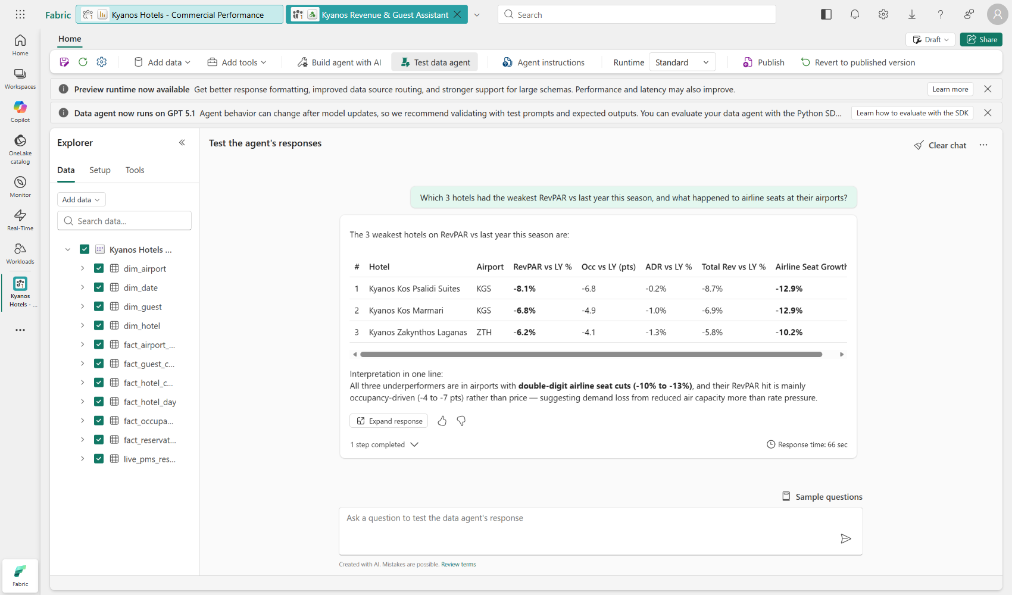
Figure 9 – Data agent answer (English)
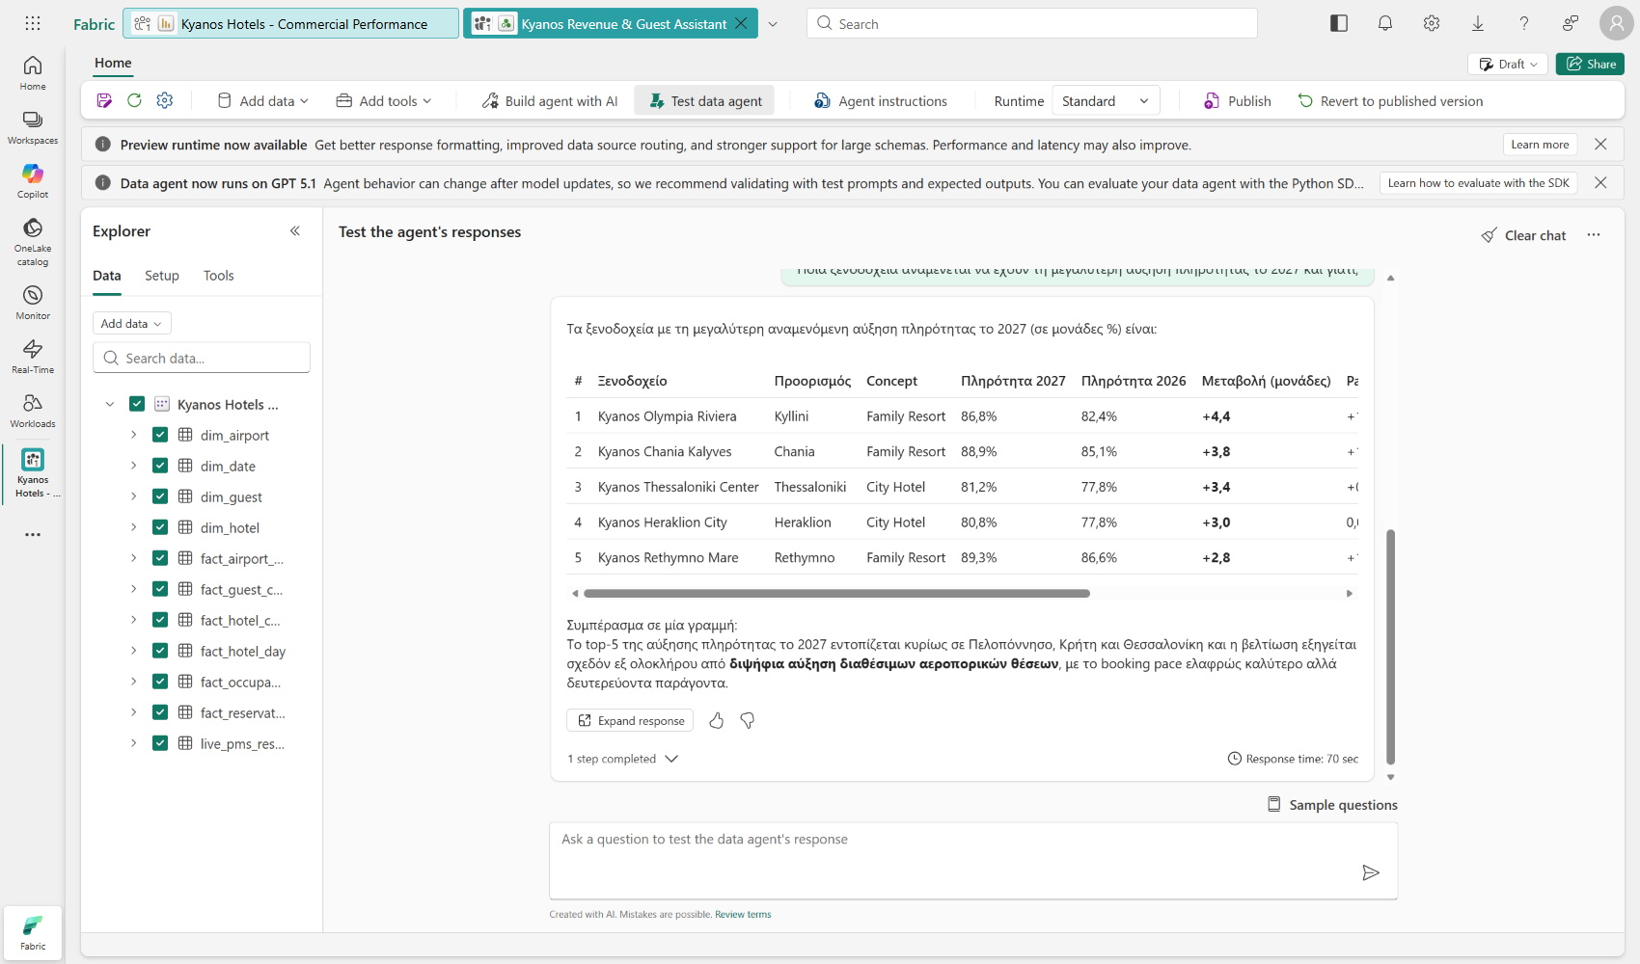
Figure 10 – Data agent answer (Greek)

13. Fabric IQ ontology
KyanosHotelsOntology turns gold tables into connected business concepts that people and agents can navigate (e.g. “which Platinum guests arrive at a hotel with open air-conditioning cases?”). It is deployed through the items API with entity types, data bindings to lakehouse tables (schema gold) and relationship contextualizations. Fabric automatically creates a companion lakehouse and graph model.

13.1 Entity types
Entity | Bound table | Key | Display property | Properties
Hotel | gold.iq_hotel | hotel_id | hotel_name | 15
Airport | gold.iq_airport | airport_code | airport_name | 5
VipGuest | gold.iq_vip_guest | guest_id | guest_name | 8
UpcomingStay | gold.iq_upcoming_stay | reservation_id | confirmation_no | 11
OpenCase | gold.iq_open_case | case_id | case_id | 9
TourOperator | gold.iq_tour_operator | tour_operator_id | tour_operator_name | 5

13.2 Relationships
Relationship | Source → target | Binding table | Join
served_by | Hotel → Airport | gold.iq_hotel | hotel_id → airport_code
stays_at | UpcomingStay → Hotel | gold.iq_upcoming_stay | reservation_id → hotel_id
booked_by | UpcomingStay → VipGuest | gold.iq_upcoming_stay | reservation_id → guest_id
sold_by | UpcomingStay → TourOperator | gold.iq_upcoming_stay | reservation_id → tour_operator_id
case_at | OpenCase → Hotel | gold.iq_open_case | case_id → hotel_id

13.3 Entity tables (notebook 04)
- iq_hotel – hotel attributes plus 2026 occupancy, RevPAR, RevPAR vs LY, average case CSAT and open cases.
- iq_airport – seat growth 2026 and 2027 per airport.
- iq_vip_guest – 2,943 Gold/Platinum members with upcoming stays; iq_upcoming_stay – 3,600 future stays of VIP guests.
- iq_open_case – 124 open Salesforce cases; iq_tour_operator – 6 tour operators with 2026 room nights and 2027 on-the-books.
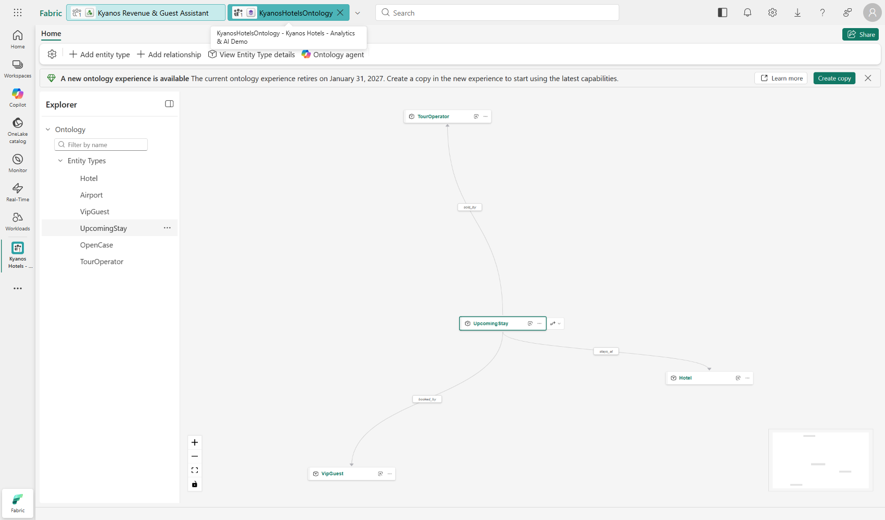
Figure 11 – Ontology graph around UpcomingStay
Note
The ontology editor shows a banner that a new ontology experience is available (the current one retires on 31 January 2027). The built-in Ontology agent (preview) did not respond to an automated test prompt; treat it as optional in demos.

14. Live PMS simulator and demo operations

14.1 Simulator
- src/pms_live_sim.py connects to KyanosPMS with an Entra token and inserts realistic reservations (1–3 every ~6 s) with confirmation numbers starting KL.
- Bookings respect hotel seasons (resorts get Summer 2027 arrivals, city hotels arrive within 75 days), channel mix, board types and rates derived from each hotel's recent Booking.com ADR.
- burst N HOTEL inserts a tour-operator group block (N rooms × 7 nights) – the visible "live moment" in the demo.
- The connection is re-established every 40 minutes and on errors, because Entra access tokens expire.

14.2 Control script
Command | Effect
./demo-control.ps1 warmup | Reframe the semantic model, sync the lakehouse SQL endpoint metadata, run warm-up DAX queries
./demo-control.ps1 start | Start the simulator in the background (PID in .sim.pid, log in sim.log)
./demo-control.ps1 burst 25 KYN-OLY | Insert a 25-room group block at Kyanos Olympia Riviera
./demo-control.ps1 status | Process state and number/value of simulator bookings
./demo-control.ps1 stop | reset | Stop the simulator | stop and delete all simulator bookings

14.3 Measured latency
Path | Observed
INSERT in KyanosPMS → new Delta version in OneLake | Seconds (new _delta_log entry immediately after insert)
INSERT → visible in Direct Lake model (DAX) | ≈13 seconds for a 12-row burst
INSERT → visible in lakehouse SQL endpoint via shortcut | Not until a metadata sync (lazy for shortcut tables); refreshMetadata API forces it

14.4 Demo run sheet (summary)
- 10:30 – reset, warmup, start; open workspace, report, data agent, SQL query editor, notebook 03, ontology.
- Mirroring story → burst → Live PMS Feed shows the bookings in ~15 s.
- Lakehouse schemas and shortcut → notebook 02 (data quality, Copilot) → Direct Lake model and RLS.
- Report: Executive Overview (Kos/Zakynthos), Hotel Scorecard (A/C cluster), Channels (direct strategy), Copilot prompts.
- 2027 AI outlook and MLflow → data agent in Greek → ontology → phased plan and next steps.
Full talk track: docs/DEMO_SCRIPT.md in the repository.

15. Build and deployment process
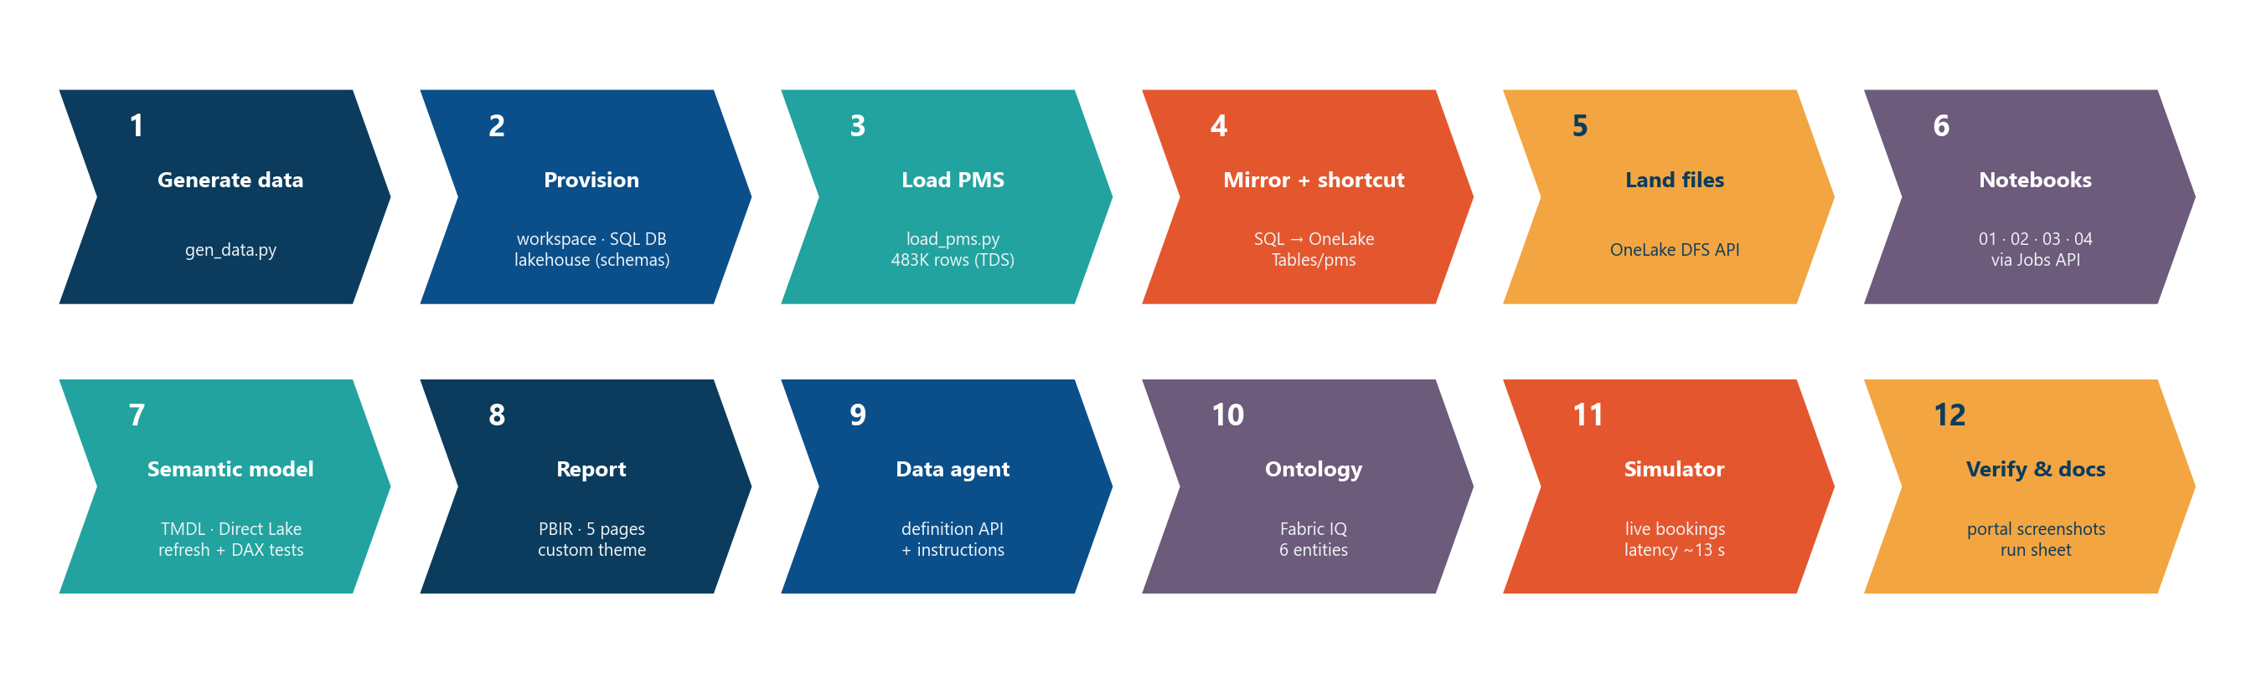
Figure 12 – Build process
# | Step | Script / API | What happens
1 | Generate data | python src/gen_data.py | Synthetic PMS, Salesforce, SAP and airline datasets (seeded) into data/
2 | Provision | deploy.py infra · POST /workspaces, /items | Workspace on capacity; Lakehouse (enableSchemas); SQL database; connection details captured in .state.json
3 | Load PMS | python src/load_pms.py · TDS + Entra token | DDL for pms schema; 483K reservations loaded
4 | Mirror + shortcut | deploy.py shortcut · POST …/shortcuts | Automatic SQL → OneLake replication; Tables/pms schema shortcut
5 | Land files | deploy.py landing · OneLake DFS API | Four CSVs to Files/landing/*
6 | Notebooks | deploy.py notebooks run · Jobs API RunNotebook | Create/update notebooks (fabricGitSource) and run 01 → 02 → 03 (→ 04)
7 | Semantic model | deploy.py model · items API (format TMDL) + Power BI refreshes API | Deploy TMDL, reframe, validate with executeQueries
8 | Report | deploy.py report · items API (PBIR) | Deploy pages, visuals and custom theme
9 | Data agent | deploy.py agent · items API | Instructions + semantic-model data source, draft and published
10 | Ontology | deploy.py run-nb4 ontology | Entity tables, then ontology definition (entity types, bindings, relationships)
11 | Simulator | demo-control.ps1 | Live bookings; latency measured
12 | Verify | Playwright + DAX | Portal screenshots of every page, agent tests, KPI checks

15.1 Authentication
- All REST calls use tokens from az account get-access-token (scoped with --subscription or --tenant from config.json) for the audiences Fabric (api.fabric.microsoft.com), Power BI (analysis.windows.net/powerbi/api), OneLake storage (storage.azure.com) and SQL (database.windows.net).
- Every step is idempotent: items are looked up by type and name and updated with updateDefinition when they exist.

15.2 Repository structure
Path | Content
config.json / .state.json | Subscription, capacity, workspace name / IDs of deployed items and endpoints
src/gen_data.py | Synthetic data generator (hotels, reservations, guests, CRM, ERP, seats)
src/load_pms.py, src/sqlconn.py | PMS DDL + loader; Entra-token SQL connection helper
src/fab.py, src/deploy.py | Fabric REST helper (auth, LRO polling, definitions); step-based deployer
src/notebooks.py | Notebook sources 01–04
src/model.py | Semantic model: tables, columns, 53 measures, relationships, roles → TMDL
src/report.py | PBIR report builder (pages, visuals, theme)
src/agent.py, src/ontology.py | Data agent definition; ontology definition
src/pms_live_sim.py, src/warmup.py, demo-control.ps1 | Live simulator, warm-up, demo control
docs/ | DEMO_SCRIPT.md, screenshots, this documentation and its build scripts

16. Issues encountered and resolutions
Build log of problems found during implementation and testing, and how each was resolved.
# | Issue | Resolution
1 | Package install via uv failed (TLS handshake) | Used pip with system Python; mssql-python wheel installed
2 | No ODBC Driver 18 on the build machine | mssql-python (bundled driver) with access token in attrs_before (1256)
3 | mssql-python rejected 'Connection Timeout' keyword | Removed the keyword from the connection string
4 | bulkcopy opened a second connection without the token (login failed) | Automatic fallback to executemany batches of 20K
5 | First forecast model ≈ 'same as last year'; Kos forecast to grow | Target = change vs LY; pace and seat features smoothed; monotonic constraints (MAE 3.31 vs 4.09)
6 | Notebook 03 failed: indentation error at the start of a cell | Fixed; every cell is now compile-checked before deployment
7 | Model deploy failed: measure 'Arrivals' clashes with column 'arrivals' | Renamed to 'Guest Arrivals' (names are case-insensitive in a table)
8 | GOP margin unrealistic (56%) | Recalibrated SAP cost drivers → ~40%
9 | vs LY measures showed −100% when LY was blank | DIVIDE(x − LY, LY) and IF(NOT ISBLANK(LY), …) patterns
10 | Airline seats did not react to hotel filters | TREATAS(VALUES(dim_hotel[airport_code]), dim_airport[airport_code])
11 | KPI comparison text clipped under cards | Tile = container textbox + two transparent cards
12 | Channels & Guests visuals failed: duplicate guest_id on the one side | De-duplicated 99 Privilege Club IDs in notebook 02
13 | Lakehouse SQL endpoint did not show new mirrored rows | Delta and Direct Lake were already current; SQL endpoint metadata sync is lazy for shortcuts → refreshMetadata in warm-up
14 | Workspace folder names rejected ('·', '&', '.', '-') | Simple alphanumeric names (e.g. '4 Power BI')
15 | Ontology lakehouse/graph could not be moved to a folder | Child items move with their parent ontology
16 | Browser showed the previous report version after an update | Hard reload with a cache-busting query parameter
17 | Live PMS page empty on a new day (TODAY() filter) | Rolling 24-hour window with NOW() and COALESCE(…, 0)
18 | Ontology agent (preview) did not answer an automated prompt | Kept optional in the demo

17. Important considerations

17.1 Mirroring SQL Server (customer environment)
- SQL Server 2016–2022 mirroring uses Change Data Capture; SQL Server 2025 uses the Fabric change feed and requires Azure Arc.
- Tables must have a primary key (2016–2022). Legacy PMS tables without keys cannot be mirrored directly – mirror the existing data warehouse instead, or use an incremental Copy job from a readable replica.
- Mirroring runs only from the primary replica of an availability group; failover cluster instances are not supported.
- A DDL change on a mirrored table stops mirroring until CDC is disabled and re-enabled for that table (vendor upgrades!).
- Long-running transactions hold back transaction-log truncation – monitor log growth.
- Replication compute is free; mirrored storage is free up to a limit tied to capacity size; queries consume capacity. Up to 1,000 tables per mirrored database.
- Source RLS, object-level permissions and dynamic data masking are not propagated to OneLake – re-apply security in Fabric (semantic model RLS/OLS, OneLake security).

17.2 Direct Lake and the semantic model
- No scheduled refresh is needed; framing happens automatically on Delta commits (keep 'Keep Direct Lake data up to date' on). A manual reframe is useful after bulk rebuilds.
- Check the Direct Lake guardrails for the chosen SKU (rows per table, memory) when sizing production; exceeding them causes fallback or errors.
- Calculated tables and calculated columns are not used – all shaping happens in notebooks, which keeps the model Direct Lake-friendly.
- Measure names must be unique within a table regardless of case and must not collide with column names.
- NOW() / TODAY() evaluate in UTC in the service – align timestamps (the simulator writes UTC).

17.3 Security and governance
- RLS roles exist but have no members – assign GMs/regional managers before sharing; test with 'Test as role'.
- dim_guest contains personal data (names, emails). In production: hide or remove PII columns from broad models, apply object-level security, sensitivity labels and source-side masking.
- The data agent and Copilot respect the user's model permissions and RLS.

17.4 Capacity and licensing
- The whole demo runs on an F8; Copilot and data agents work from F2 upward.
- Below F64, report consumers need Power BI Pro licences; from F64, viewers with a free licence can consume content.
- Pause the capacity when the demo is not needed (a paused capacity makes the items unavailable).

17.5 Known limitations of the demo
- Data is synthetic and static apart from the live table; to roll the snapshot forward, change AS_OF and regenerate.
- Salesforce, SAP and airline data arrive as CSV files rather than live connectors.
- The forecast is trained on one season pair (2025 → 2026); production would use several years, weather/events and nightly retraining.
- The data agent takes 60–70 seconds per answer; pre-asked questions are kept in the chat as a fallback.

18. Appendices

18.1 Appendix A – Fabric item inventory
Workspace Kyanos Hotels - Analytics & AI Demo. Item IDs are generated per deployment and recorded locally in .state.json.
Folder | Type | Item
1 Sources PMS on SQL | SQLDatabase | KyanosPMS
1 Sources PMS on SQL | SQLEndpoint | KyanosPMS
2 OneLake unified data | Lakehouse | KyanosLakehouse
2 OneLake unified data | Notebook | 01_Ingest_Salesforce_SAP_Airports
2 OneLake unified data | Notebook | 02_Build_Gold_Model
2 OneLake unified data | SQLEndpoint | KyanosLakehouse
3 AI forecasting | MLExperiment | kyanos-occupancy-forecast
3 AI forecasting | MLModel | kyanos-occupancy-forecast
3 AI forecasting | Notebook | 03_AI_Demand_Forecast_2027
4 Power BI | Report | Kyanos Hotels - Commercial Performance
4 Power BI | SemanticModel | Kyanos Hotels Model
5 Agents and Fabric IQ | DataAgent | Kyanos Revenue & Guest Assistant
5 Agents and Fabric IQ | GraphModel | KyanosHotelsOntology_graph_<id>
5 Agents and Fabric IQ | Lakehouse | KyanosHotelsOntology_lh_<id>
5 Agents and Fabric IQ | Notebook | 04_Fabric_IQ_Ontology_Entities
5 Agents and Fabric IQ | Ontology | KyanosHotelsOntology
5 Agents and Fabric IQ | SQLEndpoint | KyanosHotelsOntology_lh_<id>

18.2 Appendix B – Semantic model column dictionary

18.2.1 dim_date (gold.dim_date)
Calendar 2025-2027. Snapshot (today) is 6 Oct 2026; is_closed_ytd = Jan-Sep closed months.
Column | Type | Visible | Notes
date | dateTime | yes | key (date table); format dd mmm yyyy
year | int64 | yes
quarter | string | yes
month_num | int64 | hidden
month | string | yes | sort by month_num
year_month | string | yes
month_start | dateTime | yes | format mmm yyyy
week_start | dateTime | yes | format dd mmm yyyy
weekday_num | int64 | hidden
weekday | string | yes | sort by weekday_num
season | string | yes
is_actual | boolean | yes
is_closed_ytd | boolean | yes

18.2.2 dim_hotel (gold.dim_hotel)
The 24 Kyanos hotels and resorts with destination, airport, concept and general manager.
Column | Type | Visible | Notes
hotel_id | int64 | hidden
hotel_code | string | yes
hotel_name | string | yes
hotel_short_name | string | yes
destination | string | yes
region | string | yes | category StateOrProvince
airport_code | string | yes
stars | int64 | yes
concept | string | yes
rooms | int64 | yes
latitude | double | yes | category Latitude
longitude | double | yes | category Longitude
operating_model | string | yes
general_manager | string | yes
gm_email | string | yes

18.2.3 dim_airport (gold.dim_airport)
Greek airports serving the hotels.
Column | Type | Visible | Notes
airport_code | string | yes
airport_name | string | yes
airport_region | string | yes

18.2.4 dim_guest (gold.dim_guest)
Guest profile from the PMS enriched with Salesforce Privilege Club membership.
Column | Type | Visible | Notes
guest_id | int64 | hidden
guest_name | string | yes
email | string | yes
country_code | string | yes
country | string | yes | category Country
language | string | yes
member_id | string | yes
is_member | boolean | yes
loyalty_tier | string | yes
marketing_opt_in | boolean | yes
top_preference | string | yes
lifetime_nights | int64 | yes

18.2.5 fact_hotel_day (gold.fact_hotel_day)
One row per hotel per day: rooms available vs sold and revenue. Future dates hold on-the-books business.
Column | Type | Visible | Notes
hotel_id | int64 | hidden
date | dateTime | hidden
rooms_available | int64 | hidden
rooms_sold | int64 | hidden
room_revenue | double | hidden
extras_revenue | double | hidden
arrivals | int64 | hidden
is_actual | boolean | hidden
total_revenue | double | hidden

18.2.6 fact_hotel_cost (gold.fact_hotel_cost)
Monthly operating costs per hotel from SAP (payroll, F&B cost of sales, energy, commissions, maintenance, marketing).
Column | Type | Visible | Notes
hotel_id | int64 | hidden
month_start | dateTime | hidden
cost_category | string | yes
gl_account | string | yes
amount_eur | double | hidden

18.2.7 fact_reservation (gold.fact_reservation)
Every PMS reservation (incl. cancellations) with channel, segment, board, lead time and revenue.
Column | Type | Visible | Notes
reservation_id | int64 | hidden
confirmation_no | string | yes
hotel_id | int64 | hidden
guest_id | int64 | hidden
room_type | string | yes
booking_date | dateTime | yes | format dd mmm yyyy
arrival_date | dateTime | yes | format dd mmm yyyy
departure_date | dateTime | yes | format dd mmm yyyy
nights | int64 | yes
lead_time_days | int64 | yes
channel | string | yes
channel_group | string | yes
market_segment | string | yes
tour_operator | string | yes
board_type | string | yes
adults | int64 | yes
children | int64 | yes
status | string | yes
is_cancelled | boolean | hidden
is_active | boolean | hidden
rate_amount | double | hidden
room_revenue | double | hidden
extras_revenue | double | hidden
cancel_date | dateTime | yes | format dd mmm yyyy
created_at | dateTime | hidden

18.2.8 fact_guest_case (gold.fact_guest_case)
Salesforce Service Cloud guest cases (complaints, requests, compliments) with CSAT.
Column | Type | Visible | Notes
case_id | string | yes
confirmation_no | string | yes
hotel_id | int64 | hidden
created_date | dateTime | yes | format dd mmm yyyy
category | string | yes
sub_category | string | yes
origin | string | yes
status | string | yes
csat_score | int64 | yes

18.2.9 fact_airport_seats (gold.fact_airport_seats)
Weekly scheduled arriving airline seats per airport (2027 = published schedules).
Column | Type | Visible | Notes
airport_code | string | hidden
week_start | dateTime | hidden
arriving_seats | int64 | hidden
flights | int64 | hidden
season_year | int64 | hidden
data_status | string | yes

18.2.10 fact_occupancy_forecast (gold.fact_occupancy_forecast)
AI occupancy forecast per hotel-day for Jan-Sep 2027 (booking pace + airline seats model, MLflow).
Column | Type | Visible | Notes
hotel_id | int64 | hidden
date | dateTime | hidden
rooms_available | double | hidden
otb_rooms | double | hidden
ly_otb_rooms | double | hidden
forecast_rooms_sold | double | hidden
forecast_room_revenue | double | hidden
ly_rooms_sold | double | hidden
ly_room_revenue | double | hidden
seat_growth | double | hidden
pace_vs_ly | double | hidden
otb_occ | double | hidden
forecast_occ | double | hidden
ly_occ | double | hidden
model_run_id | string | hidden
snapshot_date | dateTime | hidden

18.2.11 live_pms_reservation (pms.Reservation)
LIVE: the PMS reservation table mirrored from SQL in near real time (no ETL).
Column | Type | Visible | Notes
ReservationId | int64 | hidden
ConfirmationNo | string | yes
HotelId | int64 | hidden
GuestId | int64 | hidden
BookingDate | dateTime | yes | format dd mmm yyyy
ArrivalDate | dateTime | yes | format dd mmm yyyy
Nights | int64 | yes
Channel | string | yes
MarketSegment | string | yes
BoardType | string | yes
RoomRevenue | decimal | hidden
Status | string | yes
CreatedAt | dateTime | yes | format dd mmm yyyy hh:nn:ss

18.3 Appendix C – Key code excerpts

18.3.1 fact_hotel_day – stay explosion and hotel calendar (notebook 02)
# fact_hotel_day: one row per hotel per calendar day (rooms available vs sold, revenue, arrivals)
act = spark.table("gold.fact_reservation").where("is_active")
nights = (act.withColumn("i", F.explode(F.sequence(F.lit(0), F.col("nights") - 1)))
.select("hotel_id", F.date_add("arrival_date", F.col("i")).alias("date"),
(F.col("room_revenue") / F.col("nights")).alias("rr"), (F.col("extras_revenue") / F.col("nights")).alias("xr")))
sold = nights.groupBy("hotel_id", "date").agg(F.count("*").alias("rooms_sold"), F.sum("rr").alias("room_revenue"), F.sum("xr").alias("extras_revenue"))
arr = act.groupBy("hotel_id", F.col("arrival_date").alias("date")).agg(F.count("*").alias("arrivals"))
cal = (spark.table("gold.dim_date").select("date").crossJoin(hotel.select(F.col("HotelId").alias("hotel_id"), "Rooms", "OpenMMDD", "CloseMMDD", "Airport")))
md = F.date_format("date", "MM-dd")
cal = cal.withColumn("is_open", (md >= F.col("OpenMMDD")) & (md <= F.col("CloseMMDD")))
fact_day = (cal.join(sold, ["hotel_id", "date"], "left").join(arr, ["hotel_id", "date"], "left")
.select("hotel_id", "date", F.when(F.col("is_open"), F.col("Rooms")).otherwise(0).alias("rooms_available"),
F.coalesce("rooms_sold", F.lit(0)).alias("rooms_sold"), F.round(F.coalesce("room_revenue", F.lit(0.0)), 2).alias("room_revenue"),
F.round(F.coalesce("extras_revenue", F.lit(0.0)), 2).alias("extras_revenue"), F.coalesce("arrivals", F.lit(0)).alias("arrivals"),
(F.col("date") <= F.lit(AS_OF)).alias("is_actual"))
.withColumn("total_revenue", F.round(F.col("room_revenue") + F.col("extras_revenue"), 2)))
save(fact_day, "fact_hotel_day")

18.3.2 Rooms on the books at a snapshot date (notebook 03)
def otb_as_of(snap):
"""Rooms on the books per hotel-night as they stood on the snapshot date."""
r = res[(res.booking_date <= snap) & ((res.cancel_date.isna()) | (res.cancel_date > snap)) & (res.status != "No-Show")]
r = r.loc[r.index.repeat(r.nights)].copy()
r["date"] = r.arrival_date + pd.to_timedelta(r.groupby(level=0).cumcount(), unit="D")
return r.groupby(["hotel_id", "date"]).size().rename("otb_rooms").reset_index()

18.3.3 Model training with MLflow (notebook 03)
mlflow.set_experiment("kyanos-occupancy-forecast")
params = dict(max_iter=300, learning_rate=0.04, max_leaf_nodes=15, min_samples_leaf=60, l2_regularization=1.0)
mask = np.random.default_rng(7).random(len(train)) < 0.8
with mlflow.start_run(run_name="pace-model-summer-2027") as run:
model = HistGradientBoostingRegressor(**params, monotonic_cst=MONOTONIC, random_state=7)
model.fit(train.loc[mask, FEATURES], train.loc[mask, TARGET])
pred = np.clip(train.loc[~mask, "ly_occ"] + model.predict(train.loc[~mask, FEATURES]), 0, 1)
mae = mean_absolute_error(train.loc[~mask, "occ"], pred)
base = mean_absolute_error(train.loc[~mask, "occ"], train.loc[~mask, "ly_occ"])
mlflow.log_params({**params, "features": ",".join(FEATURES), "target": TARGET, "snapshot": str(AS_OF.date())})
mlflow.log_metric("mae_occupancy_pts", round(mae * 100, 2))
mlflow.log_metric("naive_same_as_last_year_mae_pts", round(base * 100, 2))
model.fit(train[FEATURES], train[TARGET])
mlflow.sklearn.log_model(model, "model", registered_model_name="kyanos-occupancy-forecast", input_example=train[FEATURES].head(5))
print(f"Holdout MAE {mae*100:.1f} occupancy points vs. naive 'same as last year' {base*100:.1f}")

18.3.4 Semantic model deployment and refresh (src/deploy.py)
state["model"] = upsert("SemanticModel", "Kyanos Hotels Model", MD.model_parts(WS, state["lh"]), "TMDL")
POST https://api.powerbi.com/v1.0/myorg/groups/{ws}/datasets/{model}/refreshes {"type": "full"}
POST https://api.powerbi.com/v1.0/myorg/groups/{ws}/datasets/{model}/executeQueries {"queries":[{"query":"EVALUATE ..."}]}

18.4 Appendix D – Glossary
Term | Meaning
ADR | Average daily rate = room revenue ÷ rooms sold
RevPAR | Revenue per available room = room revenue ÷ rooms available (= ADR × occupancy)
TRevPAR | Total revenue (rooms + F&B + other) ÷ rooms available
GOP / GOPPAR | Gross operating profit = total revenue − operating costs; GOP per available room
OTB / pace | On-the-books business for future dates / OTB compared with the same point last year
LY | Last year, same period (SAMEPERIODLASTYEAR)
Mirroring | Fabric feature that continuously replicates a database into OneLake as Delta
Shortcut | OneLake pointer to data in another item or store, without copying
Direct Lake | Power BI storage mode that reads Delta tables in OneLake directly, without import refresh
Framing | Direct Lake step that points the model at the latest Delta version
TMDL / PBIR | Text-based definition formats for semantic models / Power BI reports
MLflow | Experiment tracking and model registry built into Fabric Data Science
Data agent | Fabric item that answers natural-language questions over selected data sources
Ontology (Fabric IQ) | Business entities and relationships bound to OneLake data, navigable as a graph

