Domain Class Model - dfentz

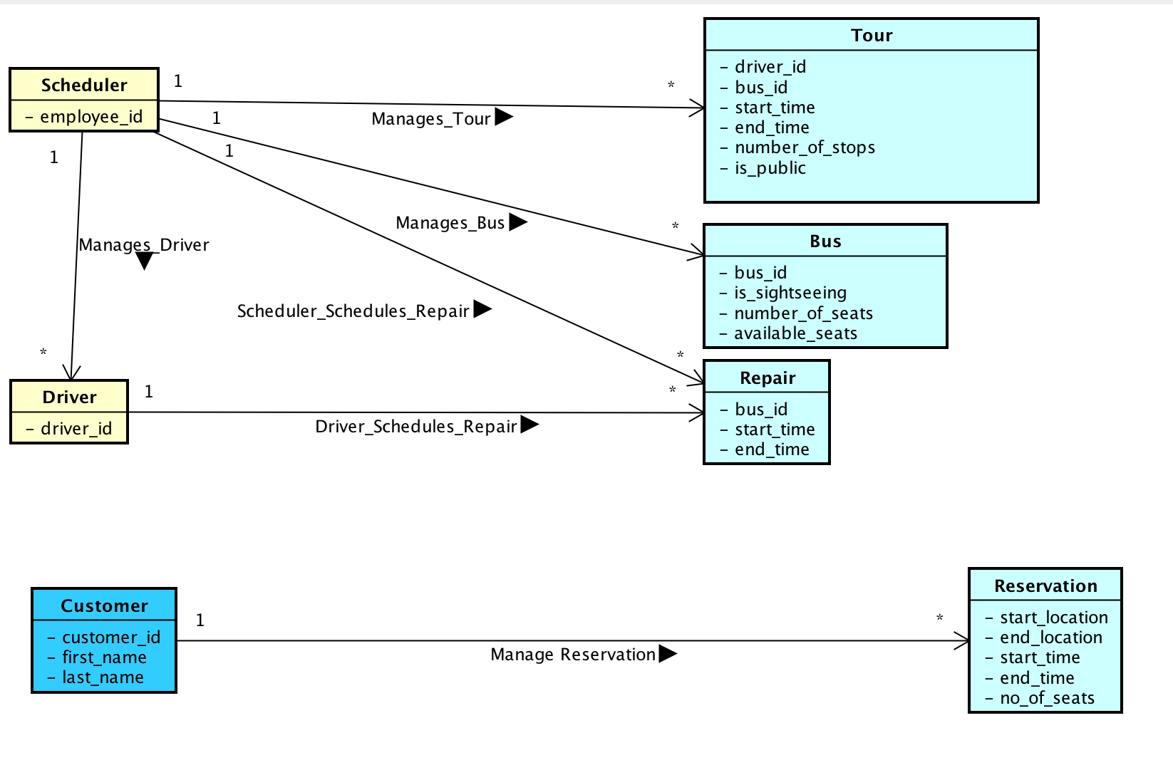

Use Case Model - dfentz

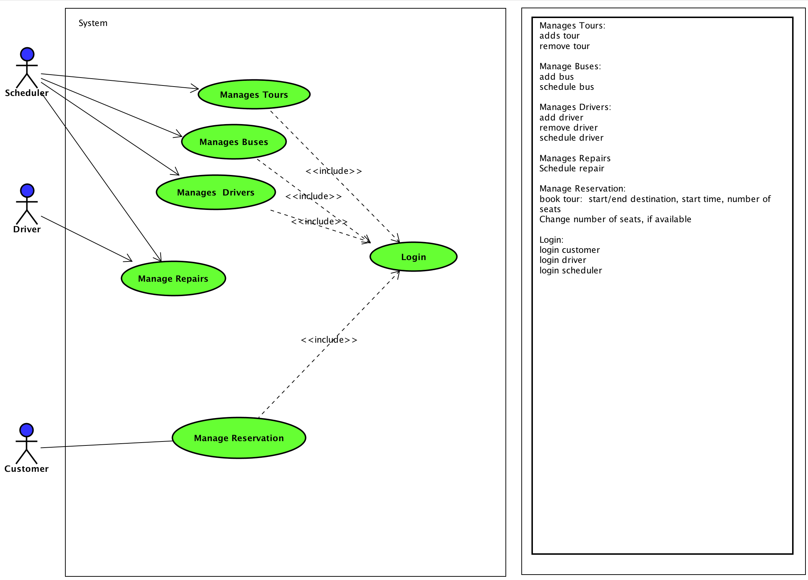

Book Tour - Alex

Add Bus - Veronica

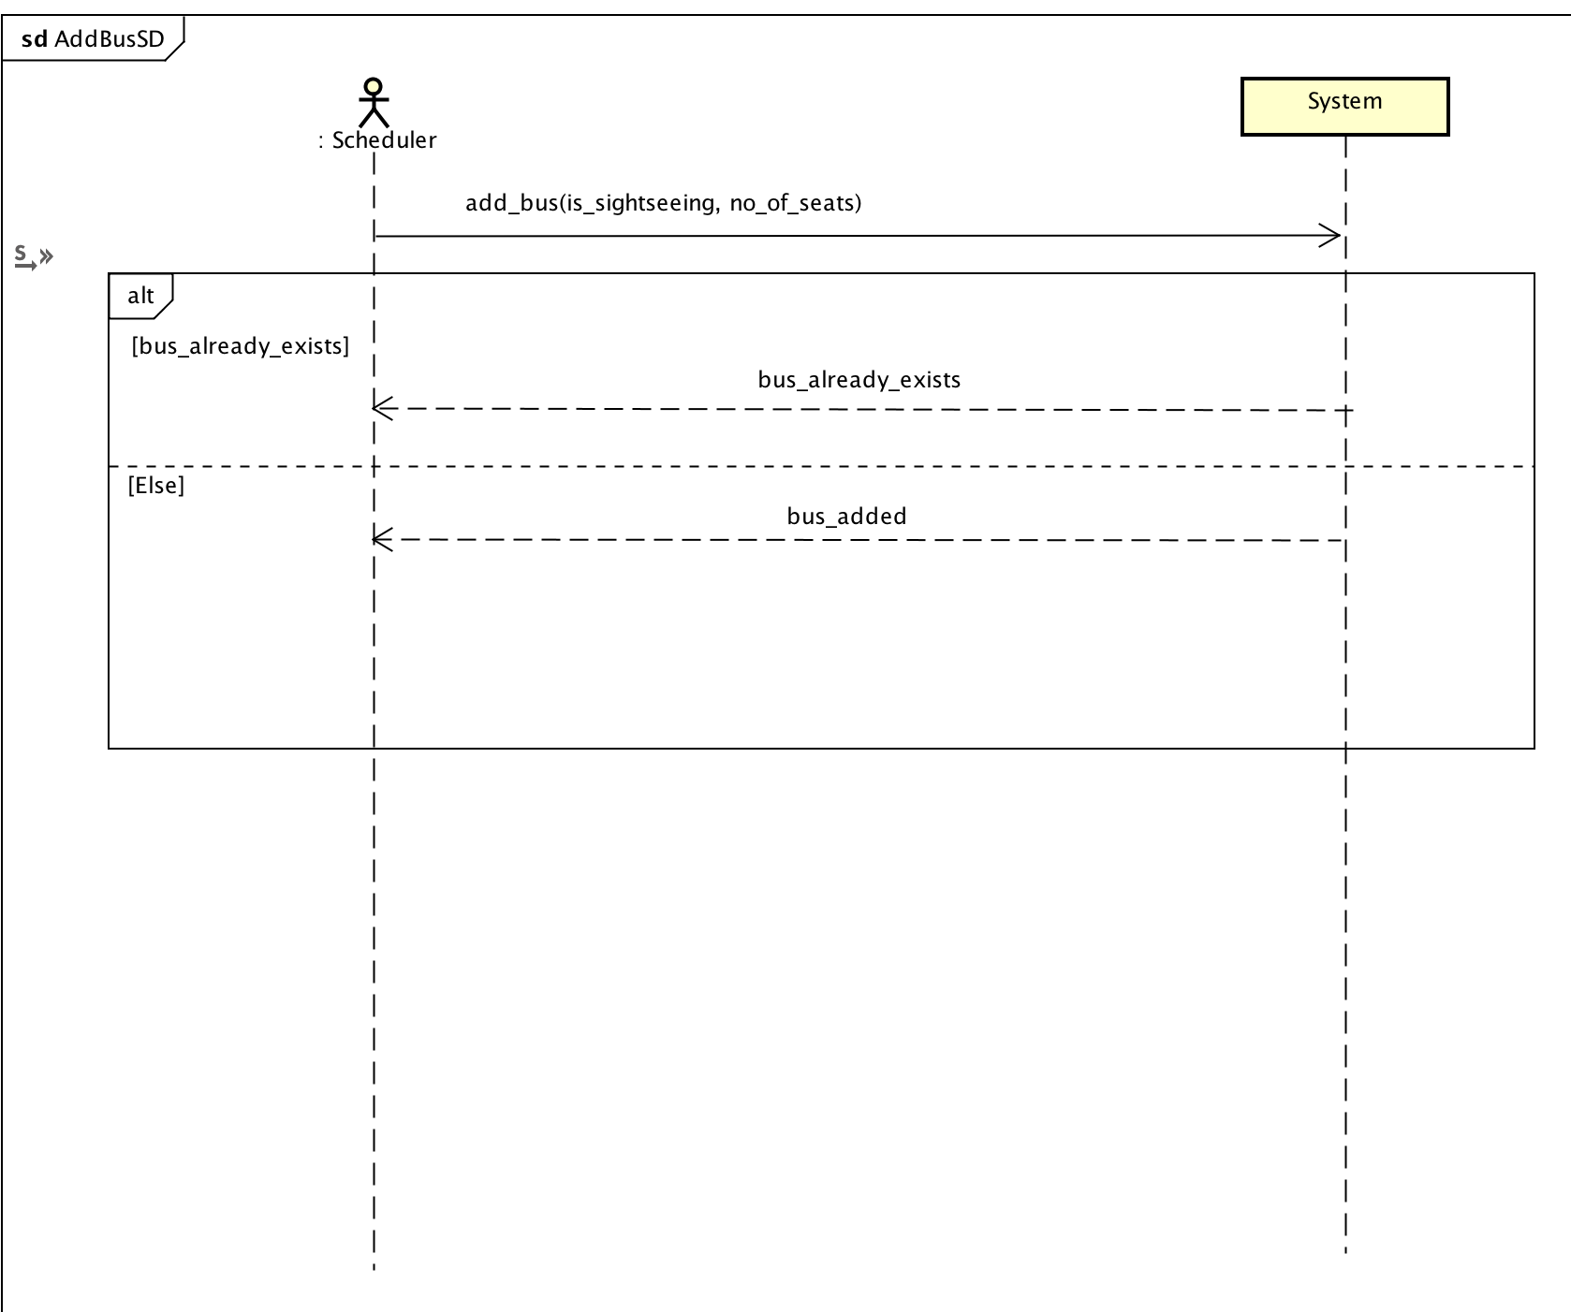

Remove Bus – Veronica

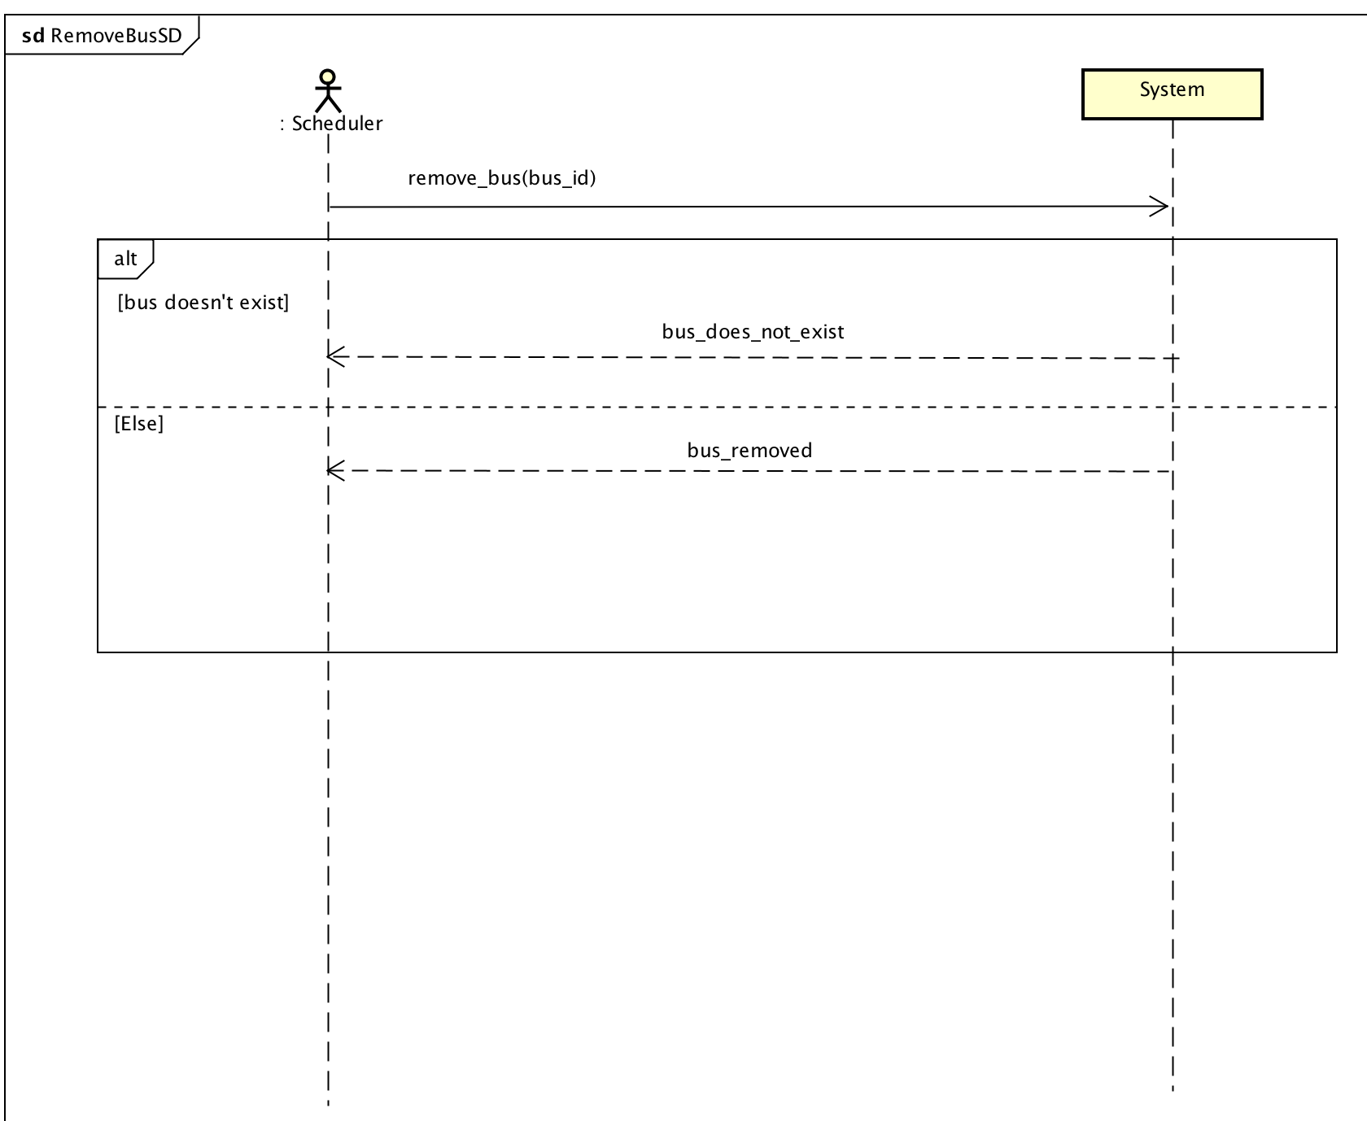

Add Driver - Jonathan

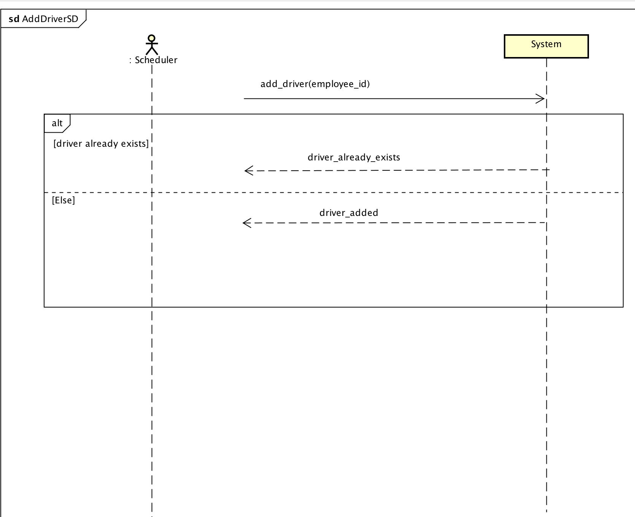

Remove Driver – Jonathan

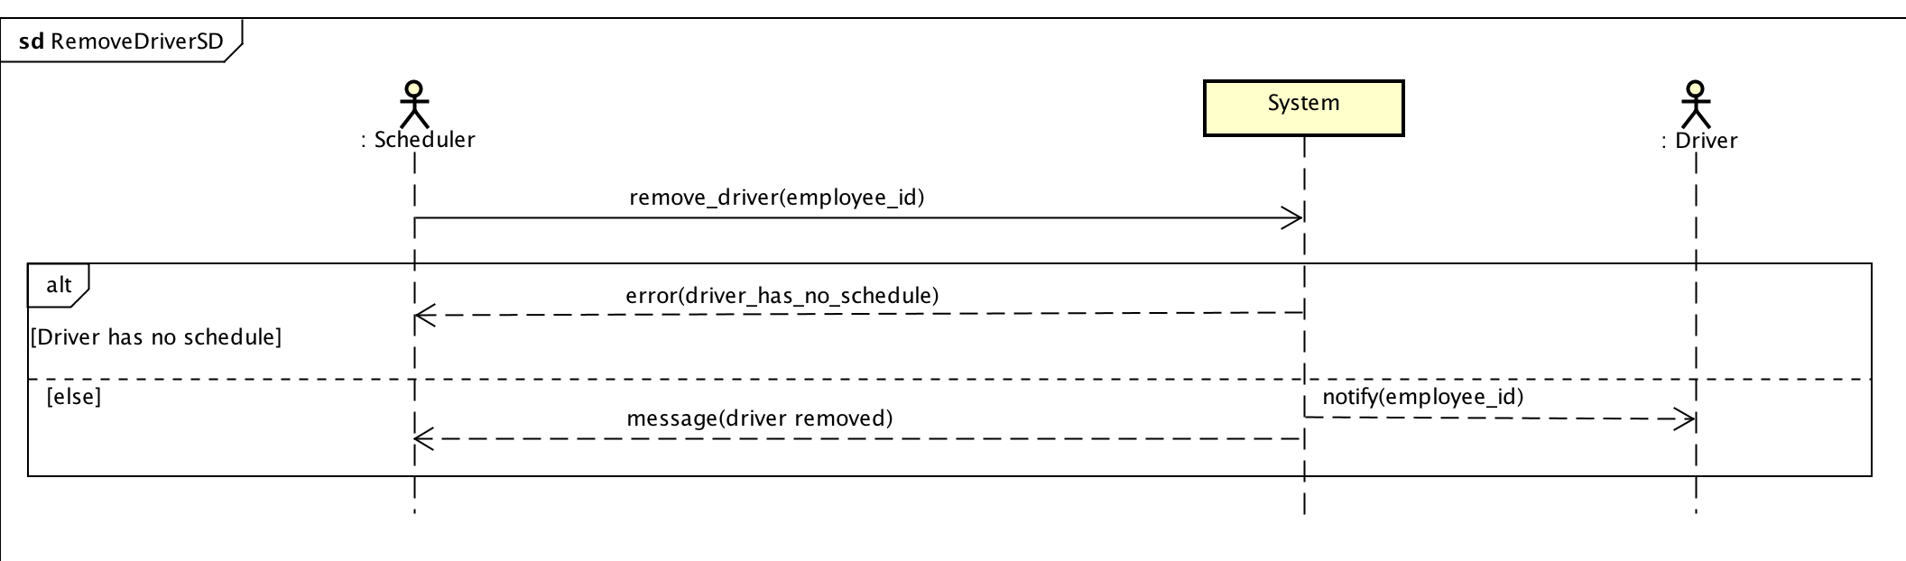

Schedule Driver – gdekker5

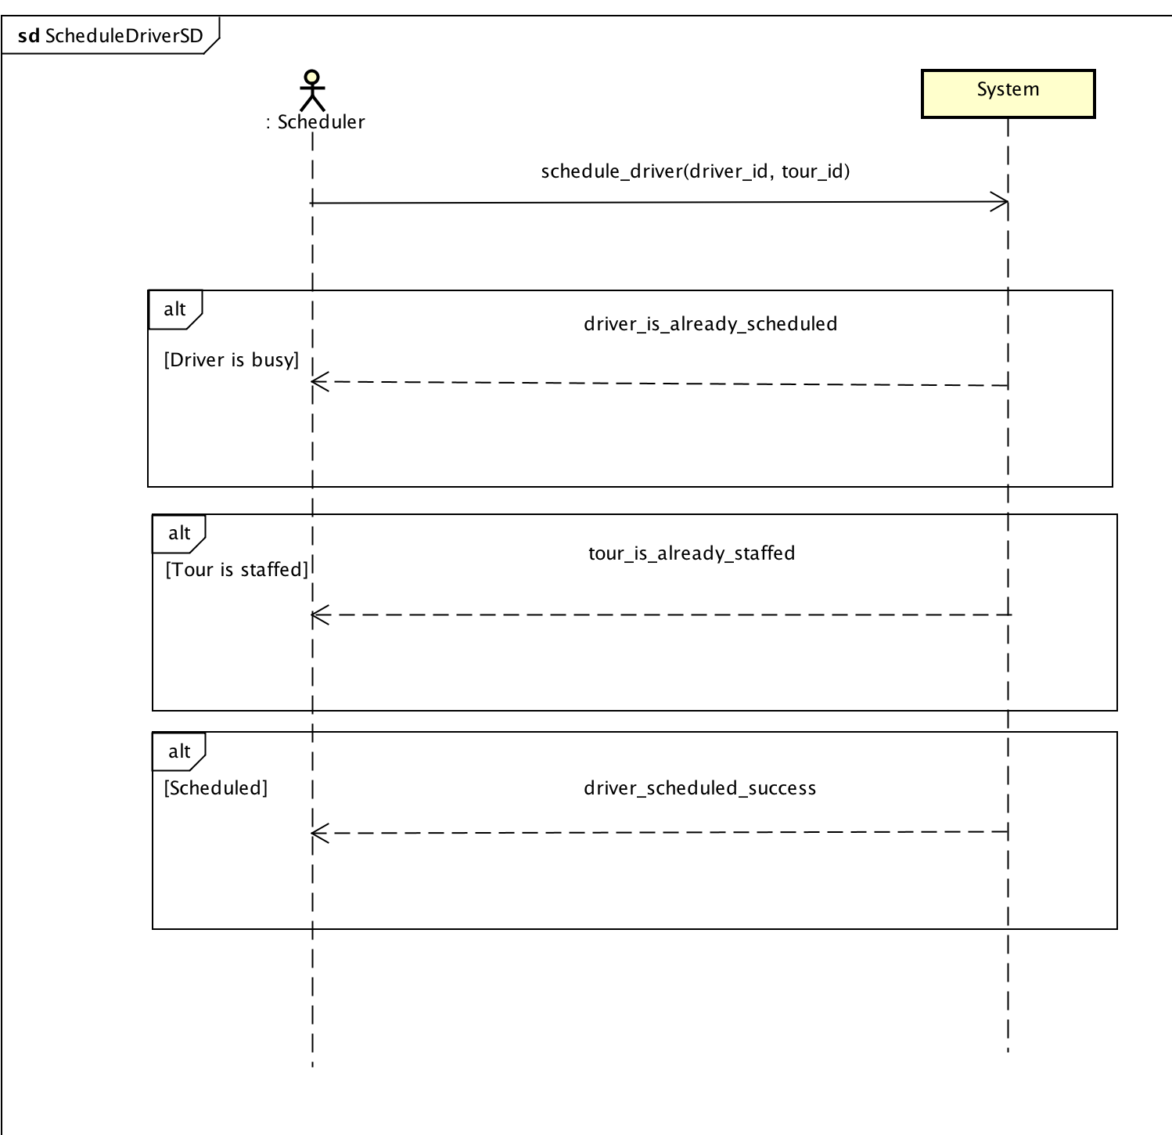

Schedule Repair – gdekker5

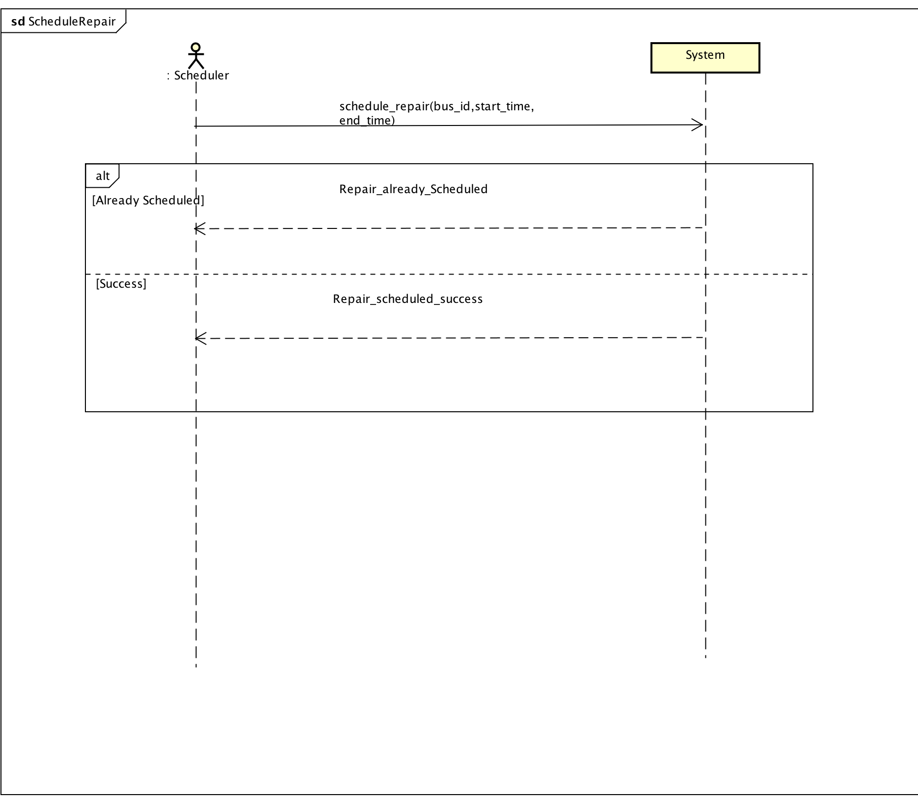

Login - dfentz