Tile Match 2020 Project

What, why and how is Tile Match 2020 Project?

Tile Match 2020 is a learning/portofolio project that’s also aiming to somewhat remake a classic Tile Match game from late 80s or early 90s, now with a bit of modern 3D magic and compatibility. The intented target audience is limited to my mother, who still enjoys playing original.

Why exactly Tile Match?

The main reason for picking Tile Match is the limited scope. I needed a project that allowed me to solidify some concepts of OpenGL, C++ and game architecture without being distracted by concepts of physics, complex animation, scalability and so on. In this game it should be sufficient that the player can flip some 80(ish) cards and match them. No need for collision detection, bsp trees, AI, big material system, sorted rendering queues and so on. Keep it simple, stupid.
Also, my mother likes the Tile Matching game we had on our 386 when I was a kid. I felt like the technology might have progressed enough that I can do some justice to the vision of the original one and add some vision of my own.

The Original Inspiration
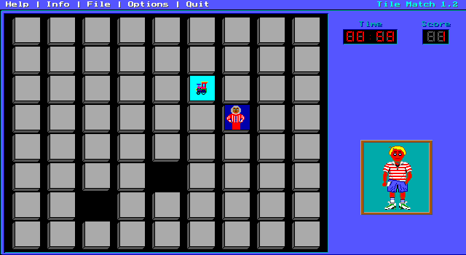
Image 1: The original tile matching game

Due to the influx of simple tile matching games for mobile market, tracking back the original game has been a bit tricky. I found some leftover images of the game that show it titled ”Tile Match 1.2”. I believe the game had actually a more descriptive name with original author’s name included, but I haven’t been able to trace it yet. Anyway, the information presented in Image 1 is mostly what we’ll need anyway. Gameplay wise the target spec is going to be a 9*8 grid with a timer. Everything beyond that is extra.
The kid on the bottom right (the one with unfortunate sunburns) had some superficial animations to reflect your performace, but I don’t think he’ll make it to the alpha phase at least. The score calculator can be used to keep track of guessing accuracy, but for the most of it, it’s a race against the clock rather than a game of precision.
Outside the core gameplay, the game had some options to change the card backs, tileset and match set size (16 being a small, medium 36 or so) and highscores for the aforementioned set sizes. The high scores seemed to be purely about minimizing time and that’s the way we’ll be doing it also.
There’s some happy beeps for succesful matching and some sad boops for missed matches. There was also an ear-grinding PC-Speaker theme, but we are not going to replicate that.

My Targets

My main target is to create a smooth-running OpenGL-driven version that produces gameplay similar to the original Tile Match. I’m not going to tie myself too tightly on specifics, but some guidelines from the original are good. For clarity and emphasis, I’ll list them here:

- The game should run smoothly on 9*8 deck and remain visually pleasant & readable at such card count. A little bit of extra doesn’t hurt, but we’re not going to fret over 5000 card sets or so.
- The timer is used for scoring the run. Original operated at a second precision (not sure how accurate their time measurement was on 386 system), but we’ll probably go for some fractions of a second. The fastest runs will be put in a highscore list.
- The game needs to have switchable tilesets. Some of my mothers grandchildren may be hired for art direction/assistance. Hopefully we’ll get some nice tilesets. These tilesets will likely be available only in the limited release my mother gets.
- The game should run smoothly on most Windows and Linux systems. Tablets and phones are tempting, but we are keeping the scope limited for now at least. The exact details of min sys requirements are a bit sketchy at this point. We’ll see how it goes once we are rendering those 72 tiles or so.
- There’s no exact decision on the language of the game yet. It shouldn’t be a big deal whether there’s a Finnish translation available or not. It might be interesting to create portable string sets, but those are not in the project scope at this point.
- Some sound would be nice. Blips and beeps could be sufficient. I’m going to have to do some research on the possibilities before committting to a specific solution here.
- In case where there isn’t an explicit decision made on a feature or approach, the guideline is Keep It Simple, Stupid.

Used technologies

The game is built around modern OpenGL for decent portability and simplicity. GLFW will be used for abstracting some of the platform specific window creation and input code and Glad will ensure the access to modern OpenGL functions.
SDL2 was considered as an alternative to GLFW, but GLFW seems like a more transparent, thin and purposeful set of tools for an OpenGL project.
For sound OpenAL seems like the go-to option, but I’m still keeping my options open.

OpenGL

Modern OpenGL is used for rendering. For now, we’ll assume the target hardware is going to support the newest 4.6 version. If mobile devices or MacOs need to be targeted, 4.1 or some OpenGL ES versions might be necessary. In general we are not diving too deep into finest rendering details, so likely a step back to an earlier version shouldn’t be a catasrophic rewrite task. At this point I’m mostly concerned about error checking and some sneaky changes in the spec.
As it is with the rest of the project, I’m trying to keep things simple. No separable shader pipelines, no sortable render queues or so. The rendering might even be simple OOP approach with draw command issued for each card separately. Due to the simple card geometry, instancing might actually be ineffective or even detrimental.
One of the major simplifications (or complications) is that there’s no attempt to abstract the OpenGL into renderer. Everything is allowed to modify the state. This can obviously lead to spaghetti code, but also makes the small scale design much less cumbersome.

GLFW
GLFW is used for portability and cutting some unnecessary corners in window creation, OpenGL context acquisition, input and timekeeping.

GLAD
Glad is used for loading the function pointers to OpenGL API. No big surprises here.

GLM

The go-to math library for most OpenGL projects. No surprises here either. For now we’ll be using roughly the default configuration, unlikely I’ll need bigger adjustments for OpenGL only project.

Possible future ideas

Matching more than 2 similar tiles. How about triplets or quadruplets?

Game mode where all the tiles are shown initially. Then all get turned face down and the timer starts. Accuracy gets scored?
Reduces some of the luck elements?
Encourages memorization rather than reflexes?

