Requirements:

1. Statistical information of the considered data. For eg. Mean, median, average, standard deviation, skew, kurtosis, etc.
2. Number of samples and range (date: from to) in train, valid, and test data
3. Plots for MSE, RMSE, MAE, RMSE, and $R^{2}$
   1. Default parameters
   2. Fine tuned with hyperopt
   3. Fine tuned with BHO

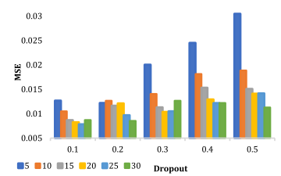

Here 5-30 represents the hidden units of the LSTM

1. Table for optimal architecture (consists of value of the fine tuned parameters)
2. Actual vs, predicted plots (train, valid, and test)
3. Plots for actual vs predicted for all models considered
4. If possible, we will try to show how the regression line fits

