**HTML**

**Learn html simple easy learning**

HTML stands for Hyper Text Markup Language, which is the most widely used language on Web to develop web pages. HTML was created by Tim-Berners-Lee in late 1991 but "HTML 2.0" was the first standard HTML specification which was published in 1995. HTML 4.01 was a major version of HTML and it was published in late 1999. Though HTML 4.01 version is widely used but currently we are having HTML-5 version which is an extension to HTML 4.01, and this version was published in 2012.**HTML tutorial** or HTML 5 tutorial provides basic and advanced concepts of HTML. Our HTML tutorial is developed for beginners and professionals. In our tutorial, every topic is given step-by-step so that you can learn it in a very easy way. If you are new in learning HTML, then you can learn HTML from basic to a professional level and after learning HTML with CSS and JavaScript you will be able to create your own interactive and dynamic website. But Now We will focus on HTML only in this tutorial.

The major points of HTML are given below:

* HTML stands for HyperText Markup Language.
* HTML is used to create web pages and web applications.
* HTML is widely used language on the web.
* We can create a static website by HTML only.
* Technically, HTML is a Markup language rather than a programming language.

# What is HTML

**Hyper Text:** HyperText simply means "Text within Text." A text has a link within it, is a hypertext. Whenever you click on a link which brings you to a new webpage, you have clicked on a hypertext. HyperText is a way to link two or more web pages (HTML documents) with each other.

**Markup language:** A markup language is a computer language that is used to apply layout and formatting conventions to a text document. Markup language makes text more interactive and dynamic. It can turn text into images, tables, links, etc.

**Web Page:** A web page is a document which is commonly written in HTML and translated by a web browser. A web page can be identified by entering an URL. A Web page can be of the static or dynamic type. **With the help of HTML only, we can create static web pages.**

Hence, HTML is a markup language which is used for creating attractive web pages with the help of styling, and which looks in a nice format on a web browser. An HTML document is made of many HTML tags and each HTML tag contains different content.

## HTML Example

In this tutorial, you will get a lot of HTML examples, at least one example for each topic with explanation.

|  |  |
| --- | --- |
| Coding | Output: |
| C:\Users\Lav-4_1\Pictures\v.PNG | C:\Users\Lav-4_1\Pictures\vv.PNG |

## Description of HTML Example

**<!DOCTYPE> :** It defines the document type or it instruct the browser about the version of HTML.

**<html >**: This tag informs the browser that it is an HTML document. Text between html tag describes the web document. It is a container for all other elements of HTML except <!DOCTYPE>

**<head>:** It should be the first element inside the <html> element, which contains the metadata (information about the document). It must be closed before the body tag opens.

**<title>:** As its name suggested, it is used to add title of that HTML page which appears at the top of the browser window. It must be placed inside the head tag and should close immediately. (Optional)

**<body>**: Text between body tag describes the body content of the page that is visible to the end user. This tag contains the main content of the HTML document.

**<h1>**: Text between <h1> tag describes the first level heading of the webpage.

**<p>**: Text between <p> tag describes the paragraph of the webpage.

## HTML Versions

Since the time HTML was invented there are lots of HTML versions in market, the brief introduction about the HTML version is given below:

**HTML 1.0:** The first version of HTML was 1.0, which was the barebones version of HTML language, and it was released in1991.

**HTML 2.0:** This was the next version which was released in 1995, and it was standard language version for website design. HTML 2.0 was able to support extra features such as form-based file upload, form elements such as text box, option button, etc.

**HTML 3.2:** HTML 3.2 version was published by W3C in early 1997. This version was capable of creating tables and providing support for extra options for form elements. It can also support a web page with complex mathematical equations. It became an official standard for any browser till January 1997. Today it is practically supported by most of the browsers.

**HTML 4.01:** HTML 4.01 version was released on December 1999, and it is a very stable version of HTML language. This version is the current official standard, and it provides added support for stylesheets (CSS) and scripting ability for various multimedia elements.

**HTML5 :** HTML5 is the newest version of HyperText Markup language. The first draft of this version was announced in January 2008. There are two major organizations one is W3C (World Wide Web Consortium), and another one is WHATWG( Web Hypertext Application Technology Working Group) which are involved in the development of HTML 5 version, and still, it is under development.

## Features of HTML

1) It is a very **easy and simple language**. It can be easily understood and modified.

2) It is very easy to make an **effective presentation** with HTML because it has a lot of formatting tags.

3) It is a **markup language**, so it provides a flexible way to design web pages along with the text.

4) It facilitates programmers to add a **link** on the web pages (by html anchor tag), so it enhances the interest of browsing of the user.

5) It is **platform-independent** because it can be displayed on any platform like Windows, Linux, and Macintosh, etc.

6) It facilitates the programmer to add **Graphics, Videos, and Sound** to the web pages which makes it more attractive and interactive.

7) HTML is a case-insensitive language, which means we can use tags either in lower-case or upper-case.

# HTML text Editors :

* An HTML file is a text file, so to create an HTML file we can use any text editors.
* Text editors are the programs which allow editing in a written text, hence to create a web page we need to write our code in some text editor.
* There are various types of text editors available which you can directly download, but for a beginner, the best text editor is Notepad (Windows) or TextEdit (Mac).
* After learning the basics, you can easily use other professional text editors which are, **Notepad++, Sublime Text, Vim, etc**.
* In our tutorial, we will use Notepad and sublime text editor. Following are some easy ways to create your first web page with Notepad, and sublime text.

## A. HTML code with Notepad. (Recommended for Beginners)

Notepad is a simple text editor and suitable for beginners to learn HTML. It is available in all versions of Windows, from where you easily access it.

**Step 1: Open Notepad (Windows)**

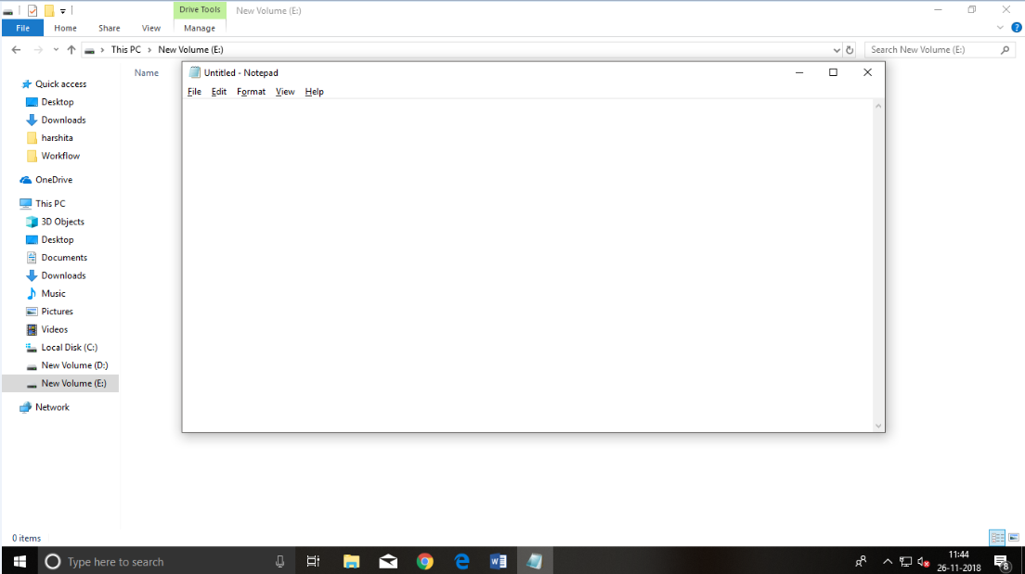

**Step 2: Write code in HTML**

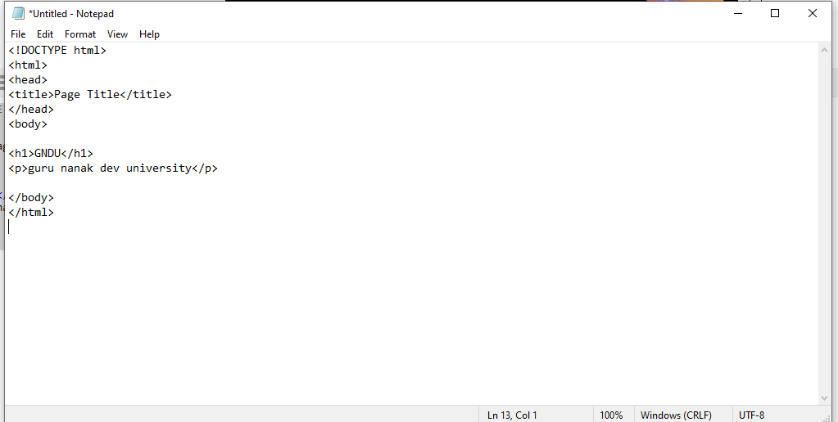

**Step 3: Save the HTML file with .htm or .html extension.**

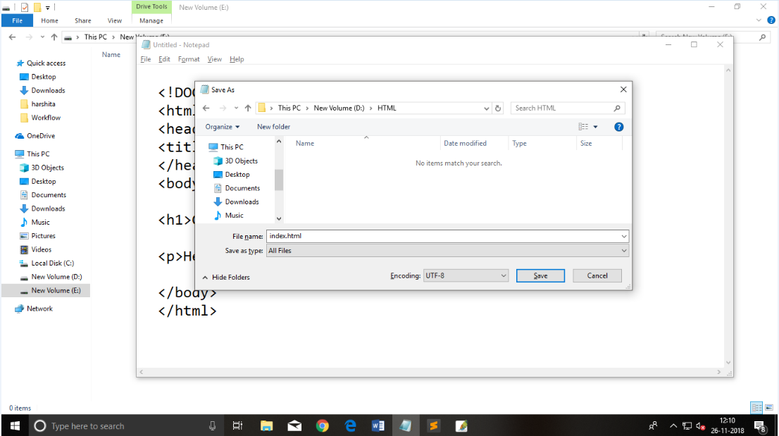

**Step 4: Open the HTML page in your web browser.**

To run the HTML page, you need to open the file location, where you have saved the file and then either double-click on file or click on open with option

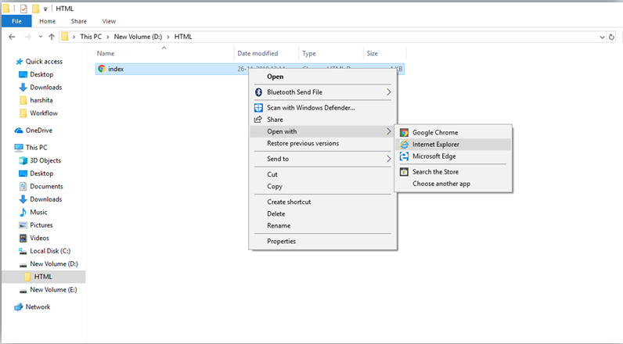



## B. HTML code with Sublime Text-editor.(Recommended after learning basics of HTML)

When you will learn the basics of HTML, then you can use some professional text editors, which will help you to write an efficient and fast code. So to use Sublime Text editors, first it needs to download and install from internet. You can easily download it from this <https://www.sublimetext.com/download> link and can install in your PC.

# Building blocks of HTML

An HTML document consist of its basic building blocks which are:

* **Tags:** An HTML tag surrounds the content and apply meaning to it. It is written between < and > brackets.
* **Attribute:** An attribute in HTML provides extra information about the element, and it is applied within the start tag. An HTML attribute contains two fields: name & value.

## Syntax :

**<tag** name  attribute\_name= " attr\_value"**>** content **</** **tag** name**>**

**Elements:** An HTML element is an individual component of an HTML file. In an HTML file, everything written within tags are termed as HTML elements.

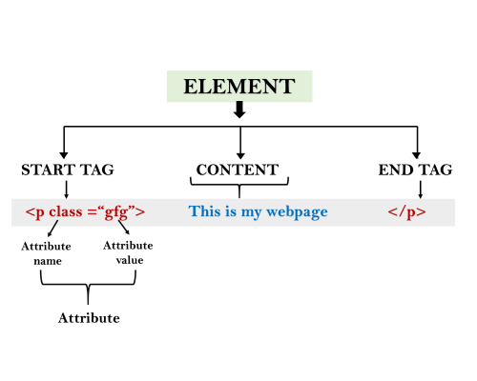

|  |  |
| --- | --- |
| **Coding:** | **Output:** |
|  | C:\Users\Lav-4_1\Pictures\1010.PNG |

# HTML Tags

HTML tags are like keywords which defines that how web browser will format and display the content. With the help of tags, a web browser can distinguish between an HTML content and a simple content. HTML tags contain three main parts: opening tag, content and closing tag. But some HTML tags are unclosed tags.

When a web browser reads an HTML document, browser reads it from top to bottom and left to right. HTML tags are used to create HTML documents and render their properties. Each HTML tags have different properties.

An HTML file must have some essential tags so that web browser can differentiate between a simple text and HTML text. You can use as many tags you want as per your code requirement.

* All HTML tags must enclosed within < > these brackets.
* Every tag in HTML perform different tasks.
* If you have used an open tag <tag>, then you must use a close tag </tag> (except some tags)

## Syntax :

<tag> content </tag>

## HTML Tag Examples

#### Note: HTML Tags are always written in lowercase letters. The basic HTML tags are given below:

|  |  |
| --- | --- |
| C:\Users\Lav-4_1\Pictures\111111.PNG | C:\Users\Lav-4_1\Pictures\11.PNG |

# HTML Tags

HTML tags are like keywords which defines that how web browser will format and display the content. With the help of tags, a web browser can distinguish between an HTML content and a simple content. HTML tags contain three main parts: opening tag, content and closing tag. But some HTML tags are unclosed tags.

When a web browser reads an HTML document, browser reads it from top to bottom and left to right. HTML tags are used to create HTML documents and render their properties. Each HTML tags have different properties.

An HTML file must have some essential tags so that web browser can differentiate between a simple text and HTML text. You can use as many tags you want as per your code requirement.

* All HTML tags must enclosed within < > these brackets.
* Every tag in HTML perform different tasks.
* If you have used an open tag <tag>, then you must use a close tag </tag> (except some tags)

## Syntax

<tag> content </tag>

## HTML Tag Examples

#### Note: HTML Tags are always written in lowercase letters. The basic HTML tags are given below:

<p> Paragraph Tag </p>

## <h2> Heading Tag </h2>

<b> **Bold Tag** </b>

<i> *Italic Tag* </i>

<u> Underline Tag</u>

[**Test it Now**](http://www.javatpoint.com/oprweb/test.jsp?filename=htmltags1)

## Unclosed HTML Tags

Some HTML tags are not closed, for example br and hr.

**<br> Tag**: br stands for break line, it breaks the line of the code.

**<hr> Tag**: hr stands for Horizontal Rule. This tag is used to put a line across the webpage.

## HTML Meta Tags

DOCTYPE, title, link, meta and style

## HTML Text Tags

<p>, <h1>, <h2>, <h3>, <h4>, <h5>, <h6>, <strong>, <em>, <abbr>, <acronym>, <address>, <bdo>, <blockquote>, <cite>, <q>, <code>, <ins>, <del>, <dfn>, <kbd>, <pre>, <samp>, <var> and <br>

## HTML Link Tags

<a> and <base>

## HTML Image and Object Tags

<img>, <area>, <map>, <param> and <object>

## HTML List Tags

<ul>, <ol>, <li>, <dl>, <dt> and <dd>

## HTML Table Tags

table, tr, td, th, tbody, thead, tfoot, col, colgroup and caption

## HTML Form Tags

form, input, textarea, select, option, optgroup, button, label, fieldset and legend

## HTML Scripting Tags

script and noscript

#### Note: We will see examples using these tags in later charters.

# HTML Headings :

In html, there are 6 heading tags.

h1, h2 , h3 , h4, h5, h6

Headings are defined with the <h1> to <h6> tags.

<h1> defines the most important heading. <h6> defines the least important heading.

**Note:** Browsers automatically add some white space (a margin) before and after a heading.

## Headings Are Important

Search engines use the headings to index the structure and content of your web pages.

Users often skim a page by its headings. It is important to use headings to show the document structure.

<h1> headings should be used for main headings, followed by <h2> headings, then the less important <h3>, and so on.

**Note:** Use HTML headings for headings only. Don't use headings to make text **BIG** or **bold**.

## Bigger Headings

Each HTML heading has a default size. However, you can specify the size for any heading with the style attribute, using the CSS font-size property:

### Example

<h1 style="font-size:60px;">Heading 1</h1>

|  |  |
| --- | --- |
| **Coding :** | **Output :** |
| C:\Users\Lav-4_1\Pictures\qqq.PNG | C:\Users\Lav-4_1\Pictures\qq.PNG |

**HTML Horizontal Rules :**

The <hr> tag defines a thematic break in an HTML page, and is most often displayed as a horizontal rule.

The <hr> element is used to separate content (or define a change) in an HTML page:

Example:

|  |  |
| --- | --- |
| Code: | Output: |
| C:\Users\Lav-4_1\Pictures\ww.PNG | C:\Users\Lav-4_1\Pictures\www.PNG |

The HTML <head> element is a container for metadata. HTML metadata is data about the HTML document. Metadata is not displayed.

The <head> element is placed between the <html> tag and the <body> tag.

## How to View HTML Source?

Have you ever seen a Web page and wondered "Hey! How did they do that?"

### View HTML Source Code:

Right-click in an HTML page and select "View Page Source" (in Chrome) or "View Source" (in Edge), or similar in other browsers. This will open a window containing the HTML source code of the page.

### Inspect an HTML Element:

Right-click on an element (or a blank area), and choose "Inspect" or "Inspect Element" to see what elements are made up of (you will see both the HTML and the CSS). You can also edit the HTML or CSS on-the-fly in the Elements or Styles panel that opens.

**HTML Text Formatting Elements**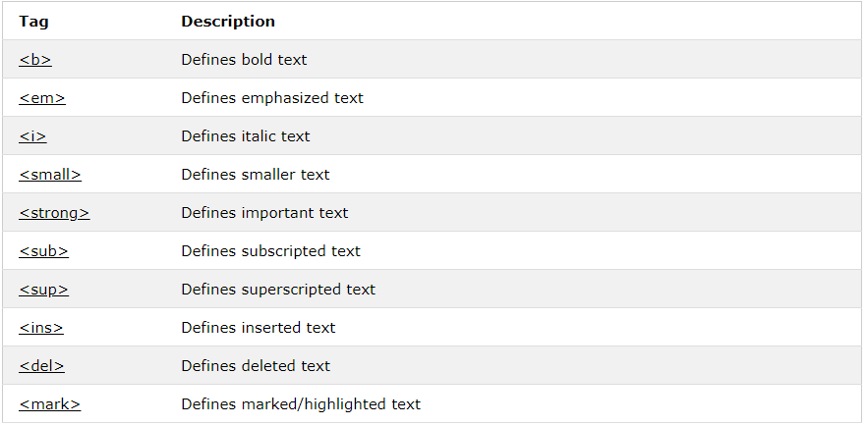

**HTML Comments**

Comment tags are used to insert comments in the HTML source code.

HTML Comment Tags :

You can add comments to your HTML source by using the following syntax:

<!-- Write your comments here -->

Notice that there is an exclamation point (!) in the opening tag, but not in the closing tag.

**Note:** Comments are not displayed by the browser, but they can help document your HTML source code.

|  |  |
| --- | --- |
| Code: | Output: |
| C:\Users\Lav-4_1\Pictures\d.PNG | C:\Users\Lav-4_1\Pictures\dd.PNG |

Comments are also great for debugging HTML, because you can comment out HTML lines of code, one at a time, to search for errors.

# HTML Colors :

HTML colors are specified using predefined color names, or RGB, HEX, HSL, RGBA, HSLA values.

**Color Names :**

In HTML, a color can be specified by using a color name:

|  |  |
| --- | --- |
| Code: | Output: |
| C:\Users\Lav-4_1\Pictures\c.PNG | C:\Users\Lav-4_1\Pictures\cc.PNG |

HTML supports [140 standard color names](https://www.w3schools.com/colors/colors_names.asp).

## Text Color

You can set the color of text:

|  |  |
| --- | --- |
| Code | Output |
| C:\Users\Lav-4_1\Pictures\4.PNG |  |

Using HTML you can provide colors to borders, you can also give values of colors in hexadecimal form and using opacity.

# HTML Styles – CSS :

# CSS = Styles and Colors

Manipulate Text

Colors,  Boxes

## Styling HTML with CSS

**CSS** stands for **C**ascading **S**tyle **S**heets.

CSS describes **how HTML elements are to be displayed on screen, paper, or in other media**.

CSS **saves a lot of work**. It can control the layout of multiple web pages all at once.

CSS can be added to HTML elements in 3 ways:

* **Inline** - by using the style attribute in HTML elements
* **Internal** - by using a <style> element in the <head> section
* **External** - by using an external CSS file

The most common way to add CSS, is to keep the styles in separate CSS files. However, here we will use inline and internal styling, because this is easier to demonstrate, and easier for you to try it yourself.

## Inline CSS

An inline CSS is used to apply a unique style to a single HTML element.

An inline CSS uses the style attribute of an HTML element.

This example sets the text color of the <h1> element to blue.

|  |
| --- |
| C:\Users\Lav-4_1\Pictures\qqqq.PNG |
| C:\Users\Lav-4_1\Pictures\aaaa.PNG |

## Internal CSS :

An internal CSS is used to define a style for a single HTML page.

An internal CSS is defined in the <head> section of an HTML page, within a <style> element:

|  |
| --- |
| C:\Users\Lav-4_1\Pictures\cm.PNGC:\Users\Lav-4_1\Pictures\qqad.PNG |
|  |

## External CSS :

An external style sheet is used to define the style for many HTML pages.

**With an external style sheet, you can change the look of an entire web site, by changing one file!**

To use an external style sheet, add a link to it in the <head> section of the HTML page

**HTML Links :**

Links are found in nearly all web pages. Links allow users to click their way from page to page.

## HTML Links - Hyperlinks

HTML links are hyperlinks.

You can click on a link and jump to another document.

When you move the mouse over a link, the mouse arrow will turn into a little hand.

**Note:** A link does not have to be text. It can be an image or any other HTML element.

## HTML Links - Syntax

Hyperlinks are defined with the HTML <a> tag:

<a href="*url*">*link text*</a>

The href attribute specifies the destination address (https://www.w3schools.com/html/) of the link.

The **link text** is the visible part (Visit our HTML tutorial).

Clicking on the link text will send you to the specified address.

**Note:** Without a forward slash at the end of subfolder addresses, you might generate two requests to the server. Many servers will automatically add a forward slash to the end of the address, and then create a new request.

## HTML Links - The target Attribute

The target attribute specifies where to open the linked document.

The target attribute can have one of the following values:

* \_blank - Opens the linked document in a new window or tab
* \_self - Opens the linked document in the same window/tab as it was clicked (this is default)
* \_parent - Opens the linked document in the parent frame
* \_top - Opens the linked document in the full body of the window
* framename - Opens the linked document in a named frame.

## HTML Links - Image as Link:

It is common to use images as links:

### Example

<a href="default.asp">  
  <img src="smiley.gif" alt="HTML tutorial" style="width:42px;height:42px;border:0;">  
</a>

## Chapter Summary :

* Use the <a> element to define a link
* Use the href attribute to define the link address
* Use the target attribute to define where to open the linked document
* Use the <img> element (inside <a>) to use an image as a link

# HTML Images :

|  |
| --- |
| C:\Users\Lav-4_1\Pictures\gg.PNG |
| C:\Users\Lav-4_1\Pictures\g.PNG |

## Defining an HTML Table

An HTML table is defined with the <table> tag.

Each table row is defined with the <tr> tag. A table header is defined with the <th> tag. By default, table headings are bold and centered. A table data/cell is defined with the <td> tag.

|  |  |
| --- | --- |
| Code : | Output: |
| C:\Users\Lav-4_1\Pictures\ggg.PNG | C:\Users\Lav-4_1\Pictures\mm.PNG |

# HTML Lists:

|  |  |
| --- | --- |
| Code: | Output: |
| C:\Users\Lav-4_1\Pictures\bb.PNG | C:\Users\Lav-4_1\Pictures\b.PNG |

# HTML Iframes :

## Iframe Syntax :

An HTML iframe is defined with the <iframe> tag:

<iframe src="URL"></iframe>

# HTML Forms

## The <form> Element

The HTML <form> element defines a form that is used to collect user input:

<form>  
.  
*form elements*  
.  
</form>

## The <input> Element

The <input> element is the most important form element.

The <input> element can be displayed in several ways, depending on the **type** attribute.

## The Submit Button

<input type="submit"> defines a button for **submitting** the form data to a **form-handler**.

The form-handler is typically a server page with a script for processing input data.

## The Action Attribute

The action attribute defines the action to be performed when the form is submitted.

Normally, the form data is sent to a web page on the server when the user clicks on the submit button.

## The Method Attribute

The method attribute specifies the HTTP method (**GET**or **POST**) to be used when submitting the form data

When to Use GET?

The default method when submitting form data is GET.

However, when GET is used, the submitted form data will be **visible in the page address field**:

/action\_page.php?firstname=Mickey&lastname=Mouse

**Notes on GET:**

* Appends form-data into the URL in name/value pairs
* The length of a URL is limited (2048 characters)
* Never use GET to send sensitive data! (will be visible in the URL)
* Useful for form submissions where a user wants to bookmark the result
* GET is better for non-secure data, like query strings in Google

## When to Use POST?

Always use POST if the form data contains sensitive or personal information. The POST method does not display the submitted form data in the page address field.

**Notes on POST:**

* POST has no size limitations, and can be used to send large amounts of data.
* Form submissions with POST cannot be bookmarked

|  |  |
| --- | --- |
| Code : | Output: |
| C:\Users\Lav-4_1\Pictures\n.PNG | C:\Users\Lav-4_1\Pictures\nn.PNG |

# HTML Multimedia:

Multimedia on the web is sound, music, videos, movies, and animations.

Multimedia comes in many different formats. It can be almost anything you can hear or see.

Examples: Images, music, sound, videos, records, films, animations, and more.

Web pages often contain multimedia elements of different types and formats.

In this chapter you will learn about the different multimedia formats.

## Browser Support

The first web browsers had support for text only, limited to a single font in a single color.

Later came browsers with support for colors and fonts, and images!

Audio, video, and animation have been handled differently by the major browsers. Different formats have been supported, and some formats require extra helper programs (plug-ins) to work.

Multimedia Formats

Multimedia elements (like audio or video) are stored in media files.

The most common way to discover the type of a file, is to look at the file extension.

Multimedia files have formats and different extensions like: .swf, .wav, .mp3, .mp4, .mpg, .wmv, and .avi.

## Common Video Formats

|  |  |
| --- | --- |
| Videoformats | MP4 is the new and upcoming format for internet video.  MP4 is recommended by YouTube.  MP4 is supported by Flash Players. |

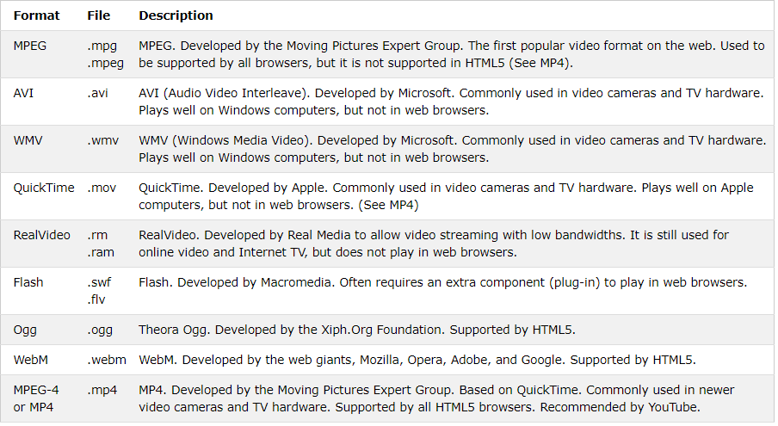

# HTML5 Video

## Playing Videos in HTML

Before HTML5, a video could only be played in a browser with a plug-in (like flash).

The HTML5 <video> element specifies a standard way to embed a video in a web page.

|  |  |
| --- | --- |
| C:\Users\Lav-4_1\Pictures\ff.PNG | C:\Users\Lav-4_1\Pictures\gj.PNG |

# HTML YouTube Videos

The easiest way to play videos in HTML, is to use YouTube.

## Struggling with Video Formats?

Earlier in this tutorial, you have seen that you might have to convert your videos to different formats to make them play in all browsers.

Converting videos to different formats can be difficult and time-consuming.

An easier solution is to let YouTube play the videos in your web page.

## Playing a YouTube Video in HTML

To play your video on a web page, do the following:

* Upload the video to YouTube
* Take a note of the video id
* Define an <iframe> element in your web page
* Let the src attribute point to the video URL
* Use the width and height attributes to specify the dimension of the player
* Add any other parameters to the URL (see below)

|  |  |
| --- | --- |
| Code : | Output : |
| C:\Users\Lav-4_1\Pictures\dfd.PNG | C:\Users\Lav-4_1\Pictures\yhth.PNG |

<----------------------------------------------------------→