

**System Requirements & Specifications**

**Team 3**

**Victor Munoz**

**Aidan Henry**

**Nana Ofosu Budu**

**Muyiwa Coker**

Public Library System

Table of Contents

1. Introduction 4

1.1 Purpose 4

1.2 Product Scope 4

1.3 Definitions, Acronyms, Abbreviations 5

1.4 References 5

1.5 Overview 5

2. Overall Description 5

2.1 Product Perspective 5

2.2 Product Functions 6

2.3 User Characteristics 9

2.4 Constraints 9

2.5 Assumptions 9

3. Registration System Requirements 9

4. Registration System Models 10

5. Log in System Requirements 10

6. Log in System Models 11

7. Forgot Password System Requirements 11

8. Forgot Password System Models 11

9. Basic Search System Requirements 11

10. Basic Search System Models 12

11. Advanced Search System Requirements 12

12. Advanced Search System Models 13

13. Patron Search System Requirements 13

14. Patron Search System Models 15

15. Reservations System Requirements 15

16. Reservations System Models 16

17. Printing Funds System Requirements 16

18. Printing Funds System Models 17

19. Late Fee System Requirements 17

20. Late Fee System Models 18

21. Update Patron Records System Requirements 18

22. Update Patron Records System Models 19

23. Update Book Records System Requirements 19

24. update Book Records System Models 21

25. Log Out System Requirements 21

26. Log Out System Models 21

Appendix A 21

1. Introduction

## Purpose

The current library system has become outdated and underperforming. The web portal lacks sections for book suggestions and library events. Book searching has limited options and can be made more user-friendly. A new system that is more efficient and has added features will be developed. This document will describe the overall design of a public library system. Including detail information on book characteristics needed for searching, and functions allocated to librarians, library attendants, patrons, and administrators needed to maintain user and book records, lend media, and maintain the library catalogue. Vendor interaction will be limited and will not be considered in this release.

## Product Scope

Two separate web portals will be maintained one for patrons, and one for librarians, attendants, administrators. One URL will be used for log in. After login the appropriate user type will be determined based on the username and user will be redirected to the appropriate web portal for each user type or user type group. All user types will interact with the same database under varying levels of access. Staff will have the option to switch between the patron portal and the staff portal.

Patrons will be able to:

* Create login account with Library Card
* Perform book and other media searches
* Make reservations
* Receive notifications when resources become available
* Reset Password

Librarians

* Process late fee payments and add printing funds
* Checkout books
* Search patron/book records
* Update patron/book records

Attendants

* Process late fee payments and add printing funds
* Checkout books

Administrators

## Definitions, Acronyms, Abbreviations

|  |  |
| --- | --- |
| Term | Definition |
| Patron | Library card holder that makes use of library resources |
| Vendor | Sells books and other media as requested by librarian |
| Librarian | Manages patron’s accounts, maintains catalogue of media resources |
| Library Attendant | Facilitates book/media checkout, receives payment, issues library cards |
| Administrator | Makes changes to system, performs updates, adds features |
| PHP | Web Server language used to validate data, and interact with database |
| SQL | Language used to manipulate database |
| HTML | Scripting language used to create framework of webpages |

## References

<Fill in info>

## Overview

This document describes the different entities needed in the library system. It will also describe the constraints and dependencies. Case studies will be used to illustrate the functional requirements of the system.

1. Overall Description

## Product Perspective

The Library System is intended to be used by the city’s public libraries. The system is to be used by five types of users, patrons, librarians and administrators.

## Product Functions

The functions of the system are as follows:

* Allow users to login
* Search books and other media with a variety of search options such as media, ISBN, title, year, author etc.
* User types will have varying levels of access and functions
* Patrons are able to make reservations online. Checkout must be done by librarian.

End

## User Characteristics

There will be four different types of users, patrons, librarians, library attendants, and administrators. Patrons and staff members will have separate web portals, with different functions and features.

Before being able to create an online account, patrons will need to obtain a library card from the library. Once this is obtained patrons will be able to create an online account and log in to the system. Once logged in patrons may search media, make reservations, log out of the system. On the first release patrons will not be able to pay late fees or add printing funds. This will be done by librarians and attendants, at least initially until a further release is developed.

Librarians and library assistants must be employees and authorized by management to use the system. Once they have been authorized and an account has been created by an administrator they may log in to the system. Library attendants will be able to check out books, receive payments, search media, search patrons. Librarians will have all functions allotted to library attendants plus have the ability to edit or add book records, update patron records, and purchase books and other media.

Administrator have all functions that librarians have except that of checking out books, processing payments and ordering books. In addition, administrators may delete records from the database, add new staff members to the database, perform password resets for everyone only if needed, and perform general maintenance on the database.

## Constraints

The system will be entirely web based and there will be no need to install software on any individual computer.

## Assumptions

System will be compatible with all web browsers and can be used from a wide variety of devices.

1. User Requirements

The Library is to be used by four user types: patrons, librarians, library attendants and administrators.

## Patron User Requirements

Patrons will have functions such as registering, searching for books, making reservations, and resetting passwords. For registration to occur patrons must have a library card and no amount owed for late fees.

A close up of a logo

Description generated with very high confidence

## Librarian User Requirements

Librarians will be able to search and update media and patron records, and be able to accomplish transactions such as checking out media, process returns, and process payments for late fees and printing funds. A close up of a logo

Description generated with high confidence

## Library Attendant User Requirements

Attendants will be able to search media and patron records, however they will not be able to edit them. Similarly to librarians they will be able to checking out media, process returns, and process payments for late fees and printing funds.

A close up of a logo

Description generated with very high confidence

## Administrator User Requirements

Administrators will be able to search and edit media and patron records and will be the only user type with the ability to delete records. Record deleting will be done by interacting directly with the database and will not be part of the system design.

A close up of a logo

Description generated with very high confidence

## 

1. Registration System Requirements

|  |  |
| --- | --- |
| USE CASE | LOG IN |
| Description | Create online account for patrons. Staff accounts will be created by administrators only and are not part of the system requirements. To obtain a library card patrons must present proof of identity and residency to librarian or library assistant in person at a library location. The required information to create an account will be first/last name, library card number, home address, telephone number, and e-mail address. Username is auto generated. Password must meet requirements: Eight characters in length, at least one upper case letter, one lower case letter and one special character. |
| Actors | Library patron |
| Preconditions | Patrons must have a library card |
| Basic Flow | 1. User selects register option 2. Enter personal information, first/last name, library card number, home address, telephone number, email address 3. Click register 4. Data validated 5. Account activated 6. Redirect to login page |
| Post-conditions | Account is activated. Username and password are stored in the database. Appropriate level of access is given. After login patron will be directed to the patron portal. |
| Alternate flows | Select cancel – back to login page  Data cannot be validated – user must correct data input to meet requirements |

1. Registration System Models

A picture containing device, meter

Description generated with very high confidence

The diagram describes the process of creating a patron’s online account. After being issued a library card, patrons may navigate to the library’s website, where they will click the register button. A new page will open and users may fill out the fields in the form. Library card number will be the first field as the patron finishes typing the number the information will be validated, if the library card has already been registered a message will be displayed stating that an online account already exists. If this is the case patrons may go back to the log in page and attempt to log in. At login there will also be options to recover the username and reset the password. Next the user will fill out personal information on the form, such as first and last names, home address, telephone, and email address. Home address must be within the library’s area of service. Telephone number must include three digit area code and seven digit phone number. The email address must include the at symbol and at least one dot. A username will be generated, and the patron will be asked to create a password. The password must be eight characters in length, have at least one upper case letter, one lower case letter and one special character. If any of the information is left blank or if it does not meet the requirements a message will be displayed stating which field needs to be completed or corrected. Having passed all validation requirements, users may click the submit button. An account will be created and the user will be redirected to the log in page.

1. Log in System Requirements

|  |  |
| --- | --- |
| USE CASE | LOG IN |
| Description | Allow users into appropriate system module. Patrons will redirected to the patron module while staff will be redirected to the staff module. |
| Actors | Library patrons, librarians, assistants, administrators |
| Preconditions | Librarians, assistants and administrators share same log in portal.  Patrons and vendors have separate log in portals  Patron must have a Library Card and be registered in the database  Librarians, assistants and administrators must be employed and authorized by management  Username not case sensitive. |
| Basic Flow | 1. Go to log in page 2. User types in user name and password 3. Information is validated 4. Appropriate Web portal opens |
| Post-conditions | Username and Password must match data in database. |
| Alternate flows | Error message – ‘username or password incorrect’  Option 1 – Incorrect username/password - try again  Option 2 – Too many attempts account locked contact administrator |

1. Log in System Models

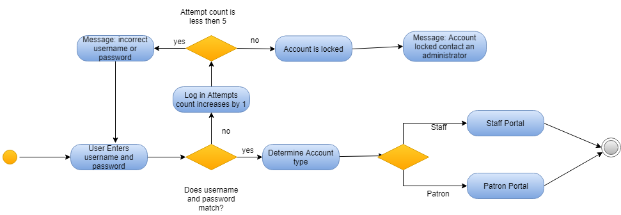

The log in page will be used by patrons and staff members. Users need to type in their username and password. The username and password must match what is in the database. If either the username or password do not match the count for number of attempts will increase by one. If the number of attempts is less then five user will receive a message stating that the username or password are incorrect. User can then try to log in again. If the number of attempts exceeds five the account will be locked and users will receive a message stating that the account is locked and that they need to contact the system administrator. In the case that username and password match users will be directed to the appropriate portal according to user type. Patrons will be redirected to the patron portal, while staff members will be redirected to the staff portal.

1. Reset Password System Requirements

|  |  |
| --- | --- |
| USE CASE | BASIC SEARCH |
| Description | Patron’s who have forgotten their passwords or wish to change their passwords can click on ‘forgot username/password’. Users select option to reset password. Users will be prompted to select the method used to receive a security code. Users can select call, text or email. The security code is typed in and submitted. Users type in new password and retype it to confirm. |
| Actors | Patrons |
| Preconditions |  |
| Basic Flow | 1. On the log in screen select ‘forgot username/password’ 2. Select change password 3. Select option to receive security code 4. Security code is sent 5. Type in security code 6. Type in password 7. Confirm password 8. New password is updated in the system 9. User can log in with the new password |
| Post-conditions | Password is updated in the database |
| Alternate flows | Option 1 – get username   1. On the log in screen select ‘forgot username/password’ 2. Select get username 3. Select option to receive security code 4. Security code is sent 5. Type in security code 6. Username is shown on screen 7. User can attempt log in |

1. Reset password System Models

A picture containing device, meter, sky

Description generated with high confidence

User who wish to change their passwords or have forgotten their passwords can click on the ‘forgot username/password’ option in the log in screen. The users will then be prompted to select either recover username or reset password. If reset password is selected the user will then be prompted to select a method to receive the security code. The options are call, text, or email. The security code in entered and the user enters the new password. After retyping the password to confirm the user clicks on reset password button. The password is updated in the database and the log in page opens.

1. Recover Username System Requirements

|  |  |
| --- | --- |
| USE CASE | BASIC SEARCH |
| Description | Patron’s who have forgotten their username can click on ‘forgot username/password’ and select recover username. After entering their library card number the username will be displayed on screen. |
| Actors | Patrons |
| Preconditions |  |
| Basic Flow | 1. On the log in screen select ‘forgot username/password’ 2. Select get username 3. Enter library card number 4. Username is displayed on screen |
| Post-conditions | Username is displayed on screen |
| Alternate flows |  |

1. Recover Username System Models

A close up of a red light

Description generated with very high confidence

To recover the password users select the recover password option. The library card and last name of the user is entered. If the two input match with the data in the database the username is displayed and the user can click a button to go back to the log in screen.

1. Basic Search System Requirements

|  |  |
| --- | --- |
| USE CASE | BASIC SEARCH |
| Description | Search for available media using several criteria. Basic search box is located at the top center of main patron portal. Defaults to search all media. Basic search box defaults to search by keyword, but will search by ISBN if detected. Users have the ability to perform advanced searches by typing special keywords, a colon, and the search criteria. For example to search by title users must type this in the search box, title:Java a Complete Guide. Commas, separate search categories, e.g. title:Java a Complete Guide, year: 2015. Operators such as ‘and’, ‘or’ and ‘not’ may also be used, e.g. title: Java and Guide, year: 2015 or 2016. To Avoid ambiguity or if search criteria includes keywords quotations marks can be used, e.g. title: “Java” and “Guide”. |
| Actors | Library patron, librarian, attendant, administrator |
| Preconditions | User must log in to the system. Staff must switch to patron portal. |
| Basic Flow | 1. Select basic search box 2. Type in keyword or ISBN 3. Browse through results 4. Order results by ‘relevant’, ‘popular’ ‘date published’ ‘author’ ‘title’ 5. Filter out results by using filters: format (book, newspaper, magazine, journal etc.), author, year(select between what years), subject(history, science etc). |
| Post-conditions | User will receive a list of results that can be ordered. Options to filter out list will also be available. |
| Alternate flows | Use advanced search using special keywords: title, keyword, year, author, ISBN, format, subject |

1. Basic Search System Models

A picture containing red, device

Description generated with very high confidence

When doing a basic search users will type in a keyword and a search by keyword will be performed. This type of search will look at title, subject, author, description and other media information that contains the keyword and return a list of results. Users can also specify the type of search performed by using special commands. For example to search by title users would type in title: [author’s name]. Operators such as ‘and’, ‘or’ and ‘not’ can be used to be even more specific. A more detail description is found in the use case. After the user clicks on the search button a list of results matching the criteria will be shown.

1. Advanced Search System Requirements

|  |  |
| --- | --- |
| USE CASE | ADVANCED SEARCH |
| Description | If a more detailed search is desired users can select the advanced search option below the basic search box. Clicking the advanced search box will redirect user to a new page that will include two rows with fields to control a search. Additional rows may be added to get an even more detailed search. The first field in a row will be a dropdown that will include all search categories: title, keyword, year, author, ISBN, format, subject and location. The second field will be a search box where the search criteria may be typed. At the end of the row a button with a minus sign will be used to remove the row. Below the search box there will be buttons to select operators, ‘and’, ‘or’, ‘not’. The operator buttons will also serve to add rows. For example, if a search for an author must include both ‘John’ and ‘Perry” users may select author from first dropdown field, type in John on the first search box, click on ‘and’ button to add new row. On the second row first field from the dropdown menu again select author. Type in ‘Perry” and click search. This search will find only books that with an author name that includes both John and Perry. |
| Actors | Library patron, librarian, attendant, administrator |
| Preconditions | User must log in to the system and click on the advanced search option. Staff must first switch to patron portal. |
| Basic Flow | 1. Select search category from dropdown menu 2. Type in search criteria 3. Use operator buttons (‘and’, ‘or’, ‘not’) to add more searching rows as needed 4. Click search 5. Order results by ‘relevant’, ‘popular’ ‘date published’ ‘author’ ‘title’ 6. Filter out results by using filters: format (book, newspaper, magazine, journal etc.), author, year(select between what years), subject(history, science etc). |
| Post-conditions | User will receive a list of results that can be ordered. Options to filter out list will also be available. |
| Alternate flows |  |

1. Advanced Search System Models

A picture containing device, meter

Description generated with very high confidence

The advanced search option allows users to add more search rows by using the operator buttons. First users must select search option from the dropdown menu. The options are: keyword, author, title, year, media type, subject and ISBN. After all desired search rows have been added and all search criteria has been input user can click on the search button and obtain the results.

1. Patron Search System Requirements

|  |  |
| --- | --- |
| USE CASE | SEARCH PATRON RECORDS |
| Description | Staff will often need to lookup patron records to verify status of account. Staff will be able to see how much is owed in late fee’s, how much money remains in printing funds, home address to verify residency information is up to date, telephone in case patron needs to be contacted. The search by library card number row will be static and sit at the top. At checkout after scanning the card the number will be input into this search box. When using other criteria such as first name and last name the library card search can be left blank. Clicking on the operators will add a new search row. Clicking on a record will redirect to the full record page of the patron. Once here additional functions may be performed such as paying late fees, adding printing funds, or checking out books. |
| Actors | Librarian, attendant, administrator |
| Preconditions | Users must be staff members and be given special privileges to access data in the database. After log in staff members will be redirected to the Staff Portal. Once in the portal staff will have list of names ordered alphabetically showing 20 records per page. At the top of the list there will be search options. |
| Basic Flow | 1. Staff logs in and is redirected to Staff Portal 2. Staff selects search option from drop down (FirstName, LastName, Telephone number, Library Card Number, etc.) 3. Click on operator to add another search row if desired 4. Once patron record is found click on it to access patron record page 5. From patron record page staff can process payments, add funds or checkout media |
| Post-conditions |  |
| Alternate flows | Option 1- Library card is scanned   1. Static search box to lookup by library card is populated 2. Once patron record is found click on it to access patron record page 3. From patron record page staff can process payments, add funds or checkout media |

1. Patron Search System Models
2. Reservations System Requirements

|  |  |
| --- | --- |
| USE CASE | MAKING RESERVATIONS |
| Description | After patron logs in and finds a book he or she may make a reservation for the book. First users will select the pickup location and then click on ‘make reservations’. If the reservation is not located at the pickup location it will be delivered from another system library. The reservation period of 7 days starts after the reserved media has been delivered to the pickup location. On the webpage for a specific book there will be a picture of the book and below the picture there will be basic information such as title, author, year and ISBN. A short description will also be included towards the bottom of the page. To the right there will be a button to make a reservation and select the pickup location. A notification is added under the notifications area. The notifications area can be accessed by clicking on the notifications icon(bell) at the top right of the page. The notification will include where to pick up the book, availability/delivery status, and time period left to pick up the reservation. The icon will also have a number indicating how many notifications exists. Notifications will also be added 2 days before the 7 day pick up period to remind users to pick up their reservations. Once a reservation has been made the librarian or attendant will receive a request to grab the reservation from the shelves and bring it to the front desk. Reservations will be kept at the front desk for up to 7 days. Reservations are only for books and exclude all other media. |
| Actors | Library patron |
| Preconditions | User must log in to the system and find the desired book |
| Basic Flow | 1. Click reserve 2. Select pick up location from pop up 3. Pop up will indicate if media is available for pickup today or a delivery wait period 4. Click OK 5. Media will be added to the patron’s reservations list |
| Post-conditions | Users will be receive a notification |
| Alternate flows |  |

1. Reservations System Models
2. Book Checkout System Requirements

|  |  |
| --- | --- |
| USE CASE | ADD PRINTING FUNDS |
| Description | Librarians or attendants will first need to scan the library card to find the patrons record. This record is for transactions and can only be edited by librarians. The record will have a list of media currently checked out, a list of reservations made and a checkout cart where items are placed before checkout. The books will then be scanned and added to the checkout cart, if a scanned book matches one in the reservations list it will be taken off the reservations list before going into the check out cart. If a book cannot be scanned it will have to be searched and added to the reservations list. From the reservations list it is also possible to add to the checkout cart by clicking on the add button. Once all books are in the checkout cart staff will click checkout. The books will disappear from the checkout cart and go into the currently checked out list. |
| Actors | Librarians and attendants |
| Preconditions | Account must be in good standing with no overdue amounts |
| Basic Flow | 1. Library Card is scanned 2. Patron’s record is opened 3. Books are scanned 4. Scanned books found in reserved list are removed from that list 5. Scanned books are added to checkout 6. Check out button is clicked 7. Books are removed from cart and added to currently checked out table 8. Close patient record |
| Post-conditions | Books will stay on the currently checked out table until they are returned |
| Alternate flows | Option 1 - book cannot be scanned   1. Library Card is scanned 2. Patron’s record is opened 3. Search book using the search box 4. Add books to reserved list 5. Add from reserved list to the checkout cart 6. Checkout button is clicked 7. Books are removed from cart and added to currently checked out table 8. Book status is changed from ‘instock’ to ‘checkedout’ in the database 9. Close patient record |

1. Book Checkout System Models
2. Book Return System Requirements

|  |  |
| --- | --- |
| USE CASE | ADD PRINTING FUNDS |
| Description |  |
| Actors | Librarians and attendants |
| Preconditions |  |
| Basic Flow | 1. Library Card is scanned 2. Patron’s record is opened 3. Books are scanned 4. Scanned books are compared to books in the currently checked out list 5. Matches are removed from currently checkedout list to the check in cart 6. Check in button is clicked 7. Book status is changed from ‘checkedout’ to ‘instock’ in the database 8. Patron’s record is closed |
| Post-conditions | The status of the book will be changed to ‘instock’ |
| Alternate flows | Option 1 - book cannot be scanned  The book’s ISBN will have to be manually input  Option 2 – book is not found in the currently checkedout list  Book return cannot proceed and a message appears on screen, ‘this book is not the list of currently checkedout books’ |

1. Book Return System Models
2. Printing Funds System Requirements

|  |  |
| --- | --- |
| USE CASE | ADD PRINTING FUNDS |
| Description | Librarians, and attendants can add funds to patron’s accounts for printer usage. The price will be .10 cents per B/W page. Color printing is not available. Top amount allowed in the prepaid account will be 20 dollars. Users must use their library cards to print or make copies. After pages have been printed the charge will be deducted from the prepaid account. Staff can receive payment in the form of cash or by credit card. Credit card information may be saved with the patron’s consent to facilitate future addition of funds. |
| Actors | Librarians, and attendants |
| Preconditions | Patron record must exist, and staff must have rights to add funds. |
| Basic Flow | 1. Open patron record page 2. Input amount to be paid 3. Click add funds 4. Select cash on pop up window 5. Click Process Payment 6. Funds are added |
| Post-conditions | Entered amount will be charged to credit card. Prepaid account funds will increase by the same amount. |
| Alternate flows | Option 1- Saved Credit Card   1. Open patron record page 2. Input amount to be paid 3. Click add funds 4. Select Credit on pop up window 5. Select saved credit card 6. Click Process Payment 7. Funds are added   Option 2 – input credit card info manually   1. Open patron record page 2. Input amount to be paid 3. Click add funds 4. Select Credit on pop up window 5. Enter credit card information 6. Click Process Payment 7. Funds are added   Option 3 – Credit Card reader   1. Open patron record page 2. Input amount to be paid 3. Click add funds 4. Select Credit on pop up window 5. Insert Card into credit card reader 6. Click Process Payment 7. Funds are added |

1. Printing Funds System Models
2. Late Fee System Requirements

|  |  |
| --- | --- |
| USE CASE | SEARCH PATRON RECORDS |
| Description | Once in the patron record page staff will be able to receive payment for late fees. |
| Actors | Librarian, attendant, administrator |
| Preconditions | Patron record must exist. |
| Basic Flow | 1. Open patron record page 2. Input amount to be paid 3. Click pay fee 4. Select cash on pop up window 5. Click Process Payment 6. Amount due is updated |
| Post-conditions | If amount is not paid in full patron will not be able to use checkout, make reservations or print. |
| Alternate flows | Option 1- Saved Credit Card   1. Open patron record page 2. Input amount to be paid 3. Click pay fee 4. Select Credit on pop up window 5. Select saved credit card 6. Click Process Payment 7. Amount due is updated   Option 2 – input credit card info manually   1. Open patron record page 2. Input amount to be paid 3. Click pay fee 4. Select Credit on pop up window 5. Enter credit card information 6. Click Process Payment 7. Amount due is updated   Option 3 – Credit Card reader   1. Open patron record page 2. Input amount to be paid 3. Click pay fee 4. Select Credit on pop up window 5. Insert Card into credit card reader 6. Click Process Payment 7. Amount due is updated |

1. Late Fee System Models
2. Update Patron Records System Requirements

|  |  |
| --- | --- |
| USE CASE | ADD/EDIT BOOK RECORDS |
| Description | Only librarians and administrators will have access to patron records. There will be two buttons near the bottom of the screen to apply changes, new record, and update. Clicking new Record will bring up a new blank record. Clicking update will apply changes made to the fields. |
| Actors | Librarian, administrator |
| Preconditions | Only librarians and administrators will be able to access patron records |
| Basic Flow | 1. Open patron record 2. Make changes to fields 3. Click update 4. Data is updated in the database |
| Post-conditions |  |
| Alternate Flows | Option 1 – new record   1. Open patron record 2. Click new record 3. New blank record page is opened 4. Fill out required information 5. Click update 6. Record is added to the database |

1. Update Patron Records System Models
2. Update Book Records System Requirements

|  |  |
| --- | --- |
| USE CASE | ADD/EDIT BOOK RECORDS |
| Description | Only librarians and administrators will have access to book records. There will be three buttons near the bottom of the screen to apply changes, new record, delete, and update. Clicking new Record will bring up a new blank record. Clicking delete will delete the record. Clicking update will apply changes made to the fields. |
| Actors | Librarian, administrator |
| Preconditions | Only librarians and administrators will be able to access book records |
| Basic Flow | 1. Open book record 2. Make changes to fields 3. Click update 4. Data is updated in the database |
| Post-conditions |  |
| Alternate Flows | Option 1 – delete record   1. Open book record 2. Click delete 3. Record is deleted from the database   Option 2 – new record   1. Open book record 2. Click new record 3. New blank record page is opened 4. Fill out required information 5. Click update 6. Record is added to the database |

1. update Book Records System Models
2. Log Out System Requirements

|  |  |
| --- | --- |
| USE CASE | BASIC SEARCH |
| Description | After user is done with the system they should log out of the system. |
| Actors | Library patron, librarian, attendant, administrator, and vendor |
| Preconditions | User must be log in to the system in order to logout. |
| Basic Flow | 1. Click on Account button while logged in. 2. Click the logout button. |
| Post-conditions | User will be returned to the home page. |
| Alternate flows | None |

1. Log Out System Models

A screenshot of a cell phone

Description generated with very high confidenceAppendix A

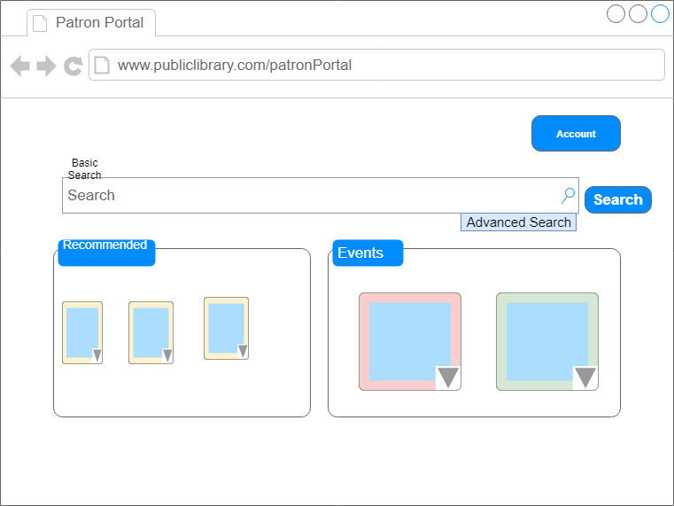

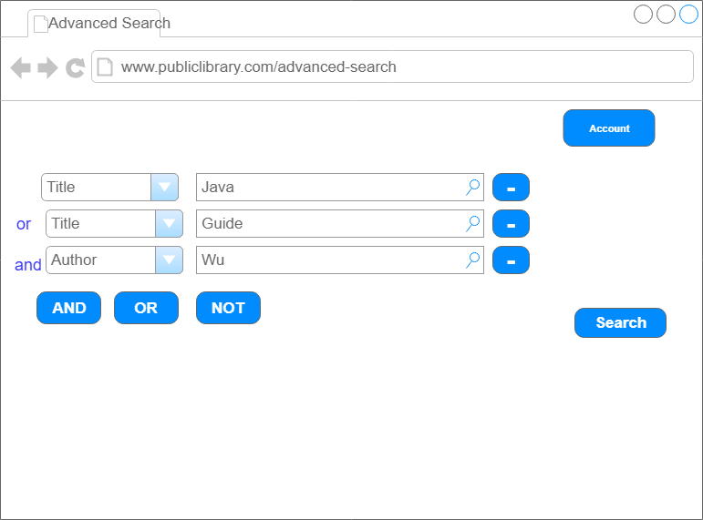

A screenshot of a cell phone

Description generated with very high confidence

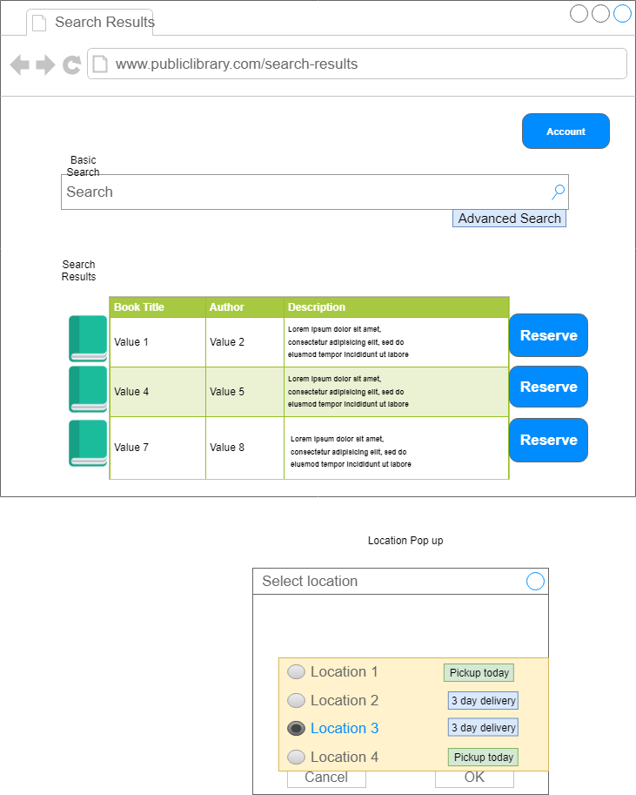

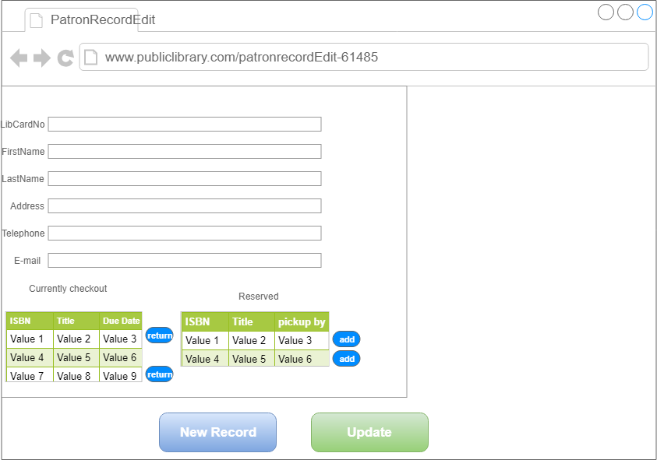

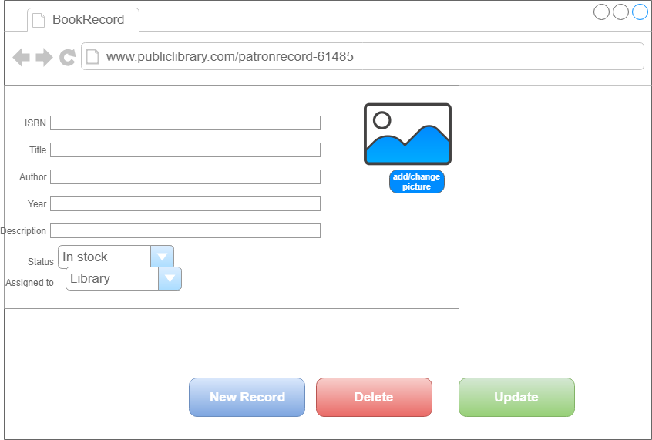

A screenshot of a social media post

Description generated with very high confidence