Microservices

Table of Contents

1. Introduction to Web Service 3

2. SOAP Web service 3

***Microservices***

# Introduction to Web Service

The following are the three features that define any web service.

* Designed to allow machine to machine interaction.
* Should be platform independent.
* Should be able to communicate over a network or can be throught a managed queue.

Every Web Service will have a service definition which provides the following information.

* Request / Response Format – XML, JSON, Plain Text
* Request Structure
* Response Structure
* End points

# SOAP Web service

The SOAP is a protocol defined for a given webservice. The data being transmitted will have a defined structure composed of SOAP Envelope incorporating SOAP Header and SOAP Body.

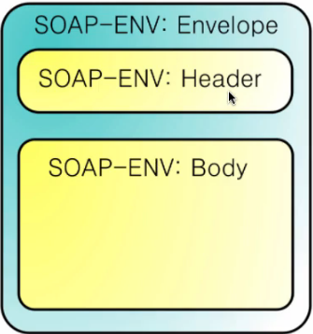

The SOAP Web service defines two ways of implementing communication, one through the HTTP and als by means of managed queue.